

# Agency Viewer

OTCnet Participant User Guide

Table of Contents

Overview, Topics, and Audience 1

Overview 1

Topics 1

Audience 2

Topic 1 Introduction to OTCnet 3

Overview 3

OTCnet Elements 3

OTCnet Process Flow: Deposit Reporting 5

OTCnet End Users 5

Topic 2 Overview of OTCnet Participant User Guide Content 7

Introduction 7

Administration Participant User Guide 7

Deposit Processing and Reporting Participant User Guides 8

Topic 3 Requesting Access for Yourself in SailPoint IIQ 10

Self-Register/Create an Account in SailPoint IIQ 10

Self-Register/Create an Account in SailPoint IIQ 11

Request Access for Yourself in SailPoint IIQ 12

Request Access for Yourself in SailPoint IIQ 13

Topic 4 Log in to OTCnet Online 16

Log in to OTCnet Online 16

Log in to OTCnet Online 17

Topic 5 Navigating the OTCnet Home Page 19

OTCnet Online Main Menu 19

OTCnet Online Deposit Processing Tab Functionality 20

OTCnet Online Check Processing Tab Functionality 21

OTCnet Online Card Processing Tab Functionality 22

OTCnet Online Administration Tab Functionality 23

OTCnet Online Reports Tab Functionality 24

Topic 6 Viewing Deposits 25

View a Deposit 25

View a Deposit 27

Topic 7 Search for a Deposit 29

Search for a Deposit 30

Download Deposit Information 32

Download Deposit Information 33

Topic 8 Searching Adjustments 36

Searching for and Viewing Adjustments 36

Searching for and Viewing Adjustments 37

Downloading Search Results for Adjustments 39

Downloading Search Results for Adjustments 40

Topic 9 Viewing Reports 41

Topic 10 Reports by User Role 42

Topic 11 Types of Reports 45

Business Reports 45

Security Reports 47

Administration Reports 48

Historical Reports 48

Topic 12 Viewing Reports 49

Business Reports 49

View Business Reports: Adjustments by OTC Endpoint 51

View Business Reports: Deposits by Accounting Code 53

View Business Reports: Deposits by OTC Endpoint 55

View Business Reports: Deposit History by Status 57

View Business Reports: Non-Reporting OTC Endpoints 59

Administration Reports 61

View Administrative Reports: Vouchers Completed 62

View Administrative Reports: Vouchers in Progress 64

Historical Reports 66

View Historical Reports: Deposit Historical Report 68

View Historical Reports: Adjustment Historical Report 71

Summary 74

List of Figures

Figure 1: OTCnet Elements 4

Figure 2: Deposit Processing Workflow 5

Figure 3. SailPoint IIQ Login Page 11

Figure 4. SailPoint Home Page with Manage My Access Button 13

Figure 5. Add Access Screen 14

Figure 6. Review and Submit Screen 14

Figure 7. OTCnet Log In Screen 17

Figure 8. First Time Log In Screen 18

Figure 9. OTCnet Main Menu Page 19

Figure 10. OTCnet Homepage Message Overlay 20

Figure 11. Deposit Processing Tab 21

Figure 12. Check Processing Tab 22

Figure 13. Card Processing Tab 22

Figure 14. Administration Tab 23

Figure 15. Manage Reports 24

Figure 16: View Deposits Page 27

Figure 17: Search Results Table 31

Figure 18: Download Button 33

Figure 19: Download Attributes Selection 34

Figure 20: Additional Search Criteria 37

Figure 21: Download Button 40

Figure 22: Adjustments by OTC Endpoint Parameters Page 51

Figure 23: Deposits by Accounting Code Report Preview Page 53

Figure 24: Deposits by OTC Endpoint Report Preview Page 55

Figure 25: Deposit History by Status Preview Page 57

Figure 26: Non-Reporting OTC Endpoints Preview Page 59

Figure 27: View Voucher Event Log Page 62

Figure 28: Voucher Event Details Report Output 63

Figure 29: In Progress View Voucher Event Log Page 64

Figure 30: In Progress Voucher Event Details Report Output 65

Figure 31: Deposit Historical Report Criteria Page 68

Figure 32: Adjustment Historical Report Criteria Page 71

List of Tables

Table 1: End User Roles 6

Table 2: Administration User Guides 7

Table 3: Deposit Processing User Guides 8

Table 4. Main Menu Link Descriptions 19

Table 5. Deposit Processing Tab Descriptions 20

Table 6. Check Processing Tab Descriptions 21

Table 7. Card Processing Tab Descriptions 22

Table 8. Administration Tab Descriptions 23

Table 9. Reports Tab Descriptions 24

Table 10: Deposit Status 25

Table 11: Search Criteria Fields 29

Table 12: Search Results Deposit Statuses 29

Table 13: Search Criteria Fields 36

Table 14: Types of Reports and Purpose 41

Table 15: Business Reports by Federal Program Agency User Roles 42

Table 16: Business Reports by Financial Institution/Federal Reserve Bank as Financial Institution User Roles 42

Table 17: Security Reports by Federal Program Agency User Roles 43

Table 18: Security Reports by Financial Institution/Federal Reserve Bank as Financial Institution User Roles 43

Table 19: Administration Reports by Federal Program Agency User Roles 43

Table 20: Administration Reports by Financial Institution/Federal Reserve Bank as Financial Institution User Roles 44

Table 21: Historical Reports by Federal Program Agency User Roles 44

Table 22: Historical Reports by Financial Institution/Federal Reserve Bank as Financial Institution User Roles 44

Table 23: Business Reports by User Role 45

Table 24: Security Reports by Federal Program Agency User Roles 45

Table 25: Security Reports by Financial Institution/Federal Reserve Bank as Financial Institution User Roles 46

Table 26: Administration Reports by Federal Program Agency User Roles 46

Table 27: Business Reports 46

Table 28: Security Reports by User Role 47

Table 29: Administration Reports by Financial Institution/Federal Reserve Bank as Financial Institution User Roles 47

Table 30: Security Reports 47

Table 31: Administration Reports 48

Table 32: Deposit Processing Historical Report 48

Glossary

Click this [link](https://www.fiscal.treasury.gov/otcnet/training/wbt/content/course_OTC/glossary.htm) to access the full OTCnet Glossary.

## Overview, Topics, and Audience

### Overview

Welcome to the *Agency Viewer Participant User Guide.* In this guide, you will learn:

* The introduction to OTCnet
* The overview of the OTCnet Participant User Guide content
* How to request access for yourself in SailPoint IIQ
* How to log in to OTCnet
* How to navigate the OTCnet home page
* The purpose of viewing deposits
* How to view a deposit draft
* How to view a deposit awaiting approval
* How to view a submitted deposit
* How to view a confirmed deposit
* How to view a deposit adjustment
* How to view a rejected deposit details
* How to search for and locate deposits using one or more search criteria
* How to download deposit voucher(s) as an XML or CSV file
* The purpose of searching adjustments
* How to search and locate adjustments using one or more search criteria
* How to download adjustment voucher(s) as an XML or CSV file
* The purpose of viewing reports
* The various types of reports you can access by role
* The types of reports
* The detail each report provides and how to view and download those reports

### Topics

1. Introduction to OTCnet
2. Overview of OTCnet Participant User Guide Content
3. Requesting access for yourself in SailPoint IIQ
4. Logging in to OTCnet
5. Navigating the OTCnet Home Page
6. Viewing Deposits
7. Searching Deposits
8. Searching Adjustments
9. Viewing Reports
10. Reports by Access Type
11. Types of Reports
12. Viewing Reports

### Audience

The intended audience for the Agency *Viewer Participant User Guide* includes:

* Agency Viewer

## Topic 1 Introduction to OTCnet

### Overview

The Bureau of the Fiscal Service (BFS) Over the Counter Division (OTCD) provides the Over-the-Counter Channel Application (OTCnet) to facilitate the prompt electronic processing, reporting of deposits and transaction activities. OTCnet financial services include retail transactions made at agency offices, face-to-face collection points, and point of sale (POS) locations throughout the US and abroad.

OTCD oversees the systems, networks and program infrastructure which enable world-class OTCnet financial services including the collection of checks, cash, coins and credit, debit, and gift card transactions at agency POS locations around the globe. The OTCD is responsible for implementing a coordinated government-wide strategy for the collection of over-the-counter transaction and deposit activities (cash, card, check, foreign checks/currency, seized currency), and the transition from paper checks to electronic mechanisms.

OTCnet is a secure web-based system that enables federal agencies to integrate check conversion, deposit reporting, and card processing, so that all check, cash, coin, and card deposits to the TGA are handled by one web-based application.

OTCnet offers agencies superior customer service and high-quality e-commerce solutions for collections and reporting needs.

OTCnet Financial Services includes the following:

* Electronic processing of US checks presented for cashing, payment, or deposit
* Processing of US currency, foreign currency cash and foreign check item deposits
* Acceptance of credit, debit, and gift cards (Visa, MasterCard, American Express, Discover)
* Support of the Self-Service Kiosk
* Automation of the collection and settlement process
* Support of online reporting and research capability for reconciliation and inquiries
* Improvements of deposit history record keeping

### OTCnet Elements

OTCnet is comprised of five elements:

1. *Administration
2. Check Capture, Check Processing and Reporting
3. Deposit Processing and Reporting
4. Card Processing
5. Self-Service Kiosk: Web Service

*Administration functions support Check Capture, Check Processing and Reporting, Deposit Processing and Reporting, Card Processing, and Self-Service Kiosk as shown in Figure 1.

Figure 1: OTCnet Elements

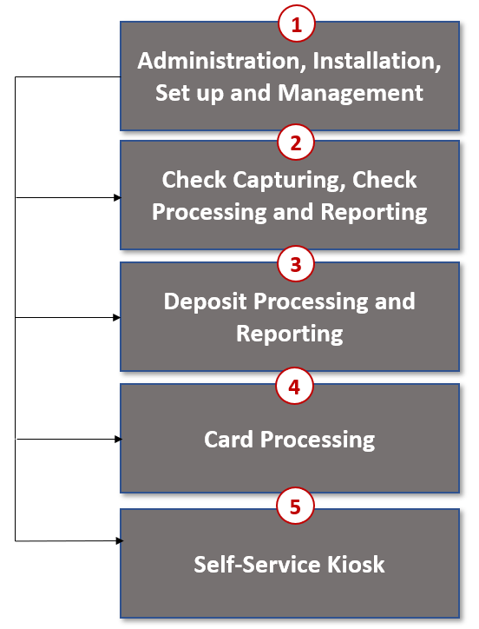

The functions of the five elements are:

* **Administration**: allows for those with administrative permissions to install, setup users, and manage OTCnet
* **Deposit Processing**: permits federal agencies the ability to create and submit deposits for confirmation. This platform also allows for Financial Institutions (FIs) to confirm those deposits and create adjustments electronically. Deposits can be created for US currency, foreign cash, and foreign check items
* **Check Capturing, Check Processing**: converts personal and business checks into electronic fund transfers. Transactions can be consumer, consumer accounts receivable, and business transactions
* **Card Processing**: allows agencies to provide their customers an option to make their payments via credit/debit cards and gift cards
* **Self-Service Kiosk**: third party vendor standalone kiosk supported by OTCnet

### OTCnet Process Flow: Deposit Reporting

Deposit Processing electronically collects and automates US and Foreign funds which facilitates the classification of Treasury collections daily.

As shown in Figure 2, the Deposit Preparer, or Agency, electronically reports the deposit to Treasury using OTCnet and prints out the OTCnet deposit ticket. The bank deposit ticket, OTCnet deposit ticket, cash, and checks (US and foreign) are taken to your Treasury General Account (TGA) Bank. At the TGA Back, the Deposit Confirmer confirms the deposit, rejects the deposit, or creates an adjustment to the deposit using OTCnet. The Collections Information Repository (CIR) is formerly the Transaction Reporting System (TRS).

OTCnet sends commercial deposit voucher information to CIR. CIR receives commercial deposit information from OTCnet for reconciliation and transmits to Treasury Cash Management System (TCMS) for cash concentration purposes. TCMS receives the commercial deposit data from CIR and initiates the cash concentration activity.

The Deposit Preparer and Deposit Viewer can access OTCnet to view their deposit ticket information, as well as access reports, receive rejections, and view adjustments.

Figure 2: Deposit Processing Workflow

OTCnet 
Card Processing Workflow
1. The Card Operator (Agency) initiates the Card Processing payment. The Agency can also access Collections Information Repository (CIR) to retrieve deposit information.

2. The customer pays with a credit, debit or gift card (Visa, Mastercard, American Express or Discover) at an agency workstation. The customer authorizes the amount to be charged to his/her account.

3. The Verifone/OTCnet terminal sends transaction data to Worldpay for authorization.

4. Worldpay processes the payment in four steps:
Step 1 - Authorization (Real Time)Worldpay sends the transaction data over to the card issuer through the card networks (Visa, Mastercard, American Express and Discover). The card issuer determines if funding is available or not and returns authorization back through the card networks to Worldpay.Step 2 - ClearingFunds in the daily transaction batch are cleared from Worldpay to Comerica Bank. The processing cut off for credit card payments is 4:30 AM and 2:00 AM for debit card payments.Step 3 - SettlementThe card issuer sends the settlement money back to Worldpay via the card networks once the payments have been authorized and cleared. The timing varies by credit/debit network for when the settlement money is sent back to Worldpay.Step 4 - Deposit ReportingIf the payment is approved, Worldpay sends deposit voucher transaction data to CIR via the Worldpay flat file the following morning between 4:00 AM - 6:00 AM.
5. TCMS receives the commercial deposit data from CIR and initiates the cash concentration activity via the National Settlement Service (NSS).

6. NSS transfers funds to the Treasury General Account (TGA) / Federal Reserve Bank (FRB) and reconciles with Worldpay / Comerica Bank.


### OTCnet End Users

There are four functional areas of the OTCnet application:

1. Administration
2. Check Capture, Processing and Reporting
3. Deposit Processing and Reporting
4. Card Processing

The user role you hold is based on the types of tasks you perform.

* Administration user roles, with varying degrees of permission, and perform administrative duties such as user management and system installation.
* Check Capture/Check Processing and Reporting user roles perform functions to capture checks, process checks, access reports and edit or view the Master Verification Database (MVD).
* Deposit Processing and Reporting user roles create deposits, approve, confirm (reject or adjust), and/or view information as shown in Table 1..
* Card Processing user roles perform functions to process card transactions.

Table 1: End User Roles

| Administration | Check Capture/ Check Processing and Reporting | Deposit Processing and Reporting | Card Processing |
| --- | --- | --- | --- |
| **Agency**   * Check Capture Supervisor * Check Capture Administrator * Accounting Specialist/ Local * Accounting Specialist * Card Administrator   **Financial Institution/ Federal Reserve**   * Primary Security Administrator * Local Security Administrator | **Agency**   * Check Capture Operator * Check Capture Lead Operator * Check Capture Supervisor * Batch Approver* * Batch Uploader* * Master Verification Database (MVD) Editor * Master Verification Database (MVD) Viewer | **Agency**   * Deposit Preparer * Deposit Approver * Viewer   **Financial Institution/ Federal Reserve**   * Deposit Confirmer * Viewer | **Agency**   * Card Operator |

*Batch Approver and Batch Uploader are sub-roles assigned to users with existing roles.

## Topic 2 Overview of OTCnet Participant User Guide Content

### Introduction

These OTCnet Participant User Guides are intended to provide you with the skills you need to use OTCnet, a system by which users can capture and process checks, and/or process deposits. Users with appropriate permissions can install, setup, and manage OTCnet.

The Participant User Guide can be used independent of or in conjunction with the OTCnet Web-based Training (WBT). The Participant User Guides are accessible through the OTCnet web site, OTCnet application help link site or through the User Guides button located within the WBT.

The Participant User Guides offer a series of 32 functionality-related user guides with individual topics for Administration, Deposit Processing, Check Capture and Check Processing and Card Processing. Each OTCnet Participant User Guide topic includes step-by-step instructions with critical images for completing tasks.

Although separated by segment, the User Guides may be printed individually or as one complete manual. You are not required to complete all 32 user guides, though it is highly encouraged that you access the guides pertaining to your user role.

In addition to the above-mentioned guides, this OTCnet Participant User Guide was created to support *Agency Viewer* specific instruction. Below is an introduction to the related Deposit Processing OTCnet functionality.

### Administration Participant User Guide

The Administration Participant User Guide includes ten user guides, including Check Capture, Check Processing, Deposit Processing and Card Processing Administrative functionality. Table 2 describes the related concepts covered in each guide:

Table 2: Administration User Guides

| User Guides | Description |
| --- | --- |
| 1. Introduction to OTCnet and Overview of OTCnet Participant User Guide Content | In this user guide, you will learn about the background of OTCnet, the element and process flows that make up OTCnet as well as overview of the Participant User Guides. |
| 1. Accessing and Navigating OTCnet | In this user guide, you will learn how to log in, establish security settings and how to use the OTCnet Main Page. |
| 1. Managing User Accounts | In this user guide, you will learn how to create a user account, update a user account, and assign user privileges |
| 1. Managing Your Agency’s Hierarchy, Accounting Codes, and Processing Options | In this user guide, you will learn how to create a hierarchy, designate an OTC Endpoint, establish a Financial Institution relationship, and designate a check capture location, modify and import accounting codes, modify endpoint mappings, and modify and view processing options. |
| 1. Configuring Administration and Card Processing Settings | In this user guide, you will learn how to manage custom labels, manage processing options and create and edit user defined fields. |
| 1. Viewing Financial Institutions | In this user guide, you will learn how to view Financial Institution details. |
| 1. OLB Setup Guide | In this user guide, you will learn how to download and install the OTCnet Local Bridge (OLB) Application, create the OLB profile and import OLB credentials. |
| 1. Configuring Card Terminal Processing Settings | In this user guide, you will learn how to set up or modify card terminal configuration, unregister a card terminal, view card terminal configuration, search an audit log and select a 80mm card receipt printer. |
| 1. Configuring Check Processing Settings Online | In this user guide, you will learn how to set up, modify and view a terminal configuration, view an audit log and download firmware. |
| 1. Setting Up and Configuring Check Capture Offline | In this user guide, you will learn how to a properly install offline check capture software; manage offline check capture; set up scanners; and configure check capture settings in offline mode. |

In addition to the Participant User Guides, the OTCnet Printable Job Aids walks an Administrator through the steps to e.g., set up an organizational hierarchy and Check Capture and Check Processing Administrative settings. These may be used in conjunction with the 10 Administration user guides reviewed above.

### Deposit Processing and Reporting Participant User Guides

10 Chapters make up the Deposit Processing and Reporting Participant User Guide. Table 3 describes the related concepts covered in each Chapter:

Table 3: Deposit Processing User Guides

| User Guides | Description |
| --- | --- |
| 1. Introduction to OTCnet and Overview of OTCnet Participant User Guide Content | In this user guide, you will learn about the background of OTCnet, the element and process flows that make up OTCnet as well as overview of the Participant User Guides. |
| 1. Accessing and Navigating OTCnet | In this user guide, you will learn how to log in, establish security settings and how to use the OTCnet Main Page. |
| 1. Creating and Modifying Deposits | In this user guide, you will learn how to create and modify deposits. |
| 1. Searching for Deposits | In this user guide, you will learn how to search for and download deposits. |
| 1. Approving Deposits or Returning Deposits to Draft | In this user guide, you will learn how to approve deposits or return deposits to draft. |
| 1. Confirming, Rejecting or Adjusting Deposits | In this user guide, you will learn how to confirm deposits, adjust deposits, or apply a credit/debit adjustment for US Currency and Foreign Check Items. |
| 1. Managing Adjustments | In this user guide, you will learn how to create a returned item adjustment for US Currency and Foreign Check Items. |
| 1. Searching Adjustments | In this user guide, you will learn how to search and download adjustments. |
| 1. Viewing Reports | In this user guide, you will learn how to view and pull administrative and business reports. |
| 1. Viewing Deposits | In this user guide, you will learn how to view deposit drafts, deposits awaiting approval, confirmed deposits, deposit adjustments, rejected deposit details, submitted deposits and how to download vouchers. |

## Topic 3 Requesting Access for Yourself in SailPoint IIQ

Following the transition to Common Approach to Identity Assurance (CAIA), SailPoint IdentityIQ (IIQ) environment will be used to manage the identities and provisioning of new users.

CAIA is a solution consisting of a common federation platform by which users would be able to register, proof, and authenticate their identity via one or more selected credential service providers to access Fiscal Service programs.

Prospective OTCnet users can create identities through **Personal Identity Verification Cards** (**PIV**) or **Common Access Cards** (**CAC**), or **ID.me.**

* Government agency users and contractors with **PIV**/**CAC** linked to their OTCnet accounts will have their identities transitioned seamlessly into CAIA.
* Non-government users without **PIV**/**CAC** cards will not be able to automatically transition their identities once the move to CAIA has been made. These users will need to use **ID.me** to create new user identities.

While completing your self-registration in SailPoint IIQ, as a prospective OTCnet user, you can select your desired role(s) and high-level org(s) based on instructions from your security administrator(s).

### Self-Register/Create an Account in SailPoint IIQ

You can self-register in SailPoint IIQ/create an account using **PIV**/**CAC** or **ID.me.**

Follow the on-screen instructions to sign in with an existing account or create an account. If prompted, follow the on-screen instructions to verify your identity. After completing all steps, you should see the SailPoint IIQ home page.

Self-Register/Create an Account in SailPoint IIQ

To self-register in SailPoint IIQ, navigate to the SailPoint IIQ environment at: [*https://iiq.fiscal.treasury.gov/*](https://iiq.fiscal.treasury.gov/) and complete the following steps:

1. Log in using **PIV**/**CAC** or **ID.me**, as shown in Figure 3.

Figure 3. SailPoint IIQ Login Page

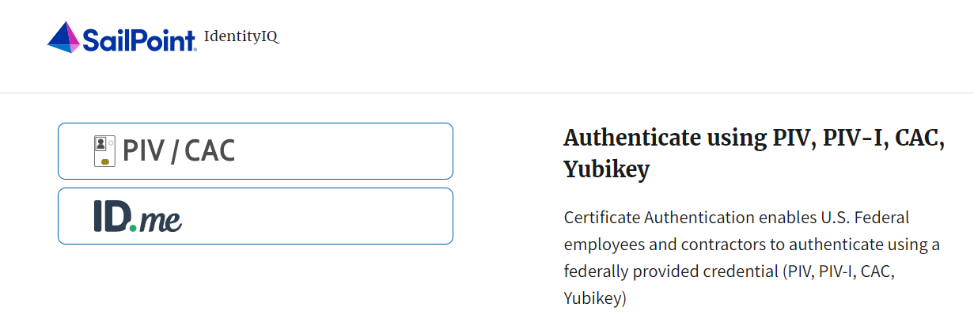

1. Follow the on-screen instructions to sign in with an existing account or create an account.
2. If prompted, follow the on-screen instructions to verify your identity.
3. After completing all steps, you should see the SailPoint IIQ home page.

Application Tip



New OTCnet users including those with **PIV**/**CAC** access should go through SailPoint IIQ to do the self-registration to create an account and request role(s) and high-level org(s) before logging to OTCnet. Once their high-level access is approved in SailPoint IIQ, they can proceed to login to OTCnet.

### Request Access for Yourself in SailPoint IIQ

If you need application entitlement, sign into SailPoint IIQ and request the specific access you need (self-request). Then the application approvers will receive a notification that there is an access request available to review. Once approved, you will be able to refresh your browser and successfully sign into the OTCnet application.

To request access for yourself, log into SailPoint IIQ and navigate to **Manage My Access.** Make sure **Add Access** is selected. In the search field, enter part or all of the **HLO**/**role** name you want to request. Select the **HLO**/**role** by clicking the **checkmark** to the left of the **HLO**/**role** name. Then select **Next**. On the **Review and Submit** screen, verify the requested **HLO**/**role(s)** are correct and select the **Submit** button.

A confirmation message will appear. SailPoint IIQ will automatically notify the necessary approvers to review the request. Once approved, your PLSA/LSA can create your identity in OTCnet and assign endpoints and roles for you. You will receive an autogenerated email when your user account is created in OTCnet.

Request Access for Yourself in SailPoint IIQ

To request access for yourself in SailPoint IIQ, complete the following steps:

1. From the **Home** screen of SailPoint, navigate to **Manage My Access** through the **Manage MyAccess** button as shown in Figure 4.

Figure 4. SailPoint Home Page with Manage My Access Button

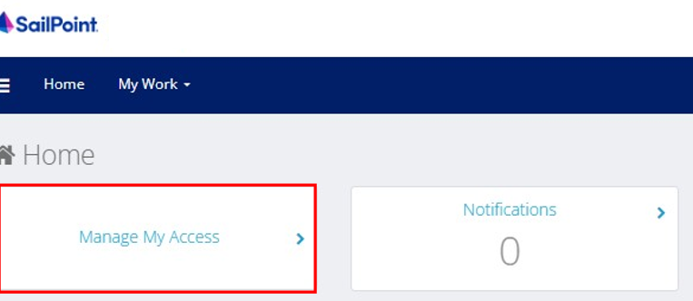

1. On the **Manage My Access** screen, ensure that **Add Access** tab is selected as shown in Figure 5.

Application Tips



Search for the specific **HLO** name (e.g., Alaska USA Federal Credit Union) and user **role** (e.g., Check Capture Operator).If the HLO or user role’s name is not known, type **HLO**/**Role** in the search field.

1. Search for an **HLO**. Select an **HLO** by clicking the **checkmark** to the left of the **HLO’s** name.
2. Continue on the same screen to search for a user role. Select a **role** by clicking the **checkmark** to the left of the **role’s** name. Then select **Next.**

Application Tips



* Multiple **HLOs** and **roles** can be selected.
* All roles selected in SailPoint IIQ will be validated (and edited as needed) in OTCnet by the designated **PLSA**/**LSA**.

Figure 5. Add Access Screen

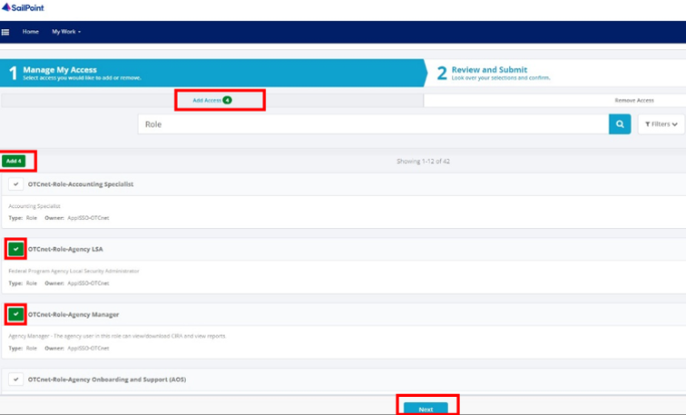

1. On the **Review and Submit** screen, verify the requested **HLOs** and **role(s)** are correct. Select the **voice bubble** to the right of the **HLO** or **role** to add any comments.
2. Select the **Submit** button at the bottom when finished, as shown in Figure 6.

Figure 6. Review and Submit Screen

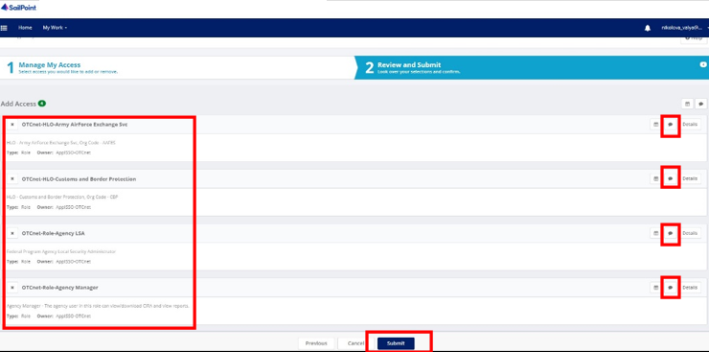

1. A confirmation message will appear. SailPoint IIQ will automatically notify the necessary approvers to review the request. Once approved, your PLSA/LSA can create your identity in OTCnet and assign endpoints and roles for you.

Application Tips



* You will receive an autogenerated email when your user account is created in OTCnet.
* Then you can access the OTCnet application.

## Topic 4 Log in to OTCnet Online

To log in to Fiscal Service Single Sign On (OTCnet Online), from the OTCnet Online login screen, use your **PIV**/**CAC** credentials, if you are a government user or contractor or **ID.me**, if you are a non-government user.

If you are a government employee or contractor who has a **PIV**/**CAC** card, you must link it to your BFS SSO account.

If you are a non-government user who creates an account through **ID.me,** youwill specify your email address. ID.me is a private single sign-on provider that meets the government’s online identity proofing and authentication requirements.

Accounts registered by users for CAIA authentication are not application-specific, the same account credentials can be used on other sites or applications that are linked to CAIA. For example, Social Security Administration, Internal Revenue Service, Department of Veterans Affairs, and other government agencies accept **ID.me** credentials for logging in.

### Log in to OTCnet Online

To log in to OTCnet Online, visit <https://otcnet.for.fiscal.treasury.gov> and log in with the following options: **PIV**/**CAC** or **ID.me**. Select the option that suits you best and follow the on-screen instructions to verify your identity or create an account in SailPoint IIQ.

Once you log in to OTCnet, you will be able to access functionality for one or more of the following:

* Administration
* Deposit Processing and Reporting
* Check Capture
* Check Processing
* Card Processing

The OTCnet Local Bridge (OLB) application is required for performing check processing, check capture, card processing and terminal configuration operations. If you are a **Check Capture Administrator**, **Check Capture Supervisor**, **Check Capture Lead Operator**, **Check Capture Operator, Card Operator** or **Card Administrator**, the **OLB** application must be started on the terminal to perform these operations.

Log in to OTCnet Online

To log in to Fiscal Service Single Sign On (OTCnet Online), complete the following steps:

1. Access [*https://otcnet.for.fiscal.treasury.gov*](https://otcnet.for.fiscal.treasury.gov)*.* A page is presented which displays the following log in options: **PIV/CAC** and **ID.me**, as shown in Figure 7.

Figure 7. OTCnet Log In Screen

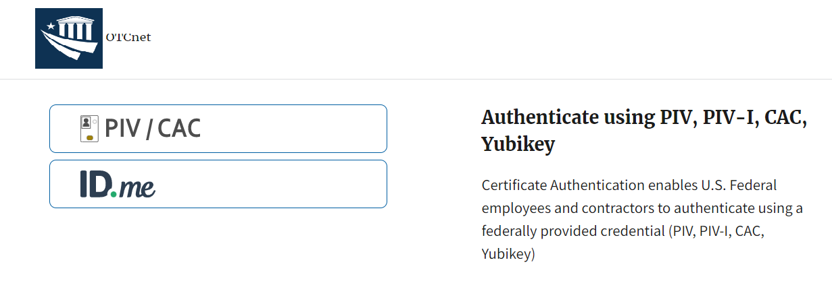

1. Select the option that best represents your status and follow the on-screen instructions to verify your identity or create an account in SailPoint IIQ.

Application Tip

Application Tips



**PIV/CAC (Government Users/Contractors)**

* Select the **PIV**/**CAC** button.
* If prompted, select your certificate, and enter your pin.
* If prompted, follow the on-screen instructions to verify your email address

The first time a **PIV**/**CAC** certificate is used to authenticate, the email verification process is initiated.

* A web page is displayed prompting you to submit your **email address** that will be associated with your certificate. A **verification code** is sent to the email address specified.
* A web page is displayed to allow you to input the verification code from the email.

Application Tip



**ID.me for Non-Government Users**

* Select the **ID.me** button.
* Follow the on-screen instructions to sign in with an existing account or create an account.
* If prompted, follow the on-screen instructions to verify your identity.

1. When you log in to OTCnet Online for first time you maybe alerted that you are not permitted to access the application until your agency’s security administrator completes your user provisioning in OTCnet as shown in Figure 8.
2. Once your agency’s security administrator has imported your user identity to OTCnet, and assigned endpoints and roles for you, you will be able to access the application.

Figure 8. First Time Log In Screen

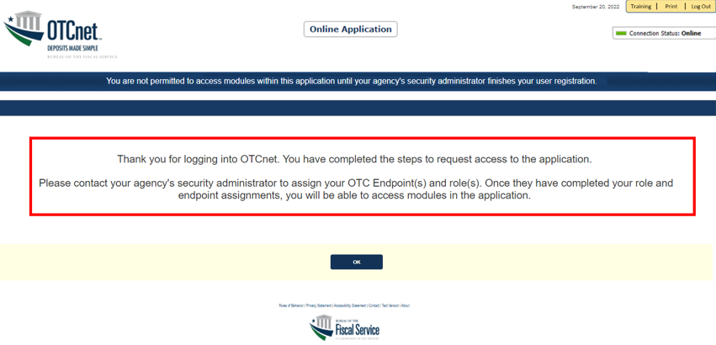

1. To completely log out, close your browser. You will need to reauthenticate next time you login to OTCnet.

Application Tip



As a **Check Capture Administrator**, **Check Capture Supervisor**, **Check Capture Lead Operator**, **Check Capture Operator**, **Card Operator** or **Card Administrator**, when logging in to OTCnet Online and using Microsoft Edge or Google Chrome, the OTCnet splash screen does not appear.

## Topic 5 Navigating the OTCnet Home Page

The *OTCnet Online* home page allows **Check Capture Supervisors**, **Check Capture Lead Operators**, **Check Capture Operators** and **Card Operators** to process deposits, capture checks, process checks, process card transactions, view reports, and perform administrative and security functions. Additionally, a user can access information for training, help and to update a user profile. The OTCnet Online home page is accessible for users to either view or perform any of these functionalities.

The *OTCnet Offline* home page allows **Check Capture Supervisors**, **Check Capture Lead Operators** and **Check Capture Operators** to capture checks along with transaction data, perform administrative functions and access help information. The OTCnet Offline home page is accessible by users to either view or perform any of the functionalities mentioned in *OTCnet Online*.

### OTCnet Online Main Menu

To access the OTCnet Main Menu, log in with your **PIV**/**CAC** or **ID.me** credentials with the following url, *https://otcnet.for.fiscal.treasury.gov*. Table 4 provides a list of the Main Menu options available to you. They are accessible on the upper right corner of the OTCnet application.

Table 4. Main Menu Link Descriptions

| **Link** | **Description** |
| --- | --- |
| Home | Allows a user to return to the OTCnet home page. |
| Training | Allows a user to access the Web-Based Training (WBT) and other corresponding training materials. |
| Print | Allows a user to print the page. |
| Help | Allows a user to access help for the page they are on. |
| Log Out | Allows a user to log out of OTCnet. |

The Main Menu is shown in Figure 9. The links are accessible on the upper right side of the OTCnet home page.

Figure 9. OTCnet Main Menu Page

**OTCnet Homepage Message Overlay**

All user roles have access to the OTCnet Homepage Message Overlay, in OTCnet Online (you will not see it in OTCnet Offline). For all Microsoft Edge and Google Chrome users, the message overlay automatically presents when you first log in to OTCnet.

The message overlay is a messaging platform presenting important news and information on the OTCnet system as shown in Figure 10. It is recommended that you read the messages, close the message overlay, and continue viewing the OTCnet homepage.

Figure 10. OTCnet Homepage Message Overlay

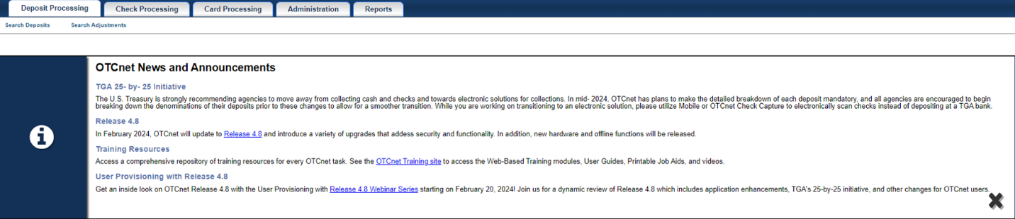

### OTCnet Online Deposit Processing Tab Functionality

To access the OTCnet Deposit Processing functionality, log in with your **PIV**/**CAC** or **ID.me** credentials. Table 5 provides a list of the Deposit Processing functions that are available to you.

Table 5. Deposit Processing Tab Descriptions

| **Function** | **Description** |
| --- | --- |
| Create Deposit | Allows a user to create deposits for US Currency, Foreign Check Items, and/or Foreign Currency Cash. |
| Search Deposits | Allows a user to search for deposits. |
| Search Adjustments | Allows a user to search for adjustments. |
| Create Returned Item Adjustment | Allows a user to create a returned item adjustment. |

The Deposit Processing tab, as shown in Figure 11, allows you to access Deposit Processing functionality, though depending on your user role, you may not see all functionality.

Figure 11. Deposit Processing Tab

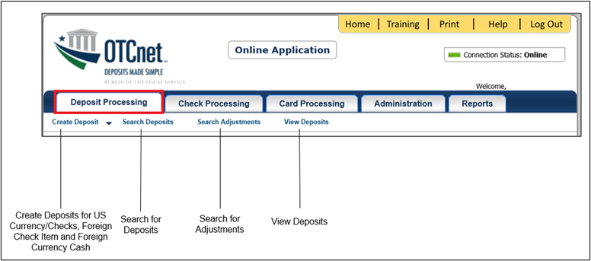

### OTCnet Online Check Processing Tab Functionality

To access the OTCnet Check Processing functionality, log in with your **PIV**/**CAC** or **ID.me** credentials. Table 6 provides a list of the Check Processing functions that are available to you.

Table 6. Check Processing Tab Descriptions

| **Function** | **Description** |
| --- | --- |
| Manage Verification | Allows a user to search and/or create an MVD record. |
| CIRA Query | Allows a user to view and/or modify a CIRA record. |
| Batch Management | Allows a user to search, view, close, approve and submit a batch. A user may edit and void an item within a batch with the proper permission. |
| Check Scan | Allows a user to scan checks. |
| Transmission History | Allows a user to view transmission history for batches that are uploaded from the offline check capture application. |

The Check Processing tab is shown in Figure 12. Depending on your user role, you may not see all functionality shown in the image.

Figure 12. Check Processing Tab

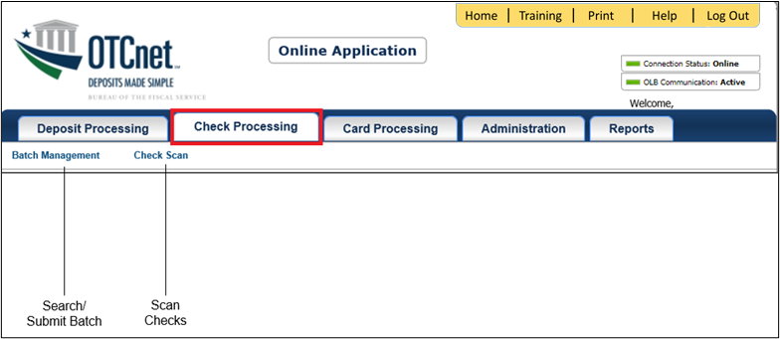

### OTCnet Online Card Processing Tab Functionality

To access the OTCnet card processing functionality, log in with your **PIV**/**CAC** or **ID.me** credentials. Table 7 provides a list of the card processing functions that are available to you.

Table 7. Card Processing Tab Descriptions

| **Function** | **Description** |
| --- | --- |
| Card Transaction Query | Allows a user to query a card transaction. |
| Process Card Payment | Allows a user to process a card payment. |

The Card Processing tab is shown in Figure 13. Depending on your user role, you may not see all functionality shown in the image.

Figure 13. Card Processing Tab

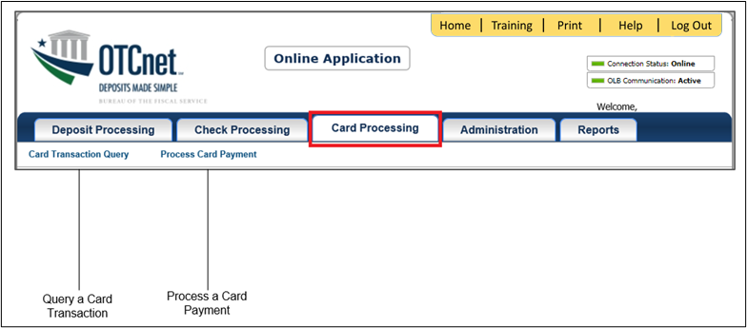

### OTCnet Online Administration Tab Functionality

To access the OTCnet Administration functionality, log in with your **PIV**/**CAC** or **ID.me** credentials. Table 8 provides a list of the Administration functions that are available to you.

Table 8. Administration Tab Descriptions

| **Function** | **Description** |
| --- | --- |
| Manage Organizations | Allows a user to manage Organization Hierarchy, Accounting Codes, Custom Labels, Processing Options, and User Defined Fields. |
| Manage FI | Allows a user to create and/or modify a Financial Institution, transfer FI RTN Numbers, transfer CA$HLINK accounts, and maintain FRB CA$HLINK accounts. |
| Manage Users | Allows a user to manage OTCnet user accounts and profiles. |
| Management | Allows a user to manage OTCnet processes. |
| Manage Check Processing | Allows a user to manage terminal configuration and forms. |
| Manage Card Processing | Allows a user to manage terminal configuration. |
| Manage Centralized Deployment | Allows users access to the following: Release Configuration, Edit Release and Download Release. |
| Audit | Allows a user to review the audit log history. |
| Utilities | Allows a user to review batch utilities, including Batch Recreate and Batch Repair. |

The Administration tab is shown in Figure 14. Depending on your user role, you may not see all functionality shown in the image.

Figure 14. Administration Tab

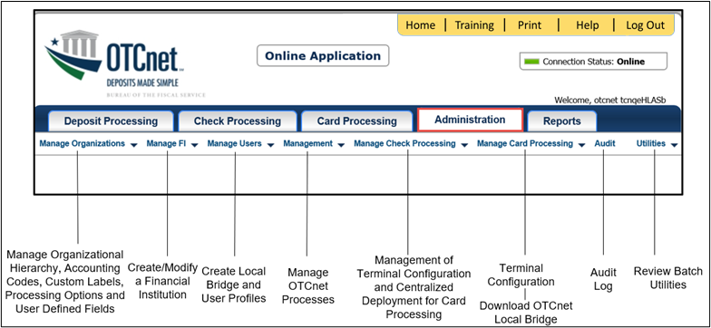

### OTCnet Online Reports Tab Functionality

To access the OTCnet Reports functionality, log in with your **PIV**/**CAC** or **ID.me** credentials. Table 9 provides a list of the Reports functions that are available to you. Depending on your user role, you are only authorized to view and download certain reports.

Table 9. Reports Tab Descriptions

| **Function** | **Description** |
| --- | --- |
| Deposit Processing Reports | Allows a user to view and download Business, Security and Administration reports. |
| Check Processing Reports | Allows a user to access Check Processing reports. |
| Historical Reports | Allows a user to query and download historical reports. |

The Reports tab is shown in Figure 15. Depending on your user role, you may not see all functionality shown in the image.

Figure 15. Manage Reports

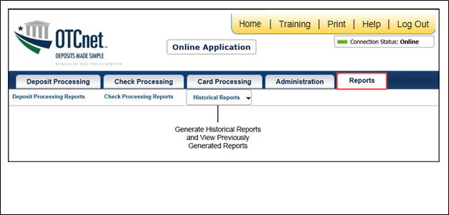

## Topic 6 Viewing Deposits

As an **Agency Viewer**, you are authorized to view deposit vouchers. You may view deposits to locate those in process or see deposit transactions belonging to others in the organization.

You have permission to view only certain deposits. The deposit status types available for viewing are included in Table 10.

Table 10: Deposit Status

| Deposit Status | Description |
| --- | --- |
| Draft | A deposit that is saved for modification at a later date by a Deposit Preparer |
| Awaiting Approval | A deposit that is waiting for deposit confirmation by a Deposit Approver |
| Submitted | A deposit that is submitted and waiting deposit confirmation by a Deposit Confirmer |
| Confirmed | A deposit that has been reviewed and confirmed by a financial institution (FI) or federal reserve bank (FRB) |
| Rejected | A deposit that is returned by a Financial Institution or FRB to the Deposit Preparer to create a new deposit |

### View a Deposit

To view a deposit, select **My Deposits in Process**, **Adjustments in Error**, **Deposits in Error**, or **Deposits Within My Organization.** Click the voucher number of the deposit you would like to view and change the number of records displayed per page, from the drop-down menu options next to record count.

* **My Deposits in Process**: Displays deposits that require addition action (e.g. Draft, Awaiting Approval, Submitted, Rejected, and Confirmed) based on user permissions.

If the user only has an FI Viewer or FRB Viewer role and selects this page, it returns no results. If the user is a Deposit Confirmer or FRB Confirmer, the table displays the column indicating the Confirm option to allow for multiple confirmations at the same time. For all other user roles, this column is hidden.

* **Adjustments in Error**: Displays adjustments that have validation errors awaiting acknowledgement by the financial institution that the error has been resolved.

The **Adjustments in Error** page displays any CA$HLINK II validation errors that need acknowledgment by the financial institution that the error has been resolved. No results appear if there are not any CA$HLINK II validation errors. To document why the error occurred and how the error was resolved, select the Voucher Number link is selected. This page only returns results for the **Deposit Confirmer** and **FI Viewer** roles. Other roles have the ability to select this page from the dropdown but do not see no results. Vouchers displayed in this section are also displayed in the History section of the page with the appropriate deposit status (Confirmed).

* **Deposits in Error**: Displays deposits that have validation errors awaiting acknowledgement by the financial institution that the error is resolved. With **Deposit Confirmer** or **FI Viewer** privileges, the **Deposits in Error** details appears.

The **Deposits in Error** page displays any CA$HLINK II validation errors that need acknowledgment by the financial institution that the error has been resolved. No results appear if there are not any CA$HLINK II validation errors. To document why the error occurred and how the error was resolved, select the Voucher Number link is selected. This page only returns results for the **Deposit Confirmer** and **FI Viewer** roles. Other roles have the ability to select this page from the dropdown but do not see results. Vouchers displayed in this section are also displayed in the History section of the page with the appropriate deposit status (Confirmed).

* **Deposits Within My Organization**: Displays a list of deposits that have been entered in the system, based on the agency endpoint or financial institution to which the user has access. With **Deposit Confirmer** or **FI Viewer** privileges, the **Deposits Within My Organization** details appears.
* The **Deposits Within My Organization** page displays voucher dates in reverse chronological order (including future dated deposits) and the status within (i.e. Draft, Submitted, Rejected, and Confirmed). The number of deposits displayed is based upon the display days processing options defined for the OTC Endpoint that the agency user has permission to view. If the user has permission for more than one OTC Endpoint, the processing option with the greatest number of days is used. If the user is an **FI Viewer** or an **FS Viewer**, the number of display days is set at 45.

View a Deposit

To view a deposit, complete the following steps:

1. From the **Deposit Processing** tab, click **View Deposits**. The *View Deposit* page appears.
2. From the **Select Display** drop-down menu, select **My Deposits in Process**, **Adjustments in Error**, **Deposits in Error**, or **Deposits Within My Organization**.
3. Click the **Voucher Number** of the deposit you need to view as shown in Figure 16.

Figure 16: View Deposits Page

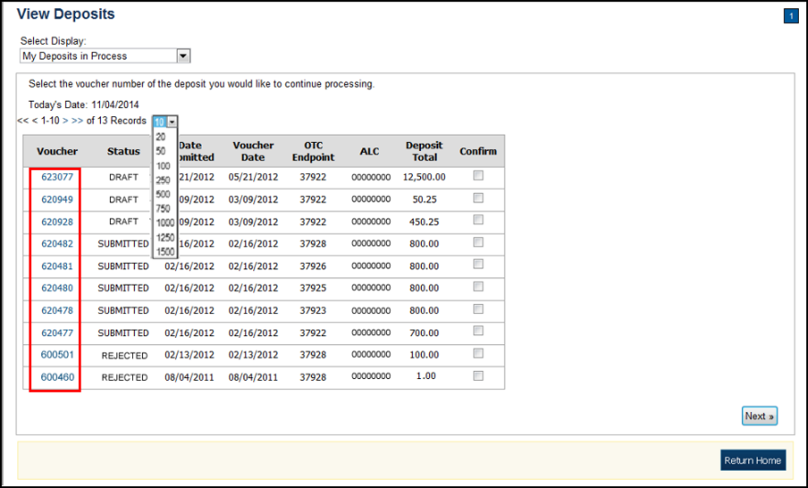

Application Tips



* By default, up to 10 records are displayed per page. To change the number of records displayed per page, select from the drop-down menu options next to the record count.
* When your Financial Institution makes an adjustment to a deposit, it appears in the **Adj**. column of the **Deposit Transactions** section of the table.
* To view additional details, click the appropriate **Voucher Number**.
* The *View Confirmed Deposit* page appears. Under **Adjustment Information**, click the **Voucher Number** to view the deposit adjustment details.

Additional Buttons



* Click **Cancel** to return to the OTCnet Home Page. No data   
  is saved.
* Click **Confirm** to confirm a deposit (Visible if a user has   
  Deposit Confirmer privileges).
* Click **Clear** to clear all data fields and reset to the default selections.
* Click **Delete** to eliminate the deposit. (Visible if a user has Deposit
* Preparer privileges.)
* Click **Print Deposit Ticket** to print a formatted deposit ticket.
* Click **View Voucher Event Log** to view the history of the   
  deposit voucher.
* Click **Voucher Event State** to view voucher details.
* Click **Next** to advance to the next page. (Visible only in My Deposits in Process view).
* Click **Previous** to return to the previous page.
* Click **Return Home** to return to the OTCnet Home Page.
* Click **Reject** to reject a deposit (Visible if a user has Deposit Confirmer privileges.)
* Click **Adjust** to adjust a deposit (Visible if a user has Deposit Confirmer privileges.)
* Click **Save as Draft** to save the information without submitting the deposit. (Visible if a user has Deposit Preparer privileges.)
* Click **Submit** to complete the process and display the Confirmation   
  page. (Visible if a user has Deposit Approver privileges.)
* Click **Update CAN**/**ACCT Key** to update the account number assigned to a deposit. (Visible if a user has Deposit Confirmer privileges.)
* Click **Add Adjustment** to adjust a deposit. (Not visible for Foreign Check Items.)

## Topic 7 Search for a Deposit

As an **Agency Viewer**, you are authorized to search for a deposit voucher and download and save the searched deposit voucher(s) as an XML or CSV file.

To search for a deposit, select the **Search Deposits** function. The **Search Deposits** function enables you to search for a deposit voucher using one or more criteria. If you do not specify any criteria, the search results include all deposits in the system that you have access to view. You can run additional searches; the Search Results table that appears is cleared and re-populated with the results of the new search. See Table 11 for search criteria fields.

Table 11: Search Criteria Fields

| Search Criteria Groupings | Search Criteria Fields |
| --- | --- |
| Search Conditions | * Organization * OTC Endpoint * ALC * Prepared by * Voucher Number * Deposit Status * Agency Block 6 * Deposit Type |
| Voucher Date | * From and To Date |
| Deposit Date | * From and To Date |
| Deposit Total | * From and To Total |
| Financial Institution Information | * Routing Transit Number * Demand Deposit Account * CA$HLINK II Account Number * FRB Account Key * FRB Cost Center Work Unit |

Under the **Search Deposits** function, if you run a search without specifying any criteria, the search results include all deposits in the system that you have access to view Table 12.

Table 12: Search Results Deposit Statuses

|  |  |
| --- | --- |
| Draft | A deposit that is saved for modification at a later date by a Deposit Preparer |
| Awaiting Approval | A deposit that is waiting for deposit confirmation by a Deposit Approver |
| Submitted | A deposit that is submitted and waiting deposit confirmation by a Deposit Confirmer |
| Confirmed | A deposit that has been reviewed and confirmed by a Financial Institution or FRB |
| Rejected | A deposit that is returned by a Financial Institution or FRB to the Deposit Preparer to create a new deposit |

Search for a Deposit

To search for a deposit, complete the following steps:

1. From the **Deposit** **Processing** tab, click **Search** **Deposit**. The *Search* *Deposit* page appears.
2. Enter the search criteria for the deposit you would like to view and click **Search**. The *Search Results* table appears.

Under Search Conditions, *optional*

* Select the **Organization**
* Select the **OTC Endpoint**
* Enter the **ALC (Agency Location Code)**
* Enter **Prepared by** details
* Enter the **Voucher #**
* Select the **Deposit Status**
* Enter **Agency Use (Block 6)** details
* Select the **Deposit Type**
* Enter the **From** and **To** Voucher Date
* Enter the **From** and **To** Deposit Date
* Enter the **From** and **To** Deposit Total

Application Tip



Voucher From date must be 5 years or less from the current date. Vouchers more than five years old are viewed from the **Historical Reports** menu.

Under **Financial Institution Information**, *optional*

* Enter the **RTN (Routing Transit Number)**
* Enter the **DDA (Demand Deposit Account)**
* Enter the **CAN (CA$HLINK II Account Number)**
* Enter the **FRB Account Key (Federal Reserve Bank Account Key)**
* Enter the **FRB CCWU (Federal Reserve Bank Cost Center Work Unit)**

Under **User Defined Field Information**, *if applicable*, *optional*

* Enter the **Deposit UDF (User Defined Fields)**
* Enter the **Accounting Subtotal UDF details**

Application Tips



* User Defined Fields (UDFs) only display to users who have access to an organization that has previously defined UDFs.
* UDFs appear at the bottom of the page.
* Up to three UDFs can be displayed for **Deposit** and two for **Accounting Subtotal.**

1. Click the **Voucher Number** of the deposit whose details you would like to view as shown in Figure 17.

Figure 17: Search Results Table

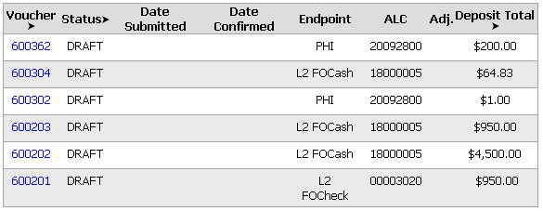

Application Tips



* Deposit totals are not displayed for unconfirmed foreign check items for which **Other** was selected as the country of deposit during deposit creation.
* Click **Download** to save the search deposit results as an XML or CSV file.

Additional Buttons



* Click **Edit** to modify the deposit draft. (Visible if a user has **Deposit Preparer** privileges.)
* Click **Previous** to return to the previous page.
* Click **Print Deposit Ticket** to print a formatted deposit ticket.
* Click **Return Home** to return to the OTCnet Home Page.
* Click **View Voucher Event Log** to view the history of the   
  deposit voucher events.

### Download Deposit Information

After searching for your deposit, you can download the retrieved information. To download the results of a deposit, first use the **Search Deposits** function.

To download search results, enter the optional search criteria for the deposit you would like to view and click **Search**. Search criteria under **Search Conditions**, including **Voucher**, **Status**, **Date Submitted**, **Date Confirmed**, **OTC Endpoint**, **ALC**, **Adj.**, and **Deposit Total**.

Search criteria under **Financial Institution Information** and enter **User Defined Field Information** details.

You can also download your results by selecting the **XML file** or **CSV file** format. Check the desired attributes that you want to download for **Deposit Information**, **Financial Institution Information**, **Agency Information**, **Accounting Subtotals and User Defined Data**, and **Foreign Deposit Information.** Open or save your file.

Download Deposit Information

To download the search results for a deposit, complete the following steps:

1. Click **Download** from the *Search Results* table. The *Download Deposits* page appears as shown in Figure 18.

Figure 18: Download Button

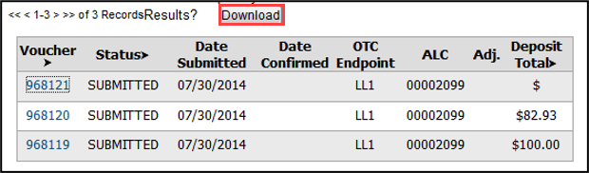

Application Tip



The *Search Results* table does not display **Deposit Total** values for unconfirmed Foreign Check Item deposits associated with a Country of Deposit selection of **Other**.

1. Select **XML file** or **CSV file** as the file format.
2. Check the desired attributes that you want to download for the following:
   * **Deposit Information**
   * **Financial Institution Information**
   * **Agency Information**
   * **Accounting Subtotals and User Defined Data**
   * **Foreign Deposit Information**
3. Click **Submit** as shown in Figure 19. The *File Download* dialog box appears.

Figure 19: Download Attributes Selection

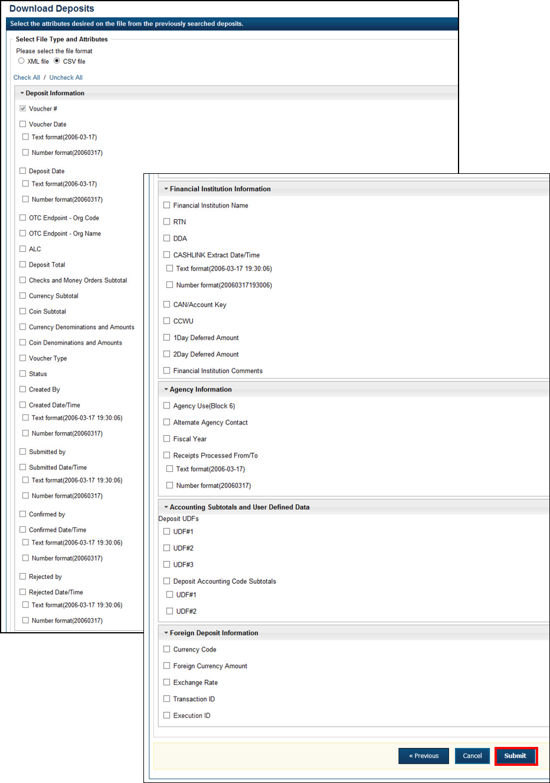

1. Click **Open** or **Save.**

Application Tips



* Click **Open** and the content of the file displays.
* Click **Save** to choose the location where you want to save the file.

Additional Buttons



* Click **Cancel** to return to the OTCnet Home Page. No data is saved.
* Click **Clear** to clear all data fields and reset to the default selections.
* Click **Download** to download the search results.
* Click **Previous** to return to the previous page.
* Click **Print Deposit Ticket** to print a formatted deposit ticket.
* Click **Search** to display the deposits that match the search criteria.
* Click **Return Home** to return to the OTCnet Home Page.

## Topic 8 Searching Adjustments

As an **Agency Viewer**, you are authorized to search for and view adjustments and download and save the searched adjustment voucher(s) as an XML or CSV file. You may review adjustments to understand why a deposit is adjusted and what corrections were made.

To search for an adjustment to a **US Currency** or **Foreign Check Items** deposit, click the **Search Adjustments** function. The **Search Adjustments** function enables you to search for a deposit voucher using one or more criteria.

If you do not specify any criteria, the search results include all deposits in the system that you have access to view. If you run additional searches, the Search Results table repopulates with the results of the new search. See Table 13 for search criteria fields.

Table 13: Search Criteria Fields

| Search Criteria Groupings | Search Criteria Fields |
| --- | --- |
| Search Conditions | * Organization * OTC Endpoint * ALC * Adjustment Category * Voucher Number * Adjustment Type * Prepared By * Adjustment Reason |
| Voucher Date | * Date Range |
| Adjustment Amount | * Total Range |
| Deposit Date | * Date Range |
| Original Deposit Date | * Date Range |
| Financial Institution Information | * Routing Number * Demand Deposit Account * CA$HLINK II Account Number * FRB Account Key * FRB Cost Center Work Unit |

### Searching for and Viewing Adjustments

**Search Adjustments**—you may search adjustments by selecting specific criteria. For this function, if you run a search without specifying any criteria, the search results include all deposits in the system that you have access to view.

To view an adjustment, you can download your search results by selecting the **Voucher #**, **Voucher Date**, **Date of** **Deposit, Reason Code**, **ALC, Adj. (Type)**, **Debit/Credit** and **Adjustment Amount**.

Searching for and Viewing Adjustments

To search for and view an adjustment, complete the following steps:

1. Click the **Deposit Processing** tab, click **Search Adjustments**. The *Search Adjustments* page appears.
2. Enter the search criteria and click **Search**.

Under **Search Conditions**, *optional*

* + Select an **Organization**
  + Select an **OTC Endpoint**
  + Enter an **ALC (Agency Location Code)**
  + Select an **Adjustment Category**
  + Enter a **Voucher #**
  + Select an **Adjustment Type**
  + Enter the **Prepared by** name
  + Select an **Adjustment Reason**
  + Enter the **From**: and **To**: Voucher Dates
  + Enter the **From**: and **To**: Adjustment Amount
  + Enter the **From**: and **To**: Deposit Date
  + Enter the **From**: and **To**: Original Deposit Date

Additional search criteria is displayed as shown in Figure 20.

Figure 20: Additional Search Criteria

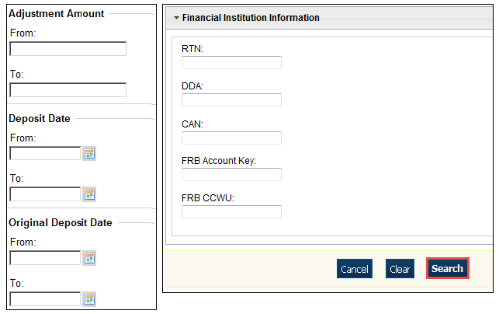

Application Tip



**Voucher From** date must be five years or less prior to the current date. Vouchers more than five years old can be viewed from the **Historical Reports** menu.

1. *The Search Results* table appears. Click the **Voucher Number** of the adjustment for the details you need to view.

Application Tip



Values do not display in the **Adjustment Amount** column for unconfirmed foreign check item deposits that were entered with a **Country of Deposit** of **Other**.

Additional Buttons



* Click **Download** to save the adjustment results as an **XML o**r **CSV** file.
* Click **Previous** to return to the previous page.
* Click **Return Home** to return to the OTCnet Home Page.
* Click **View Voucher Event Log** to view the history of the deposit voucher.

### Downloading Search Results for Adjustments

To download your search results, use the **Search Adjustments** function. After searching for your adjusted deposit, you can download the information you retrieve.

To download your search results for a deposit, enter the optional search criteria for your adjusted deposit, e.g., **Voucher #**, **Voucher Date**, **Date of Deposit**, **Reason Code**, **ALC**, **Adj. (Type)**, **Debit/Credit** and **Adjustment Amount**. You can also download the results.

Select either the **XML file** or **CSV file** format. Verify the desired attributes you want to download for **Adjustment Information**, **Original Deposit Information**, **Financial Institution Information** and **Foreign Return Item Information**. Open or save the file.

Downloading Search Results for Adjustments

To download the search results for a deposit, complete the following steps:

1. The Search Results table appears, click **Download** as shown in Figure 21. The *Download Deposits* page appears.

Figure 21: Download Button

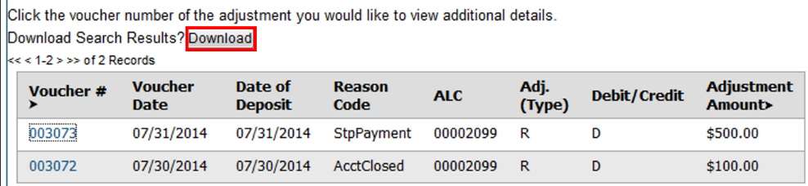

1. Select either the **XML file** or **CSV file** format.
2. Verify your desired attributes for download:
   * **Deposit Information**
   * **Financial Institution Information**
   * **Agency Information**
   * **Accounting Subtotals and User Defined Data**
   * **Foreign Deposit Information**
3. Click **Submit**. The *File Download* dialog box appears.
4. Click **Open** or **Save**.

Application Tips



* Click **Open** and the content of the file appears.
* Click **Save** to choose the location where you will save the file.

Additional Button



Click **Cancel** to return to the OTCnet Home Page. No data is saved.

## Topic 9 Viewing Reports

As a user or viewer with access to the Deposit Processing functionality, you may access one or more of the **Business Reports**, **Security Reports**, **Administration Reports** or **Historical Reports**. You may need to view or download a report for e.g., adjustment activity, user information or voucher status. Each report provides deposit information specific to the select type of data requested. Table 14 describes the purpose of each report type.

Table 14: Types of Reports and Purpose

| Report | Purpose of Report |
| --- | --- |
| Business | Provides specific reporting detail for deposit and adjustment activity by type, status and processing options for Agencies and Financial Institutions |
| Security | Provides specific reporting detail for access groups and users for Agencies and Financial Institutions |
| Administration | Provides specific reporting detail for interface to CIR,* as well as detailed information about completed and in progress vouchers |

*The Collections Information Repository (CIR) was formerly referred to as the Transaction Reporting System (TRS).

## Topic 10 Reports by User Role

Access to view reports in OTCnet is dependent on your user role. Table 15 presents the OTCnet user roles with access to each OTCnet report. Reports are grouped into the following categories:

* Business Reports
* Security Reports
* Administration Reports
* Historical Reports

Table 15: Business Reports by Federal Program Agency User Roles

| Business Reports | Deposit Preparer | Deposit Approver | Accounting Specialist | Local Accounting Specialist | FPA Viewer | Agency LSA | Agency PLSA |
| --- | --- | --- | --- | --- | --- | --- | --- |
| Adjustment Activity (FI) | blank | blank | blank | blank | blank | blank | blank |
| Adjustments By OTC Endpoint | • | • | blank | blank | • | blank | blank |
| Daily Voucher Report | blank | blank | • | • | blank | blank | blank |
| Deposit Activity (FI) | blank | blank | blank | blank | blank | blank | blank |
| Deposits By Accounting Code | • | • | blank | blank | • | blank | blank |
| Deposits By OTC Endpoint | • | • | blank | blank | • | blank | blank |
| Deposit History By Status (FPA) | • | • | blank | blank | • | blank | blank |
| Non-Reporting OTC Endpoint | • | • | • | • | • | blank | blank |
| Processing Options by Agency EP | blank | blank | • | • | blank | blank | blank |

Table 16: Business Reports by Financial Institution/Federal Reserve Bank as Financial Institution User Roles

| Business Reports | FI  Confirmer | FRB  Confirmer | FI  Viewer | FRB  Viewer | LSA | PLSA |
| --- | --- | --- | --- | --- | --- | --- |
| Adjustment Activity (FI) | • | blank | • | blank | blank | blank |
| Adjustments By OTC Endpoint | blank | blank | blank | blank | blank | blank |
| Daily Voucher Report | blank | blank | blank | blank | blank | blank |
| Deposit Activity (FI) | • | blank | • | blank | blank | blank |
| Deposits By Accounting Code | blank | blank | blank | blank | blank | blank |
| Deposits By OTC Endpoint | blank | blank | blank | blank | blank | blank |
| Deposit History By Status (FPA) | blank | blank | blank | blank | blank | blank |
| Non-Reporting OTC Endpoint | blank | blank | blank | blank | blank | blank |
| Processing Options by Agency EP | blank | blank | blank | blank | blank | blank |

Table 17: Security Reports by Federal Program Agency User Roles

| Security Reports | Deposit Preparer | Deposit Approver | Accounting Specialist | Local Accounting Specialist | FPA Viewer | Agency LSA | Agency PLSA |
| --- | --- | --- | --- | --- | --- | --- | --- |
| Primary Access Groups without a PLSA | blank | blank | blank | blank | blank | blank | blank |
| Users by Access Group (FI) | blank | blank | blank | blank | blank | blank | blank |
| Users by Access Group (FPA) | blank | blank | blank | blank | blank | • | • |
| Users by Role (FI) | blank | blank | blank | blank | blank | blank | blank |
| Users by Role (FPA) | blank | blank | blank | blank | blank | • | • |
| User Information | blank | blank | blank | blank | blank | • | • |

Table 18: Security Reports by Financial Institution/Federal Reserve Bank as Financial Institution User Roles

| Security Reports | FI  Confirmer | FRB  Confirmer | FI  Viewer | FRB  Viewer | LSA | PLSA |
| --- | --- | --- | --- | --- | --- | --- |
| Primary Access Groups without a PLSA | blank | blank | blank | blank | blank | blank |
| Users by Access Group (FI) | blank | blank | blank | blank | • | • |
| Users by Access Group (FPA) | blank | blank | blank | blank | blank | blank |
| Users by Role (FI) | blank | blank | blank | blank | • | • |
| Users by Role (FPA) | blank | blank | blank | blank | blank | blank |
| User Information | blank | blank | blank | blank | • | • |

Table 19: Administration Reports by Federal Program Agency User Roles

| Admin. Reports/ Misc. | Deposit  Preparer | Deposit Approver | Accounting Specialist | Local Accounting Specialist | FPA Viewer | Agency LSA | Agency PLSA |
| --- | --- | --- | --- | --- | --- | --- | --- |
| View CIR File Status* | blank | blank | blank | blank | blank | blank | blank |
| View Vouchers Complete | • | • | blank | blank | • | blank | blank |
| View Voucher Event Log | • | • | blank | blank | • | blank | blank |
| View Voucher Event Detail | • | • | blank | blank | • | blank | blank |
| View Vouchers In Progress | • | • | blank | blank | • | blank | blank |
| View Voucher Event Log | • | • | blank | blank | • | blank | blank |
| View Voucher Event Detail | • | • | blank | blank | • | blank | blank |
| Change Current State | blank | blank | blank | blank | blank | blank | blank |
| Acknowledge Error Resolution | blank | blank | blank | blank | blank | blank | blank |

* The Collections Information Repository (CIR) was formerly referred to as the Transaction Reporting System (TRS).

Table 20: Administration Reports by Financial Institution/Federal Reserve Bank as Financial Institution User Roles

| Admin. Reports/ Misc. | FI  Confirmer | FRB  Confirmer | FI  Viewer | FRB  Viewer | LSA | PLSA |
| --- | --- | --- | --- | --- | --- | --- |
| View CIR File Status | • | • | • | • | blank |  |
| View Vouchers Complete | • | • | • | • | blank |  |
| View Voucher Event Log | • | • | • | • | blank |  |
| View Voucher Event Detail | • | • | • | • | blank |  |
| View Vouchers In Progress | • | • | • | • | blank |  |
| View Voucher Event Log | • | • | • | • | blank |  |
| View Voucher Event Detail | • | • | • | • | blank |  |
| Change Current State | blank | blank | blank | blank | blank |  |
| Acknowledge Error Resolution | • | • | blank | blank | blank |  |

Table 21: Historical Reports by Federal Program Agency User Roles

| Historical Reports | Deposit Preparer | Deposit Approver | Accounting Specialist | Local Accounting Specialist | FPA Viewer | Agency LSA | Agency PLSA |
| --- | --- | --- | --- | --- | --- | --- | --- |
| Deposit Historical Report | • | • | blank | blank | • | blank | blank |
| Adjustment Historical Report | • | • | blank | blank | • | blank | blank |

Table 22: Historical Reports by Financial Institution/Federal Reserve Bank as Financial Institution User Roles

| Historical Reports | FI Confirmer | FRB Confirmer | FI Viewer | FRB Viewer | LSA | PLSA |
| --- | --- | --- | --- | --- | --- | --- |
| Deposit Historical Report | • | • | • | • | blank | blank |
| Adjustment Historical Report | • | • | • | • | blank | blank |

## Topic 11 Types of Reports

There are four primary report categories within OTCnet:

1. Business Reports
2. Security Reports
3. Administration Reports
4. Historical Reports

### Business Reports

If you are a **Deposit Preparer**, **Deposit Approver**, **Accounting Specialist, Local Accounting Specialist**, **Federal Program Agency (FPA) Viewer**, **Financial Institution (FI) Confirmer**, **Federal Reserve Bank (FRB) Confirmer**, **FI Viewer**, or **FRB Viewer**, you may access to one or more of the reports listed below.

Table 23: Business Reports by User Role

| Business Reports | FI  Confirmer | FRB  Confirmer | FI  Viewer | FRB  Viewer | LSA | PLSA |
| --- | --- | --- | --- | --- | --- | --- |
| Adjustment Activity (FI) | • | blank | • | blank | blank | blank |
| Adjustments By OTC Endpoint | blank | blank | blank | blank | blank | blank |
| Daily Voucher Report | blank | blank | blank | blank | blank | blank |
| Deposit Activity (FI) | • | blank | • | blank | blank | blank |
| Deposits By Accounting Code | blank | blank | blank | blank | blank | blank |
| Deposits By OTC Endpoint | blank | blank | blank | blank | blank | blank |
| Deposit History By Status (FPA) | blank | blank | blank | blank | blank | blank |
| Non-Reporting OTC Endpoint | blank | blank | blank | blank | blank | blank |
| Processing Options by Agency EP | blank | blank | blank | blank | blank | blank |

Table 24: Security Reports by Federal Program Agency User Roles

| Security Reports | Deposit Preparer | Deposit Approver | Accounting Specialist | Local Accounting Specialist | FPA Viewer | Agency LSA | Agency PLSA |
| --- | --- | --- | --- | --- | --- | --- | --- |
| Primary Access Groups without a PLSA | blank | blank | blank | blank | blank | blank | blank |
| Users by Access Group (FI) | blank | blank | blank | blank | blank | blank | blank |
| Users by Access Group (FPA) | blank | blank | blank | blank | blank | • | • |
| Users by Role (FI) | blank | blank | blank | blank | blank | blank | blank |
| Users by Role (FPA) | blank | blank | blank | blank | blank | • | • |
| User Information | blank | blank | blank | blank | blank | • | • |

Table 25: Security Reports by Financial Institution/Federal Reserve Bank as Financial Institution User Roles

| Security Reports | Deposit Preparer | Deposit Approver | Accounting Specialist | Local Accounting Specialist | FPA Viewer | Agency LSA | Agency PLSA |
| --- | --- | --- | --- | --- | --- | --- | --- |
| Primary Access Groups without a PLSA | blank | blank | blank | blank | blank | blank | blank |
| Users by Access Group (FI) |  |  |  |  |  | • | • |
| Users by Access Group (FPA) |  |  |  |  |  |  |  |
| Users by Role (FI) |  |  |  |  |  | • | • |
| Users by Role (FPA) |  |  |  |  |  |  |  |
| User Information |  |  |  |  |  | • | • |

Table 26: Administration Reports by Federal Program Agency User Roles

| Admin. Reports/ Misc. | Deposit Preparer | Deposit Approver | Accounting Specialist | Local Accounting Specialist | FPA Viewer | Agency LSA | Agency PLSA |
| --- | --- | --- | --- | --- | --- | --- | --- |
| View CIR File Status | blank | blank | blank | blank | blank | blank | blank |
| View Vouchers Complete | • | • | blank | blank | • | blank | blank |
| View Voucher Event Log | • | • | blank | blank | • | blank | blank |
| View Voucher Event Detail | • | • | blank | blank | • | blank | blank |
| View Vouchers In Progress | • | • | blank | blank | • | blank | blank |
| View Voucher Event Log | • | • | blank | blank | • | blank | blank |
| View Voucher Event Detail | • | • | blank | blank | • | blank | blank |
| Change Current State | blank | blank | blank | blank | blank | blank | blank |
| Acknowledge Error Resolution | blank | blank | blank | blank | blank | blank | blank |

Table 27: Business Reports

| Business Report | Purpose of Business Report |
| --- | --- |
| Adjustment Activity (FI) | Allows you to view adjustments made by your Financial Institution (FI) |
| Adjustments by OTC Endpoints | Allows you to view adjustments made by your Agency Location Code (ALC) |
| Daily Voucher Report | Allows you to view the daily voucher extract |
| Deposit Activity (FI) | Allows you to view deposits submitted to your FI |
| Deposits by Accounting Code | Allows you to view deposits by accounting code |
| Deposits by OTC Endpoint | Allows you to view deposits by OTC Endpoint. |
| Deposit History by Status | Allows you to view deposits by status |
| Non-Reporting OTC Endpoints | Allows you to view OTC Endpoints that have not reported a deposit. |
| Processing Options by OTC Endpoints | Allows you to view processing options defined for endpoints within the organization. |

### Security Reports

If you are an **Agency Primary Security Administrator (PLSA)**, **Agency Local Security Administrator (LSA**), **FI/FRB PLSA** or **FI/FRB LSA**, you may access one or more of the reports listed below.

Table 28: Security Reports by User Role

| Admin. Reports/ Misc. | Deposit Preparer | Deposit Approver | Accounting Specialist | Local Accounting Specialist | FPA Viewer | Agency LSA | Agency PLSA |
| --- | --- | --- | --- | --- | --- | --- | --- |
| View CIR File Status | blank | blank | blank | blank | blank | blank | blank |
| View Vouchers Complete | • | • | blank | blank | • | blank | blank |
| View Voucher Event Log | • | • | blank | blank | • | blank | blank |
| View Voucher Event Detail | • | • | blank | blank | • | blank | blank |
| View Vouchers In Progress | • | • | blank | blank | • | blank | blank |
| View Voucher Event Log | • | • | blank | blank | • | blank | blank |
| View Voucher Event Detail | • | • | blank | blank | • | blank | blank |
| Change Current State | blank | blank | blank | blank | blank | blank | blank |
| Acknowledge Error Resolution | blank | blank | blank | blank | blank | blank | blank |

Table 29: Administration Reports by Financial Institution/Federal Reserve Bank as Financial Institution User Roles

| Admin. Reports/ Misc. | FI Confirmer | FRB Confirmer | FI  Viewer | FRB  Viewer | LSA | PLSA |
| --- | --- | --- | --- | --- | --- | --- |
| View CIR File Status | • | • | • | • | blank | blank |
| View Vouchers Complete | • | • | • | • | blank | blank |
| View Voucher Event Log | • | • | • | • | blank | blank |
| View Voucher Event Detail | • | • | • | • | blank | blank |
| View Vouchers In Progress | • | • | • | • | blank | blank |
| View Voucher Event Log | • | • | • | • | blank | blank |
| View Voucher Event Detail | • | • | • | • | blank | blank |
| Change Current State | blank | blank | blank | blank | blank | blank |
| Acknowledge Error Resolution | • | • | blank | blank | blank | blank |

To obtain specific details for the reports that each role may view or download, refer to the table above.

Table 30: Security Reports

| Security Report | Purpose of Security Report |
| --- | --- |
| Users by Access Group (FI) | Allows you to view users by Financial Institution. |
| Users by Access Group (FPA) | Allows you to view users by OTC Endpoint. |
| User Information | Allows that you to view a user’s contact information. |
| Users by Role (FI) | Allows you to view users by role for your Financial Institution. |
| Users by Role (FPA) | Allows you to view users by role for your OTC Endpoint. |

### Administration Reports

If you are a **Deposit Preparer**, **Deposit Approver**, **FPA Viewer**, **FI Confirmer**, **FRB Confirmer**, **FI Viewer**, or **FRB Viewer**, you may access one or more of the reports listed in Table 30.

To obtain specific details for the reports each role may view or download, refer to Table 30.

Table 31: Administration Reports

| Administration Report | Purpose of Administration Report |
| --- | --- |
| View CIR File Status | The status of CIR files that have been processed by Collections Information Repository (CIR) or are ready for CIR to process. |
| View Vouchers Completed | Allows you to view the status of deposit and adjustment vouchers that have completed processed through the FI System To System Interface in the past 36 hours. |
| View Vouchers in Progress | Allows you to view the status of deposit and adjustment vouchers in progress. |

### Historical Reports

As a **Financial Institution Viewer**, you have access to the reports listed in Table 31.

Table 32: Deposit Processing Historical Report

| Deposit Processing Historical Report | Purpose of Report |
| --- | --- |
| Deposit Historical Report | Allows you to view historical deposit transaction data. |
| Adjustment Historical Report | Allows you to view historical deposit adjustment and returned item adjustment transaction data. |

## Topic 12 Viewing Reports

### Business Reports

This section provides you with details on how to view and download **Business Reports.**

***Adjustments by OTC Endpoint***

To view adjustments by OTC Endpoint, you are presented with the option to include search criteria, i.e., **Organization, Adjustment Type, ALC, Adjustment Date** (**From:** and **To:**), **Deposit Date** (**From:** and **To:**), **Adjustment Amount** (**From:** and **To:**), and **Report With Children.**

The report presents adjustment activity by OTC Endpoint, including the **Financial Institution, Adjust Date, Deposit Date, Voucher Date, Voucher #, Adjustment Amount,** and **Adjustment Type** bycredit or debit.It also presents the **ALC#** You can export the report as a **PDF**, **Excel** or **Word** file, download it or print it.

***Deposits by Accounting Code***

To view deposits by accounting code, you are presented with the option to include search criteria, i.e., the **Organization, ALC, Accounting Code, Voucher Date (From:** and **To:), Deposit Total (From:** and **To:),** and **Report with Children.**

The report presents deposits by Accounting Code, including the **OTC Endpoint, Voucher #, Deposit Date,** and **Accounting Code Amount.** You can export the report as a **PDF**, **Excel** or **Word** file, download it or print it.

***Deposits by OTC Endpoint***

To view deposits by OTC Endpoint, you are presented with the option to include search criteria, i.e., **Organization, ALC, Voucher Date (From:** and **To:)**, **Deposit Total (From:** and **To:)** and **Report With Children.**

The report presents deposits by OTC Endpoint, including the **Status Date, Voucher Date, Voucher #, Voucher Type, Deposit Amount,** and **Status Code (Awaiting Approval [AWAP] or DRAFT).** You can export the report as a **PDF**, **Excel** or **Word** file, download it or print it.

***Deposit History by Status***

To view deposit history by status, you are presented with the option to include search criteria, i.e., **Organization, ALC, Status, Status Date (From:** and **To:), Deposit Total (From:** and **To:)**, and **Report With Children.**

The report presents deposit history by status, including the **Voucher Type, Status Date, Voucher Date, Voucher #,** and **Deposit Amount.** It also includes the **Status Code: Awaiting Approval** and **ALC#.** You can export the report as a **PDF**, **Excel** or **Word** file, download it or print it.

***Non-Reporting OTC Endpoints***

To view non-reporting OTC endpoints, you are presented with the option to include search criteria, i.e., the **Deposit Date (From:** and **To:)** and **Report with Children.**

The report presents Non-Reporting OTC Endpoints, including the **Date of Creation (Highest Level)** and **OTC Endpoint (Training Team Top Level** and **Lower Levels).** You can export the report as a **PDF**, **Excel** or **Word** file, download it or print it.

View Business Reports: Adjustments by OTC Endpoint

To view adjustments by OTC Endpoint report, complete the following steps:

1. From the **Reports** tab, click **Deposit Processing Reports**. The *View Reports* page appears.
2. Under **Business Reports**, click **Adjustments by OTC Endpoint**. The *Adjustments by OTC Endpoint* parameters page appears.
3. Enter your search criteria.
   * Select the **Organization**, *required*
   * Select the **Adjustment Type**, *required*
   * Select the **ALC** (Agency Location Code)
   * Enter the **From**: and **To**: Adjustment Date range
   * Enter the **From**: and **To**: Deposit Date range
   * Enter the **From**: and **To**: Adjustment Amount range
   * Click **Yes** or **No** for **Report With Children**

Application Tips



* The date range for **Adjustment Date** and **Deposit Date** cannot exceed 15 months.
* Click **Yes** For **Report with Children** to generate a report that contains data for the selected OTC Endpoint and all lower level OTC Endpoints.
* Click **No** For **Report with Children** to generate a report that contains data only for the selected OTC Endpoint.

1. Click an OTC Endpoint to initiate the report. The *Adjustments by OTC Endpoint* preview appears as shown in Figure 22.

Figure 22: Adjustments by OTC Endpoint Parameters Page

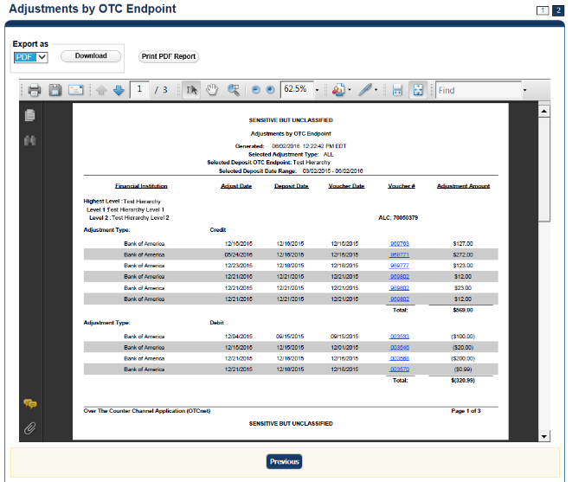

Application Tips



* **TGA** denotes a deposit processing OTC Endpoint.
* **CHK** denotes a check capture OTC Endpoint.
* **M** denotes a mapped accounting code; an open lock denotes access permission; and a closed lock denotes no access permission.
* **CDC** denotes card processing OTC Endpoint.

1. Under **Export as**, you have the following options:
   * Select **PDF**, **Excel** or **Word format**
   * Click **Download**
     + Or
   * Click **Print** **PDF Report**

Application Tip



All Adjustments associated with Deposits with an original voucher date older than 5 years and Returned Item Adjustments with an adjustment voucher date older than 5 years have been archived to the archive database, according to the Fiscal Service data retention policy. These transactions are viewable through the *Historical Reports* page (**Home**>**Reports**>**Historical** **Reports**).

Additional Button



Click **Previous** to return to the previous page.

View Business Reports: Deposits by Accounting Code

To view a deposit by accounting code report, complete the following steps:

1. From the **Reports** tab, click **Deposit Processing Reports**. The *View Reports* page appears.
2. Under **Business Reports**, click **Deposits by Accounting Code**. The *Deposits by Accounting Code* parameters page appears.
3. Enter your search criteria.
   * Select the **Organization**, *required*
   * Select the **ALC** (Agency Location Code)
   * Select the **Account Code**, *required*
   * Enter the **From**: and **To**: Voucher Date range
   * Enter the **From**: and **To**: Deposit Total range
   * Click **Yes** or **No** for **Report With Children**

Application Tips



* The date range for Voucher Date cannot exceed 15 months.
* Click **Yes** for **Report With Children** to generate a report that contains data for the selected OTC Endpoint as well as all of the lower level OTC Endpoints.
* Click **No** for **Report With Children** to generate a report that contains data only for the selected OTC Endpoint.

1. Click an OTC Endpoint to initiate the report. The *Deposits by Accounting Code* preview page appears as shown in Figure 23.

Figure 23: Deposits by Accounting Code Report Preview Page

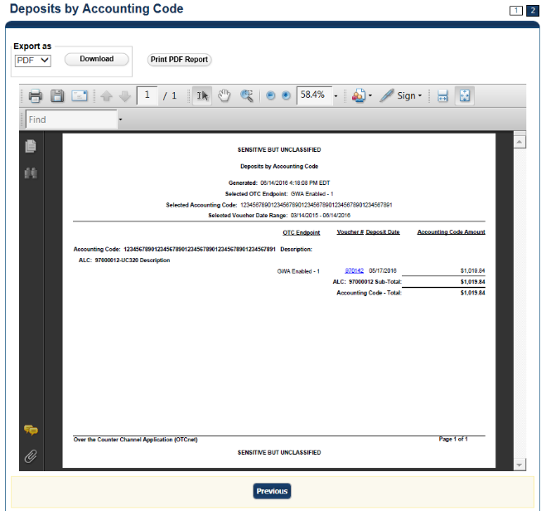

Application Tips



* **TGA** denotes a deposit processing OTC Endpoint.
* **CHK** denotes a check capture OTC Endpoint.
* **M** denotes a mapped accounting code; an open lock denotes access permission; and a closed lock denotes no access permission.
* **CDC** denotes card processing OTC Endpoint.

1. Under Export as, you have the following options:
   * Select **PDF**, **Excel** or **Word** **format**
   * Click **Download**

Or

* + Click **Print PDF Report**

Application Tips



* Deposits with a voucher date older than five years does not display on the report but they may be viewed from the Historical *Reports* page (**Home**>**Reports**>**Historical Reports**).
* Unconfirmed Foreign Check items entered with a Country of Deposit value of **Other** does not display values in the **Voucher Amount** column.

Additional Button



Click **Previous** to return to the previous page.

View Business Reports: Deposits by OTC Endpoint

To view a deposit by OTC Endpoint report, complete the following steps:

1. From the **Reports** tab, click **Deposit Processing Reports**. The *View Reports* page appears.
2. Under **Business Reports**, click **Deposits by OTC Endpoint**. The *Deposits by OTC Endpoint* parameters page appears.
3. Enter your search criteria.
   * Select the **Organization**, *required*
   * Select the **ALC** (Agency Location Code)
   * Enter the **From**: and **To**: Voucher Date range
   * Enter the **From**: and **To**: Deposit Total range
   * Click **Yes** or **No** for **Report With Children**

Application Tips



* The date range for **Voucher Date** cannot exceed 15 months.
* Click **Yes** for **Report With Children** to generate a report that contains data for the selected OTC Endpoint as well as all of the lower level OTC Endpoints.
* Click **No** for **Report With Children** to generate a report that contains data only for the selected OTC Endpoint.

1. Click an OTC Endpoint to initiate the report. The *Deposits by OTC Endpoint* preview page appears as shown in Figure 24.

Figure 24: Deposits by OTC Endpoint Report Preview Page

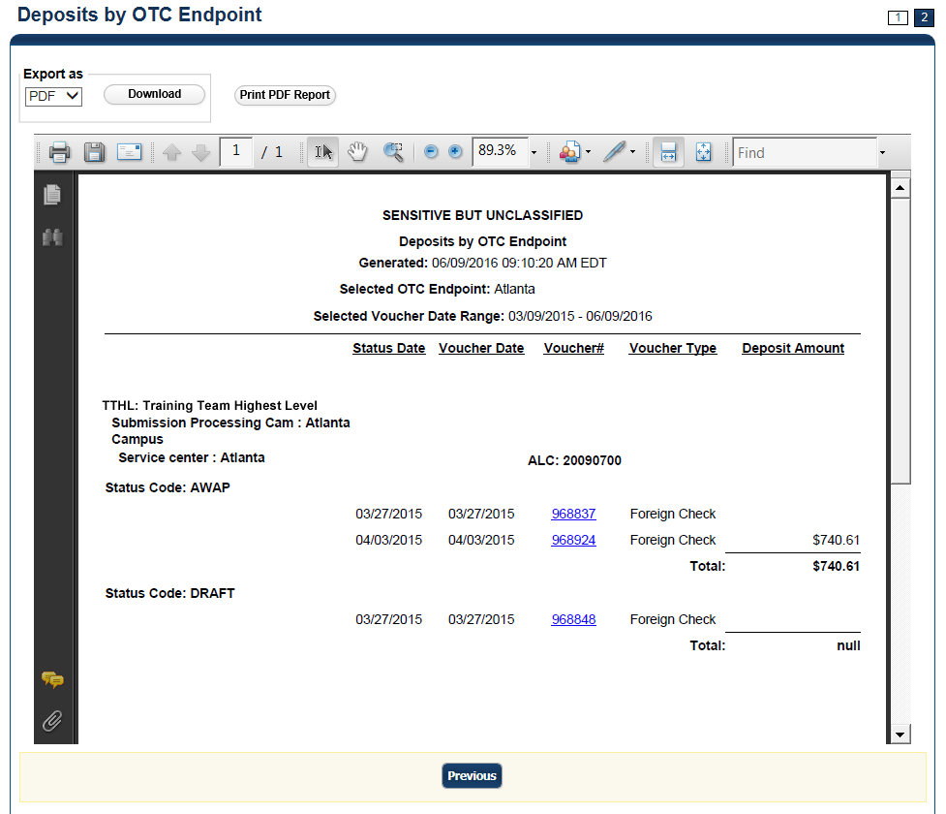

Application Tips



* **TGA** denotes a deposit processing OTC Endpoint.
* **CHK** denotes a check capture OTC Endpoint.
* **M** denotes a mapped accounting code; an open lock denotes access permission; and a closed lock denotes no access permission.
* **CDC** denotes card processing OTC Endpoint.

1. Under Export as, you have the following options:
   * Select **PDF**, **Excel** or **Word format**
   * Click **Download**

Or

* + Click **Print PDF Report**

Application Tips



* Deposits with a voucher date older than five years does not display on the report but they may be viewed from the *Historical Reports* page (**Home**>**Reports**>**Historical Reports**).
* Unconfirmed Foreign Check items entered with a Country of Deposit value of **Other** does not display values in the **Voucher Amount** column.

Additional Button



Click **Previous** to return to the previous page.

View Business Reports: Deposit History by Status

To view a deposit history by status report, complete the following steps:

1. From the **Reports** tab, click **Deposit Processing Reports**. The *View Reports* page appears.
2. Under **Business Reports**, click **Deposit History by Status**. The *Deposit History by Status* parameters page appears.
3. Enter your search criteria.
   * Select the **Organization**, *required*
   * Select the **ALC** (Agency Location Code)
   * Select the **Status**, *required*
   * Enter the **From**: and **To**: Status Date range
   * Enter the **From**: and **To**: Deposit Total range
   * Click **Yes** or **No** for **Report With Children**

Application Tips



* Click **Yes** for **Report With Children** to generate a report that contains data for the selected OTC Endpoint as well as all of the lower level OTC Endpoints.
* Click **No** for **Report With Children** to generate a report that contains data only for the selected OTC Endpoint.

1. Click an OTC Endpoint to initiate the report. The *Deposit History by Status* preview page appears as shown in Figure 25.

Figure 25: Deposit History by Status Preview Page

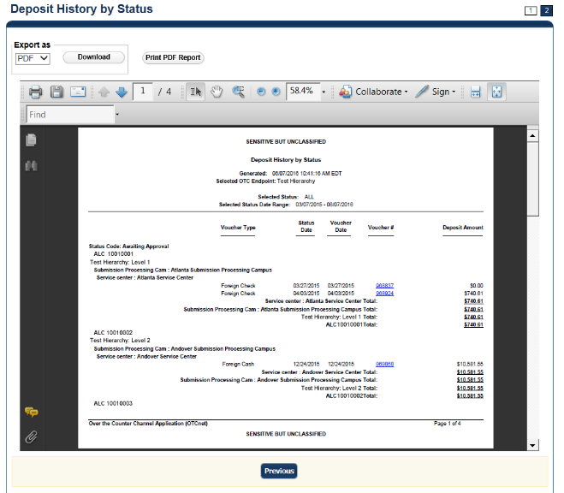

Application Tips



* **TGA** denotes a deposit processing OTC Endpoint.
* **CHK** denotes a check capture OTC Endpoint.
* **M** denotes a mapped accounting code; an open lock denotes access permission; and a closed lock denotes no access permission.
* **CDC** denotes card processing OTC Endpoint.

1. Under **Export as**, you have the following options:
   * Select **PDF**, **Excel** or **Word format**
   * Click **Download**

Or

* + Click **Print PDF Report**

Application Tips



* Deposits with a voucher date older than five years does not display on the report but they may be viewed from the *Historical Reports* page (**Home**>**Reports**>**Historical Reports**).
* Unconfirmed Foreign Check items entered with a **Country of Deposit** value of **Other** does not display values in the **Voucher Amount** column.

Additional Button



Click **Previous** to return to the previous page.

View Business Reports: Non-Reporting OTC Endpoints

To view a non-reporting OTC Endpoint report, complete the following steps:

1. From the **Reports** tab, click **Deposit Processing Reports**. The *View Reports* page appears.
2. Under **Business Reports**, click **Non-Reporting OTC Endpoints**. The *Non-Reporting OTC Endpoints* parameters page appears.
3. Enter your search criteria.
   * Enter the **From**: and **To**: Deposit Date range
   * Click **Yes** or **No** for **Report With Children**

Application Tips



* The date range for **Deposit Date** cannot exceed 15 months.
* Click **Yes** for **Report With Children** to generate a report that contains data for the selected OTC Endpoint as well as all of the lower level OTC Endpoints.
* Click **No** for **Report With Children** to generate a report that contains data only for the selected OTC Endpoint.

1. Click an OTC Endpoint to initiate the report. The *Non-Reporting OTC Endpoints* preview page appears as shown in Figure 26.

Figure 26: Non-Reporting OTC Endpoints Preview Page

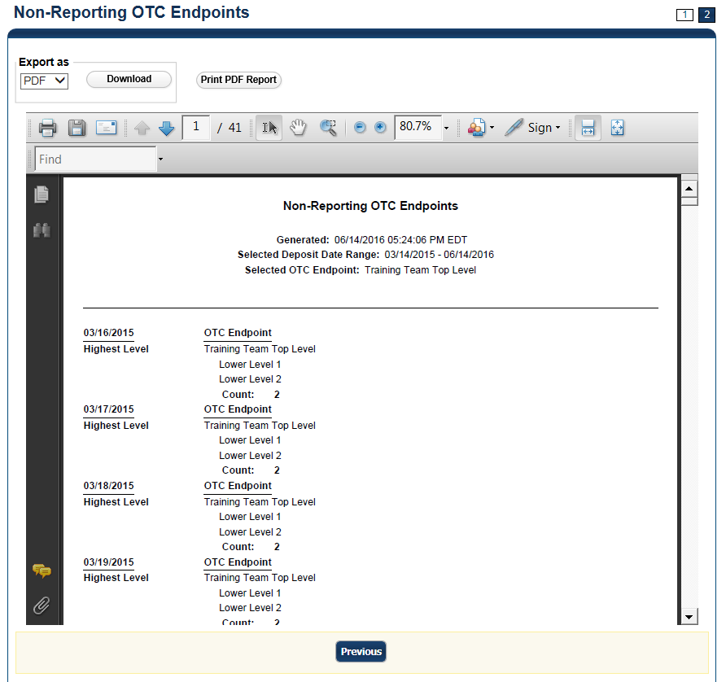

1. Under **Export as**, you have the following options:
   * Select **PDF**, **Excel** or **Word** format
   * Click **Download**

Or

* + Click **Print PDF Report**

Application Tips



* **TGA** denotes a deposit processing OTC Endpoint.
* **CHK** denotes a check capture OTC Endpoint.
* **M** denotes a mapped accounting code; an open lock denotes access permission; and a closed lock denotes no access permission.
* **CDC** denotes card processing OTC Endpoint.

Additional Button



Click **Previous** to return to the previous page.

### Administration Reports

This section provides you with detail on how to view and download **Administration Reports.**

**Administration Reports** available for viewing include:

***View Vouchers Completed***

To view the Vouchers Completed report, you are presented with the option to include search criteria for the following items: **Voucher #, Voucher Status, Voucher Type, Financial Institution, Voucher Complete Timestamp,** and **CL II Trace Number.**

The report presents the event log, including **Voucher Information**, i.e., **Voucher #, Voucher Date, Voucher Type, Voucher Status, Voucher Status Timestamp, Deposit Date, CA$HLINK II Trace #** and **Financial Institution** and **Voucher Event State,** including the date the voucher was created on.

Additionally, the Voucher Event Details report presents the **Voucher #, Voucher Date, Voucher Event State, Voucher Event State Timestamp, Voucher Event LoginID, Voucher Type, Voucher Status, Voucher Status Timestamp, Deposit Date, CA$HLINK II Trace #, Financial Institution,** and **Voucher Event Comments.**

***View Vouchers in Progress***

To view the Vouchers in Progress report, you are presented with the option to include search criteria, i.e., **Voucher #, Voucher Status, Voucher Type,** and **Financial Institution.**

The report presents vouchers in progress and includes the **Voucher Information**: **Voucher #, Voucher Date, Voucher Type, Voucher Status, Voucher Status Timestamp, Deposit Date, CA$HLINK II Trace #,** and **Financial Institution.** The **Voucher Event Log** includes the **Voucher Event State** and the date the voucher was created on.

Additionally, the Voucher Event Details report presents the **Voucher #, Voucher Date, Voucher Event State, Voucher Event State Timestamp, Voucher Event LoginID, Voucher Type, Voucher Status, Voucher Status Timestamp, Deposit Date, CA$HLINK II Trace #, Financial Institution,** and **Voucher Event Comments.**

View Administrative Reports: Vouchers Completed

To view a voucher’s completed report, complete the following steps:

1. From the **Reports** tab, click **Deposit Processing Reports**. The *View Reports* page appears.
2. Under **Administration Reports**, click **View Vouchers Completed**. The *View Vouchers* *Completed* page appears.
3. Click the **Voucher #** hyperlink. The *Voucher Event Log* page appears as shown in   
   Figure 27.

Figure 27: View Voucher Event Log Page

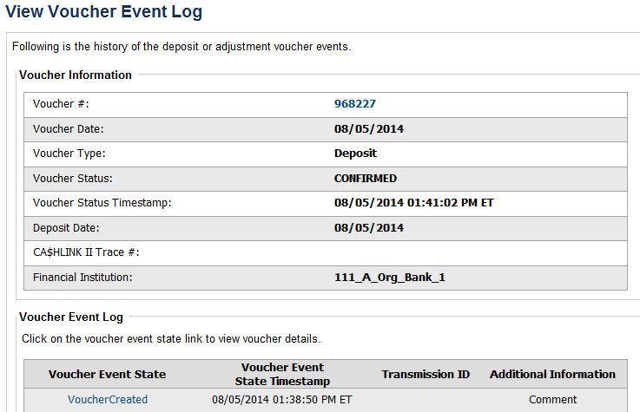

Application Tip



The **View Voucher Event** shows additional information about the voucher and the history of the voucher events through the FI System to System Interface.

1. Click the **Voucher #** hyperlink to view the details of the deposit or adjustment. The *Voucher Details Information* page or the *View Adjustment Details* page appears.

Or

Click a **Voucher Event State** hyperlink to view the voucher event details. The *Voucher Event Details* page appears as shown in Figure 28.

Figure 28: Voucher Event Details Report Output

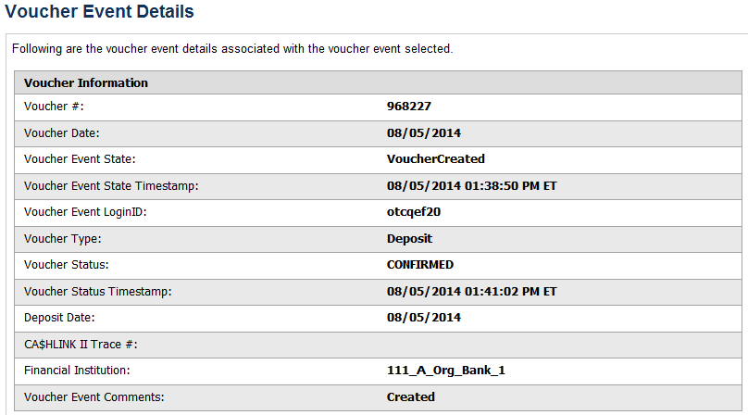

Application Tips



The *Voucher Event Details* page presents the following:

* Processing errors associated with the voucher event
* Additional information about the voucher and the transmission associated with the voucher events through the FI System To System Interface
* The Collections Information Repository (CIR) interface

Additional Buttons



* Click **Cancel** to return to the OTCnet Home Page. No data is saved.
* Click **Clear** to clear all data fields and reset to the default selections.
* Click **Previous** to return to the previous page.
* Click **Refresh** to redisplay the page with any additional vouchers that are in-process.
* Click **Return Home** to return to the previous page.

View Administrative Reports: Vouchers in Progress

To view a voucher in progress report, complete the following steps:

1. From the **Reports** tab, click **Deposit Processing Reports**. The *View Reports* page appears.
2. Under **Administration Reports**, click **View Vouchers In Progress**. The *View Vouchers in Progress* page appears.

Application Tip



The *Vouchers In Progress* page only displays non-archived deposits or adjustments with a voucher date that is five years or less from to the current date.

1. Click the **Voucher #** hyperlink to view the *Voucher Event Log* page and additional voucher information. The *View Voucher Event Log* page appears as shown in Figure 29.

Figure 29: In Progress View Voucher Event Log Page

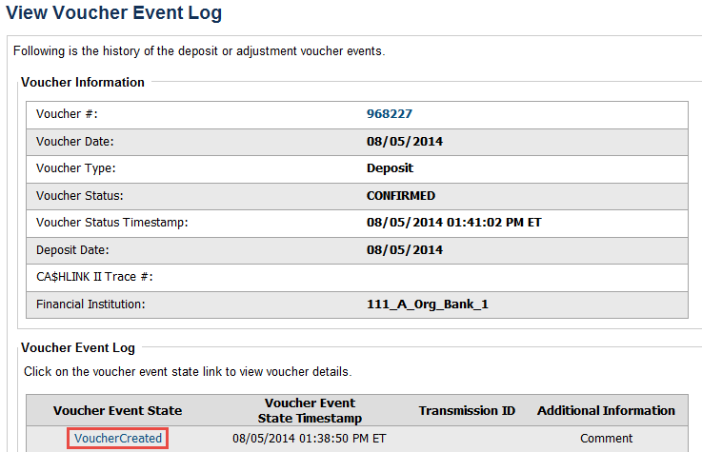

Application Tip



The **View Voucher Event** presents additional information about the voucher and the history of the voucher events through the FI System To System Interface.

1. Click the **Voucher #** hyperlink to view the details of the deposit or adjustment. The *Voucher Details Information* page or the *View Adjustment Details* page appears.

Or

Click a **Voucher Event State** hyperlink to view the voucher event details. The *Voucher Event Details* page appears as shown in Figure 30.

Figure 30: In Progress Voucher Event Details Report Output



Application Tip



The *Voucher Event Details* page presents processing errors associated with the voucher event and additional information about the voucher and the transmission associated with the voucher events through the FI System To System Interface, and the Collections Information Repository (CIR) interface.

Additional Buttons



* Click **Cancel** to return to the OTCnet Home Page. No data is saved.
* Click **Clear** to clear all data fields and reset to the default selections.
* Click **Previous** to return to the previous page.
* Click **Refresh** to redisplay the page with any additional vouchers that   
  are in-process.
* Click **Return** **Home** to return to the previous page.

### Historical Reports

This section provides you with detail on how to generate and view previously generated **Deposit Processing Historical Reports**.

***Deposit Processing Historical Report***

Deposit Processing Historical reports are used to query and download deposit information with a specified Voucher Date from the archival database. Deposit transactions with a voucher date older than the minimum data retention period, as specified by Fiscal Service, may not be displayed on the report as these transactions are eligible to be deleted. As a result, this deposit information may not be accessible and will be removed from the archival database.

Historical reports are generated asynchronously (not occurring at the same time), allowing you to continue to use OTCnet.

Depending on the volume of data requested, it can take between 5 and 20 minutes for the report to generate.

You can search for check records by **Organization**, **OTC Endpoint**, **Agency Location Code (ALC)**, **Prepared by**, **Voucher Number**, **Deposit Status**, **Agency Use (Block 6)**, **Deposit Type**, **Voucher Date**, **Deposit Date**, **Deposit Total**, and **Financial Institution Information** search criteria.

When the report request is submitted, its status is set to **Submitted**. After the report is successfully generated, the status is set to **Completed** and the report is available for download in CSV format.

***Deposit Historical Report***

To generate a deposit historical report, you are presented with the option to include search criteria, i.e., **Organization, OTC Endpoint, ALC, Prepared by, Voucher #, Deposit Status, Agency Use (Block 6)** details**, Deposit Type, Voucher Date (From:** and **To:), Deposit Date (From:** and **To:)** and **Deposit Total (From** and **To:).**

The report presents a historical record of deposits and can only be downloaded in **CSV** format.

***Adjustment Historical Report***

To generate an adjustment historical report, you are presented with the option to include search criteria, i.e., **Organization, OTC Endpoint, ALC, Adjustment Category, Voucher #, Adjustment Type, Prepared By, Adjustment Reason, Voucher Date (From:** and **To:)**, **Adjustment Amount (From** and **To:), Deposit Date (From:** and **To:)** and **Original Deposit Date (From:** and **To:)**.

The report presents a historical record of adjustments and can only be downloaded in **CSV** format.

Adjustments associated to deposits with a voucher date older than the minimum data retention period, as specified by Fiscal Service, may not be displayed on the report as these transactions are eligible to be deleted. As a result, this adjusted deposit information may not be accessible and will be removed from the archival database.

***Previously Generated Historical Reports***

To view previously generated historical reports, you are presented with a table of criteria, i.e., **Report Type, Submitted Time, Search Criteria Parameters, Status,** and **Download.**

The reports present a historical record of deposits or adjustments, the details of which are available above under their respective types. These reports can only be downloaded in **CSV** format.

View Historical Reports: Deposit Historical Report

To generate a Deposit Historical Report, complete the following steps:

1. From the **Reports** tab, select **Historical Reports**>**Generate Historical Reports**. The *Generate Historical Reports* page appears.
2. Under **Deposit Processing Historical Reports**, click **Deposit Historical Report**. The *Deposit Historical Report* page appears as shown in Figure 31.

Figure 31: Deposit Historical Report Criteria Page

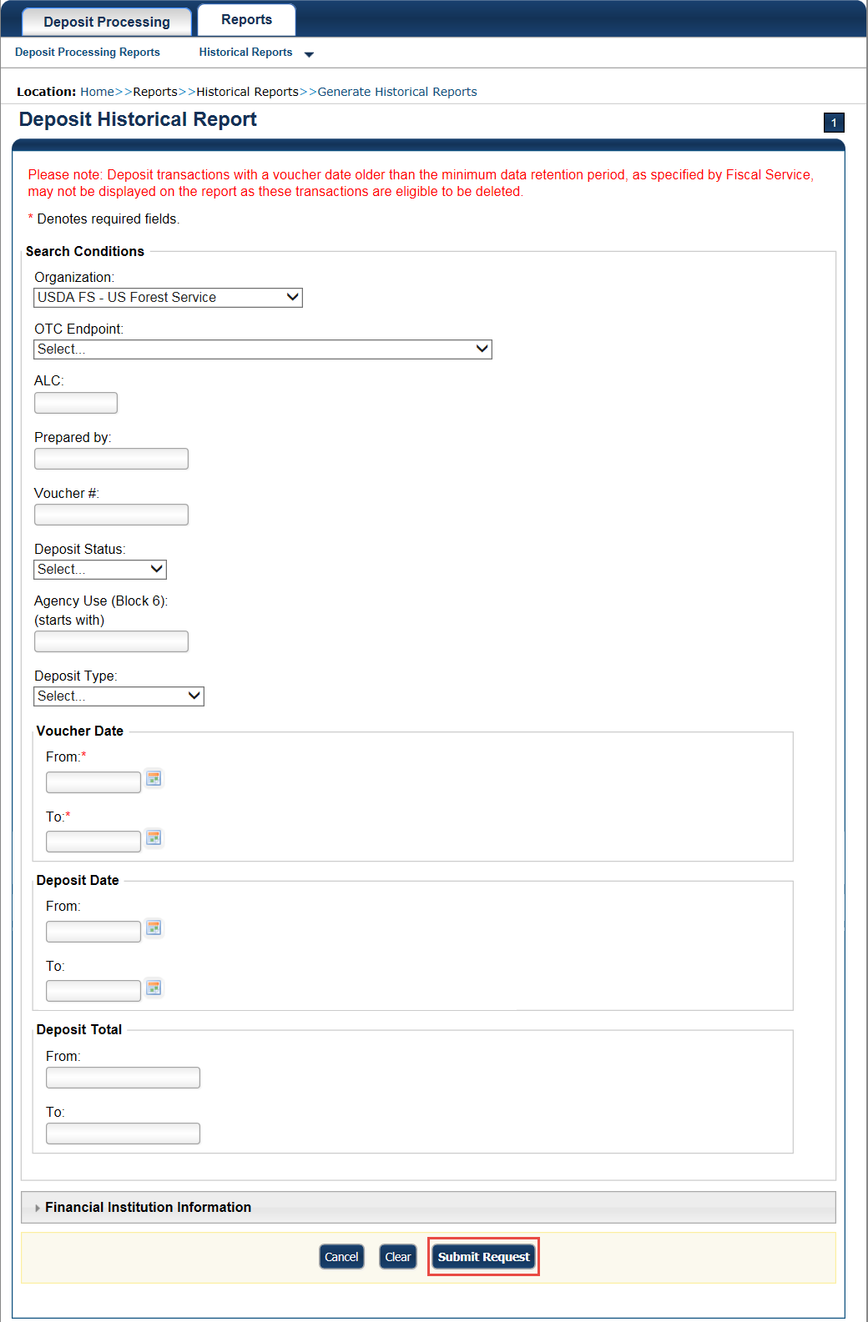

Application Tip



The Deposit Historical Report is generated asynchronously (not occurring at the same time) allowing you to continue using the OTCnet application. The time it takes to generate a report depends on the volume of data queried and therefore varies.

1. Enter your search criteria.

Under Search Conditions:

* Select an **Organization**
* Select an **OTC Endpoint**
* Enter an **ALC**
* Enter the **Prepared b**y
* Enter the **Voucher #**
* Select a **Deposit Status**
* Enter the Agency Use (Block 6) details
* Select a **Deposit Type**
* Enter the **From** and **To** Voucher Date, *required*
* Enter the **From** and **To** Deposit Date
* Enter the **From** and **To** Deposit Total

Application Tips



* The Voucher Date is a required field and the maximum date range for the **From** and **To** Voucher Date is one year. The Voucher Date must be entered in MM/DD/YYYY format.
* The **From** and **To** Deposit Date must be entered in MM/DD/YYYY format.

Under Financial Institution Information, *optional*

* Enter the **RTN** (**Routing Transit Number**)
* Enter the **DDA** (**Demand Deposit Account**)
* Enter the **CAN** (**CA$HLINK II Account Number**)
* Enter the **FRB Account Key** (**Federal Reserve Bank Account Key**)
* Enter the **FRB CCWU** (**Federal Reserve Bank Cost Center Work Unit**)

Application Tips



* The FRB Account Key must be three digits in length. The FRB Account Key field does not display for FI Deposit Confirmers or FI Viewers.
* The FRB CCWU must be four digits in length. If it is less than four digits, enter a zero at the beginning of the CCWU number (e.g. 0123). The FRB Account Key field does not display for FI Deposit Confirmers or FI Viewers.

Under **User Defined Field Information**, *if applicable*, *optional*

* Enter the **Deposit UDF** (**User Defined Field**) details
* Enter the **Accounting Subtotal UDF** details

Application Tip



User Defined Fields (UDFs) only display to users who have access to an organization that has previously defined UDFs. UDFs appear at the bottom of the page. Up to three UDFs can be displayed for **Deposit** and two for **Accounting Subtotal**.

1. Click **Submit Request**. A “*Your report request has been successfully received*” message appears.

Application Tip



Once a request is submitted you cannot submit the same request again for seven days. If a duplicate request is submitted within seven days the following message displays: *“Duplicate Request: You have submitted a report request based on identical report criteria in the last 7 days. Please revise your report criteria or access the previously generated report request.”*

Additional Buttons



* Click **Cancel** to return to the OTCnet Home Page. No data is saved.
* Click **Clear** to clear all data fields and reset to the default selections.

1. Once the request is submitted, navigate to **Previously Generated Historical Reports** (**Reports** tab>**Historical Reports**>**View Previously Generated Historical Reports**) and download the report in CSV format by clicking the **CSV** icon in the **Download** column for the report.

View Historical Reports: Adjustment Historical Report

To generate an Adjustment Historical Report, complete the following steps:

1. From the **Reports** tab, select **Historical Reports** and click **Generate Historical Reports**.
2. From the **Deposit Processing Historical Reports** section of the page, click **Adjustment** **Historical Report**. The *Adjustment Historical Report* page appears as shown in Figure 32.

Figure 32: Adjustment Historical Report Criteria Page

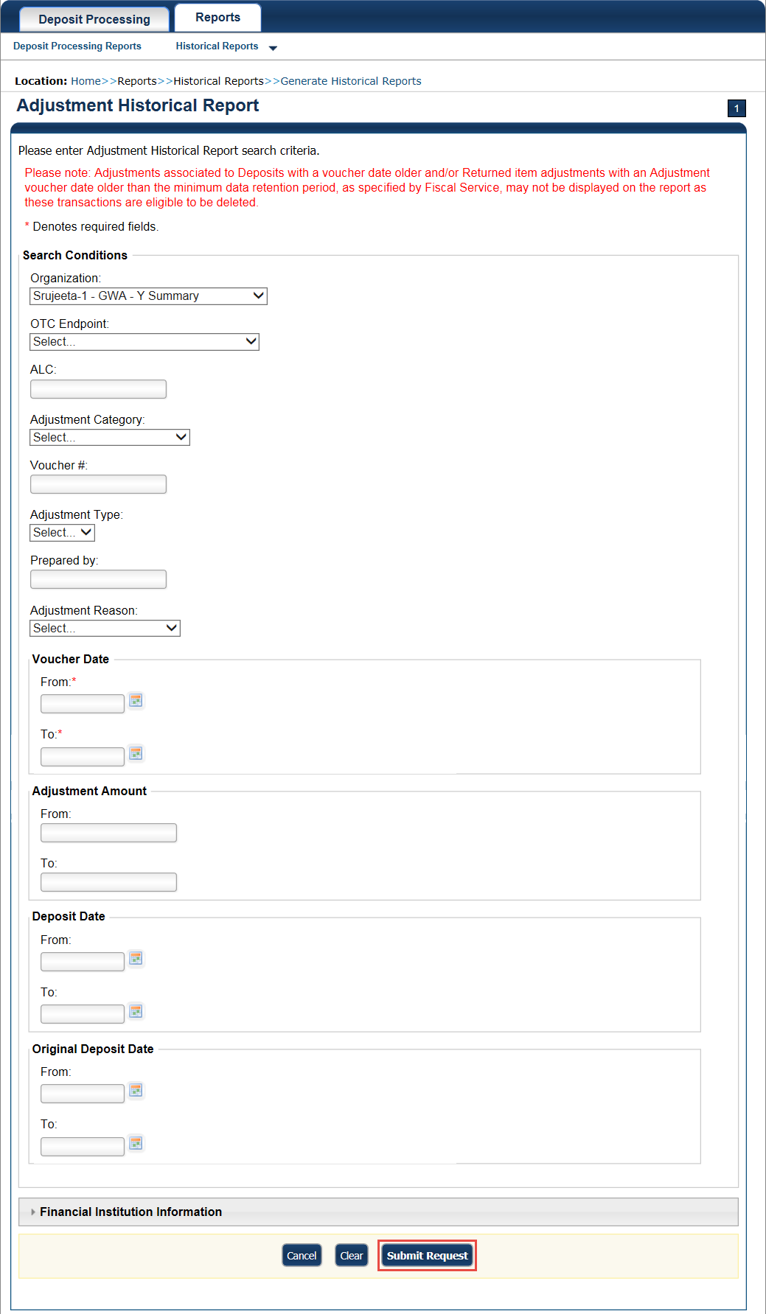

Application Tip



The Adjustment Processing historical report is generated asynchronously (not occurring at the same time) allowing you to continue using the OTCnet application. Depending on the volume of data queried it can take between 5 and 20 minutes to generate the report.

1. Enter your search criteria.

Under **Search Conditions**

* Select an **Organization**
* Select an **OTC Endpoint**
* Enter an **ALC**
* Select an **Adjustment Category**

Application Tips



* Select **Deposit Adjustment** to include deposit adjustments in the search results. The **Deposit Adjustment** search can be further limited by the user by selecting either **Debit** or **Credit** from the **Adjustment Type** drop-down list.
* Select **Returned Item Adjustment** to include only returned item adjustments (US Currency and Foreign Check Item) in the search results. The Returned Item Adjustment search does not have to be further qualified using the **Adjustment Type** drop-down list since returned item adjustments always have an Adjustment Type of **Debit**. If the user selects **Credit** from the **Adjustment Type** drop-down list after selecting a **Returned Item Adjustment**, no results appear since **Credit** returned item adjustments do not exist.
* Select **RIA – Foreign Currency** to only include returned item adjustments related to Foreign Check Items in the search results.
* Select **RIA – US Currency** to only include US Currency Returned Item Adjustments in the search results.
* Select no Adjustment Category (e.g., Select...), both deposit and returned item adjustments are included in the search results.
* Select Adjustment Type Debit to include all debit deposit adjustments and returned item adjustments in the search results. Select Credit to include only credit deposit adjustments in the search results.
  + Enter the **Voucher #**
  + Select an **Adjustment Type**
  + Enter the **Prepared by**
  + Select an **Adjustment Reason**
  + Enter the **From** and **To** Voucher Date, *required*
* Enter the **From** and **To** Adjust Amount Date
* Enter the **From** and **To** Deposit Date
* Enter the **From** and **To** Original Deposit Date

Application Tips



* The Voucher Date is a required field and the maximum date range for the **From** and **To** Voucher Date is one year. The Voucher Date must be entered in MM/DD/YYYY format.
* The **From** and **To** Deposit Date must be entered in MM/DD/YYYY format.

Under Financial Institution Information, *optional*

* Enter the **RTN** (**Routing Transit Number**)
* Enter the **DDA** (**Demand Deposit Account**)
* Enter the **CAN** (**CA$HLINK II Account Number**)
* Enter the **FRB Account Key** (**Federal Reserve Bank Account Key**)
* Enter the **FRB CCWU** (**Federal Reserve Bank Cost Center Work Unit**)

Application Tips



* The FRB Account Key must be three digits in length. The FRB Account Key field does not display for FI Deposit Confirmers or FI Viewers.
* The FRB CCWU must be four digits in length. If it is less than four digits, enter a zero at the beginning of the CCWU number (e.g. 0123). The FRB Account Key field does not display for FI Deposit Confirmers or FI Viewers.

1. Click **Submit Request**. A “*Your report request has been successfully received*” message appears.

Application Tip



Once a request is submitted you cannot submit the same request again for seven days. If a duplicate request is submitted within seven days the following message displays: *“Duplicate Request: You have submitted a report request based on identical report criteria in the last 7 days. Please revise your report criteria or access the previously generated report request.”*

Additional Buttons



* Click **Cancel** to return to the OTCnet Home Page. No data is saved.
* Click **Clear** to clear all data fields and reset to the default selections.

1. Once the request has been submitted, navigate to **Previously Generated Historical** **Reports** (**Reports** tab>**Historical Reports**>Vi**ew Previously Generated Historical Reports**) and download the report in CSV format by clicking the CSV icon in the **Download** column for the report.

## Summary

In this chapter, you learned:

* The Introduction to OTCnet
* The Overview of OTCnet Participant User Guide Content
* How to request access for yourself in SailPoint IIQ
* How to log on to OTCnet
* How to navigate the OTCnet home page
* The purpose of viewing deposits
* How to view a deposit draft
* How to view a deposit awaiting approval
* How to view a submitted deposit
* How to view a confirmed deposit
* How to view a deposit adjustment
* How to view a rejected deposit details
* How to search for and locate deposits using one or more search criteria
* How to download deposit voucher(s) as an XML or CSV file.
* The purpose of searching adjustments
* How to search and locate adjustments using one or more search criteria
* How to download adjustment voucher(s) as an XML or CSV file
* The purpose of viewing reports
* The various types of reports you can access by role
* The types of reports
* The detail each report provides and how to view and download those reports