

OTCnet Participant User Guide

Table of Contents

Overview, Topics, and Audience 1

Overview 1

Topics 1

Audience 1

Topic 1 Viewing Reports 2

Topic 2 Reports by User Role 3

Topic 3 Types of Reports 6

Business Reports 6

Security Reports 8

Administration Reports 10

Historical Reports 11

Topic 4 Viewing Reports 12

Business Reports 12

Security Reports 33

Administration Reports 43

Historical Reports 51

Topic 5 Viewing a Financial Institution 61

View a Financial Institution 61

View a Financial Institution 62

Summary 64

List of Figures

Figure 1: Adjustments Activity (FI) Preview Page 15

Figure 2: Adjustments by OTC Endpoint Parameters Page 17

Figure 3: Daily Voucher Report Page 19

Figure 4: Deposit Activity (FI) Preview Page 21

Figure 5: Deposits by Accounting Code Report Preview Page 23

Figure 6: Deposits by OTC Endpoint Report Preview Page 25

Figure 7: Deposit History by Status Preview Page 27

Figure 8: Non-Reporting OTC Endpoints Preview Page 29

Figure 9: Processing Options by OTC Endpoints Report Output Preview Page 32

Figure 10: Users by Access Group (FI) Report Preview Page 34

Figure 11: Users by Access Group (FPA) Preview Page 37

Figure 12: User Information Preview Page 38

Figure 13: Users by Role (FI) Preview Page 40

Figure 14: Users by Role (FPA) Preview Page 42

Figure 15: Adjustment-Voucher Detail PDF 46

Figure 16: View Voucher Event Log Page 47

Figure 17: Voucher Event Details Report Output 48

Figure 18: In Progress View Voucher Event Log Page 49

Figure 19: In Progress Voucher Event Details Report Output 50

Figure 20: Deposit Historical Report Criteria Page 53

Figure 21: Adjustment Historical Report Criteria Page 56

Figure 22: View Previously Generated Reports 59

Figure 23: View FRB Detail 62

Figure 24: View Financial Institution Detail 62

List of Tables

Table 1: Types of Reports and Purpose 2

Table 2: Business Reports by Federal Program Agency User Roles 3

Table 3: Business Reports by Financial Institution/Federal Reserve Bank as Financial Institution User Roles 3

Table 4: Security Reports by Federal Program Agency User Roles 4

Table 5: Security Reports by Financial Institution/Federal Reserve Bank as Financial Institution User Roles 4

Table 6: Administration Reports by Federal Program Agency User Roles 4

Table 7: Administration Reports by Financial Institution/Federal Reserve Bank as Financial Institution User Roles 5

Table 8: Historical Reports by Federal Program Agency User Roles 5

Table 9: Historical Reports by Financial Institution/Federal Reserve Bank as Financial Institution User Roles 5

Table 10: Business Reports by User Role 6

Table 11: Security Reports by Federal Program Agency User Roles 6

Table 12: Security Reports by Financial Institution/Federal Reserve Bank as Financial Institution User Roles 7

Table 13: Administration Reports by Federal Program Agency User Roles 7

Table 14: Business Reports 7

Table 15: Security Reports by User Role 8

Table 16: Administration Reports by Financial Institution/Federal Reserve Bank as Financial Institution User Roles 8

Table 17: Security Reports 9

Table 18: Administration Reports 10

Table 19: Deposit Processing Historical Report 11

Glossary

Click this [link](https://www.fiscal.treasury.gov/otcnet/training/wbt/content/course_OTC/glossary.htm) to access the full OTCnet Glossary.

## Overview, Topics, and Audience

### Overview

Welcome to *Viewing Reports*. In this chapter, you will learn:

* The purpose of viewing reports
* The various types of reports you can access by role
* The types of Business, Security, Administration and Historical reports
* The detail each report provides and how to view and download the reports

### Topics

This chapter is organized by the following topics:

* Viewing Reports
* Reports by User Role
* Types of Reports
* Viewing Reports
* Viewing a Financial Institution

### Audience

The intended audience for the *Viewing Reports Participant* User Guide includes:

* All Deposit Processing Users (viewing various reports depends on your level of access)

## Topic 1 Viewing Reports

As a user or viewer with access to the Deposit Processing functionality, you may access one or more of the **Business Reports**, **Security Reports**, **Administration Reports** or **Historical Reports**. You may need to view or download a report for e.g., adjustment activity, user information or voucher status. Each report provides deposit information specific to the select type of data requested. Table 1 below describes the purpose of each report type.

Table : Types of Reports and Purpose

| Report | Purpose of Report |
| --- | --- |
| Business | Provides specific reporting detail for deposit and adjustment activity by type, status and processing options for Agencies and Financial Institutions |
| Security | Provides specific reporting detail for access groups and users for Agencies and Financial Institutions |
| Administration | Provides specific reporting detail for interface to CIR,* as well as detailed information about completed and in progress vouchers |

*The Collections Information Repository (CIR) was formerly referred to as the Transaction Reporting System (TRS).

## Topic 2 Reports by User Role

Access to view reports in OTCnet is dependent of your user role. Table 2 presents the OTCnet user roles with access to each OTCnet report. Reports are grouped into the following categories:

* Business Reports
* Security Reports
* Administration Reports
* Historical Reports

Table : Business Reports by Federal Program Agency User Roles

| Business Reports | Deposit Preparer | Deposit Approver | Accounting Specialist | Local Accounting Specialist | FPA Viewer | Agency LSA | Agency PLSA |
| --- | --- | --- | --- | --- | --- | --- | --- |
| Adjustment Activity (FI) | blank | blank | blank | blank | blank | blank | blank |
| Adjustments By OTC Endpoint | • | • | blank | blank | • | blank | blank |
| Daily Voucher Report | blank | blank | • | • | blank | blank | blank |
| Deposit Activity (FI) | blank | blank | blank | blank | blank | blank | blank |
| Deposits By Accounting Code | • | • | blank | blank | • | blank | blank |
| Deposits By OTC Endpoint | • | • | blank | blank | • | blank | blank |
| Deposit History By Status (FPA) | • | • | blank | blank | • | blank | blank |
| Non-Reporting OTC Endpoint | • | • | • | • | • | blank | blank |
| Processing Options by Agency EP | blank | blank | • | • | blank | blank | blank |

Table : Business Reports by Financial Institution/Federal Reserve Bank as Financial Institution User Roles

| Business Reports | FI  Confirmer | FRB  Confirmer | FI  Viewer | FRB  Viewer | LSA | PLSA |
| --- | --- | --- | --- | --- | --- | --- |
| Adjustment Activity (FI) | • | blank | • | blank | blank | blank |
| Adjustments By OTC Endpoint | blank | blank | blank | blank | blank | blank |
| Daily Voucher Report | blank | blank | blank | blank | blank | blank |
| Deposit Activity (FI) | • | blank | • | blank | blank | blank |
| Deposits By Accounting Code | blank | blank | blank | blank | blank | blank |
| Deposits By OTC Endpoint | blank | blank | blank | blank | blank | blank |
| Deposit History By Status (FPA) | blank | blank | blank | blank | blank | blank |
| Non-Reporting OTC Endpoint | blank | blank | blank | blank | blank | blank |
| Processing Options by Agency EP | blank | blank | blank | blank | blank | blank |

Table : Security Reports by Federal Program Agency User Roles

| Security Reports | Deposit Preparer | Deposit Approver | Accounting Specialist | Local Accounting Specialist | FPA Viewer | Agency LSA | Agency PLSA |
| --- | --- | --- | --- | --- | --- | --- | --- |
| Primary Access Groups without a PLSA | blank | blank | blank | blank | blank | blank | blank |
| Users by Access Group (FI) | blank | blank | blank | blank | blank | blank | blank |
| Users by Access Group (FPA) | blank | blank | blank | blank | blank | • | • |
| Users by Role (FI) | blank | blank | blank | blank | blank | blank | blank |
| Users by Role (FPA) | blank | blank | blank | blank | blank | • | • |
| User Information | blank | blank | blank | blank | blank | • | • |

Table : Security Reports by Financial Institution/Federal Reserve Bank as Financial Institution User Roles

| Security Reports | FI  Confirmer | FRB  Confirmer | FI  Viewer | FRB  Viewer | LSA | PLSA |
| --- | --- | --- | --- | --- | --- | --- |
| Primary Access Groups without a PLSA | blank | blank | blank | blank | blank | blank |
| Users by Access Group (FI) | blank | blank | blank | blank | • | • |
| Users by Access Group (FPA) | blank | blank | blank | blank | blank | blank |
| Users by Role (FI) | blank | blank | blank | blank | • | • |
| Users by Role (FPA) | blank | blank | blank | blank | blank | blank |
| User Information | blank | blank | blank | blank | • | • |

Table : Administration Reports by Federal Program Agency User Roles

| Admin. Reports/ Misc. | Deposit  Preparer | Deposit Approver | Accounting Specialist | Local Accounting Specialist | FPA Viewer | Agency LSA | Agency PLSA |
| --- | --- | --- | --- | --- | --- | --- | --- |
| View CIR File Status* | blank | blank | blank | blank | blank | blank | blank |
| View Vouchers Complete | • | • | blank | blank | • | blank | blank |
| View Voucher Event Log | • | • | blank | blank | • | blank | blank |
| View Voucher Event Detail | • | • | blank | blank | • | blank | blank |
| View Vouchers In Progress | • | • | blank | blank | • | blank | blank |
| View Voucher Event Log | • | • | blank | blank | • | blank | blank |
| View Voucher Event Detail | • | • | blank | blank | • | blank | blank |
| Change Current State | blank | blank | blank | blank | blank | blank | blank |
| Acknowledge Error Resolution | blank | blank | blank | blank | blank | blank | blank |

* The Collections Information Repository (CIR) was formerly referred to as the Transaction Reporting System (TRS).

Table : Administration Reports by Financial Institution/Federal Reserve Bank as Financial Institution User Roles

| Admin. Reports/ Misc. | FI  Confirmer | FRB  Confirmer | FI  Viewer | FRB  Viewer | LSA | PLSA |
| --- | --- | --- | --- | --- | --- | --- |
| View CIR File Status | • | • | • | • | blank |  |
| View Vouchers Complete | • | • | • | • | blank |  |
| View Voucher Event Log | • | • | • | • | blank |  |
| View Voucher Event Detail | • | • | • | • | blank |  |
| View Vouchers In Progress | • | • | • | • | blank |  |
| View Voucher Event Log | • | • | • | • | blank |  |
| View Voucher Event Detail | • | • | • | • | blank |  |
| Change Current State | blank | blank | blank | blank | blank |  |
| Acknowledge Error Resolution | • | • | blank | blank | blank |  |

Table : Historical Reports by Federal Program Agency User Roles

| Historical Reports | Deposit Preparer | Deposit Approver | Accounting Specialist | Local Accounting Specialist | FPA Viewer | Agency LSA | Agency PLSA |
| --- | --- | --- | --- | --- | --- | --- | --- |
| Deposit Historical Report | • | • | blank | blank | • | blank | blank |
| Adjustment Historical Report | • | • | blank | blank | • | blank | blank |

Table : Historical Reports by Financial Institution/Federal Reserve Bank as Financial Institution User Roles

| Historical Reports | FI Confirmer | FRB Confirmer | FI Viewer | FRB Viewer | LSA | PLSA |
| --- | --- | --- | --- | --- | --- | --- |
| Deposit Historical Report | • | • | • | • | blank | blank |
| Adjustment Historical Report | • | • | • | • | blank | blank |

## Topic 3 Types of Reports

There are four primary report categories within OTCnet:

1. Business Reports
2. Security Reports
3. Administration Reports
4. Historical Reports

### Business Reports

If you are a **Deposit Preparer**, **Deposit Approver**, **Accounting Specialist, Local Accounting Specialist**, **Federal Program Agency (FPA) Viewer**, **Financial Institution (FI) Confirmer**, **Federal Reserve Bank (FRB) Confirmer**, **FI Viewer**, or **FRB Viewer**, you may access to one or more of the reports listed below.

Table : Business Reports by User Role

| Business Reports | FI  Confirmer | FRB  Confirmer | FI  Viewer | FRB  Viewer | LSA | PLSA |
| --- | --- | --- | --- | --- | --- | --- |
| Adjustment Activity (FI) | • | blank | • | blank | blank | blank |
| Adjustments By OTC Endpoint | blank | blank | blank | blank | blank | blank |
| Daily Voucher Report | blank | blank | blank | blank | blank | blank |
| Deposit Activity (FI) | • | blank | • | blank | blank | blank |
| Deposits By Accounting Code | blank | blank | blank | blank | blank | blank |
| Deposits By OTC Endpoint | blank | blank | blank | blank | blank | blank |
| Deposit History By Status (FPA) | blank | blank | blank | blank | blank | blank |
| Non-Reporting OTC Endpoint | blank | blank | blank | blank | blank | blank |
| Processing Options by Agency EP | blank | blank | blank | blank | blank | blank |

Table : Security Reports by Federal Program Agency User Roles

| Security Reports | Deposit Preparer | Deposit Approver | Accounting Specialist | Local Accounting Specialist | FPA Viewer | Agency LSA | Agency PLSA |
| --- | --- | --- | --- | --- | --- | --- | --- |
| Primary Access Groups without a PLSA | blank | blank | blank | blank | blank | blank | blank |
| Users by Access Group (FI) | blank | blank | blank | blank | blank | blank | blank |
| Users by Access Group (FPA) | blank | blank | blank | blank | blank | • | • |
| Users by Role (FI) | blank | blank | blank | blank | blank | blank | blank |
| Users by Role (FPA) | blank | blank | blank | blank | blank | • | • |
| User Information | blank | blank | blank | blank | blank | • | • |

Table : Security Reports by Financial Institution/Federal Reserve Bank as Financial Institution User Roles

| Security Reports | Deposit Preparer | Deposit Approver | Accounting Specialist | Local Accounting Specialist | FPA Viewer | Agency LSA | Agency PLSA |
| --- | --- | --- | --- | --- | --- | --- | --- |
| Primary Access Groups without a PLSA | blank | blank | blank | blank | blank | blank | blank |
| Users by Access Group (FI) |  |  |  |  |  | • | • |
| Users by Access Group (FPA) |  |  |  |  |  |  |  |
| Users by Role (FI) |  |  |  |  |  | • | • |
| Users by Role (FPA) |  |  |  |  |  |  |  |
| User Information |  |  |  |  |  | • | • |

Table : Administration Reports by Federal Program Agency User Roles

| Admin. Reports/ Misc. | Deposit Preparer | Deposit Approver | Accounting Specialist | Local Accounting Specialist | FPA Viewer | Agency LSA | Agency PLSA |
| --- | --- | --- | --- | --- | --- | --- | --- |
| View CIR File Status | blank | blank | blank | blank | blank | blank | blank |
| View Vouchers Complete | • | • | blank | blank | • | blank | blank |
| View Voucher Event Log | • | • | blank | blank | • | blank | blank |
| View Voucher Event Detail | • | • | blank | blank | • | blank | blank |
| View Vouchers In Progress | • | • | blank | blank | • | blank | blank |
| View Voucher Event Log | • | • | blank | blank | • | blank | blank |
| View Voucher Event Detail | • | • | blank | blank | • | blank | blank |
| Change Current State | blank | blank | blank | blank | blank | blank | blank |
| Acknowledge Error Resolution | blank | blank | blank | blank | blank | blank | blank |

Table : Business Reports

| Business Report | Purpose of Business Report |
| --- | --- |
| Adjustment Activity (FI) | Allows you to view adjustments made by your Financial Institution (FI) |
| Adjustments by OTC Endpoints | Allows you to view adjustments made by your Agency Location Code (ALC) |
| Daily Voucher Report | Allows you to view the daily voucher extract |
| Deposit Activity (FI) | Allows you to view deposits submitted to your FI |
| Deposits by Accounting Code | Allows you to view deposits by accounting code |
| Deposits by OTC Endpoint | Allows you to view deposits by OTC Endpoint. |
| Deposit History by Status | Allows you to view deposits by status |
| Non-Reporting OTC Endpoints | Allows you to view OTC Endpoints that have not reported a deposit. |
| Processing Options by OTC Endpoints | Allows you to view processing options defined for endpoints within the organization. |

### Security Reports

If you are an **Agency Primary Security Administrator (PLSA)**, **Agency Local Security Administrator (LSA**), **FI/FRB PLSA** or **FI/FRB LSA**, you may access one or more of the reports listed below.

Table : Security Reports by User Role

| Admin. Reports/ Misc. | Deposit Preparer | Deposit Approver | Accounting Specialist | Local Accounting Specialist | FPA Viewer | Agency LSA | Agency PLSA |
| --- | --- | --- | --- | --- | --- | --- | --- |
| View CIR File Status | blank | blank | blank | blank | blank | blank | blank |
| View Vouchers Complete | • | • | blank | blank | • | blank | blank |
| View Voucher Event Log | • | • | blank | blank | • | blank | blank |
| View Voucher Event Detail | • | • | blank | blank | • | blank | blank |
| View Vouchers In Progress | • | • | blank | blank | • | blank | blank |
| View Voucher Event Log | • | • | blank | blank | • | blank | blank |
| View Voucher Event Detail | • | • | blank | blank | • | blank | blank |
| Change Current State | blank | blank | blank | blank | blank | blank | blank |
| Acknowledge Error Resolution | blank | blank | blank | blank | blank | blank | blank |

Table : Administration Reports by Financial Institution/Federal Reserve Bank as Financial Institution User Roles

| Admin. Reports/ Misc. | FI Confirmer | FRB Confirmer | FI  Viewer | FRB  Viewer | LSA | PLSA |
| --- | --- | --- | --- | --- | --- | --- |
| View CIR File Status | • | • | • | • | blank | blank |
| View Vouchers Complete | • | • | • | • | blank | blank |
| View Voucher Event Log | • | • | • | • | blank | blank |
| View Voucher Event Detail | • | • | • | • | blank | blank |
| View Vouchers In Progress | • | • | • | • | blank | blank |
| View Voucher Event Log | • | • | • | • | blank | blank |
| View Voucher Event Detail | • | • | • | • | blank | blank |
| Change Current State | blank | blank | blank | blank | blank | blank |
| Acknowledge Error Resolution | • | • | blank | blank | blank | blank |

To obtain specific details for the reports that each role may view or download, refer to the table above.

Table : Security Reports

| Security Report | Purpose of Security Report |
| --- | --- |
| Users by Access Group (FI) | Allows you to view users by Financial Institution. |
| Users by Access Group (FPA) | Allows you to view users by OTC Endpoint. |
| User Information | Allows that you to view a user’s contact information. |
| Users by Role (FI) | Allows you to view users by role for your Financial Institution. |
| Users by Role (FPA) | Allows you to view users by role for your OTC Endpoint. |

### Administration Reports

If you are a **Deposit Preparer**, **Deposit Approver**, **FPA Viewer**, **FI Confirmer**, **FRB Confirmer**, **FI Viewer**, or **FRB Viewer**, you may access one or more of the reports listed in Table 18: Administration Reports.

To obtain specific details for the reports each role may view or download, refer to Table 18.

Table : Administration Reports

| Administration Report | Purpose of Administration Report |
| --- | --- |
| View CIR File Status | The status of CIR files that have been processed by Collections Information Repository (CIR) or are ready for CIR to process. |
| View Vouchers Completed | Allows you to view the status of deposit and adjustment vouchers that have completed processed through the FI System To System Interface in the past 36 hours. |
| View Vouchers in Progress | Allows you to view the status of deposit and adjustment vouchers in progress. |

### Historical Reports

As a **Financial Institution Viewer**, you have access to the reports listed in Table 14.

Table : Deposit Processing Historical Report

| Deposit Processing Historical Report | Purpose of Report |
| --- | --- |
| Deposit Historical Report | Allows you to view historical deposit transaction data. |
| Adjustment Historical Report | Allows you to view historical deposit adjustment and returned item adjustment transaction data. |

## Topic 4 Viewing Reports

### Business Reports

This section provides you with details on how to view and download **Business Reports.**

#### Adjustment Activity (FI)

To view adjustments by financial institution activity, you are presented with the option to include search criteria, i.e., **Adjustment Type**, **Adjustment Reason**, **Voucher Date (From:** and **To**:), **Original Date of Deposit (From:** and **To:**), **Agency Location Code (ALC),** **Routing Transit Number (RTN)**, **Demand Deposit Account (DDA)**, **Adjustment Amount**, **Deposit Date**, **CA$HLINK II Account Number (CAN)**, **CASHLINK II Trace#** and **Report With Children**.

The report presents adjustment activity by Financial Institution, including the **Voucher #**, **Adjustment Type**, **Voucher Date**, **ALC**, **Deposit Date**, **Create Date**, **CAN**, **CL II Trace #**, **Original Deposit #** and **Voucher Amount**. You can export the report as a **PDF**, **Excel** or **Word** file, download it or print it.

***Adjustments by OTC Endpoint***

To view adjustments by OTC Endpoint, you are presented with the option to include search criteria, i.e., **Organization, Adjustment Type, ALC, Adjustment Date** (**From:** and **To:**), **Deposit Date** (**From:** and **To:**), **Adjustment Amount** (**From:** and **To:**), and **Report With Children.**

The report presents adjustment activity by OTC Endpoint, including the **Financial Institution, Adjust Date, Deposit Date, Voucher Date, Voucher #, Adjustment Amount,** and **Adjustment Type** bycredit or debit.It also presents the **ALC#** You can export the report as a **PDF**, **Excel** or **Word** file, download it or print it.

***Daily Voucher Report***

To view a daily voucher report, you are presented with the option to include search criteria, e.g., the **OTC Endpoint, Date Type (Confirmed by Financial Institution** or **Date of Deposit** and a date range)**.** The report presents a list of all vouchers on the selected date and can only be downloaded as a **.txt** file.

***Deposit Activity (FI)***

To view deposit activity for a financial institution, you are presented with the option to include search criteria, i.e., the **Status, Voucher Type, Status Date (From:** and **To:), Voucher Date (From:** and **To:), ALC, RTN, DDA, Deposit Total (From:** and **To:), Deposit Date (From:** and **To:), CAN, CA$HLINK II Trace #,** and **Report with Children.**

The report presents deposit activity by Financial Institution, including the **Status, Voucher Type, Voucher #, Voucher Date, ALC, Deposit Date, Status Date, CAN, CL II Trace #,** and **Voucher Amount.** You can export the report as a **PDF**, **Excel** or **Word** file, download it or  print it.

***Deposits by Accounting Code***

To view deposits by accounting code, you are presented with the option to include search criteria, i.e., the **Organization, ALC, Accounting Code, Voucher Date (From:** and **To:), Deposit Total (From:** and **To:),** and **Report with Children.**

The report presents deposits by Accounting Code, including the **OTC Endpoint, Voucher #, Deposit Date,** and **Accounting Code Amount.** You can export the report as a **PDF**, **Excel** or **Word** file, download it or print it.

***Deposits by OTC Endpoint***

To view deposits by OTC Endpoint, you are presented with the option to include search criteria, i.e., **Organization, ALC, Voucher Date (From:** and **To:)**, **Deposit Total (From:** and **To:)** and **Report With Children.**

The report presents deposits by OTC Endpoint, including the **Status Date, Voucher Date, Voucher #, Voucher Type, Deposit Amount,** and **Status Code (Awaiting Approval [AWAP] or DRAFT).** You can export the report as a **PDF**, **Excel** or **Word** file, download it or print it.

***Deposit History by Status***

To view deposit history by status, you are presented with the option to include search criteria, i.e., **Organization, ALC, Status, Status Date (From:** and **To:), Deposit Total (From:** and **To:)**, and **Report With Children.**

The report presents deposit history by status, including the **Voucher Type, Status Date, Voucher Date, Voucher #,** and **Deposit Amount.** It also includes the **Status Code: Awaiting Approval** and **ALC#.** You can export the report as a **PDF**, **Excel** or **Word** file, download it or print it.

***Non-Reporting OTC Endpoints***

To view non-reporting OTC endpoints, you are presented with the option to include search criteria, i.e., the **Deposit Date (From:** and **To:)** and **Report with Children.**

The report presents Non-Reporting OTC Endpoints, including the **Date of Creation (Highest Level)** and **OTC Endpoint (Training Team Top Level** and **Lower Levels).** You can export the report as a **PDF**, **Excel** or **Word** file, download it or print it.

***Processing Options by OTC Endpoints***

To view processing options by OTC endpoints, you are presented with the option to include search criteria, i.e., the **Processing Option** and **Report With Children.**

The report presents Processing Options, including the **Accounting Code Classification for Adjustments, Inherit from Parent, DR Account Code, TAS, CR Account Code, TAS,** and **Descendants can Modify.** You can export the report as a **PDF**, **Excel** or **Word** file, download it or print it.

View Business Reports: Adjustment Activity (FI)

To view the adjustment activity (FI) report, complete the following steps:

1. From the **Reports** tab, click **Deposit Processing Reports**. The *View Reports* page appears.
2. Under **Business Reports**, click **Adjustment Activity (FI)**. The *Adjustment Activity (FI)* parameters page appears.
3. Enter your search criteria.
   * Select the **Adjustment Type**, *required*
   * Select the **Adjustment Reason**
   * Enter the **From**: and **To**: Voucher Date range
   * Enter the **From**: and **To**: Original Date of Deposit range
   * Enter the **ALC** (Agency Location Code)
   * Enter the **RTN** (Routing Transit Number)
   * Enter the **DDA** (Demand Deposit Account)
   * Enter the **From**: and **To**: Adjustment Amount range
   * Enter the **From**: and **To**: Deposit Date range
   * Enter the **CAN** (CA$HLINK II Account Number)
   * Enter the **CA$HLINK II Trace #**

Application Tip



* The date range for **Voucher Date**, **Original Date of Deposit**, and **Deposit** **Date** cannot exceed 15 months.
  + Click **Yes** or **No** for **Report With Children**.

Application Tips



* Click **Yes** to generate a report that contains data for the selected OTC Endpoint and the lower level OTC Endpoints.
* Click **No** to generate a report that contains data only for the selected OTC Endpoint.

1. Click an OTC Endpoint to initiate the report. The *Adjustment Activity (FI)* preview page appears as shown in Figure 1.

Figure : Adjustments Activity (FI) Preview Page

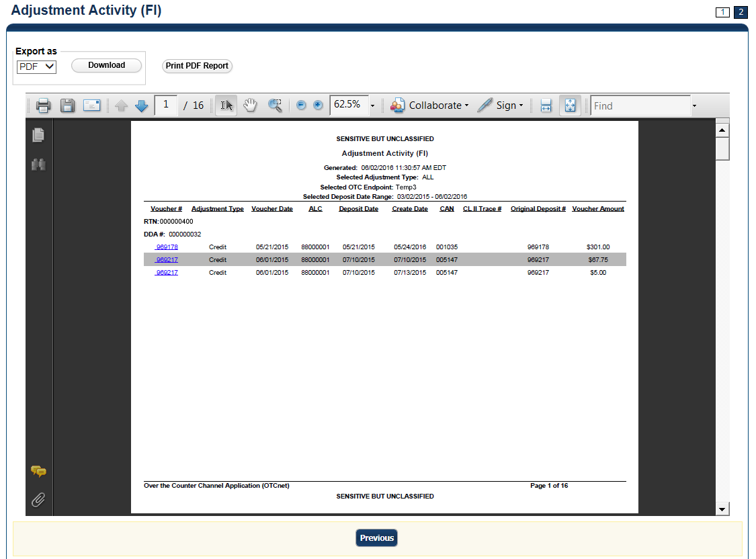

Application Tips



* **TGA** denotes a deposit processing OTC Endpoint.
* **CHK** denotes a check capture OTC Endpoint.
* **M** denotes a mapped accounting code; an open lock denotes access permission; and a closed lock denotes no access permission.
* **CDC** denotes card processing OTC Endpoint.

1. Under **Export as**, you have the following options:
   * Select **PDF**, **Excel** or **Word** **format**
   * Click **Download**

Or

* + Click **Print PDF Report**

Application Tip



All Adjustments associated with Deposits with an original voucher date older than 5 years and Returned Item Adjustments with an adjustment voucher date older than 5 years are archived to the archive database, according to the Fiscal Service data retention policy. These transactions are viewable through the *Historical Reports* page (**Home**>**Reports**>**Historical** **Reports**).

Additional Button



Click **Previous** to return to the previous page.

View Business Reports: Adjustments by OTC Endpoint

To view adjustments by OTC Endpoint report, complete the following steps:

1. From the **Reports** tab, click **Deposit Processing Reports**. The *View Reports* page appears.
2. Under **Business Reports**, click **Adjustments by OTC Endpoint**. The *Adjustments by OTC Endpoint* parameters page appears.
3. Enter your search criteria.
   * Select the **Organization**, *required*
   * Select the **Adjustment Type**, *required*
   * Select the **ALC** (Agency Location Code)
   * Enter the **From**: and **To**: Adjustment Date range
   * Enter the **From**: and **To**: Deposit Date range
   * Enter the **From**: and **To**: Adjustment Amount range
   * Click **Yes** or **No** for **Report With Children**

Application Tips



* The date range for **Adjustment Date** and **Deposit Date** cannot exceed 15 months.
* Click **Yes** For **Report with Children** to generate a report that contains data for the selected OTC Endpoint and all lower level OTC Endpoints.
* Click **No** For **Report with Children** to generate a report that contains data only for the selected OTC Endpoint.

1. Click an OTC Endpoint to initiate the report. The *Adjustments by OTC Endpoint* preview appears as shown in Figure 22.

Figure : Adjustments by OTC Endpoint Parameters Page

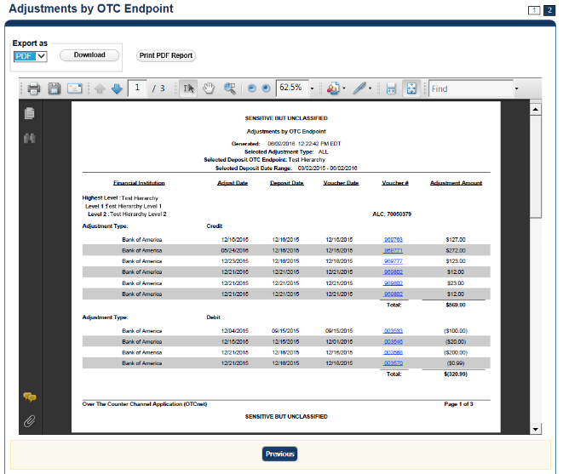

Application Tips



* **TGA** denotes a deposit processing OTC Endpoint.
* **CHK** denotes a check capture OTC Endpoint.
* **M** denotes a mapped accounting code; an open lock denotes access permission; and a closed lock denotes no access permission.
* **CDC** denotes card processing OTC Endpoint.

1. Under **Export as**, you have the following options:
   * Select **PDF**, **Excel** or **Word format**
   * Click **Download**
     + Or
   * Click **Print** **PDF Report**

Application Tip



All Adjustments associated with Deposits with an original voucher date older than 5 years and Returned Item Adjustments with an adjustment voucher date older than 5 years have been archived to the archive database, according to the Fiscal Service data retention policy. These transactions are viewable through the *Historical Reports* page (**Home**>**Reports**>**Historical** **Reports**).

Additional Button



Click **Previous** to return to the previous page.

View Business Reports: Daily Voucher Report

To view a daily voucher report, complete the following steps:

1. From the **Reports** tab, click **Deposit Processing Reports**. The *View Reports* page appears.
2. Under **Business Reports**, click **Daily Voucher Report**. The *Daily Voucher Report* page appears as shown in Figure 2.

Figure : Daily Voucher Report Page

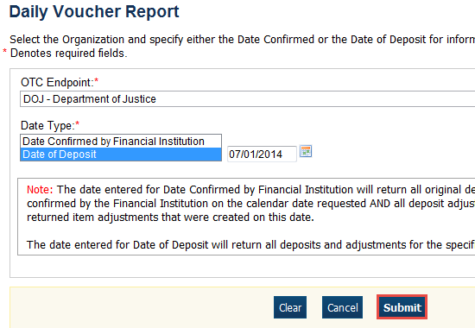

1. Enter your search criteria.
   * Select the **OTC Endpoint**, *required*
   * Select the **Date Confirmed by Financial Institution** or **Date of Deposit**, *required*
   * Enter the date range for the date the deposit was confirmed by FI or Date of Deposit
2. Click **Submit**. The *File Download* dialog box appears.
3. Click **Open**, **Save**, or **Cancel**.

Additional Buttons



* Click **Open**—the content of the file displays.
* Click **Save**—choose the location where you want to save the file.
* Click **Cancel**—the content does not display.

View Business Reports: Deposit Activity (FI)

To view a deposit activity (FI) report, complete the following steps:

1. From the **Reports** tab, click **Deposit Processing Reports**. The *View Reports* page appears.
2. Under **Business Reports**, click **Deposit Activity (FI)**. The *Deposit Activity (FI)* parameters page appears.
3. Enter your search criteria.
   * Select the **Status**, *required*
   * Select the **Voucher Type**
   * Enter the **From**: and **To**: Status Date range
   * Enter the **From**: and **To**: Voucher Date range
   * Enter the **ALC** (Agency Location Code)
   * Enter the **RTN** (Routing Transit Number)
   * Enter the **DDA** (Demand Deposit Account)
   * Enter the **From**: and **To**: Deposit Total range
   * Enter the **From**: and **To**: Deposit Date range
   * Enter the **CAN** (CA$HLINK II Account Number)
   * Enter the **CA$HLINK II Trace #**
   * Click **Yes** or **No** for **Report With Children**

Application Tips



* Click **Yes** for **Report With Children** to generate a report that contains data for the selected OTC Endpoint and all lower level OTC Endpoints.
* Click **No** for **Report With Children** to generate a report that contains data only for the selected OTC Endpoint.

1. Click an OTC Endpoint to initiate the report. The *Deposit Activity (FI)* preview page appears as shown in Figure 3.

Figure : Deposit Activity (FI) Preview Page

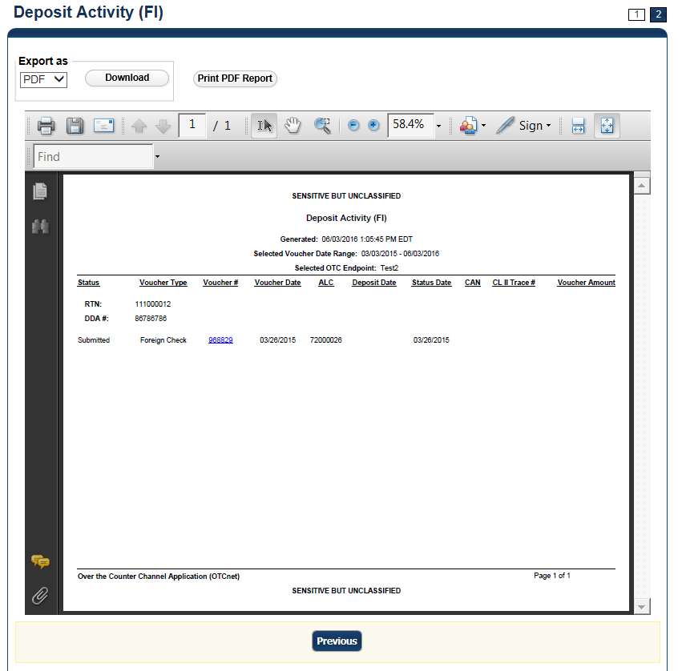

Application Tip



**TGA** denotes an OTC Endpoint; an open lock denotes access permission; and a closed lock denotes no access permission.

1. Under **Export as**, you have the following options:
   * Select **PDF**, **Excel** or **Word** format
   * Click **Download**
   * Or
   * Click **Print PDF Report**

Application Tips



* Deposits with a voucher date older than five years does not display on the report but they may be viewed from the *Historical Reports* page (**Home**>**Reports**>**Historical Reports**).
* Unconfirmed Foreign Check items entered with a Country of Deposit value of **Other** does not display values in the **Voucher Amount** column.

Additional Button



Click **Previous** to return to the previous page.

View Business Reports: Deposits by Accounting Code

To view a deposit by accounting code report, complete the following steps:

1. From the **Reports** tab, click **Deposit Processing Reports**. The *View Reports* page appears.
2. Under **Business Reports**, click **Deposits by Accounting Code**. The *Deposits by Accounting Code* parameters page appears.
3. Enter your search criteria.
   * Select the **Organization**, *required*
   * Select the **ALC** (Agency Location Code)
   * Select the **Account Code**, *required*
   * Enter the **From**: and **To**: Voucher Date range
   * Enter the **From**: and **To**: Deposit Total range
   * Click **Yes** or **No** for **Report With Children**

Application Tips



* The date range for Voucher Date cannot exceed 15 months.
* Click **Yes** for **Report With Children** to generate a report that contains data for the selected OTC Endpoint as well as all of the lower level OTC Endpoints.
* Click **No** for **Report With Children** to generate a report that contains data only for the selected OTC Endpoint.

1. Click an OTC Endpoint to initiate the report. The *Deposits by Accounting Code* preview page appears as shown in Figure 5.

Figure : Deposits by Accounting Code Report Preview Page

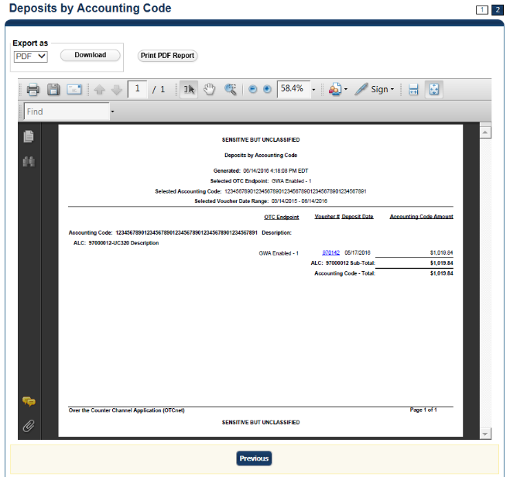

Application Tips



* **TGA** denotes a deposit processing OTC Endpoint.
* **CHK** denotes a check capture OTC Endpoint.
* **M** denotes a mapped accounting code; an open lock denotes access permission; and a closed lock denotes no access permission.
* **CDC** denotes card processing OTC Endpoint.

1. Under Export as, you have the following options:
   * Select **PDF**, **Excel** or **Word** **format**
   * Click **Download**

Or

* + Click **Print PDF Report**

Application Tips



* Deposits with a voucher date older than five years does not display on the report but they may be viewed from the Historical *Reports* page (**Home**>**Reports**>**Historical Reports**).
* Unconfirmed Foreign Check items entered with a Country of Deposit value of **Other** does not display values in the **Voucher Amount** column.

Additional Button



Click **Previous** to return to the previous page.

View Business Reports: Deposits by OTC Endpoint

To view a deposit by OTC Endpoint report, complete the following steps:

1. From the **Reports** tab, click **Deposit Processing Reports**. The *View Reports* page appears.
2. Under **Business Reports**, click **Deposits by OTC Endpoint**. The *Deposits by OTC Endpoint* parameters page appears.
3. Enter your search criteria.
   * Select the **Organization**, *required*
   * Select the **ALC** (Agency Location Code)
   * Enter the **From**: and **To**: Voucher Date range
   * Enter the **From**: and **To**: Deposit Total range
   * Click **Yes** or **No** for **Report With Children**

Application Tips



* The date range for **Voucher Date** cannot exceed 15 months.
* Click **Yes** for **Report With Children** to generate a report that contains data for the selected OTC Endpoint as well as all of the lower level OTC Endpoints.
* Click **No** for **Report With Children** to generate a report that contains data only for the selected OTC Endpoint.

1. Click an OTC Endpoint to initiate the report. The *Deposits by OTC Endpoint* preview page appears as shown in Figure 6.

Figure : Deposits by OTC Endpoint Report Preview Page

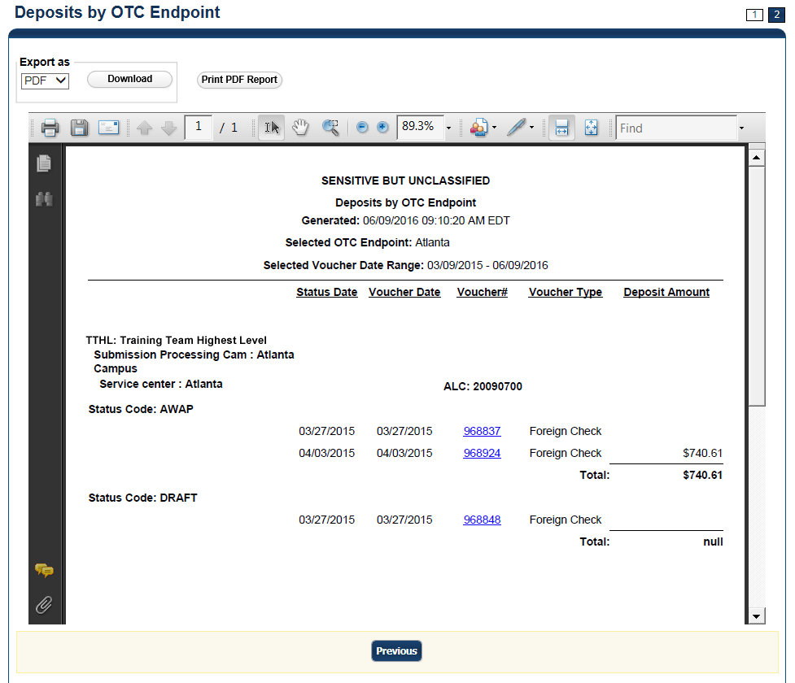

Application Tips



* **TGA** denotes a deposit processing OTC Endpoint.
* **CHK** denotes a check capture OTC Endpoint.
* **M** denotes a mapped accounting code; an open lock denotes access permission; and a closed lock denotes no access permission.
* **CDC** denotes card processing OTC Endpoint.

1. Under Export as, you have the following options:
   * Select **PDF**, **Excel** or **Word format**
   * Click **Download**

Or

* + Click **Print PDF Report**

Application Tips



* Deposits with a voucher date older than five years does not display on the report but they may be viewed from the *Historical Reports* page (**Home**>**Reports**>**Historical Reports**).
* Unconfirmed Foreign Check items entered with a Country of Deposit value of **Other** does not display values in the **Voucher Amount** column.

Additional Button



Click **Previous** to return to the previous page.

View Business Reports: Deposit History by Status

To view a deposit history by status report, complete the following steps:

1. From the **Reports** tab, click **Deposit Processing Reports**. The *View Reports* page appears.
2. Under **Business Reports**, click **Deposit History by Status**. The *Deposit History by Status* parameters page appears.
3. Enter your search criteria.
   * Select the **Organization**, *required*
   * Select the **ALC** (Agency Location Code)
   * Select the **Status**, *required*
   * Enter the **From**: and **To**: Status Date range
   * Enter the **From**: and **To**: Deposit Total range
   * Click **Yes** or **No** for **Report With Children**

Application Tips



* Click **Yes** for **Report With Children** to generate a report that contains data for the selected OTC Endpoint as well as all of the lower level OTC Endpoints.
* Click **No** for **Report With Children** to generate a report that contains data only for the selected OTC Endpoint.

1. Click an OTC Endpoint to initiate the report. The *Deposit History by Status* preview page appears as shown in Figure 7.

Figure : Deposit History by Status Preview Page

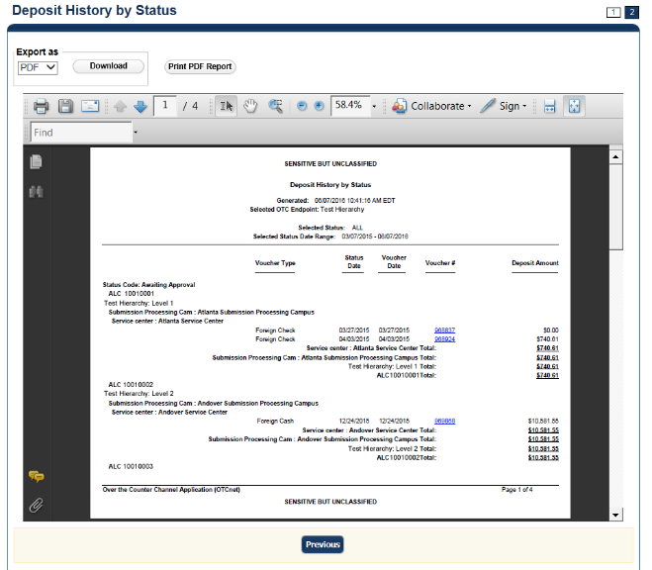

Application Tips



* **TGA** denotes a deposit processing OTC Endpoint.
* **CHK** denotes a check capture OTC Endpoint.
* **M** denotes a mapped accounting code; an open lock denotes access permission; and a closed lock denotes no access permission.
* **CDC** denotes card processing OTC Endpoint.

1. Under **Export as**, you have the following options:
   * Select **PDF**, **Excel** or **Word format**
   * Click **Download**

Or

* + Click **Print PDF Report**

Application Tips



* Deposits with a voucher date older than five years does not display on the report but they may be viewed from the *Historical Reports* page (**Home**>**Reports**>**Historical Reports**).
* Unconfirmed Foreign Check items entered with a **Country of Deposit** value of **Other** does not display values in the **Voucher Amount** column.

Additional Button



Click **Previous** to return to the previous page.

View Business Reports: Non-Reporting OTC Endpoints

To view a non-reporting OTC Endpoint report, complete the following steps:

1. From the **Reports** tab, click **Deposit Processing Reports**. The *View Reports* page appears.
2. Under **Business Reports**, click **Non-Reporting OTC Endpoints**. The *Non-Reporting OTC Endpoints* parameters page appears.
3. Enter your search criteria.
   * Enter the **From**: and **To**: Deposit Date range
   * Click **Yes** or **No** for **Report With Children**

Application Tips



* The date range for **Deposit Date** cannot exceed 15 months.
* Click **Yes** for **Report With Children** to generate a report that contains data for the selected OTC Endpoint as well as all of the lower level OTC Endpoints.
* Click **No** for **Report With Children** to generate a report that contains data only for the selected OTC Endpoint.

1. Click an OTC Endpoint to initiate the report. The *Non-Reporting OTC Endpoints* preview page appears as shown in Figure 8.

Figure : Non-Reporting OTC Endpoints Preview Page

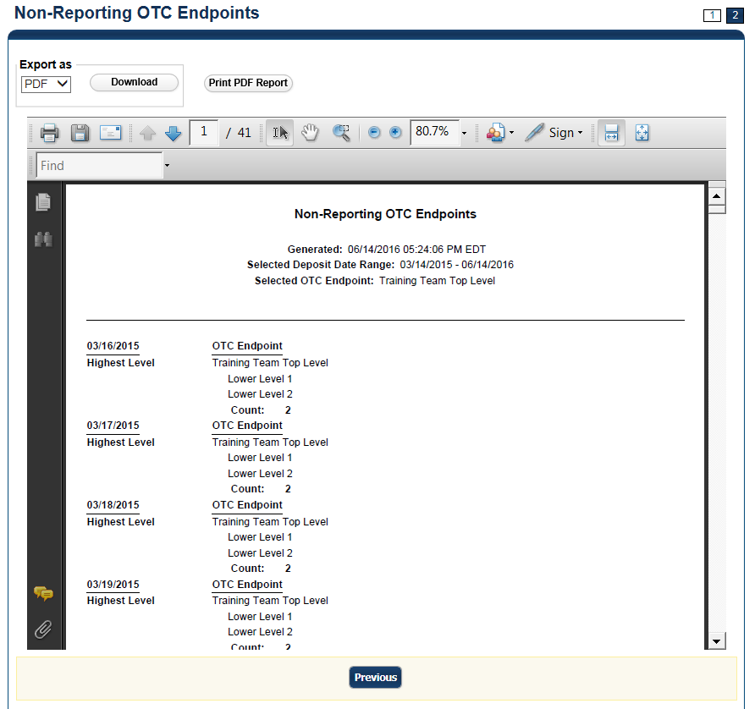

1. Under **Export as**, you have the following options:
   * Select **PDF**, **Excel** or **Word** format
   * Click **Download**

Or

* + Click **Print PDF Report**

Application Tips



* **TGA** denotes a deposit processing OTC Endpoint.
* **CHK** denotes a check capture OTC Endpoint.
* **M** denotes a mapped accounting code; an open lock denotes access permission; and a closed lock denotes no access permission.
* **CDC** denotes card processing OTC Endpoint.

Additional Button



Click **Previous** to return to the previous page.

View Business Reports: Processing Options by OTC Endpoints

To view processing options by OTC Endpoints report, complete the following steps:

1. From the **Reports** tab, click **Deposit Processing Reports**. The *View Reports* page appears.
2. Under **Business Reports**, click **Processing Options by OTC Endpoints**. The *Processing Options by OTC Endpoint* parameters page appears.
3. Enter you search criteria.
   * Enter the **Processing Option**, *required*
   * Select **Yes** or **No** for **Report With Children**

Application Tips



* For **Report With Children,** click **Yes** to generate a report that contains data for the selected OTC Endpoint as well as all of the lower level OTC Endpoints.
* For **Report With Children,** click **No** to generate a report that contains data only for the selected OTC Endpoint.
* **TGA** denotes a deposit processing OTC Endpoint.
* **CHK** denotes a check capture OTC Endpoint.
* **M** denotes a mapped accounting code; an open lock denotes access permission; and a closed lock denotes no access permission.
* **CDC** denotes card processing OTC Endpoint.

1. Click an OTC Endpoint to initiate the report. The *Processing Options by OTC Endpoints* preview page appears as shown in Figure 9.

Figure : Processing Options by OTC Endpoints Report Output Preview Page

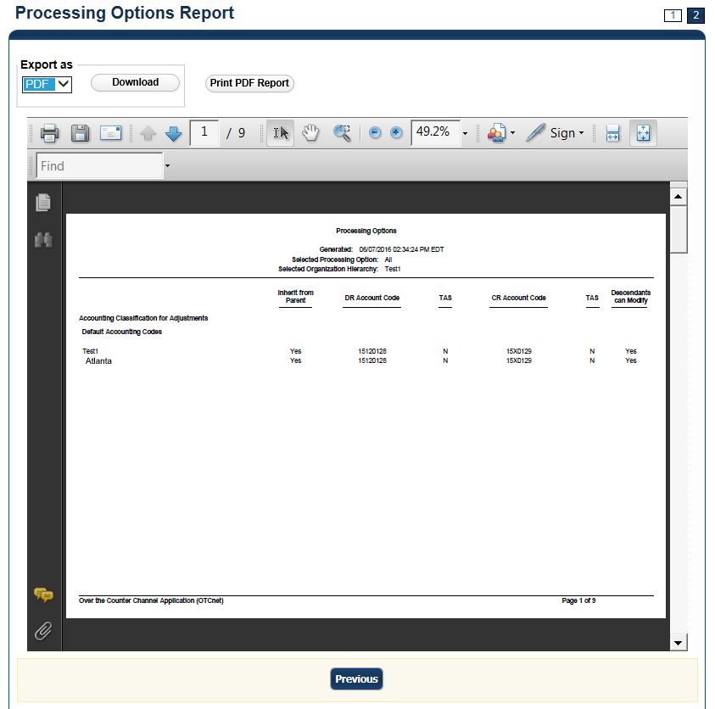

Application Tips



* **TGA** denotes a deposit processing OTC Endpoint.
* **CHK** denotes a check capture OTC Endpoint.
* **M** denotes a mapped accounting code; an open lock denotes access permission; and a closed lock denotes no access permission.
* **CDC** denotes card processing OTC Endpoint.

1. Under **Export as**, you have the following options:
   * Select **PDF**, **Excel** or **Word format**
   * Click **Download**

Or

* + Click **Print PDF Report**

Additional Button



Click **Previous** to return to the previous page.

### Security Reports

This section provides you with detail on how to view and download **Security Reports**.

There are six **Security Reports** available for viewing. This does not include the **Primary Access** **Groups without a PLSA**. This report is viewable to a **FS Security** user only. Security reports available for viewing include:

#### Users by Access Group (FI)

To view users by access group (FI), you are presented with the option to include search criteria for **Report With Children** for your selected Financial Institutions**.**

The report presents Users by Financial Institution Access Groups, including the **OTCnet Role, OTCnet Status, User Name, User ID,** and **Email Address.** You can export the report as a **PDF**, **Excel** or **Word** file, download it or print it.

***Users by Access Group (FPA)***

To view users by access group (FPA), you are presented with the option to include search criteria for **Report With Children.**

The report presents Users by Federal Program Agency Access, including the **OTCnet Role, OTCnet Status, User Name, User ID, and Email Address.** You can export the report as a **PDF**, **Excel** or **Word** file, download it or print it.

***User Information***

To view user information, you are presented with the option to include search criteria i.e., **User ID, Email Address, First Name,** and **Last Name.**

The report presents user information, including the **User ID, User Name, User Phone Number, Email, OTCnet Status, OTCnet Role, Access Group, Assigned Organizations, Employer, Employer Address,** and **Admin ID.** You can export the report as a **PDF**, **Excel** or **Word** file, download it or print it.

***Users by Role (FI)***

To view users by role (FI), you are presented with the option to include search criteria, i.e., **Role** and **Report With Children.**

The report presents Users by Financial Institution, including the **OTCnet Status, User Name, User ID, Email, Phone Number,** and **OTCnet Access Granted.** You can export the report as a **PDF**, **Excel** or **Word** file, download it or print it.

***Users by Role (FPA)***

To view users by role (FPA), you are presented with the option to include search criteria, e.g., **Role** and **Report With Children.**

The report presents Users by Federal Program Agency Access, including the **OTCnet Status, User Name, User ID, Email address, Phone Number,** and **OTCnet Access Granted.** You can export the report as a **PDF**, **Excel** or **Word** file, download it or print it.

View Security Reports: Users by Access Group (FI)

To view users by access group (FI) report, complete the following steps:

1. From the **Reports** tab, click **Deposit Processing Reports**. The *View Reports* page appears.
2. Under **Security Reports**, click **Users by Access Group (FI)**. The *Users by Access Group (FI)* parameters page appears.

Enter your search criteria.

* + Click **Yes** or **No** for **Report With Children**

Application Tips



* Click **Yes** to generate a report that contains data for the selected FIs and all lower level FIs.
* Click **No** to generate a report that contains data only for the selected FI.

1. Select a Financial Institution to initiate the report. The *Users by Access Group (FI)* preview page appears in a new window as shown in Figure 10.

Figure : Users by Access Group (FI) Report Preview Page

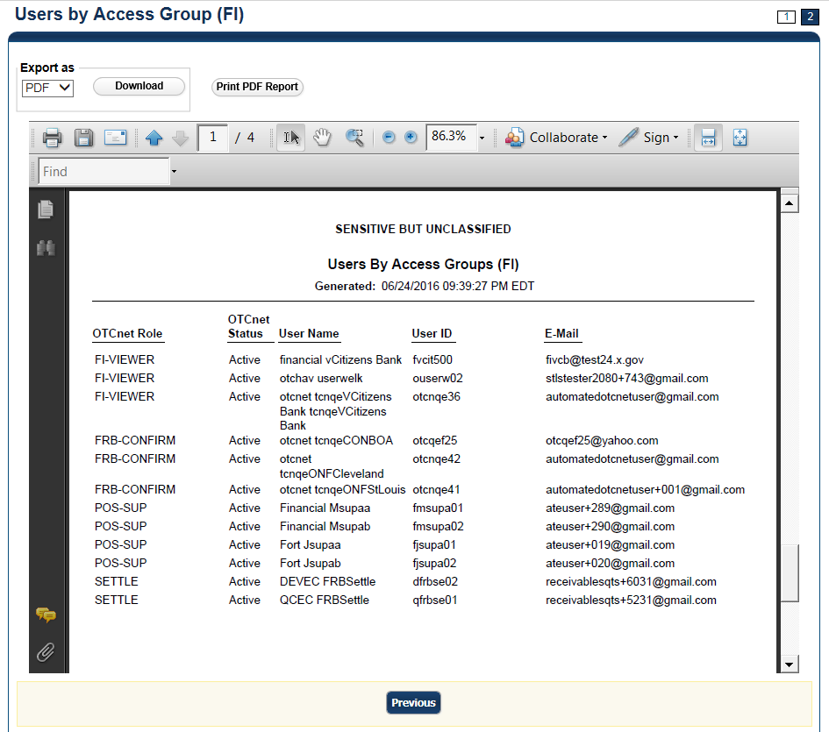

Application Tips



* **TGA** denotes a deposit processing OTC Endpoint.
* **CHK** denotes a check capture OTC Endpoint.
* **M** denotes a mapped accounting code; an open lock denotes access permission; and a closed lock denotes no access permission.
* **CDC** denotes card processing OTC Endpoint.

1. Under **Export as**, you have the following options:
   * Select **PDF**, **Excel** or **Word format**
   * Click **Download**

Or

* + Click **Print PDF Report**

Additional Button



Click **Previous** to return to the previous page.

View Security Reports: Users by Access Group (FPA)

To view the Users by Access Group (FPA) report, complete the following steps:

1. From the **Reports** tab, click **Deposit Processing Reports**. The *View Reports* page appears.
2. Under **Security Reports**, click **Users by Access Group (FPA)**. The *Users by Access Group (FPA)* parameters page appears.

Enter your search criteria.

* 1. Click **Yes** or **No** for **Report With Children**

Application Tips



* Click **Yes** to generate a report that contains data for the selected OTC Endpoint as well as all of the lower level Endpoints.
* Click **No** to generate a report that contains data only for the selected OTC Endpoint.

1. Select an OTC Endpoint to initiate the report. The *Users by Access Group (FPA)* preview page appears in a new window as shown in Figure 11.

Under **Export as**, you have the following options:

* + Select **PDF**, **Excel** or **Word format**
  + Click **Download**

Or

* + Click **Print PDF Report**

Figure : Users by Access Group (FPA) Preview Page

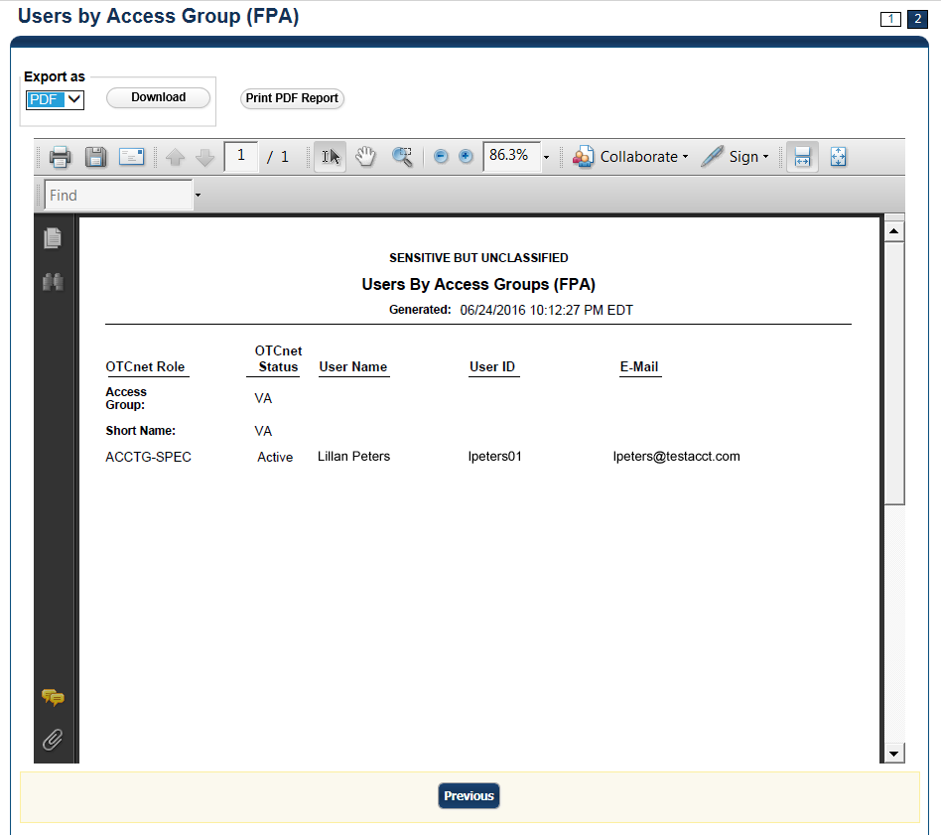

Application Tips



* If your agency has over 50 endpoints and/or over 100 users, you must drill down to a lower level within your agency to run the report. Running the report at a lower level prevents the report from overloading. Overloading results in a report with no
* data output.
* **TGA** denotes a deposit processing OTC Endpoint.
* **CHK** denotes a check capture OTC Endpoint.
* **M** denotes a mapped accounting code; an open lock denotes access permission; and a closed lock denotes no access permission.
* **CDC** denotes card processing OTC Endpoint.

Additional Button



Click **Previous** to return to the previous page.

View Security Reports: User Information

To view a user information report, complete the following steps:

1. From the **Reports** tab, click **Deposit Processing Reports**. The *View Reports* page appears.
2. Under **Security Reports**, click **User Information**. The *User Information* parameters page appears.
3. Enter the **User ID** or **E-mail Address** of the user you must view.

Or

Enter both the **First Name** and **Last Name** of the user.

1. Click **Submit** to initiate the report. The *User Information* preview page appears as shown in Figure 12.
2. Under **Export as**, you have the following options:
   * Select **PDF**, **Excel** or **Word format**
   * Click **Download**

Or

* + Click **Print** **PDF** **Report**

Figure : User Information Preview Page

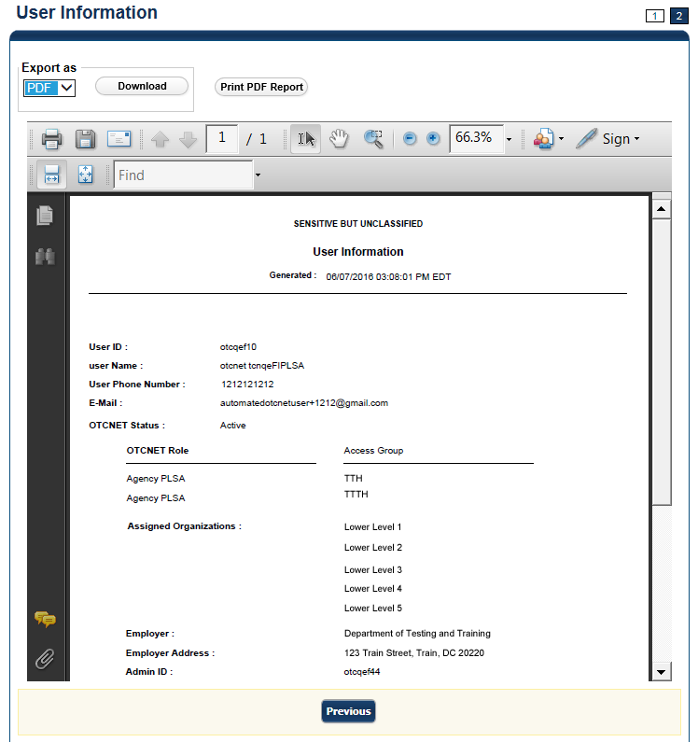

View Security Reports: Users by Role (FI)

To view users by role (FI) report, complete the following steps:

1. From the **Reports** tab, click **Deposit Processing Reports**. The *View Reports* page appears.
2. Under **Security Reports**, click **User by Role (FI)**. The *Users by Role (FI)* parameters page appears.

Enter your search criteria.

* + Select a user **Role**.
  + Click **Yes** or **No** for **Report With Children**

Application Tips



* For **Report with Children**, click **Yes** to generate a report that contains data for the selected FIs and all lower level FIs.
* For **Report with Children**, click **No** to generate a report that contains data only for the selected FI.
* **TGA** denotes a deposit processing OTC Endpoint.
* **CHK** denotes a check capture OTC Endpoint.
* **M** denotes a mapped accounting code; an open lock denotes access permission; and a closed lock denotes no access permission.
* **CDC** denotes card processing OTC Endpoint.

1. Click a Financial Institution to initiate the report. The *Users by Role (FI)* preview page appears as shown in Figure 13.
2. Under **Export as**, you have the following options:
   * Select **PDF**, **Excel** or **Word format**
   * Click **Download**

Or

* + Click **Print** **PDF** **Report**

Figure : Users by Role (FI) Preview Page

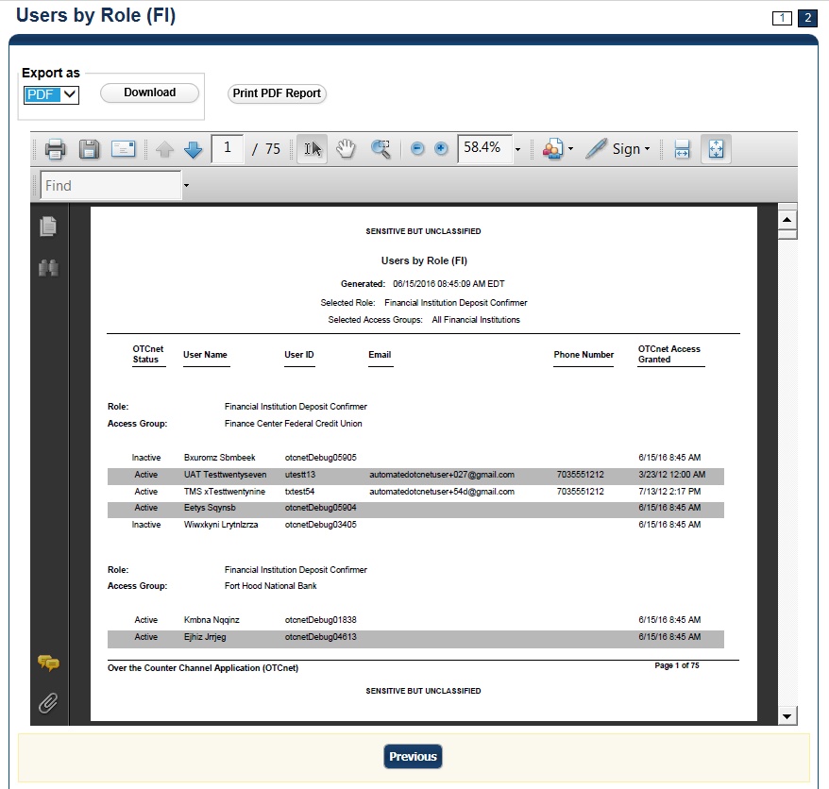

Additional Button



Click **Previous** to return to the previous page.

View Security Reports: Users by Role (FPA)

To view users by role (FPA) report, complete the following steps:

1. From the **Reports** tab, click **Deposit Processing Reports**. The *View Reports* page appears.
2. Under **Security Reports**, click **User by Role (FPA)**. The *Users by Role (FPA)* parameters page appears.

Enter your search criteria.

* + Select a user **Role**.
  + Click **Yes** or **No** for **Report With Children**

Application Tips



* Click **Yes** to generate a report that contains data for the selected OTC Endpoint as well as all of the lower level OTC Endpoints.
* Click **No** to generate a report that contains data only for the selected OTC Endpoint.

Click an OTC Endpoint to initiate the report. The report *Users by Role (FPA)* preview page appears as shown in

1. .
2. Under **Export as**, you have the following options:
   * Select **PDF**, **Excel** or **Word format**
   * Click **Download**

Or

* + Click **Print PDF Report**

Figure : Users by Role (FPA) Preview Page

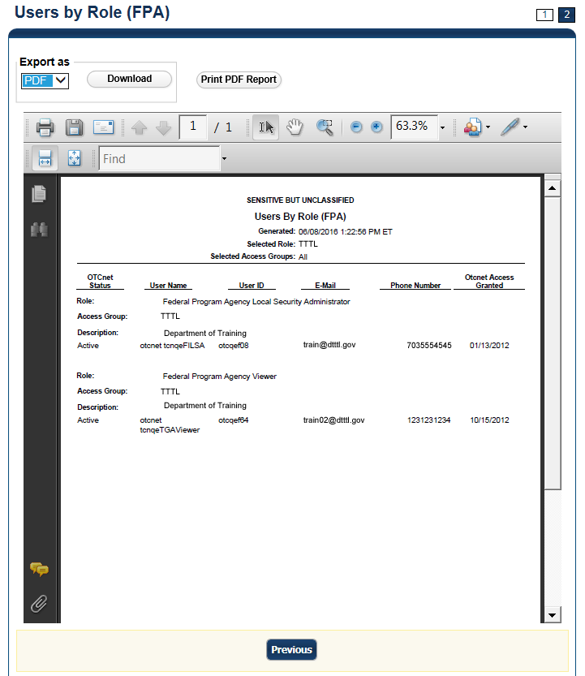

Application Tip



If your agency has over 50 endpoints and/or over 100 users, you must drill down to a lower level within your agency to run the report. Running the report at a lower level prevents the report from overloading. Overloading results in a report with no data output.

Application Tips



* **TGA** denotes a deposit processing OTC Endpoint.
* **CHK** denotes a check capture OTC Endpoint.
* **M** denotes a mapped accounting code; an open lock denotes access permission; and a closed lock denotes no access permission.  
  **CDC** denotes card processing OTC Endpoint.

Additional Button



Click **Previous** to return to the previous page.

### Administration Reports

This section provides you with detail on how to view and download **Administration Reports.**

**Administration Reports** available for viewing include:

#### View CIR File Status

To view the CIR file status report, you are presented with the following options: **Transmission(s) Not Processed** and **All Transmission(s).** Both options include: **Transmission ID, Status, Create Timestamp, Transmit Timestamp, Acknowledge Timestamp, CA$HLINK Type** and **CA$HLINK Acknowledge Timestamp.**

The report presents CIR File Status for FI, including: **Status, Voucher Type, Voucher #, Voucher Date, Agency Location Code (ALC), Deposit Date, Status Date, CA$HLINK II Account Number (CAN), TCMS Trace #, Voucher Amount, Bank, Routing Transit Number (RTN),** and **Demand Deposit Account (DDA) #.** You can export the report as a **PDF**, **Excel** or **Word** file and download or print it.

Additionally, the report presents Deposit or Adjustment Voucher details in PDF form, including the **Voucher #, Adjustment Type, Voucher Date, ALC, Deposit Date, CAN, Voucher Amount, Original Deposit Date, Original Deposit Number, Organization Name, OTC Endpoint Short Name, OTC Endpoint Description, Financial Institution, RTN, DDA, Creation Date, Creation User, CLII Extract Date, CLII Sent Date, Acknowledgement by CLII Date, CL II Trace #,** and **Voucher Status History.**

***View Vouchers Completed***

To view the Vouchers Completed report, you are presented with the option to include search criteria for the following items: **Voucher #, Voucher Status, Voucher Type, Financial Institution, Voucher Complete Timestamp,** and **CL II Trace Number.**

The report presents the event log, including **Voucher Information**, i.e., **Voucher #, Voucher Date, Voucher Type, Voucher Status, Voucher Status Timestamp, Deposit Date, CA$HLINK II Trace #** and **Financial Institution** and **Voucher Event State,** including the date the voucher was created on.

Additionally, the Voucher Event Details report presents the **Voucher #, Voucher Date, Voucher Event State, Voucher Event State Timestamp, Voucher Event LoginID, Voucher Type, Voucher Status, Voucher Status Timestamp, Deposit Date, CA$HLINK II Trace #, Financial Institution,** and **Voucher Event Comments.**

***View Vouchers in Progress***

To view the Vouchers in Progress report, you are presented with the option to include search criteria, i.e., **Voucher #, Voucher Status, Voucher Type,** and **Financial Institution.**

The report presents vouchers in progress and includes the **Voucher Information**: **Voucher #, Voucher Date, Voucher Type, Voucher Status, Voucher Status Timestamp, Deposit Date, CA$HLINK II Trace #,** and **Financial Institution.** The **Voucher Event Log** includes the **Voucher Event State** and the date the voucher was created on.

Additionally, the Voucher Event Details report presents the **Voucher #, Voucher Date, Voucher Event State, Voucher Event State Timestamp, Voucher Event LoginID, Voucher Type, Voucher Status, Voucher Status Timestamp, Deposit Date, CA$HLINK II Trace #, Financial Institution,** and **Voucher Event Comments.**

View Administration Reports: View CIR File Status

To view a CIR file status report, complete the following steps:

1. From the **Reports** tab, click **Deposit Processing Reports**. The *View Reports* page appears.
2. Under **Administration Reports**, click **View CIR File Status**. The *View CIR File Status* page appears.

Application Tip



The **Collections Information Repository (CIR)** was formerly referred to as **Transaction Reporting System (TRS)**.

1. Under the **Transmission(s) Not Processed** section, click a **Transmission ID** of the CIR transmission details you must view.

Or

Under **the All Transmission(s)** section, click a **Transmission ID** of the CIR transmission details or processing errors you must view.

Application Tips



* If a **Transmission ID** with FRB CL CA$HLINK Type is selected, the *CIR Transmission Status (FRB)* report appears in a new window.
* If a **Transmission ID** with CLII CA$HLINK Type is selected, the *CIR Transmission Status (FI)* report appears in a new window.
* There are two sections on the *View CIR File Transmission Status* page. The **Transmission(s) Not Processed** section displays report files that have not been successfully processed by CIR.
* The **All Transmission(s)** section displays all deposit report files regardless of transmission status or success.

1. The *View CIR Transmission Status* preview page appears.

Under Export as, you have the following options:

* + Select **PDF**, **Excel** or **Word** format
  + Click **Download**

Or

* + Print PDF Report

1. For further debit or adjustment voucher details, click the **Voucher #** hyperlink. The *Deposit or Adjustment Voucher Detail* report appears.
2. Click **Open**, **Save** or **Cancel**.
3. The *DepositVoucherDetail_XXX.pdf* or *AdjustmentVoucherDetail_ XXXX.pdf* report appears as shown in Figure 15.

Figure : Adjustment-Voucher Detail PDF

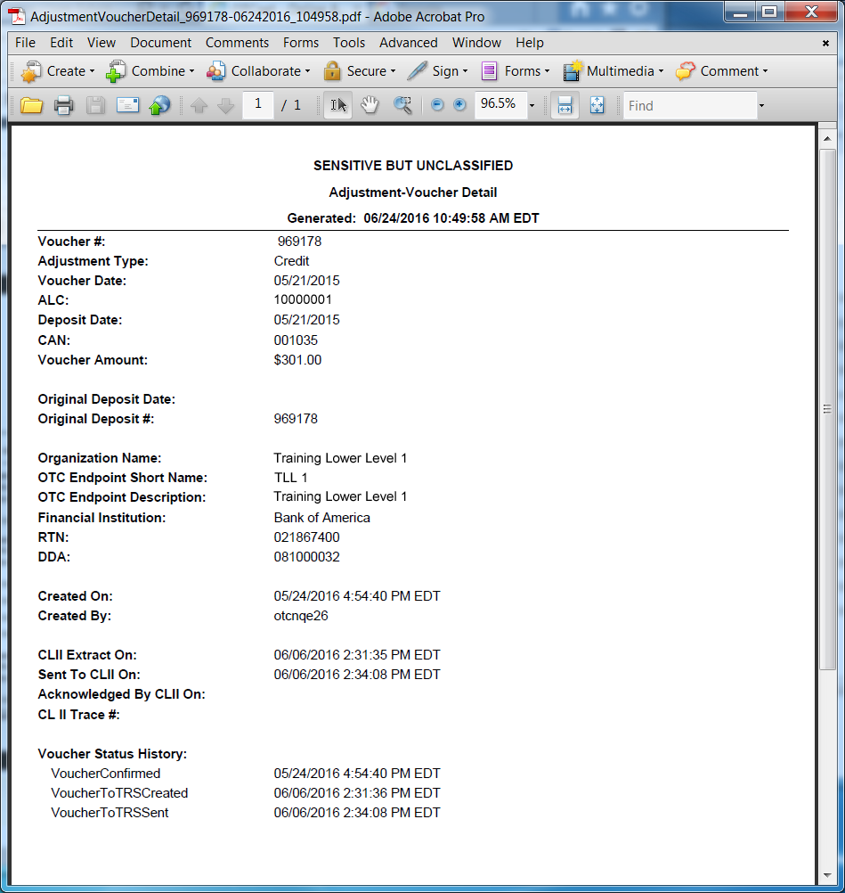

Additional Buttons



* Click **Open** the PDF is displayed.
* Click **Save** choose the location where to save the file.
* Click **Cancel** to return to the *View CIR File Status* preview page.
* Click **Previous** to return to the previous page.

View Administration Reports: View Vouchers Completed

To view a voucher’s completed report, complete the following steps:

1. From the **Reports** tab, click **Deposit Processing Reports**. The *View Reports* page appears.
2. Under **Administration Reports**, click **View Vouchers Completed**. The *View Vouchers* *Completed* page appears.
3. Click the **Voucher #** hyperlink. The *Voucher Event Log* page appears as shown in Figure 16.

Figure : View Voucher Event Log Page

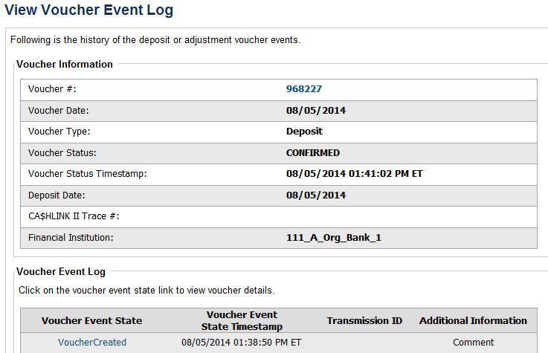

Application Tip



The **View Voucher Event** shows additional information about the voucher and the history of the voucher events through the FI System to System Interface.

1. Click the **Voucher #** hyperlink to view the details of the deposit or adjustment. The *Voucher Details Information* page or the *View Adjustment Details* page appears.

Or

Click a **Voucher Event State** hyperlink to view the voucher event details. The *Voucher Event Details* page appears as shown in Figure 17.

Figure : Voucher Event Details Report Output

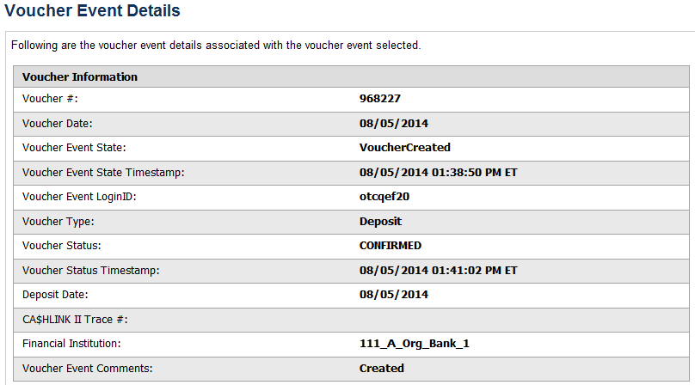

Application Tips



The *Voucher Event Details* page presents the following:

* Processing errors associated with the voucher event
* Additional information about the voucher and the transmission associated with the voucher events through the FI System To System Interface
* The Collections Information Repository (CIR) interface

Additional Buttons



* Click **Cancel** to return to the OTCnet Home Page. No data is saved.
* Click **Clear** to clear all data fields and reset to the default selections.
* Click **Previous** to return to the previous page.
* Click **Refresh** to redisplay the page with any additional vouchers that are in-process.
* Click **Return Home** to return to the previous page.

View Administration Reports: Vouchers in Progress

To view a voucher in progress report, complete the following steps:

1. From the **Reports** tab, click **Deposit Processing Reports**. The *View Reports* page appears.
2. Under **Administration Reports**, click **View Vouchers In Progress**. The *View Vouchers in Progress* page appears.

Application Tip



The *Vouchers In Progress* page only displays non-archived deposits or adjustments with a voucher date that is five years or less from to the current date.

1. Click the **Voucher #** hyperlink to view the *Voucher Event Log* page and additional voucher information. The *View Voucher Event Log* page appears as shown in Figure 18.

Figure : In Progress View Voucher Event Log Page

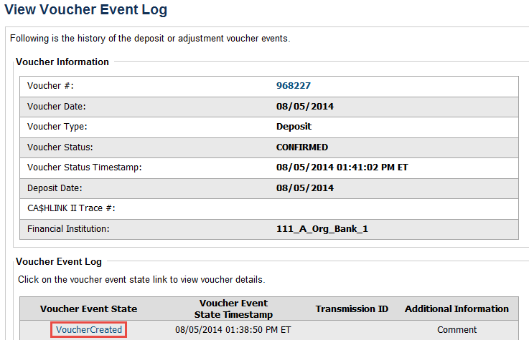

Application Tip



The **View Voucher Event** presents additional information about the voucher and the history of the voucher events through the FI System To System Interface.

1. Click the **Voucher #** hyperlink to view the details of the deposit or adjustment. The *Voucher Details Information* page or the *View Adjustment Details* page appears.

Or

Click a **Voucher Event State** hyperlink to view the voucher event details. The *Voucher Event Details* page appears as shown in Figure 19.

Figure : In Progress Voucher Event Details Report Output



Application Tip



The *Voucher Event Details* page presents processing errors associated with the voucher event and additional information about the voucher and the transmission associated with the voucher events through the FI System To System Interface, and the Collections Information Repository (CIR) interface.

Additional Buttons



* Click **Cancel** to return to the OTCnet Home Page. No data is saved.
* Click **Clear** to clear all data fields and reset to the default selections.
* Click **Previous** to return to the previous page.
* Click **Refresh** to redisplay the page with any additional vouchers that   
  are in-process.
* Click **Return** **Home** to return to the previous page.

### Historical Reports

This section provides you with detail on how to generate and view previously generated **Check Processing** and **Deposit Processing Historical Reports**.

#### Deposit Processing Historical Reports

Deposit Processing Historical reports are used to query and download deposit information with a specified Voucher Date from the archival database. Deposit transactions with a voucher date older than the minimum data retention period, as specified by Fiscal Service, may not be displayed on the report as these transactions are eligible to be deleted. As a result, this deposit information may not be accessible and will be removed from the archival database.

Historical reports are generated asynchronously (not occurring at the same time), allowing you to continue to use OTCnet.

Depending on the volume of data requested, it can take between 5 and 20 minutes for the report to generate.

If you are assigned the role of **Deposit Preparer**, **Deposit Approver**, **FI Confirmer**, **FRB** **Confirmer**, **FRB Viewer**, or **FI Viewer**, you are authorized to query and download Deposit Processing Historical reports.

You can search for check records by **Organization**, **OTC Endpoint**, **Agency Location Code (ALC)**, **Prepared by**, **Voucher Number**, **Deposit Status**, **Agency Use (Block 6)**, **Deposit Type**, **Voucher Date**, **Deposit Date**, **Deposit Total**, and **Financial Institution Information** search criteria.

When the report request is submitted, its status is set to **Submitted**. After the report is successfully generated, the status is set to **Completed** and the report is available for download in CSV format.

Historical reports available for viewing include:

#### Deposit Historical Report

To generate a deposit historical report, you are presented with the option to include search criteria, i.e., **Organization, OTC Endpoint, ALC, Prepared by, Voucher #, Deposit Status, Agency Use (Block 6)** details**, Deposit Type, Voucher Date (From:** and **To:), Deposit Date (From:** and **To:)** and **Deposit Total (From** and **To:).**

The report presents a historical record of deposits and can only be downloaded in **CSV** format.

***Adjustment Historical Report***

To generate an adjustment historical report, you are presented with the option to include search criteria, i.e., **Organization, OTC Endpoint, ALC, Adjustment Category, Voucher #, Adjustment Type, Prepared By, Adjustment Reason, Voucher Date (From:** and **To:)**, **Adjustment Amount (From** and **To:), Deposit Date (From:** and **To:)** and **Original Deposit Date (From:** and **To:)**.

The report presents a historical record of adjustments and can only be downloaded in **CSV** format.

Adjustments associated to deposits with a voucher date older than the minimum data retention period, as specified by Fiscal Service, may not be displayed on the report as these transactions are eligible to be deleted. As a result, this adjusted deposit information may not be accessible and will be removed from the archival database.

#### Previously Generated Historical Reports

To view previously generated historical reports, you are presented with a table of criteria, i.e., **Report Type, Submitted Time, Search Criteria Parameters, Status,** and **Download.**

The reports present a historical record of deposits or adjustments, the details of which are available above under their respective types. These reports can only be downloaded in **CSV** format.

Deposit Historical Report

To generate a Deposit Historical Report, complete the following steps:

1. From the **Reports** tab, select **Historical Reports**>**Generate Historical Reports**. The *Generate Historical Reports* page appears.
2. Under **Deposit Processing Historical Reports**, click **Deposit Historical Report**. The *Deposit Historical Report* page appears as shown in Figure 20.

Figure : Deposit Historical Report Criteria Page

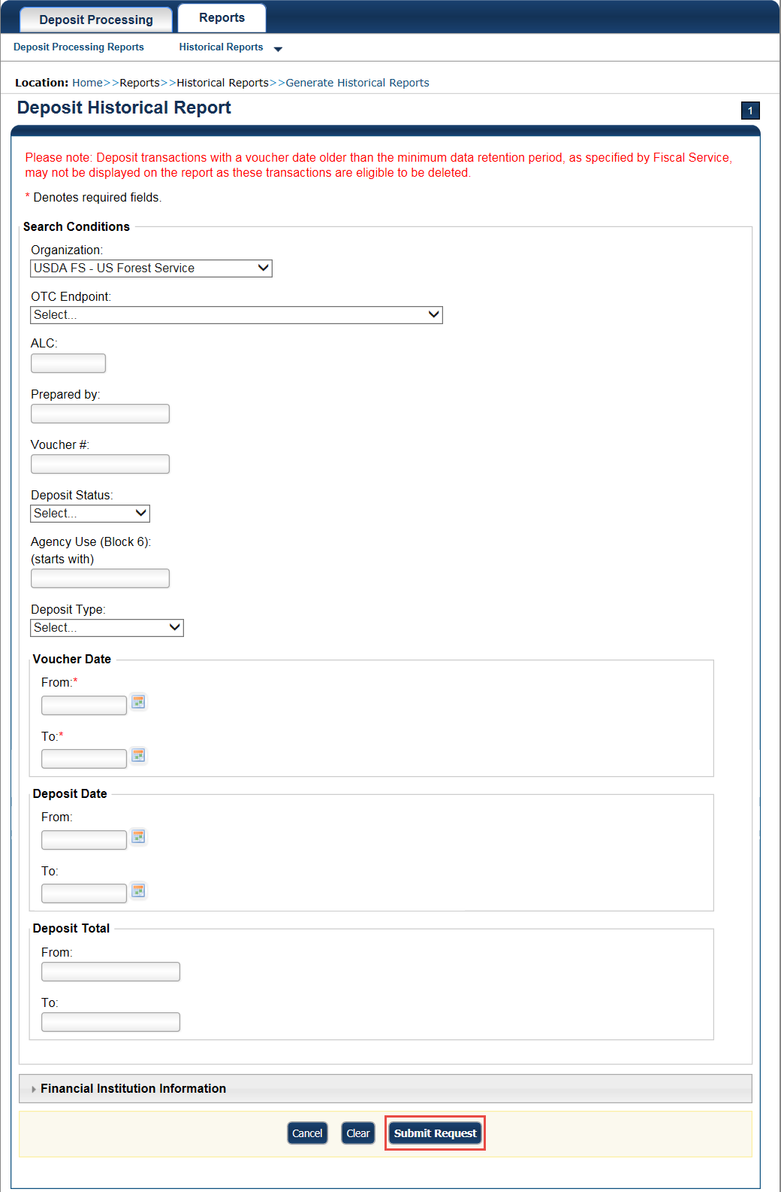

Application Tip



The Deposit Historical Report is generated asynchronously (not occurring at the same time) allowing you to continue using the OTCnet application. The time it takes to generate a report depends on the volume of data queried and therefore varies.

1. Enter your search criteria.

Under Search Conditions:

* Select an **Organization**
* Select an **OTC Endpoint**
* Enter an **ALC**
* Enter the **Prepared b**y
* Enter the **Voucher #**
* Select a **Deposit Status**
* Enter the Agency Use (Block 6) details
* Select a **Deposit Type**
* Enter the **From** and **To** Voucher Date, *required*
* Enter the **From** and **To** Deposit Date
* Enter the **From** and **To** Deposit Total

Application Tips



* The Voucher Date is a required field and the maximum date range for the **From** and **To** Voucher Date is one year. The Voucher Date must be entered in MM/DD/YYYY format.
* The **From** and **To** Deposit Date must be entered in MM/DD/YYYY format.

Under Financial Institution Information, *optional*

* Enter the **RTN** (**Routing Transit Number**)
* Enter the **DDA** (**Demand Deposit Account**)
* Enter the **CAN** (**CA$HLINK II Account Number**)
* Enter the **FRB Account Key** (**Federal Reserve Bank Account Key**)
* Enter the **FRB CCWU** (**Federal Reserve Bank Cost Center Work Unit**)

Application Tips



* The FRB Account Key must be three digits in length. The FRB Account Key field does not display for FI Deposit Confirmers or FI Viewers.
* The FRB CCWU must be four digits in length. If it is less than four digits, enter a zero at the beginning of the CCWU number (e.g. 0123). The FRB Account Key field does not display for FI Deposit Confirmers or FI Viewers.

Under **User Defined Field Information**, *if applicable*, *optional*

* Enter the **Deposit UDF** (**User Defined Field**) details
* Enter the **Accounting Subtotal UDF** details

Application Tip



User Defined Fields (UDFs) only display to users who have access to an organization that has previously defined UDFs. UDFs appear at the bottom of the page. Up to three UDFs can be displayed for **Deposit** and two for **Accounting Subtotal**.

1. Click **Submit Request**. A “*Your report request has been successfully received*” message appears.

Application Tip



Once a request is submitted you cannot submit the same request again for seven days. If a duplicate request is submitted within seven days the following message displays: *“Duplicate Request: You have submitted a report request based on identical report criteria in the last 7 days. Please revise your report criteria or access the previously generated report request.”*

Additional Buttons



* Click **Cancel** to return to the OTCnet Home Page. No data is saved.
* Click **Clear** to clear all data fields and reset to the default selections.

1. Once the request is submitted, navigate to **Previously Generated Historical Reports** (**Reports** tab>**Historical Reports**>**View Previously Generated Historical Reports**) and download the report in CSV format by clicking the **CSV** icon in the **Download** column for the report.

Adjustment Historical Report

To generate an Adjustment Historical Report, complete the following steps:

1. From the **Reports** tab, select **Historical Reports** and click **Generate Historical Reports**.
2. From the **Deposit Processing Historical Reports** section of the page, click **Adjustment** **Historical Report**. The *Adjustment Historical Report* page appears as shown in Figure 21.

Figure : Adjustment Historical Report Criteria Page

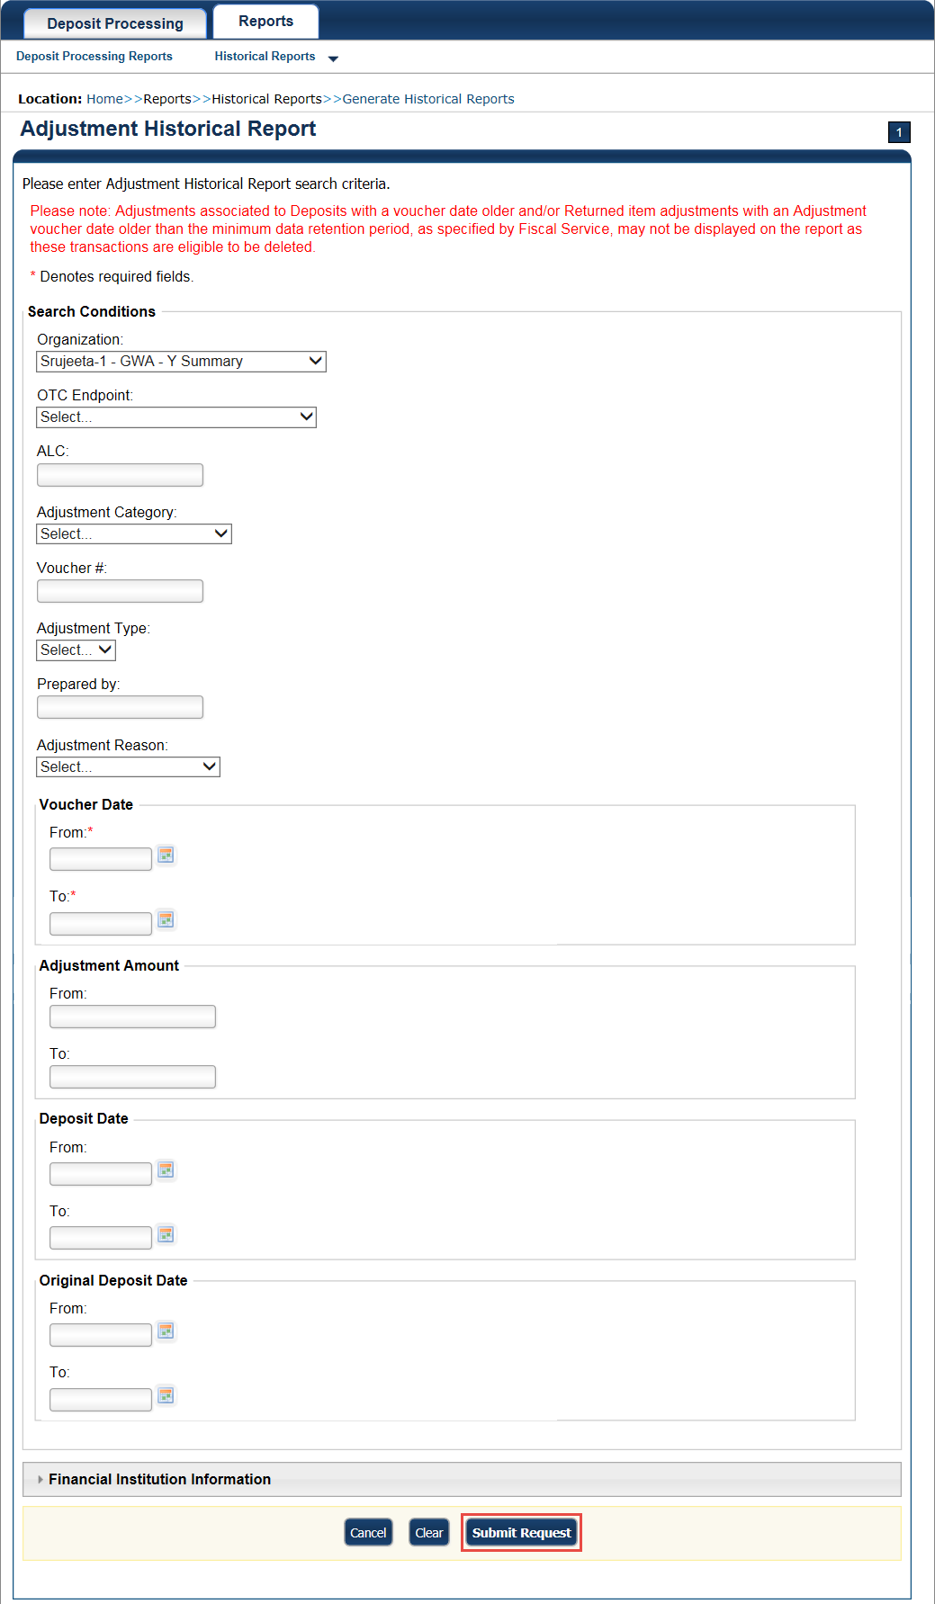

Application Tip



The Adjustment Processing historical report is generated asynchronously (not occurring at the same time) allowing you to continue using the OTCnet application. Depending on the volume of data queried it can take between 5 and 20 minutes to generate the report.

1. Enter your search criteria.

Under **Search Conditions**

* Select an **Organization**
* Select an **OTC Endpoint**
* Enter an **ALC**
* Select an **Adjustment Category**

Application Tips



* Select **Deposit Adjustment** to include deposit adjustments in the search results. The **Deposit Adjustment** search can be further limited by the user by selecting either **Debit** or **Credit** from the **Adjustment Type** drop-down list.
* Select **Returned Item Adjustment** to include only returned item adjustments (US Currency and Foreign Check Item) in the search results. The Returned Item Adjustment search does not have to be further qualified using the **Adjustment Type** drop-down list since returned item adjustments always have an Adjustment Type of **Debit**. If the user selects **Credit** from the **Adjustment Type** drop-down list after selecting a **Returned Item Adjustment**, no results appear since **Credit** returned item adjustments do not exist.
* Select **RIA – Foreign Currency** to only include returned item adjustments related to Foreign Check Items in the search results.
* Select **RIA – US Currency** to only include US Currency Returned Item Adjustments in the search results.
* Select no Adjustment Category (e.g., Select...), both deposit and returned item adjustments are included in the search results.
* Select Adjustment Type Debit to include all debit deposit adjustments and returned item adjustments in the search results. Select Credit to include only credit deposit adjustments in the search results.
  + Enter the **Voucher #**
  + Select an **Adjustment Type**
  + Enter the **Prepared by**
  + Select an **Adjustment Reason**
  + Enter the **From** and **To** Voucher Date, *required*
* Enter the **From** and **To** Adjust Amount Date
* Enter the **From** and **To** Deposit Date
* Enter the **From** and **To** Original Deposit Date

Application Tips



* The Voucher Date is a required field and the maximum date range for the **From** and **To** Voucher Date is one year. The Voucher Date must be entered in MM/DD/YYYY format.
* The **From** and **To** Deposit Date must be entered in MM/DD/YYYY format.

Under Financial Institution Information, *optional*

* Enter the **RTN** (**Routing Transit Number**)
* Enter the **DDA** (**Demand Deposit Account**)
* Enter the **CAN** (**CA$HLINK II Account Number**)
* Enter the **FRB Account Key** (**Federal Reserve Bank Account Key**)
* Enter the **FRB CCWU** (**Federal Reserve Bank Cost Center Work Unit**)

Application Tips



* The FRB Account Key must be three digits in length. The FRB Account Key field does not display for FI Deposit Confirmers or FI Viewers.
* The FRB CCWU must be four digits in length. If it is less than four digits, enter a zero at the beginning of the CCWU number (e.g. 0123). The FRB Account Key field does not display for FI Deposit Confirmers or FI Viewers.

1. Click **Submit Request**. A “*Your report request has been successfully received*” message appears.

Application Tip



Once a request is submitted you cannot submit the same request again for seven days. If a duplicate request is submitted within seven days the following message displays: *“Duplicate Request: You have submitted a report request based on identical report criteria in the last 7 days. Please revise your report criteria or access the previously generated report request.”*

Additional Buttons



* Click **Cancel** to return to the OTCnet Home Page. No data is saved.
* Click **Clear** to clear all data fields and reset to the default selections.

1. Once the request has been submitted, navigate to **Previously Generated Historical** **Reports** (**Reports** tab>**Historical Reports**>Vi**ew Previously Generated Historical Reports**) and download the report in CSV format by clicking the CSV icon in the **Download** column for the report.

Previously Generated Historical Reports

To view previously generated historical reports, complete the following steps:

1. From the **Reports** tab, select **Historical Reports** and click **View Previously Generated Reports**.

Application Tips



* When a report request is submitted and the Historical Database is unavailable, an informational message appears stating, “Historical Database is currently unavailable. All reports in Submitted status are processed when the Historical Database is available.” Report requests that are in **Submitted** status remain in **Submitted** status until the database is available and the report is generated. After the report is generated a **Completed** status is displayed.
* When a report request is submitted and the report could not generate, its status is **Error**. Resubmit your report request to ensure your report is generated. If a report displays an **Error** status, the request can be resubmitted at any time without receiving a duplicate request message.
* Report requests are user specific and are not viewable by other users.

1. The *View Previously Generated Reports* page appears as shown in Figure 22.The page lists reports that were requested within the last 7 days. Click **CSV** in the **Download** column for your desired report.

Figure : View Previously Generated Reports

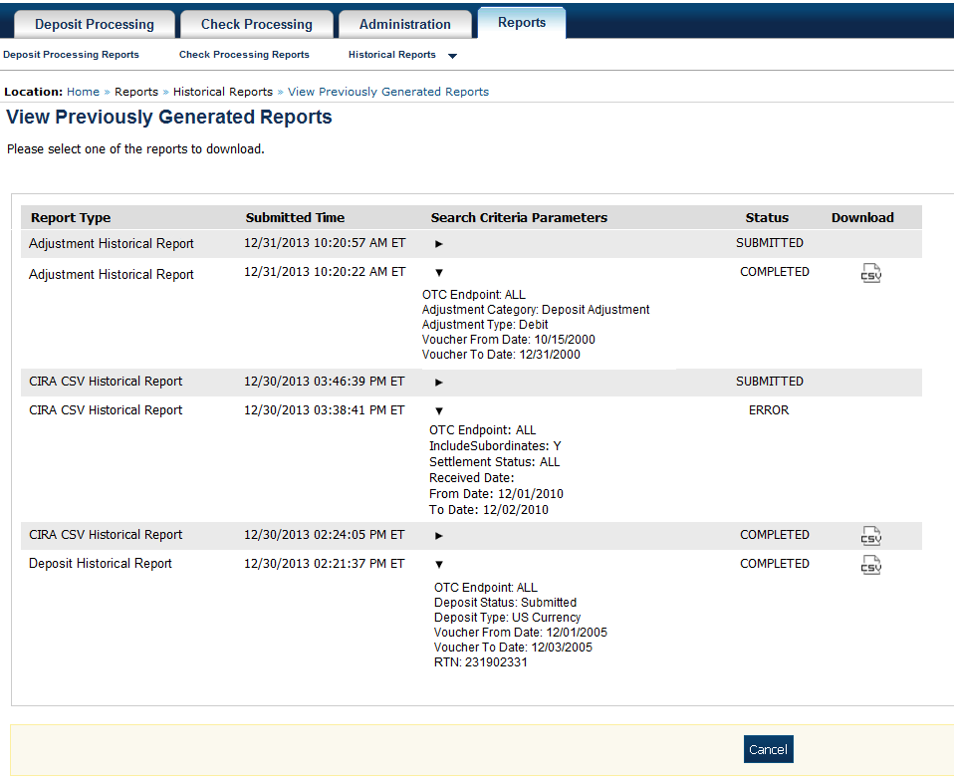

Application Tips



* After the CSV file is downloaded, open it using Excel or Notepad.
* Duplicate report requests based on identical report parameters cannot be made within seven days, however, after 7 days a duplicate report request can be submitted.

1. The *File Download* dialog box appears. Click **Open**, **Save**, or **Cancel**.

Additional Buttons



* Click **Open** and the content of the file displays.
* Click **Save to** and choose the location where you want to save the file.
* Click **Cancel and** the dialog box closes. No data is saved.

## Topic 5 Viewing a Financial Institution

As a **FRB Viewer**, you can locate and view the Financial Institution details that you have access to. You can only view a Financial Institution that has an **Active** status.

Viewing a Financial Institution (FI) allows you to see related details such as: Institution Information, Routing Transit Numbers (RTN) and Status and CA$HLINK II Account Number (CAN)/Acct Key Relationships.

### View a Financial Institution

When viewing a financial institution (FI), you are presented with a table containing FI details, i.e., **Name, City, State/Province, Country, Institution Type, Accepts Foreign Check Deposits, Accepts Foreign Cash Deposits, System to System Interface Participant, Short Name, Processes Foreign Check Deposits, Processes Foreign Cash Deposits,** and **Routing Transit Numbers.**

View a Financial Institution

To view a Financial Institution, complete the following steps:

1. From the **Administration** tab, select **Manage FI**>**Financial Institution**>**View**. The *View the Financial Institution* pages appear as shown in Figure 23 and Figure 24 below.

Figure : View FRB Detail

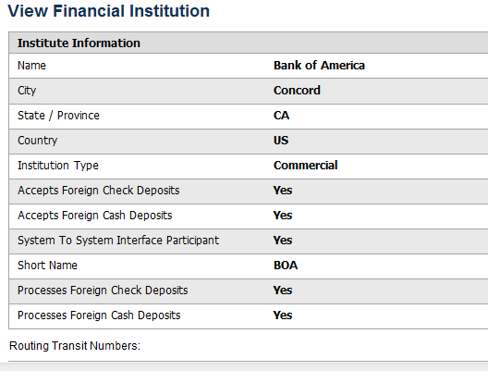

Figure : View Financial Institution Detail

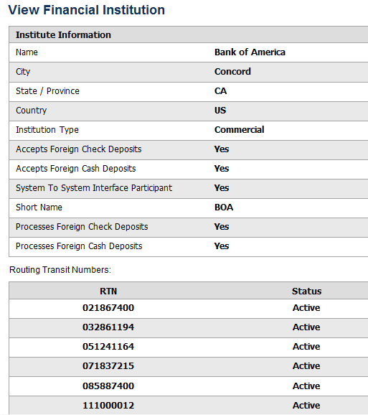

Application Tips



* Only **Active** Financial Institutions display for the selection.
* **FI Confirmers**, **FRB Confirmers**, **FI Viewers**, and **FRB Viewers** are authorized to view Institution Information, Routing Transit Numbers (RTN) and Status, and CA$HLINK II Account Number (CAN)/Acct Key Relationships.

Additional Button



Click **Return Home** to return to the OTCnet Home Page.

## Summary

In this chapter, you learned:

* The purpose of viewing reports
* The types of reports you can access by role
* The types of business, security, administration, and historical reports
* How to view, generate, and download reports