

OTCnet Participant User Guide

Table of Contents

Overview, Topics, and Audience 1

Overview 1

Topics 1

Audience 1

Topic 1 Purpose of Correcting Scanned Checks 2

Topic 2 Edit a Magnetic Ink Character Recognition (MICR) Code line 3

Correct a Magnetic Ink Character Recognition (MICR) Line 4

Topic 3 Edit a Check Item 5

Edit a Check Item 7

Summary 11

List of Figures

Figure 1. Code Line Correction Box 6

Figure 2. View Checks Page 8

List of Tables

Table 1. Code Symbol Descriptions 1 3

Table 2. Batch Status Types for OTCnet Online 5

Table 3. Batch Status Types for OTCnet Offline 5

Glossary

Click this [link](https://www.fiscal.treasury.gov/otcnet/training/wbt/content/course_OTC/glossary.htm) to access the full OTCnet Glossary.

## Overview, Topics, and Audience

### Overview

Welcome to *Correcting Scanned Checks*. In this chapter, you will learn:

* The purpose of correcting scanned checks
* How to edit a Magnetic Ink Character Recognition (MICR) code line
* How to edit a check item

### Topics

The topics in this chapter include the following:

1. Purpose of Correcting Scanned Checks
2. Edit a Magnetic Ink Character Recognition (MICR) Code Line
3. Edit a Check Item

### Audience

The intended audience for the *Correcting Scanned Checks* Participant User Guide includes:

* Check Capture Supervisor (CCS)
* Check Capture Lead Operator (CCLO)

## Topic 1 Purpose of Correcting Scanned Checks

As a **Check Capture Supervisor (CCS)** and **Check Capture Lead Operator (CCLO)** you are the only authorized users who can correct a scanned check in OTCnet Online and Offline. Correcting a check may involve one or more of the following resolutions:

* Adjusting the Magnetic Ink Character Recognition (MICR) code line
* Editing a check after it is entered and saved into OTCnet

Agency users who have permission to make corrections to checks must know the risks of submitting a check with incorrect information. They include debiting another individual’s/ company’s or Agency’s account and an increased likelihood of a returned check.

To avoid these risks, the **CCS** and **CCLO** can adjust a MICR line and edit a check after it’s scanned by either a **CCLO** or **Check Capture Operator (CCO)**.

## Topic 2 Correct a Magnetic Ink Character Recognition (MICR) Code line

As a **CCS** or **CCLO**, you are authorized to make MICR line corrections. You are prompted to key in your Login ID and Password before correcting the MICR line.

Keep the following items in mind when editing a MICR Code Line:

* If a **CCO** scans the check and the scanner detects an issue with the MICR code line data (as certain characters or all characters could not read by the scanner), the operator is prompted to correct the code line.
* If a **CCLO** scanned the check, additional authorization is not required. The Login ID and Password dialog box only appears if a **CCS** or **CCLO** is editing a MICR line for a **CCO**.
* When a *Check Processing Error* or *Unsupported Bank Number* message appears, the operator has the option to correct the code line, rescan the check, or cancel the scan. It is recommended that before attempting to correct the code line, the operator rescan the check. Rescanning the check usually corrects the error.
* If the error message continues to appear after the check is rescanned, contact your **CCS** to discuss options for capturing a check (e.g., rescanning the check again, correcting the MICR code line or using the deposit processing functionality).
* If the issue persists, and the decision is made to correct the MICR code line, OTCnet provides the symbol replacement codes to make the necessary corrections. If the scanner continues to have difficulty reading the characters in the code line, create a deposit using the **Deposit Processing tab** within OTCnet. The **Deposit Processing** tab only appears if your Agency and appropriate users have permission to create deposits using this functionality.
* For detailed support, reach the OTCnet Customer Support Center at fiscalservice**.otcchannel@citi.com** or call toll free at **866-945-7920.**

Table . Code Symbol Descriptions 1

| Code | Symbol | Description |
| --- | --- | --- |
| T | Routing number or American Bankers Association Symbol | Beginning or ending of a transit number, also known as a Routing number or ABA number. |
| O | On Us Field symbol | The On-Us field contains the account number and may also contain a serial number and transaction code. |
| A | An amount encoded check total symbol | Displays the amount of an amount-encoded check. |
| D | Dash symbol | Dash separates the values of the other fields. |

Correct a Magnetic Ink Character Recognition (MICR) Line

To correct a MICR line, complete the following steps:

1. From the *Check Scan – Perform Check Scan* page, the *Check Processing Error: Reject Characters Detected/Unsupported Bank Number* message appears. Click **Yes** to correct the code line.

Or

Click **Rescan** to rescan the check (applies only to *Reject Characters Detected* message).

Application Tip



Click **Rescan** if the check image is skewed, illegible, or upside down.

Or

Click **Cancel** to cancel the transaction.

1. The *Login ID* and *Password* dialog box appears. Enter the **Login ID** and **Password** and click **Login**.

Application Tips



* If a **Check Capture Operator (CCO)** scanned the check, OTCnet will prompt the operator for authorization.
* Only a **Check Capture Supervisor (CCS)** or **Check Capture Lead Operator (CCLO)** can perform MICR line corrections.
* The **CCS** or **CCLO** must key in his/her Login ID and Password before correcting the MICR line.
* If a **CCLO** scanned the check, additional authorization is not required.

1. The *Code Line Correction* box appears. Enter the correct numbers and click **OK**.
2. The *Code Line Correction* box closes and the scanned check image appears.

## Topic 3 Edit a Check Item

As a **Check Capture Supervisor** or **Check Capture Lead Operator**, you are the only authorized users who can edit a check within a batch. You can only edit checks in batches for OTC Endpoints that you have permission to access. You may choose to edit a check if the data entered in the amount or user defined fields were found to be incorrect.

Before editing a check, you must first search for the batch in which the check resides. You can search for batches by **OTC Endpoint**, **Created On Date**, **Batch ID**, **Cashier ID**, and/or **Batch Status**. You can only edit checks that carry an open or closed batch status.

Table . Batch Status Types for OTCnet Online

|  |  |
| --- | --- |
| Open | Indicates the batch is open and accepting new checks |
| Closed | Indicated the batch is closed and no new checks are accepted |
| Approved | Indicates the batch is ready for settlement |
| Forwarded | Indicates the batch has been sent to debit Gateway to initiate the settlement process |

Table . Batch Status Types for OTCnet Offline

|  |  |
| --- | --- |
| Open | Indicates the batch is open. Continue scanning |
| Closed | Indicates the batch is closed and no new checks are accepted |
| Approved | Indicates the batch is ready for upload and settlement. |
| Sent | Indicates the batch was uploaded online without error. |
| Acknowledged | Indicates the batch was transmitted and fully processed by the OTCnet server without error. |
| Send Error | Indicates the batch upload experienced system errors and the batch was not successfully uploaded, or a user selected to cancel the batch upload and the system halted the upload. |
| Acknowledge  Error | Indicates the acknowledge batch process experienced system errors and the acknowledgment was unsuccessful, or a user selected to cancel the batch acknowledgment which results in a batch being updated to Acknowledgment Error. |

For OTC Endpoints that are associated with an ALC that is designated as a Government-Wide Accounting (GWA) Reporter, all check transactions must be classified with an accounting code. If an ALC is not a GWA Reporter, classifying it with an accounting code is optional.

The **Agency Accounting Codes** drop-down list displays the full **Agency Accounting Code** value (up to 50 alphanumeric characters) and some portion of the **Description** (up to 15 alphanumeric characters).

In the event an Agency becomes a GWA Reporter in between a captured check and an operator selecting to save updates, and if an accounting code is not specified and is available for selection, an overlay message appears asking, “*Would you like to classify the check transaction with Accounting information*?”

If **Yes** is clicked, you are returned to the Show Item page and allowed to select an accounting code.

If **No** is clicked, a Comment dialog box appears. Enter a reason why an accounting code is not classified for the transaction.

The single **Agency Accounting Code** and **Multiple** accounting codes option is available if checks are scanned against an OTC Endpoint designated for Item Level Classification. If an ALC is designated for Summary Level Classification the **Agency Accounting Code** and **Multiple** accounting codes options are disabled.

If multiple accounting codes are used, the combined accounting code subtotal must be equal to the deposit total before proceeding to the next step. If it does not, you must go back and re-validate your subtotal entries.

Application Tips



* As the **CCS** or **CCLO,** if you opt to make a MICR code line correction, you must look at the MICR line image closely to ensure all the characters are correctly entered in the Code Line Correction box as shown in Figure 1.
* OTCnet will indicate the character(s) that are illegible by replacing it with a question mark(s). Look at the MICR line image closely to ensure all the characters are correctly captured. If they are not captured or marked with a question mark, click **Cancel** and rescan the check.
* If the scanner continues to have difficulty reading the characters in the code line, the operator can create a deposit using the Deposit Processing tab within OTCnet. The **Deposit Processing** tab only appears if your agency and appropriate users have permission to create deposits for over-the-counter collections.

Figure . Code Line Correction Box

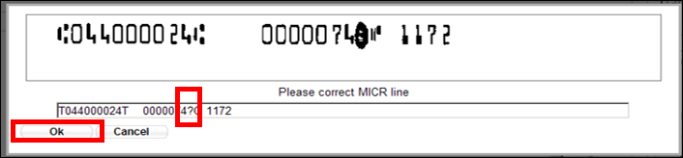

Edit a Check Item

To edit a check item, complete the following steps:

1. Click the **Check Processing tab** and click **Batch Management**. The *Search Batch* page appears.
2. Select or enter the batch search conditions you would like to view.

Under **Batch Search Conditions**, *optional*

* + Select the **OTC Endpoint** you want to **Edit** a batch for by checking the under the **Select** column

Under **Created On Date**, *optional*

* + Enter the **From** and **To** date range

Application Tips



* The **From** and **To Created On Date** must be entered in MM/DD/YYYY format.
* The **Created On Date** range cannot exceed 30 days. Additionally, if more than a 1,000 batches are created within 30 days then only the most recent 1,000 batches appear.
* If you run a search with the default **From** and **To** Created On Date range values, the search results include the most recent 30 days of batches that you have access to view. If more than 1,000 batches are created within the 30 days then only the most recent 1,000 batches appear.
* If you run a search ***without*** specifying any criteria (with the exception of the **Batch ID** field), the search results include the most recent 30 days of batches that you have access to view. If more than 1,000 batches are created within 30 days then only the most recent 1,000 batches appear.
  + Enter the **Batch ID**, *optiona*l

Application Tip



If the only search criteria entered is a valid **Batch ID,** only a single result appears, regardless of other search criteria specified.

* + Enter the **Cashier ID**, *optional*

Under **Batch Status**, *optional*

* + Select the **Status** you want to view by checking the **Open** or **Closed** box under the **Select** column

Application Tip



Only batches in **Open** or **Closed** status can be edited.

1. Click **Search**. The *View Batches* page appears.
2. Click the **Batch ID** hyperlink. The *View Checks* page appears.
3. Click the **Item ID** of the scanned check you would like to edit. An image and details of the check appear in a window below.
4. Click **Show Item** to the right of the check image to edit as shown in Figure 2. The *Show Item* page appears.

Figure . View Checks Page

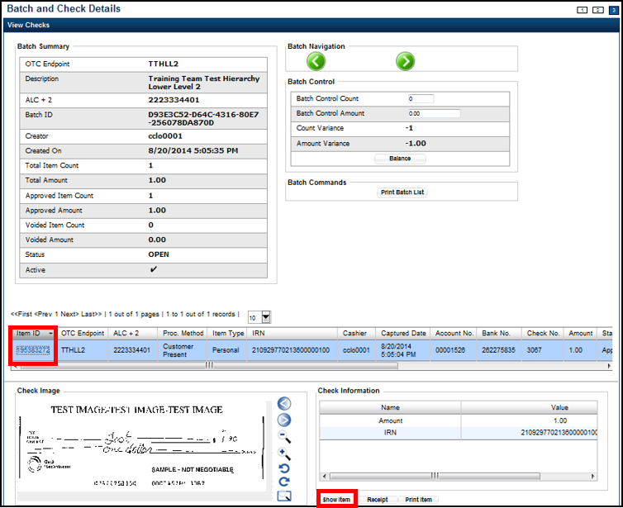

1. Update the necessary form data.

To edit the form data, complete the following:

Under **Agency Form Data**, update the check data in the field(s) provided, *if applicable*

* + Enter the **Amount**
  + Enter the **UDF** details

Application Tips



* The **Agency Form Data** form is customizable and can include fields beyond the **Amount** field (e.g., Driver’s License Number). If your Agency has additional fields, they are displayed under the **Amount** field. Your Agency may deem the field(s) either mandatory or optional for you to complete an entry.
* Ensure that you type in the data rather than copying and pasting from another source. Data that has been copied and pasted may result in an error.

Under **Agency Accounting Code**, *if applicable*

* + Click the **Agency Accounting Code** radio button and select a single accounting code from the drop-down list

Or

* + Click the **Multiple** radio button. The *Account Classification* dialog box appears.
    - Select an **Accounting Code**, enter the **Amount**, and click **Add** for each subtotal of the deposit
    - Click **Save**

Under **Server Controls**, *required*

* + Click **Update**

1. Click **Confirm** to confirm to update the check data.
2. Enter comments concerning the updated request at the prompt and click **OK**.
3. Click **OK** at the confirmation prompt stating that the check has been successfully updated.

Additional Buttons



Additional buttons on the pages that help you perform other tasks:

* Click **Cancel** to return to the OTCnet Home Page. No data is saved.
* Click **Previous** to return to the previous page.
* Click **Void All** to void all items in the batch.
* Click Print Batch List to print the batch list.
* Click **<** to go to the first batch.
* Click **>** to go to the next batch.
* Click **<<Image** to return to the previous check.
* Click **>>Image** to view the next check.
* Click **Zoom- to** reduce the image size.
* Click **Zoom+ to** enlarge the image size.
* Click **Rotate Left** to turn the image to the left.
* Click **Rotate Right** to turn the image to the right.
* Click **Show Item** to view the check item and perform update.
* Click **Void** to void a single check item.
* Click **Receipt** to print a receipt.
* Click **Print** **Item** to print an Item List report.

Additional buttons on the Show Item page that help you perform other tasks:

* Click **-Front** to return to the previous check.
* Click **Back+** to view the next check.
* Click **-Zoom** to reduce the image size.
* Click **Zoom+** to enlarge the image size.
* Click **Rotate Left+** to turn the image to the left.
* Click **Rotate Right+** to turn the image to the right.

## Summary

In this chapter, you learned:

* The purpose of correcting scanned checks
* How to edit a Magnetic Ink Character Recognition (MICR) code line
* How to edit a check item