

# Chapter 9. Configuring Check Processing Settings

OTCnet Participant User Guide

Table of Contents

Overview, Topics, and Audience 3

Overview 3

Topics 3

Audience 3

Topic 1 Purpose of Configuring Check Processing Settings Online 4

Topic 2 Set Up or Modify a Terminal Configuration 5

Configure a Check Capture Terminal Online 5

Configure a Check Capture Terminal Online 6

View Terminal Configuration 11

View Terminal Configuration 12

Topic 3 Search an Audit Log 13

Search an Audit Log Online 13

Search an Audit Log Online 14

Topic 4 Download and Install Firmware 17

Download Firmware 17

Download Firmware 18

Install Firmware 20

Install Firmware 21

Summary 23

List of Figures

Figure 1. Step 3 of 4: Update the Configured OTC Endpoints 10

Figure 2. View Terminal Configuration Page 12

Figure 3. Audit Log Output 16

Figure 4. Review Firmware Download 19

Figure 5. Destination Folder Dialog Box 22

List of Tables

Table 1. Scanner Types 5

Table 2. Audit Log User Permissions 13

Table 3. Event Types 16

Glossary

Click this [link](https://www.fiscal.treasury.gov/otcnet/training/wbt/content/course_OTC/glossary.htm) to access the full OTCnet Glossary.

## Overview, Topics, and Audience

### Overview

Welcome to *Configuring Check Processing Settings*. In this chapter, you will learn:

* The purpose of configuring check capture settings
* How to set up or modify a terminal configuration
* How to view a terminal configuration
* How to search an audit log
* How to download and install firmware

### Topics

This chapter is organized by the following topics:

1. Purpose of Configuring Check Processing Settings
2. Set Up or Modify a Terminal Configuration
3. Search an Audit Log
4. Download and Install Firmware

### Audience

The intended audience for *the Configuring Check Processing Settings* Participant User Guide includes:

*View / Modify Configuration Functions*

* Check Capture Administrator
* Check Capture Supervisor

*View Configuration Only*

* Check Capture Lead Operator
* Check Capture Operator

## Topic 1 Purpose of Configuring Check Processing Settings Online

Only **Check Capture Administrators (CCA)** and **Check Capture Supervisors (CCS)** are authorized to configure the check processing settings for your Agency terminals. Depending on your user role, you may see all, or only specific check capture activities within your Agency.

Additionally, as a **CCA**, you can manually download or upgrade application software for a terminal (e.g., the OTCnet Local Bridge [OLB] Application) used to communicate between OTCnet and the check capture terminal.

To meet your check capturing for your location, each OTCnet terminal must have configuration settings individually applied. You can add or update the following:

* **System Configuration:** Used to define LVD usage (offline users) and receipt printing
* **Application Configuration:** Used to define a Terminal ID, processing mode, specify a cashflow method, and to specify batch control and batch control prompts
* **Devices Configuration:** Used to specify the scanner type and communication channel, as well as enable franking
* **Available OTC Endpoints:** Used to add available OTC Endpoints for data entry
* **Configured OTC Endpoints:** Used to set a default OTC Endpoint, review already-configured OTC Endpoints or remove unused OTC Endpoints from the terminal

## Topic 2 Set Up or Modify a Terminal Configuration

The **CCA** and **CCS** are authorized to configure a check capture terminal. To configure a check capture terminal online, enter your system configuration, add or update your OTC endpoints and verify the terminal configuration. The **Card Administrator (CA)** is authorized to configure a card terminal.

If you are configuring a check capture terminal, you must first start the OTCnet Local Bridge (OLB) application.

The **Scanner Types** table presents a list of the scanners supported by OTCnet. They can be configured to a check capture terminal.

Table 1. Scanner Types

|  |  |
| --- | --- |
| **RDM EC7000i** | This scanner will automatically scan both sides of a check and can scan in single or batch mode (one or more checks in a batch) |
| **RDM EC9100i** | This scanner will automatically scan both sides of a check and can scan in single or batch mode (one or more checks in a batch) |
| **RDM EC9600i** | This scanner will automatically scan both sides of a check and can scan in single or batch mode (one or more checks in a batch) |
| **RDM EC9700i** | This scanner will automatically scan both sides of a check and can scan in single or batch mode (one or more checks in a batch) |
| **Panini MyVision X** | This scanner will automatically scan both sides of a check and can scan in single or batch mode (one or more checks in a batch) |
| **Panini Vision X** | This scanner will automatically scan both sides of a check and can scan in single or batch mode (one or more checks at a time) |
| **Panini I: Deal** | This scanner will automatically scan both sides of a check and can scan in single or batch mode (one or more checks at a time) |

### Configure a Check Capture Terminal Online

To configure a check capture terminal online, enter your system configuration, including **LVD Usage**, **Receipt Printing**, **Application Configuration** and **Devices Configuration** and add or update your OTC endpoints, as needed. Verify the terminal configuration, including **Configured OTC Endpoints**, **System Configuration**, **Application Configuration** and **Devices Configuration**. You can also edit the information.

Configure a Check Capture Terminal Online

To configure a check capture terminal online, complete the following steps:

1. From the **Administration** tab, select **Manage Check Processing**>**Terminal Configuration**>**Modify**. The *Step 1 of 4: Gathering Terminal Information* page may appear briefly. The *Step 2 of 4: Update the Terminal Configuration* page appears.
2. Enter the system configuration and click **Next**. The *Step 3 of 4: Update the Configured OTC Endpoints* page appears.

Under **System Configuration**,

Set **LVD Usage** by, *optional*

* Checking or unchecking **Personal Check** and/or **Non- Personal** for Customer Present
* Checking or unchecking **Personal Check** and/or **Non- Personal** for Customer Not Present

Application Tip



If you are configuring a check capture terminal and have not started the OTCnet Local Bridge (OLB) application, you receive the following message: *Terminal detection failed. Please ensure that the OLB application is running*.

Set **Receipt Printing** by, *optional*

* Checking **Customer Present**, *optional*
  + Click the **Manual** or **Automatic** radio button
    - Check **with preview**
* Checking **Customer Not Present**, *optional*
  + Click the **Manual** or **Automatic** radio button
    - Check **with preview**

Application Tips



* Leaving both the **Customer Present** and **Customer Not** **Present** fields unchecked results in the disabling of this option. If receipts are desired, click the appropriate box(es). When the **Customer Present** and/or **Customer Not** **Present** fields are clicked, the default setting is **Manual**.
  + Click **Manual** to require the operator to take additional steps to print the receipt.
  + Click **Automatic** to print a receipt each time a transaction is entered.
  + Click **with** **preview** to allow the operator to see the receipt on the screen prior to the generation of the printout.
* When printing receipts, the system prints to the Windows default printer. All receipts print to the Windows default printer.

Under **Application Configuration**,

* + - Enter the **Terminal ID**
    - Select **Single** or **Batch** for Processing mode
    - Select **Settle Best Method** or **Truncate All Items** for Cashflow
    - Check **Back Office** **Processing Only**
    - Select **Optional** or **Mandatory** for Batch Control
    - Click **Prompt on Batch Create** and/or **Prompt on Batch Close** for Batch Control Prompts

Application Tips



* The **Terminal ID** field is available for data entry during initial setup. After the **Terminal ID** is assigned, it is protected and cannot be changed.
* The **Host Name** field is automatically generated based on your computer’s registry and cannot be changed.
* The **Single** processing mode allows the user to scan only one check at a time. The **Batch** processing mode allows groups of checks to be scanned all at once, prior to the data entry for the items. The **Batch** processing mode is available for RDM EC7000i, EC9100i, EC9600i, EC9700i and Panini MyVision X, VisionX and I:Deal.
* The **Settle Best Method** is the default selection, and when selected exclusively on the configuration screen, all processing methods (**Customer Present**, **Customer Not Present**, and **Back Office**) are allowed for either personal or non-personal items on the Entry Screen. The **Back Office** processing method must be used by agencies that receive payments in person, then scan the checks at a later time in a controlled, back office environment. If **Truncate All Items** is selected, only non-personal items are allowed (for all processing methods) on the Entry Screen.
* If the **Batch Control** is set to **Optional**, OTCnet prompts the user to use the batch control. If the **Batch Control** is set to **Mandatory**, OTCnet prompts for batch control totals.

Under **Devices Configuration**,

* + - Select the **Scanner** model, *required*
    - Select **USB Port** or **Serial Port**, *required*
    - Select the Serial Port type
    - Check **Franking Enabled**, *optional*

Application Tips



* **USB Port:** RDM EC7000i, EC9100i, EC9600i, EC9700i, Panini MyVision, Panini VisionX, and Panini I: Deal scanners require a USB port communication channel. RDM EC7000i scanners support USB and Serial communication channels.
* **Serial Port and COM dropdown:** The user selects the serial port (i.e., COM port) where they have connected a serial scanner.
* **USB-to-Serial adapters:** USB-to-serial adapters are not supported. RDM EC7000i scanners support USB and Serial communication channels.
* A “*No Serial Ports are available for configuration*” message displays if a Serial Port is not available for the terminal. A “*No Serial Ports are available for configuration*” message does not display if the terminal has a COM port enabled or if there is a COM port enabled, and there is no physical Serial Port.
* The **Franking Enabled** option allows the scanner to automatically stamp the front of checks. Franking is available for RDM EC7000i, EC9100i, EC9600i, EC9700i, and Panini I: Deal scanners.

1. Add or remove the OTCnet endpoint(s) that perform check scan, designate a default OTC Endpoint, and click **Next** as shown in Figure 1. The *Step 4 of 4: Review the Terminal Configuration* page appears.

Under **Available OTC Endpoints**,

* Select the **OTC Endpoint (s)** you want to **Add** by checking the box(es) under the **Add** column, and click **Add**

Under **Configure OTC Endpoint**,

* Select a **Default OTC Endpoint**, *required*
* Select the OTC Endpoint(s) you want to **Delete** by checking the box(es) under the **Remove** column, and click **Remove**, *if applicable*

Figure 1. Step 3 of 4: Update the Configured OTC Endpoints

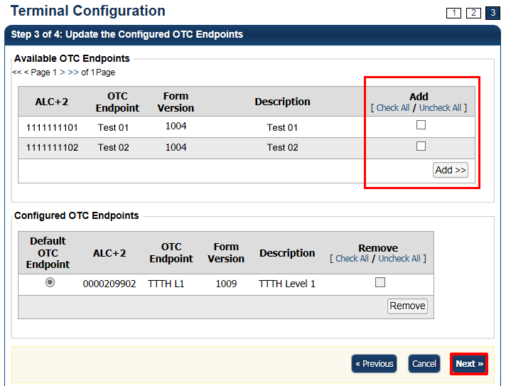

Application Tips



* The OTC Endpoints are permission based and are only visible to users with the appropriate permissions. At least one **Default OTC Endpoint** is required per terminal. While a default is chosen, it does not prevent you from scanning against another configured **OTC Endpoint**.
* Selecting a **Default OTC Endpoint** determines which OTC Endpoint to use when performing Check Scan actions.
* Multiple OTC Endpoints can be selected, but only one can be set as a **Default OTC Endpoint**.

1. Verify the Terminal Configuration is correct and click **Submit**. Click **Edit** to modify the information entered. A *Confirmation* page appears stating that the Terminal Configuration record has been updated.

Additional Buttons



* Click **Cancel** to return to the OTCnet Home Page. No data is saved.
* Click **Previous** to return to the previous page.
* Click **Return Home** to return to the OTCnet Home Page.

### View Terminal Configuration

The **CCA**, **CCS**, **Check Capture Lead Operator (CCLO)** and **Check Capture Operator (CCO)** are authorized to view check terminal configuration details for each terminal configured.

Terminal configuration details include the following:

* **OTC Endpoint Configuration:** OTC Endpoints and default OTC Endpoint
* **System Configuration:** LVD usage (offline users) and receipt printing
* **Application Configuration:** Terminal ID, host name, processing mode, cashflow method, batch control and batch control prompts
* **Devices Configuration:** Scanner type, communication channel, and franking

You can view terminal configuration from the *View Terminal Configuration* page.

View Terminal Configuration

To view terminal configuration, complete the following steps:

1. From the **Administration** tab, click **Manage Check Processing**>**Terminal Configuration**> **View**.
2. The *View* page appearsas shown in Figure 2 .

Figure 2. View Terminal Configuration Page

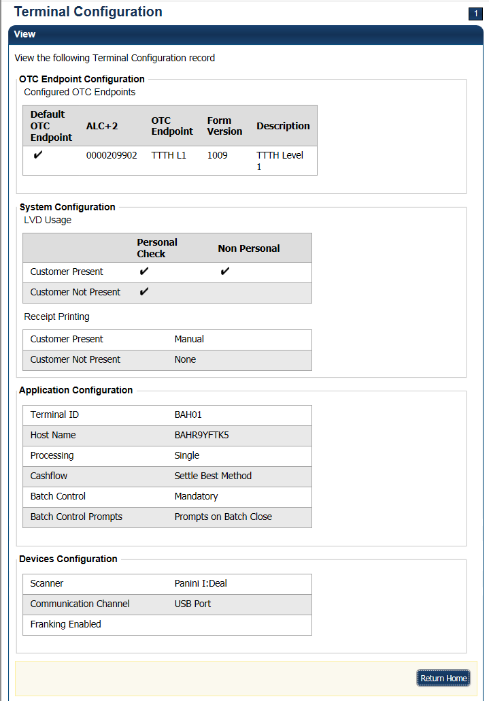

Additional Button



Click **Return Home** to go OTCnet Home.

## Topic 3 Search an Audit Log

The audit log records are interactions between the user and OTCnet. They allow users to search and view audit log entries for the completed audit trail within OTCnet. The audit log is available for download to a *Comma Separated Value* (CSV) report and opened in a spreadsheet program or available to print in a formatted audit log report.

If the audit log records contain Personally Identifiable Information (PII), the data is masked in the Transaction Description. To view more details about a specific batch, including PII, access **Batch Management**.

The **CCA**, **CCO**, **CCLO**, and **CCS** are authorized to search audit logs related to check processing activities. The **CA** and **Card Operator (CO)** are authorized to search audit logs related to card processing activities. Depending on your role, you can search for and view only specific audit logs. See Table 2 for more details.

Table 2. Audit Log User Permissions

| User Role | Audit Log Access |
| --- | --- |
| Check Capture Administrator (CCA) | Partial administration-related activities and all check capture-related activities |
| Check Capture Operator (CCO) | Own check capture-related activities |
| Check Capture Lead Operator (CCLO) | Own check capture-related activities |
| Check Capture Supervisor (CCS) | Partial check capture-related activities pertaining to own actions or actions taken by their CCO or CCLO |
| FS Viewer or Security Viewer | Administration-related, check capture-related, check processing-related, and deposit processing-related activities |
| Card Administrator  (CA) | Partial administration-related activities and all card-related activities |
| Card Operator  (CO) | Partial access to user’s own card-related activities |

You can search audit logs by module, user, **OTC Endpoint**, and other search criteria (created on date, batch ID, event type, etc.). If you run a search without specifying any criteria, by default the search results include all activities in the system that you have access to view. If you run additional searches, the *Search Results* table repopulates with the results of the new search.

### Search an Audit Log Online

To search an audit log, enter your search criteria—including module options (**Administration** **Check Capture** and **Check Processing), User, OTC Endpoint, From** and **To** dates, **Keyword (All** or make your selection from the list i.e., **Application Exception, Batch Management**, etc.)and **Category Name (All** or make your selection from the list i.e., **Accept Duplicate, Access**, etc.), **Terminal ID, Batch ID** and **Event Type (Error, Information** and **Warning) Operation Mode (All**, **Online**, or **Offline).**

Click your Audit Log ID hyperlink to view additional details for an individual audit log entry. Download and print your formatted audit log record, including the **Audit Log Record Summary**; **Audit Log ID**, **Created On**, **Context**, **User Email Address, OTC Endpoint**, **Terminal ID**, **Batch ID**, **Transaction Description**, **Module** and **Event Type**, **Audit Log Attribute Info**, **User Name** and **Audit Log Field Info**. You can also view your audit log details.

Search an Audit Log Online

To search an audit log, complete the following steps:

1. From the **Administration** tab, click **Audit**. The *Search Audit Logs* page appears.
2. Enter your search criteria.

Under **Search Criteria**, *optional*

* + - Select a **Module** type.
    - Enter a **User**
    - Select an **OTC Endpoint**
    - Enter the **From** and **To** date and time ranges, *required*
    - Select a **Keyword**, *required*
    - Select a **Category Name**, *required*
    - Enter the **Terminal ID**
    - Enter the **Batch ID**
    - Select an **Event Type**
    - Select an **Operation Mode**

Application Tips



* **Module** drop-down options vary by user role. **Module** options include **Administration**, **Check Capture**, **Check Processing**, and **Deposit Processing**.
* Card Processing **Module** options include **Administration** and **Card Processing**.
* The **From** and **To** **Created** **On** **Date** must be entered in MM/DD/YYYY format and cannot exceed 30 days.
* The **Keyword** and **Category** **Name** drop-down options vary by user role.
* **Operation Mode** options include **All**, **Online**, or **Offline**.

Application Tip



**Event Types** are categories of events that are recorded by the audit log.

Table 3. Event Types

| Event Type | Description |
| --- | --- |
| All | Includes all event types in the audit log |
| Error | Error entries are created when the system is unable to complete an action. |
| Informational | Information entries are general records of the activity that has happened while using OTCnet. |
| Warning | Warning entries are created to inform the user when events of note have taken place. This includes cancelling an action, deleting information from the system and inactive users. |

1. Click **Search**. The *Search Results* table appears as shown in Figure 3.

Figure 3. Audit Log Output

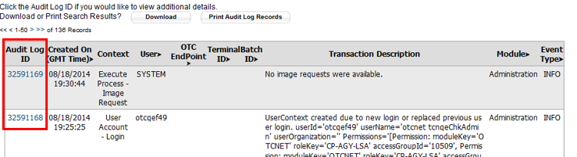

Application Tips



* Run a search without specifying any criteria, the search results include all activities in the system that you have access to view. Run additional searches, the *Search Results* table repopulates with the results of the new search.
* Click **Download** to download the search results.

1. Click the **Audit Log ID** hyperlink to view additional details for an individual audit log entry. The *View Audit Log Details* page appears.

Application Tips



* Click **Print Audit Log Records** to print a formatted audit log record.
* If the audit log records contain Personally Identifiable Information (PII) the data is masked.

Additional Buttons



* Click **Previous** to return to the previous page.
* Click **Return Home** to the OTCnet Home Page.

## Topic 4 Download and Install Firmware

### Download Firmware

If you are assigned the role of **CCA**, you are authorized to manually download check capture application firmware. The firmware “release” allows for the initial download or upgrades to the scanner software that enables a scanner to be used on a terminal. The firmware version you install also contains a series of other back-end installation files that must be used on a terminal to enable it to be used for Check Capture in OTCnet.

Prior to each firmware upgrade, the currently installed firmware must be uninstalled first.

Additionally, firmware upgrades are operating system (Windows 11 or Windows 10) and scanner (e.g., RDM EC7000i, EC9100i, EC9600i, EC9700i, Panini I;Deal, Panini MyVision, or Panini Vision X) specific. Note: Firmware versions 4.3.0 and 4.4.0 are only compatible with OLB versions 2.3.0 and above. Firmware version 4.4.0 or higher is required for the RDM EC9600i and EC9700i scanner models.

Therefore, downloading and executing the correct firmware upgrades ensures that a terminal and scanner are functioning properly. To determine firmware upgrades by firmware version, scanner, and operating system, refer to the *OTCnet System Requirements and Reference Guide* at: <https://fiscal.treasury.gov/files/otcnet/otcnet-sys-req.pdf>.

If an agency (OTC Endpoint) has multiple terminals and requires more than one firmware due to varying workstation requirements, download and execute the firmware for each terminal.

For offline users, this topic allows a user to download a “client” version of the OTCnet application to install on their terminals. Once the upgrade is downloaded to the terminal, an authorized user with terminal administrator rights must log in to the terminal and execute the upgrade. If there is more than one terminal per **OTC Endpoint**, the **CCA** must download and execute the firmware (release) for each terminal.

You must download firmware using **Download Release**, selecting **Firmware** and saving the file to your chosen location.

Download Firmware

To download firmware, complete the following steps:

1. From the **Administration** tab, click **Manage Centralized Deployment** >**Download Release**.
2. From the **Application** drop-down menu, select **Firmware**.
3. Click **Next**. The *Select Firmware for Download* page appears.

Application Tips



* Prior to each firmware upgrade, the currently installed firmware version must be uninstalled first.
* Firmware upgrades are operating system (e.g., Windows 11 or Windows 10) and scanner (e.g., EC7000i, EC9100i, EC9600i, EC9700i, Panini MyVision X) specific.
* Each firmware version has a corresponding terminal configuration(s) that it supports (by scanner and by operating system). Determine the appropriate firmware upgrade by firmware version, scanner, and operating system before downloading.

1. Click the **Firmware** hyperlink to download the firmware. The *Review Firmware Download* page appears.
2. Click **Download** as shown inFigure 4. The *Save Program* dialog box appears.

Figure 4. Review Firmware Download

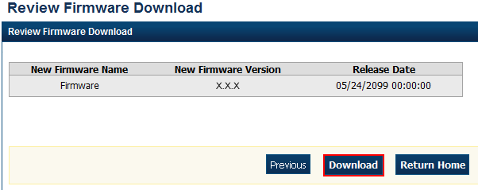

1. Click **Save** or **Cancel**.

Application Tips



* Click **Save** to choose the location where you want to save the file.
* Click **Cancel** to the *OTCnet Check Capture Application Download* page without saving the file.

Additional Buttons



* Click **Previous** to return to the previous page.
* Click **Return Home** to the OTCnet Home

### Install Firmware

After the **CCA** downloads the firmware, the next step is to install the firmware (must be done for each terminal). This can be completed by the **CCA**, **CCS**, **CCLO**, and **CCO**. However, before you install the firmware consider the following information:

* You must have Windows Administrator privileges to install the firmware.
* If using OTCnet Offline, close any open batches and upload all existing batches in Batch Management, as well as stop the Offline application.
* Ensure the scanner is not connected to the terminal as it may cause scanner connectivity issues.
* If a previous version of firmware is installed, uninstall it before installing the new firmware version. See the *Install OTCnet Firmware* printable job aid for specific directions.
* Firmware version 4.3.0 supports the RDM EC7000i, RDM EC9100i, Panini MyVisionX, Panini Vision X, and Panini I: Deal scanners. Firmware version 4.4.0 supports the RDM EC9600i and RDM EC9700i scanners.

For Windows 11 and Windows 10:

1. Access your Control Panel under **Start** > **Window Systems** > **Control** **Panel**
2. Click **Programs** > **Uninstall Programs**
3. In the Currently installed programs box, click **OTCnetFirmware**
4. Click **Remove**
5. Click Yes and wait while the Firmware uninstalls

Verify the **OTCnetFirmware** and **Panini** X.X.X **Universal** **Installer** automatically uninstalled.

For more information about the firmware version that matches the terminal settings, refer to the *OTCnet System Requirements and Reference Guide* at:  
<https://fiscal.treasury.gov/files/otcnet/otcnet-sys-req.pdf>.

To install firmware, install the firmware file (MSI file).

Install Firmware

To install OTCnet firmware, complete the following steps:

1. Locate the folder where the firmware file (MSI file) resides and double-click the file to start the installation. The *Welcome to the OTCnet Firmware Installation Wizard* dialog box appears.
2. Click **Next**. The *User Information* dialog box appears.
3. Click **Next**. The *Destination Folder* dialog box appears as shown in Figure 5.

Figure 5. Destination Folder Dialog Box

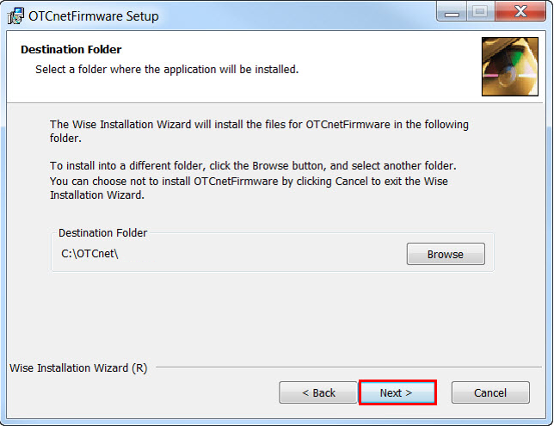

Application Tip



To install the firmware to another folder destination, click **Browse** to select a different folder. Click **Cancel** to exit the setup.

1. Click **Next**. The *Ready to Install the Application* dialog box appears.
2. Click **Next**. Wait a moment while the files install.

Application Tip



During the installation process for OTCnet Firmware, you can continue to use their workstations. However, OTCnet and all related activities are unavailable until the installation of the Firmware is complete.

The installation time can vary from workstation to workstation. Users can expect a duration of up to 30 minutes to complete full installation. Do not close the installation window until the installation is complete.

1. The *OTCnet Firmware has been successfully installed* message appears. Click **Finish**.

## Summary

This chapter provided information on:

* The purpose of configuring check processing settings
* How to set up or modify a terminal configuration
* How to view a terminal configuration
* How to search an audit log
* How to download and install firmware