

# Chapter 8. Configuring Card Terminal Processing Settings

OTCnet Participant User Guide

Table of Contents

Overview, Topics, and Audience 1

Overview 1

Topics 1

Audience 1

Topic 1 Purpose of Configuring Card Processing Settings 2

Topic 2 Set Up or Modify a Card Terminal Configuration 3

Register a Card Terminal 3

Register a Card Terminal 4

Unregister a Card Terminal 9

Unregister a Card Terminal 10

View Card Terminal Configuration 13

View Card Terminal Configuration 14

Topic 3 Search an Audit Log 15

Search an Audit Log 16

Topic 4 Select 80mm Card Receipt Printer 19

Select 80mm Card Receipt Printer 20

Summary 22

List of Figures

Figure 1: Step 1 of 3 Select OTC Endpoint and Card Terminal Type Page 4

Figure 2: Terminal Registration, Enter Card Terminal IP Address 5

Figure 3: Step 2 of 3: Card Terminal Registration and Entering the Pairing Pin in the Card Terminal 6

Figure 4. Step 2 of 3: Terminal Registration, Comparing Merchant IDs message 6

Figure 5. Step 3 of 3: Review the Card Terminal Configuration 7

Figure 6: Card Terminal Registration, Enter IP Address 10

Figure 7: Step 2 of 3: Terminal Registration 11

Figure 8: Step 3 of 3: Review the Terminal Configuration 12

Figure 9: Card Terminal Configuration View 14

Figure 10: Audit Log Input 18

Figure 11. Start OTCnet Local Bridge Startup 20

Figure 12: Confirm the 80mm Printer 20

List of Tables

Table 1: Audit Log User Permissions 15

Table 2: Event Types 17

Glossary

Select this [link](https://www.fiscal.treasury.gov/otcnet/training/wbt/content/course_OTC/glossary.htm) to access the full OTCnet Glossary.

## Overview, Topics, and Audience

### Overview

Welcome to *Configuring Card Processing Settings*. In this chapter, you will learn:

* The purpose of configuring card processing settings
* How to set up or modify a card terminal configuration
* How to view a card terminal configuration
* How to search an audit log
* How to select an 80mm Card Receipt Printer

### Topics

This chapter is organized by the following topics:

1. Purpose of Configuring Card Processing Settings
2. Set Up or Modify a Card Terminal Configuration
3. Search an Audit Log
4. Select the 80mm Card Receipt Printer

### Audience

The intended audience for the *Configuring Card Processing Settings* Participant User Guide includes:

*View / Modify Configuration Functions*

* Card Administrator
* Check Capture Administrator
* Check Capture Supervisor

*View Configuration Only*

* Card Operator
* Check Capture Lead Operator
* Check Capture Operator

## Topic 1 Purpose of Configuring Card Processing Settings

As a **Card Administrator** **(CA),** you are authorized to configure the card processing settings for your Agency’s card terminal. Additionally, as a **CA**, are authorized to manually download or upgrade application software (e.g., the OTCnet Local Bridge Application [OLB]) which is used to communicate between OTCnet and a card terminal. You must register your card terminal.

For check processing, a **Check Capture Administrator (CCA)** can also download or upgrade the OLB.

To meet your agency’s card transaction needs, each card terminal must have configuration settings individually applied. The card terminal must be paired with OTCnet **before** the card terminal can be used for processing payments in OTCnet Online. The following is a list of data elements needed to pair the card terminal to OTCnet:

* **Card Terminal Internet Protocol (IP) address**—Internet Protocol Address is a unique number or address that computing devices, (e.g., computers, laptops, tablets, etc.) connected to a computer network, use to identify themselves and communicate with other devices in an IP-based network (e.g., the Internet).
* **OTC Endpoint Credit-Debit-Card (CDC)—**The endpoint (location) setup in OTCnet for CDC processing
* **OTCnet Generated Eight-Character Pairing Pin**—A pairing pin is a unique eight-character OTCnet-generated number used to pair OTCnet and the card terminal. During card terminal setup, the card terminal prompts the user for the pairing pin.

## Topic 2 Set Up or Modify a Card Terminal Configuration

As a **Card Administrator (CA)** you are authorized to register/configure a card terminal. To register a card terminal, you must select your OTC Endpoint and enter your Card Terminal Internet Protocol (IP) Address. You can also unregister a card terminal. For this you must begin the steps to re-register a card terminal. And you are authorized to view a card terminal. To configure a card terminal, start the OLB. If the OLB is not started, you cannot pair the card terminal with OTCnet.

Once the OLB is started, ensure the following:

* The card terminal must be ethernet connected to the Internet/network and ready for pairing with the OTCnet server
* The **CA** or must use either a Static (Fixed Internet Protocol Address [IP]) or Dynamic Host Configuration Protocol (DHCP) when configuring the card terminal. A static IP Address is recommended as it will not change.

### Register a Card Terminal

To register a card terminal, modify your Card Terminal Configuration, by selecting your OTC Endpoint and entering your Card Terminal IP Address. The system searches for and displays a pairing pin, which you will enter into the card terminal. The system compares Merchant IDs and communicates when the connection is successful.

Register a Card Terminal

To register/configure a card terminal, complete the following steps:

1. From the **Administration** tab, select **Manage Card Processing**>**Card Terminal Configuration**>**Modify**. The *Step 1 of 3: Select OTC Endpoint* *and Card Terminal Type* page appears.

Application Tip



When configuring a card terminal and have not started the OLB application, you receive the following message: “*Card terminal detection failed. Ensure that the OLB application is running.*”

1. Select the OTC Endpoint. Select **Add**. The Endpoint appears under **Configured OTC Endpoint**.
2. Select the **Card Terminal Type** from the dropdown at the bottom of the page. Then select **Next** as shown in Figure 1.

Figure 1: Step 1 of 3 Select OTC Endpoint and Card Terminal Type Page

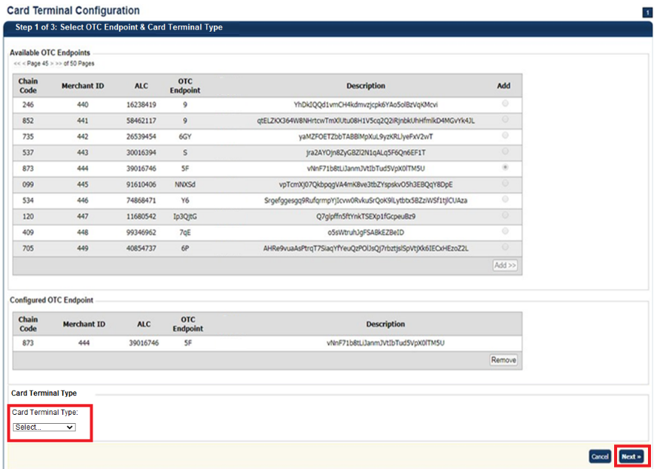

Application Tips



* You need to **upgrade the OLB** to a new version to avoid receiving an error when registering your device to OTCnet and using your **M440** card terminal.
* If you are an existing **MX925** user, you will also need to upgrade to the latest OLB to keep using the existing card terminals.

1. The *Step 2 of 3:* *Terminal Registration* page appears, as shown in Figure 2. Enter the **Card Terminal Internet Protocol (IP) Address** and select **Register**.

Figure 2: Terminal Registration, Enter Card Terminal IP Address

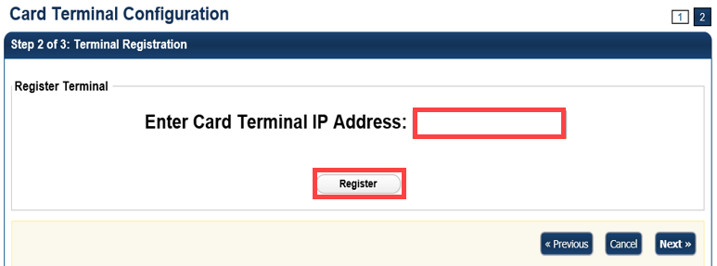

Application Tip



**Internet Protocol (IP) Address** is a unique number or address that computing devices (e.g., laptops, tablets, mobile phones, etc.) connected to a computer network, use to identify themselves and communicate with other devices in an IP-based network (e.g., the Internet). Please contact your deployment specialist to help you retrieve your IP address at: [fiscalservice.otcdeployment@citi.com](mailto:fiscalservice.otcdeployment@citi.com).

1. The system searches for the pairing pin. A pairing pin displays.
2. Enter the **Pairing Pin** on the card terminal, as shown in Figure 3. Press the **green button**. The green button indicates “**OK**” on the card terminal. The system compares Merchant IDs.

Figure 3: Step 2 of 3: Card Terminal Registration and Entering the Pairing Pin in the Card Terminal

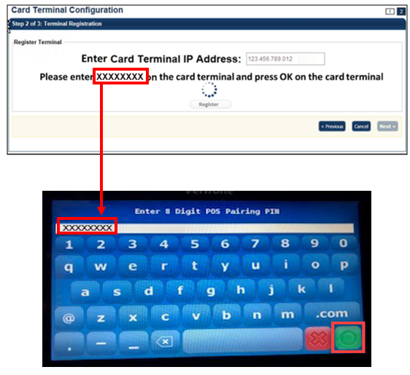

Application Tips



* A pairing pin is a unique eight-character OTCnet-generated number used to pair OTCnet and the card terminal.
* It may take 15-20 seconds to receive a pairing pin.
* The pairing pin number is entered on the card terminal.

1. The system compares **Merchant IDs** as shown in Figure 4.

Figure 4. Step 2 of 3: Terminal Registration, Comparing Merchant IDs message

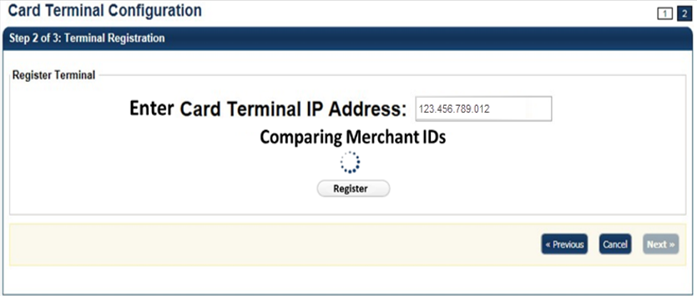

Application Tips



* A **Merchant ID** is a unique designator assigned by Worldpay to reflect the processing location.
* Each agency has several Merchant IDs under a single **Chain Code**, to distinguish which agency location processed card transactions.
* The **Merchant ID** is entered at the lower-level endpoint in OTCnet.

1. The “*Registration Successful!*” message appears. Select **Next**.
2. The “*Connection successful!*” message appears. Select **Next**.
3. *The Step 3 of 3: Review the Terminal Configuration* page appears. Select **Submit** as shown in Figure 5.

Figure 5. Step 3 of 3: Review the Card Terminal Configuration

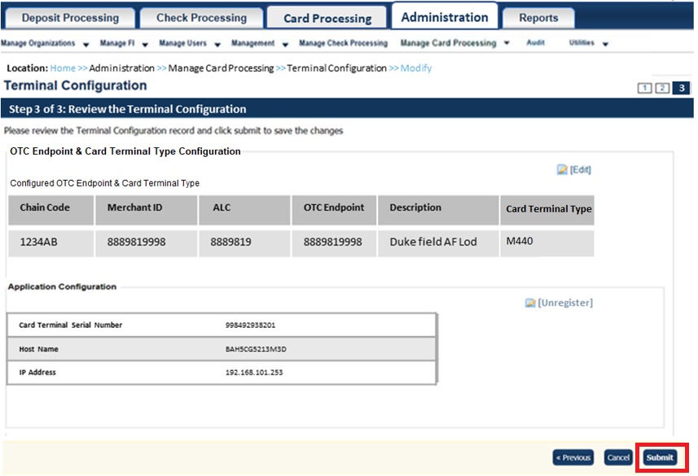

Application Tips



* Select the **Edit** hyperlink to modify the information entered.
* Select the **Unregister** hyperlink to unregister the terminal.

1. The *Confirmation* page appears. View the card terminal configurations, they are automatically populated.

Additional Button



Select **Return Home** to return to the OTCnet Home Page.

Application Tips



* When you try to refund a transaction on the **Card Transaction History Details** page with a different card terminal than the configured card terminal, the following error displays at the top of the screen: *“Registration was not found/valid, or the terminal is offline/busy.”*
* When you try to perform a card transaction on the **Process Payment** page with a different card terminal than the configured card terminal, the following error displays at the top of the screen: *“Registration was not found/valid, or the terminal is offline/busy.”*
* If you have a terminal model saved in **Card Terminal Configuration** but have a different physical card terminal connected when going through Step 2 of 3 Terminal Registration, the registration will fail with the following error displayed at the top of the screen: *“Card terminal Merchant ID does not match the Merchant ID of the configured endpoint or terminal type does not match the selected type. Please select Previous to restart Terminal Configuration.”*

### Unregister a Card Terminal

As a **CA** you are authorized to unregister a card terminal after it has been paired with OTCnet, as needed. At times, you may need to unregister a terminal (i.e., you may want to add a different card terminal to an OTCnet terminal, or you may mistakenly register a terminal and wish to unregister it). First, you must begin the steps to re-register a card terminal before you can unregister it.

To unregister a card terminal, after it’s been paired with OTCnet, there are two options:

**Option 1:** Unregister from the *Registration Successful!* page.

**Option 2:** Unregister from the Review (*Step 3 of 3: Review the Terminal   
Configuration*) page.

For Option 1, you will modify your Card Terminal Configuration by selecting an OTC Endpoint and entering the card terminal **IP Address** for the card terminal you wish to register. You will enter the pairing pin in the card terminal. Once the “*Registration Successful!*” message appears, you can unregister the card terminal.

For Option 2,you will modify your Card Terminal Configuration by selecting an OTC Endpoint and entering the card terminal **IP Address** for the card terminal you wish to register. You will enter the pairing pin in the card terminal. Once the “*Registration Successful!*” message appears, and the *Step 3 of 3: Review the Terminal Configuration* page appears, you can unregister the card terminal.

Unregister a Card Terminal

To unregister a card terminal after it’s been paired with OTCnet, there are two options:

* **Option 1:** Unregister from the *Registration Successful!* page.
* **Option 2:** Unregister from the Review (*Step 3 of 3: Review the Terminal   
  Configuration*) page.

For Option 1, complete the following steps:

1. From the **Administration** tab, select **Manage Card Processing**>**Card Terminal Configuration**>**Modify**. The *Step 1 of 3: Select OTC Endpoint* *and Card Terminal Type* page appears.
2. Select an OTC Endpoint. Select **Add**.
3. Select the **Card Terminal Type** and then select **Next**. The *Step 2 of 3: Terminal Registration* page appears.
4. Enter the card terminal **IP Address** in to the **Enter** **Card Terminal IP Address** text box for the card terminal you wish to register, as shown in Figure 6. Select **Register**.

Figure 6: Card Terminal Registration, Enter IP Address



1. OTCnet searches for the pairing pin. Once the pairing pin appears in OTCnet, enter it into the card terminal and press the **green button.** The green button indicates “**OK**” on the card terminal.

Application Tip



It may take 15-20 seconds to receive a pairing pin.

1. The “*Registration Successful!*” message appears. Select **Unregister**, as shown in Figure 7. Then select **Next**.

Figure 7: Step 2 of 3: Terminal Registration

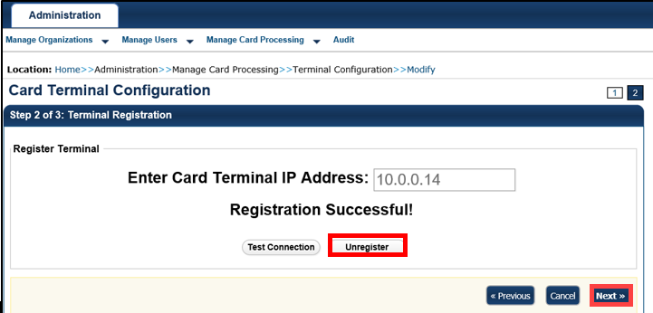

1. The “*Terminal unregistered*” message appears.

Additional Buttons



* Select **Test Connection** to test the pairing connection between the card terminal and OTCnet.
* Select **Unregister** to unregister the card terminal.
* Select **Cancel** to terminal registration. A "Registration cancelled" appears and the terminal registration stops.
* Select **Previous** to return to the previous page.
* Select **Return Home** to return to the OTCnet Home Page*.*

For Option 2, complete the following steps:

1. From the **Administration** tab, select **Manage Card Processing**>**Terminal Configuration**>**Modify**. The *Step 1 of 3: Select OTC Endpoint* *and Card Terminal Type* page appears.
2. Select an OTC Endpoint. Select **Add.**
3. Select **Card Terminal Type**.
4. Select **Next**. The *Step 2 of 3: Terminal Registration* page appears.
5. Enter the **Card Terminal IP Address** for the card terminal you wish to register. Select **Register**. OTCnet searches for the pairing pin.
6. Enter the pairing pin number, that appears in OTCnet, into the card terminal. Press the **green** **button.** The green button indicates “**OK**” on the card terminal.

Application Tip



It may take 15-20 seconds to receive a pairing pin.

1. The “*Registration Successful!”* message appears. Select **Next.**
2. The Step 3 of 3: *Review the Terminal Configuration* page appears, as shown in Figure 8**Error! Reference source not found.**. Select **Unregister**.

Figure 8: Step 3 of 3: Review the Terminal Configuration

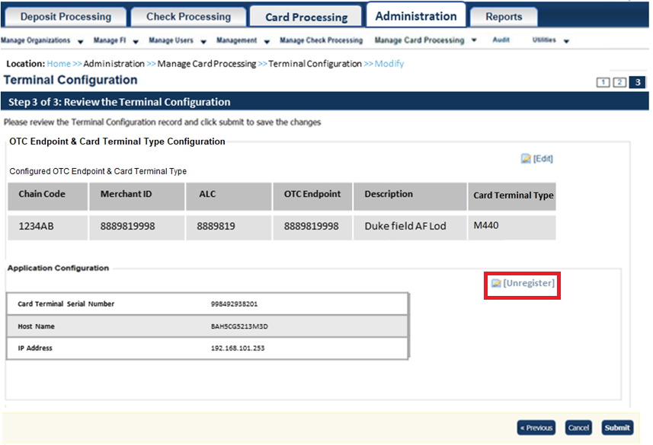

1. The “*Registration Successful!*” page appears. Select **Unregister**.
2. Select **Next**. The “*Terminal unregistered*” message appears.

Additional Buttons



* Select **Edit** to navigate to the *Step 1 of 3: Select OTC Endpoint* page *and Card Terminal Type* to remove an OTC endpoint or add another available OTC endpoint.
* Select **Unregister** to unregister the card terminal.
* Select **Cancel** to stop terminal registration. A "*Registration cancelled*" message  
  appears and the terminal registration ends.
* Select **Previous** to return to the previous page.
* Select **Return Home** to return to the OTCnet Home Page*.*

### View Card Terminal Configuration

As a **CA** and **CO** you are authorized to view a card terminal configuration.

From the *View Card Terminal Configuration* page,the following actions occur:

* OTCnet verifies your OLB connection and the card terminal configuration.
  + This typically takes about 10-15 seconds.
* The card terminal(s) that has been configured appears.

View Card Terminal Configuration

To view card terminal configuration, complete the following steps:

1. From the **Administration** tab, select **Manage Card Processing**>**Terminal Configuration**>**View**.
2. The *Card Terminal Configuration* *View* page appears, as shown in Figure 9.
3. Select **Return Home** to return to the home page.

Figure 9: Card Terminal Configuration View

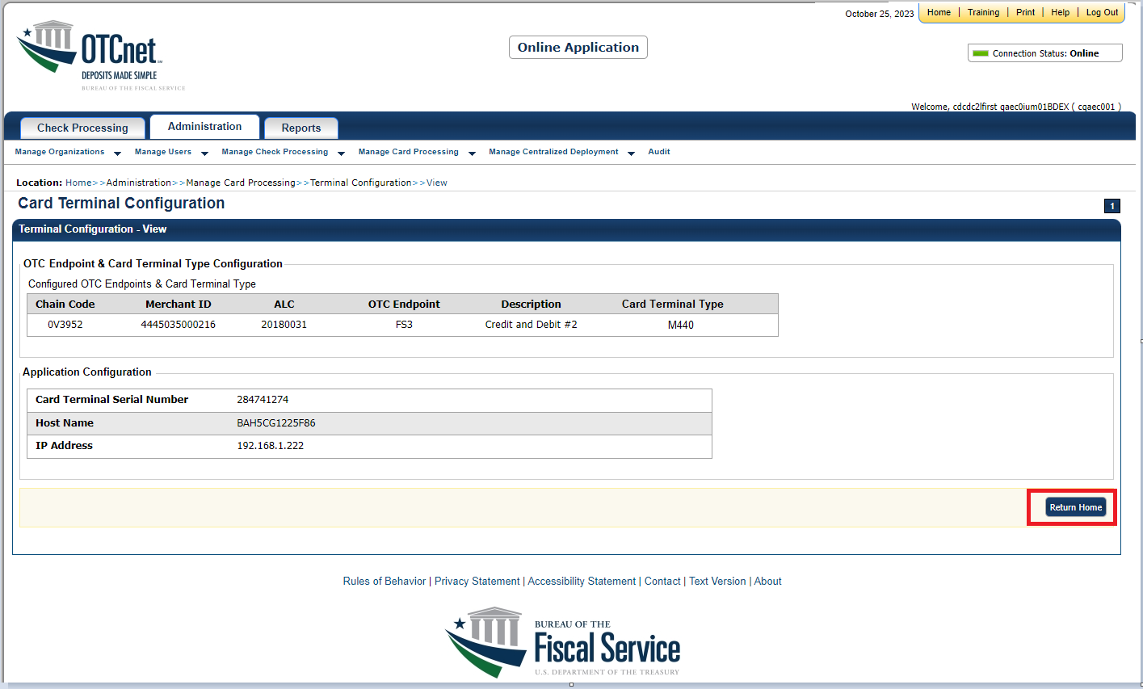

## Topic 3 Search an Audit Log

The audit log records are interactions between the user and OTCnet. They allow users to search and view audit log entries for the completed audit trail within OTCnet. The audit log is available for download to a *Comma Separated Value* (CSV) report. It opens in a spreadsheet program or can be printed in a formatted audit log report.

If the audit log records contain Personally Identifiable Information (PII), the data is masked in the Transaction Description.

The **CA** and **Card Operator (CO)** are authorized to search audit logs related to card processing activities. The **CCA, Check Card Operator (CCO)**, **Check Card Lead Operator (CCLO)** and **Check Card Supervisor (CCS)** can search audit logs related to check processing activities. Depending on your role, you can search for and view only specific audit logs. See Table 1 for details.

Table 1: Audit Log User Permissions

| User Role | Audit Log Access |
| --- | --- |
| Check Capture Administrator (CCA) | Partial administration-related activities and all check capture-related activities |
| Check Capture Operator (CCO) | Own check capture-related activities |
| Check Capture Lead Operator (CCLO) | Own check capture-related activities |
| Check Capture Supervisor (CCS) | Partial check capture-related activities pertaining to own actions or actions taken by their CCO or CCLO |
| FS Viewer or Security Viewer | Administration-related, check capture-related, check processing-related, and deposit processing-related activities |
| Card Administrator (CA) | Partial administration-related activities and all card-related activities |
| Card Operator (CO) | Partial access to user’s own card-related activities |

You can search audit logs by module, user, OTC Endpoint and other search criteria. When running a search without specifying any criteria, by default, the search results include all activities in the system that you have access to view. When running additional searches, the *Search Results* table repopulates with the results of the new search.

Search an Audit Log

To search an audit log, complete the following steps:

1. From the **Administration** tab, select **Audit**. The *Search Audit Logs* page appears.
2. Enter the search criteria for the activities you would like to view.

Under **Search Criteria**, *optional*

* + - Select a **Module** type.

Application Tips



* Card Processing **Module** options include **Administration** and **Card Processing**.
* Check processing **Module** options include **Administration**, **Check Capture**, **Check Processing**, and **Deposit Processing**.
* The **Module** drop-down options vary by user role.
  + - Enter a **User** *(login ID)*
    - Select an OTC Endpoint
    - Enter the **From** and **To** date and time ranges, *required*

Application Tip



The **From** and **To** **Create** **On** **Date** must be entered in MM/DD/YYYY format and cannot exceed 30 days.

* + - Select a **Keyword**, *required*
    - Select a **Category Name**, *required*

Application Tip



The **Keyword** and **Category** **Name** drop-down options vary by user role

* + - Enter the **Card Terminal ID***, for the workstation*
    - Enter the **Batch ID**

Application Tip



The **Batch ID** is specific to Check Processing.

* + - Select an **Event Type** (see Table 2).

Table 2: Event Types

| Event Type | Description |
| --- | --- |
| All | Includes all event types in the audit log |
| Error | Error entries are created when the system is unable to complete an action. |
| Informational | Informational entries are general records of the activity that has happened while using OTCnet. |
| Warning | Warning entries are created to inform the user when events of note have taken place. This includes cancelling an action, deleting information from the system and inactive users. |

* + - Select an Operation Mode

Application Tip



**Operation Mode** options include **All**, **Online**, or \***Offline**.   
**\*** **Offline** applies to OTCnet Check Capture Processing only.

1. Select **Search**. The *Search Results* table appears.

Application Tips



* When running a search without specifying any criteria, the search results   
  include all activities in the system that you have access to view.
* When running additional searches, the *Search Results* table repopulates with the results of the new search.

Application Tips



* Select **Download** to download the search results.
* Select **Print Audit Log** **Records** to print a formatted audit log record.

1. Select the **Audit Log ID** hyperlink to view additional details for an individual audit log entry, as shown in Figure 10. The *View Audit Log Details* page appears.

Figure 10: Audit Log Input

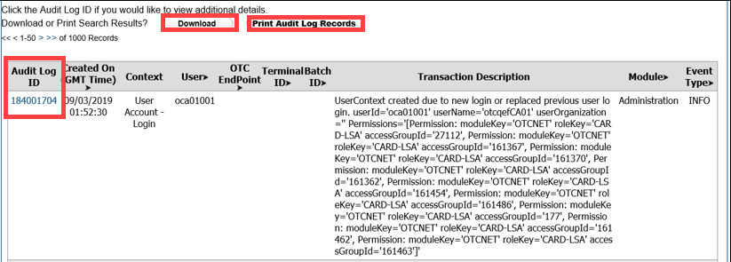

Application Tip



If the Audit Log records contain Personally Identifiable Information (PII) the data is masked.

## Topic 4 Select 80mm Card Receipt Printer

As a **Card Operator (CO**),you have the option to choose **Select 80mm Card Receipt Printer.** OTCnet offers the option to select an 80mm Card Receipt Printer for card processing receipts. Receipts are printed on 80mm (3.125 inch) paper.

Before selecting your 80mm printer, ensure that you verify the following:

* Your printer must be installed on your workstation or network. If you do not install the 80mm printer, card receipts are sent to your default Windows printer.
* The OLB is not started. If it is started, you receive a message that the OLB is running and you cannot access the OLB menu until you stop the OLB.
* You must have the latest OLB version to select the 80mm printer.

If your agency uses check processing and/or deposit processing, check or deposit items print to the Windows default printer, not the 80mm printer.

For the 80mm printer driver installation process, review the system requirements document (<https://www.fiscal.treasury.gov/files/otcnet/OTCnet-SysReq.pdf>) for additional information.

Select 80mm Card Receipt Printer

To select the 80mm Card Receipt Printer, complete the following steps:

1. Double-click the **Start OTCnet Local Bridge** icon located on the terminal’s desktop.

Or

Select **Start**>**Programs**>**Start OTCnet Local Bridge**.

1. The *OTCnet Local Bridge Startup* window appears. Select the **File** menu, and select **Select 80mm Card Receipt Printer**, as shown in Figure 11.

Figure 11. Start OTCnet Local Bridge Startup

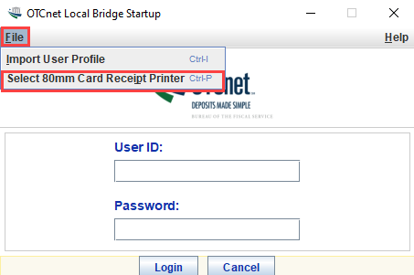

1. The *Select 80mm Card Receipt Printer* window appears. Select a printer and select **Confirm**, as shown in Figure 12.

Figure 12: Confirm the 80mm Printer

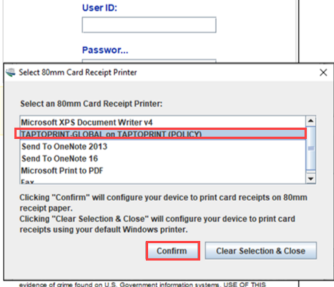

Application Tips



* To cancel your selection (**Select 80mm Card Receipt Printer**), select **Clear Selection & Close** to cancel and close the window.
* A “*The Windows default printer, ‘Microsoft Print to PDF,’ is used as your card receipt printer*” message appears.

1. The “*You have successfully chosen XXX Printer as your 80mm card receipt printer*” message appears. Select **OK** to return to the OLB Login page.

Application Tips



* In the event that your 80mm printer is no longer available (if your printer drivers are removed from the Window’s list of managed printers), the “*Your previously selected 80mm card receipt printer, ‘XXX Printer’, is no longer available. Card Receipt printing reverts back to using the Windows default printer. Please select an 80mm printer again to enable 80mm card receipt printing*” message appears on the OLB login page.
* Select **Ok**.

## Summary

In this chapter, you learned:

The purpose of configuring card processing settings

How to set up or modify a card terminal configuration

How to unregister a card terminal

How to view a card terminal configuration

How to search an audit log

How to select the 80mm Card Receipt Printer