

# Chapter 7. OTCnet Local Bridge (OLB) Setup Guide

OTCnet Participant User Guide

Table of Contents

Overview, Topics, and Audience 2

Overview 2

Topics 2

Audience 2

Topic 1 Download and Install OTCnet Local Bridge (OLB) Application 4

Download OTCnet Local Bridge (OLB) Application 4

Download OTCnet Local Bridge (OLB) Application 5

Install the OTCnet Local Bridge (OLB) Application 6

Install the OTCnet Local Bridge (OLB) Application 7

Upgrade OTCnet Local Bridge (OLB) Application 10

Upgrade OTCnet Local Bridge (OLB) Application 11

Topic 2 Create the OTCnet Local Bridge (OLB) Profile 14

Create the OTCnet Local Bridge (OLB) Profile 15

Topic 3 Import OTCnet Local Bridge (OLB) Credentials 18

Import OTCnet Local Bridge (OLB) Credentials 19

Summary 20

List of Figures

Figure 1. Download Release, OLB 5

Figure 2. OTCnet Local Bridge 7

Figure 3. Java message 8

Figure 4. Start and Stop OTCnet Local Bridge icons 9

Figure 5. Welcome to the OTCnet OLB Setup Dialog Box 11

Figure 6. Java message 13

Figure 7. Start and Stop OTCnet Local Bridge icons 13

Figure 8. Create Local Bridge and User Profile Radio Buttons and Password 15

Figure 9. Create Local Bridge and User Profile Save 16

Figure 10. Start OTCnet Local Bridge Startup 19

Glossary

Select this [link](https://www.fiscal.treasury.gov/otcnet/training/wbt/content/course_OTC/glossary.htm) to access the full OTCnet Glossary.

## Overview, Topics, and Audience

### Overview

Welcome to the *OTCnet Local Bridge (OLB) Setup Guide* In this chapter, you will learn:

* How to download and install the OTCnet Local Bridge (OLB) application
* How to create your OLB profile
* How to import your OLB credentials

### Topics

The topics in this chapter include the following:

1. Download and Install the OLB Application
2. Create the OLB Profile
3. Import the OLB Credentials

### Audience

The intended audience for the *OTCnet Local Bridge (OLB) Setup* Participant User Guide includes:

*Download OTCnet Local Bridge (OLB) Application*

* Check Capture Administrator
* Card Administrator

*Create the OTCnet OLB Profile*

* Check Capture Administrator
* Card Administrator
* Check Capture Supervisor
* Check Capture Lead Operator
* Check Capture Operator
* Card Operator

*Create OTCnet OLB Credentials*

* Check Capture Administrator
* Card Administrator
* Check Capture Supervisor
* Check Capture Lead Operator
* Check Capture Operator
* Card Operator

## Topic 1 Download and Install OTCnet Local Bridge (OLB) Application

### Download OTCnet Local Bridge (OLB) Application

The **Check Capture Administrator (CCA)** and **Card Administrator (CA)** are authorized to download the OTCnet Local Bridge (OLB). The OLB is a stand-alone application that must be installed on all user workstations performing card processing, check capture, check processing and terminal configuration operations.

Windows Administrator privileges are required to install the OLB application on a workstation. Users may contact the **CCA** or the Agency’s IT team to complete this step. The OLB must be installed before proceeding to the steps below. The download release process was streamlined for ease and efficiency—as a result, we recommend you download the newest version of   
the OLB.

OTCnet Firmware:

* For **check processing workstations**, the OLB application is installed before or after the OTCnet Firmware is installed.
  + Both the OLB application and Firmware must be installed on the workstation.
  + The OLB application is required if you are using the Deployable Disbursing System (DDS) Interface (DoD only).
* For **card processing workstations**, Firmware is not required.
* Depending on your user role, you may not have access to both **Manage Check Processing** and **Manage Card Processing** functions.

OTCnet supports Microsoft Edge and Google Chrome browsers.

When using Microsoft Edge and Google Chrome:

* Ensure the latest version of the OLB is installed.

After the **CCA** or **CA** downloads the OLB application, users (**CCA, Check Capture Supervisor [CCS]**, **Check Capture Lead Operator [CCLO]**, **Check Capture Operator [CCO], CA** and **Card Operator [CO]**) complete the following steps in setting up the OLB application:

* Install the OLB application
* Create the OLB profile
* Start the OLB application
* The OLB application is started on the workstation

Download OTCnet Local Bridge (OLB) Application

To download the OTCnet Local Bridge (OLB) application, complete the following steps:

1. From **Administration**, select **Manage Centralized Deployment**>**Download Release**.
2. The *Download Release* page appears. From the **Application** drop-down menu, select **OTCnet Local Bridge**. Select **Next** as shown inFigure 1.

Figure 1. Download Release, OLB

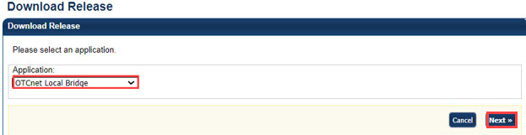

Application Tips



* By default, the **Application** drop-down menu is set to **Firmware**, select **OTCnet Local Bridge**.
* The OLB application can be installed before or after Firmware is installed.
* However, both the OLB application and Firmware must be installed for workstation configuration.

1. The *Select OTCnet Local Bridge for Download* page appears. Select the **OTCnet Local Bridge** hyperlink, for the newest version of the OLB, to download the OLB Zip file.
2. The *Review OTCnet Local Bridge Download* page appears. Select **Download**. The zip file downloads to your workstation.

Application Tip



* Before you install the new OLB version, you must uninstall any older OLB version(s).
* Select **Previous** to return to the previous page.
* Select **Return Home** to return to the OTCnet Home page.

### Install the OTCnet Local Bridge (OLB) Application

After the **CA** or **CCA** downloads the OLB application, the next step is for the **CA**, **CCA,** **CCS**, **CCLO**, **CCO, CA** and **CO** to install the OLB application. To install the OLB application, you must have Windows Administrator privileges on each workstation.

Multiple versions of the OLB are available for download. Depending on your agency, you may choose to install the newest version, or an older version—the newest version is recommended.

Version information includes the following:

* **OLB Installer**  
  For OLB version 2.5.0.0 and newer, the bundled Java Runtime Environment (JRE) was removed from the OLB installer. The OLB installer now verifies whether Java is installed on the workstation, and if the Java version is one that OTCnet supports. If Java is not installed on the workstation, Windows Administrator privileges are required to install Java.

For additional information, and to verify that you meet system and configuration requirements, review the system requirements document:  
<https://fiscal.treasury.gov/files/otcnet/otcnet-sys-req.pdf>

Before you install the OLB application, and prior to each upgrade, the currently installed OLB application version must be uninstalled.

**To uninstall a previous version of the OLB For Windows 10:**

* + If running, stop the OLB application
  + Access your Control Panel under **Star**t>**Windows Settings**>**Control Panel**
  + Double-click **Add** **or** **Remove Programs**
  + Select **OTCnet OLB** In the **Currently installed programs** box
  + Select **Remove**
  + Select **Yes** and wait while the OLB application uninstalls

Install the OTCnet Local Bridge (OLB) Application

To install the OLB application, complete the following steps:

1. Locate the folder on the workstation where the OLB zip file resides, e.g., your Downloads folder. Double click the zip file. Double-click the EXE file as shown in Figure 2 to start the installation.

Application Tip



The EXE must be launched and executed by a Windows Administrator.

Figure 2. OTCnet Local Bridge

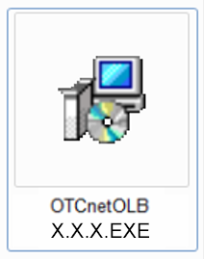

1. The Welcome to the OTCnet OLB Setup program dialog box appears. Select **Next**.

Application Tip



* Select **Cancel** to cancel and exit the setup.

1. The *Destination Location* dialog box appears. Select **Next**.

Application Tip



* It is recommended that you install the OLB application into the default destination folder (i.e., C:\Program Files\OTCnet_ olb).
* Select **Cancel** to cancel and exit the setup.
* Select **Back** to return to the previous dialog box.

1. The *Start Installation* dialog box appears. Select **Next**.
2. The *Server Port Settings* dialog box appears. Select **Next**. Wait a moment while the files install.

Application Tips



* It is recommended that you install the OLB application with the default list of fixed ports.
* If your agency has different server port settings or needs, contact Customer Support.

1. Once the *OTCnet Local Bridge* has been successfully installed message appears, select **Finish**.

Application Tips



* The OLB Installer verifies that Java is installed on the workstation.
* If Java is not installed, you will receive a “*Java X must be installed for the OLB to function. The JAVA_HOME environment variable must also be set pointing to the main Java installation folder*” message as shown in Figure 3. A Windows Administrator must install Java.

Figure 3. Java message

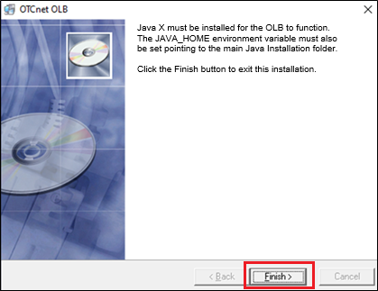

1. The OTCnet OLB start and stop icons appear on the workstation desktop as shown in Figure 4.

Figure 4. Start and Stop OTCnet Local Bridge icons

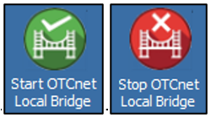

### Upgrade OTCnet Local Bridge (OLB) Application

The **CCA** and **CA** are authorized to upgrade the OLB.

As newer versions of the OTCnet OLB application become available, your Agency may choose to upgrade its workstations. *Upgrade* refers to installing an updated version of OTCnet OLB on a workstation that has a previous version of the OTCnet OLB installed.

Prior to initiating an OTCnet OLB application upgrade, consider the following information:

* Before uninstalling the OLB application, you must first stop the OLB application.
* If the OLB application is started on the workstation, ensure that it is stopped before uninstalling the application—or you cannot install the new OLB version.
* You must have Windows Administrator privileges to upgrade each computer.
* When upgrading to a newer OLB version, uninstall the previous OLB version and perform a new installation.
* If you previously created and imported your OLB credentials, you do not need to recreate and reimport your OLB credentials after upgrading to a newer OLB version.
* The OLB application is required for workstation detection and performing check capture and check processing operations.

Upgrade OTCnet Local Bridge (OLB) Application

To upgrade the OTCnet Local Bridge (OLB) Application, complete the following steps:

1. Stop the OTCnet OLB application. From the desktop, double-click **Stop OTCnet Local Bridge**.
2. Locate the folder where the OTCnet OLB application is installed and uninstall it.
3. After downloading the latest version of the OTCnet OLB application, locate the folder on the workstation where the OLB zip file resides e.g., your Downloads folder. Double click the zip file. Double click the .EXE file to start the installation.
4. The *Welcome to the OTCnet OLB Setup program* dialog box appears as shown in Figure 5. Select **Next**.

Figure 5. Welcome to the OTCnet OLB Setup Dialog Box

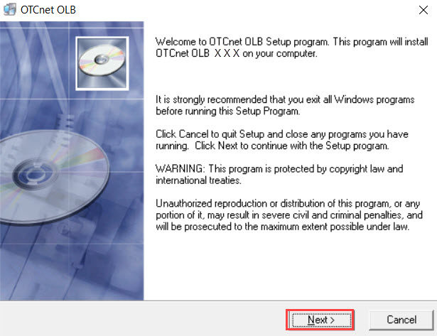

Application Tip



* Select **Cancel** to cancel and exit the setup.

1. The *Destination Location* dialog box appears. Select **Next**.

Application Tip



As a best practice, it is recommended that the OLB application is installed into the default destination folder (i.e., C:\Program Files\OTCnet_olb).

Additional Buttons



* Select **Cancel** to exit the setup.
* Select **Back** to return to the previous dialog box.

1. The *Start Installation* dialog box appears. Select **Next**.
2. The *Server Port Settings* dialog box appears. Select **Next**. Wait a moment while the files install.

Application Tip



* It is recommended that you install the OLB application with the default list of fixed ports.
* If your agency has different server port settings or needs, contact Customer Support.

1. Once the *OTCnet OLB has been successfully installed* message appears, select **Finish**.

Application Tip



* The OLB Installer verifies that Java is installed on the workstation.
* If Java is not installed, you will receive a “*Java X must be installed for the OLB to function. The JAVA_HOME environment variable must also be set pointing to the main Java installation folder*” message as shown in Figure 6. A Windows Administrator must install Java.
* To upgrade your OLB version, you do not need to recreate or import your OLB credentials.

Figure 6. Java message



1. The OTCnet OLB start and stop icons appear on the desktop of the workstation as shown in Figure 7.

Figure 7. Start and Stop OTCnet Local Bridge icons



## Topic 2 Create the OTCnet Local Bridge (OLB) Profile

After the **CCA** or **CA** downloads the OTCnet Local Bridge (OLB) application, the next step is to create the OLB profile.

If you are assigned the role of **CCA**, **CCS**, **CCLO**, **CCO**, **CA** or **CO**, you are authorized to create the OLB profile. The OLB profile is unique to each user role. Therefore, each of these user roles must create an OLB profile.

Before creating an OLB profile, consider the following information:

* Creating an OLB profile applies to all card processing and check processing users, including **CCA**, **CCS**, **CCLO**, **CCO, CA** and **CO**.
* The OLB application is required for the following:
  + Check capture workstation detection
  + The Deployable Disbursing System (DDS) Interface (DoD and Check Processing only)
  + Performing check processing and check capture operations and performing card processing operations and card workstation detection.

When creating a Local Bridge Password, keep the following Password Criteria in mind, the password must contain:

* At least 12 characters
* No more than two repeating characters

The password must not be:

* A word in a language, slang, dialect, or jargon
* Related to personal identity, history, environment, or other personal associations
* Shared or displayed in plain view

The password criteria are displayed on the page when you enter and confirm your Local Bridge password.

Create the OTCnet Local Bridge (OLB) Profile

To create an OLB profile, complete the following steps:

1. From **Administration**, select **Manage Users**>**Create Local Bridge and User Profile**.
2. Select the relevant radio button for your version of the OLB or for OTCnet Offline.

Application Tips



Before you create your new profile, and if you downloaded and installed the newest version of the OLB, you must import the new OLB credentials file, required.

1. Enter your **Local Bridge Password** and confirm your **Local Bridge Password** as shown in Figure 8. Select **Submit**.

Figure 8. Create Local Bridge and User Profile Radio Buttons and Password

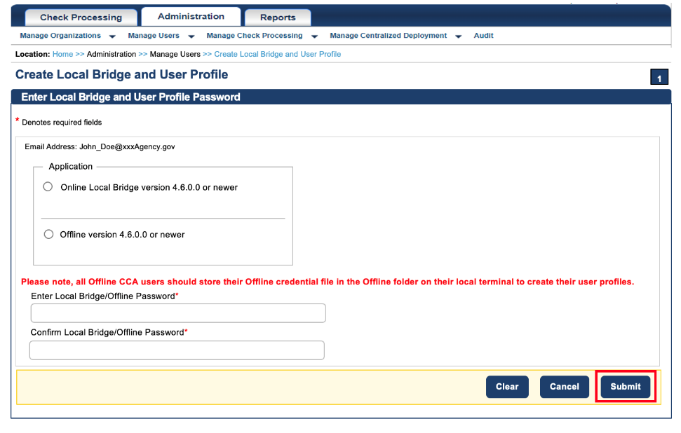

Application Tip



Select **Submit** and the system generates the credential file based on the application version selected.

Additional Buttons



* Select **Clear** to reset the password fields.
* Select **Cancel** to return to the OTCnet Home Page.

1. A *Do you want to open or save* ***[file name].ini****?* dialog box appears. Select the **Save** drop-down arrow and select **Save as**.

Application Tips



* When saving the OLB credential file, ***do not*** rename the file as the file name must remain the same as it was generated.
* If the file name is changed, the OLB application will not run.

Additional Buttons



* Select **Open** and the file opens in the Microsoft Notepad application.
* Select **Cancel** and the *Do you want to open or save* dialog box closes, you remain on the *Create Local Bridge and User Profile* page.

1. The *Save* dialog box appears. Select **Save** as shown in Figure 9 or **Cancel**.

Figure 9. Create Local Bridge and User Profile Save

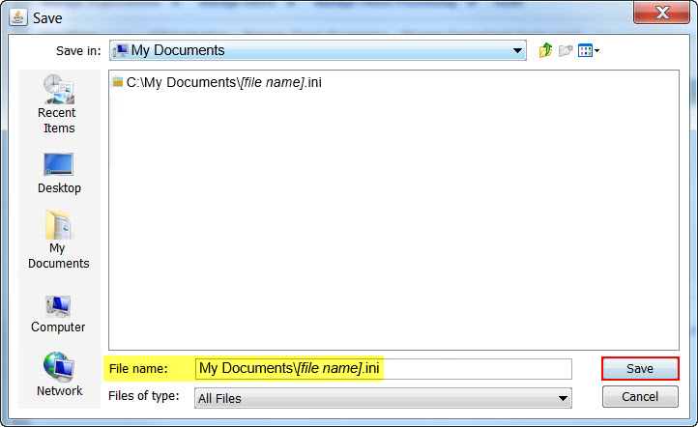

Application Tips



* Choose the location where you want to save the OLB credential file. Save the OLB credential file to any folder where you can save a file (e.g., My Documents folder, Desktop folder).
* The default location on the Save dialog box is the user’s **My Documents** folder.
* For a forgotten OLB password, or if you attempt to enter an incorrect password three times (or more), you must recreate an OLB credential file through the *Create Local Bridge and User Profile* page and save it again.
* You must also import your OLB credentials again, which is the next step in the OLB startup process.

**Additional Button**



Select **Cancel** to return to the *Create Local Bridge and User Profile* page without saving the file.

## Topic 3 Import OTCnet Local Bridge (OLB) Credentials

The OTCnet Local Bridge (OLB) application is required for OTCnet Online users performing workstation configuration, check processing, card processing and check capture operations. As a **CCA**, **CCS**, **CCLO**, **CCO**, **CA** or **CO** you are required to import your OLB credentials to the workstation.

Additional version information includes the following:

* If upgrading your OLB version, in general, you do not need to recreate or re-import your OLB credentials.
* If upgrading your OLB version from a version older than 2.2.0.0, you must recreate and re-import your OLB credentials.

The only time you need to recreate an OLB password is if you forget your OLB password. After recreating your OLB password, OTCnet users must reimport OLB credentials.

Importing OLB credentials is unique to each user. Therefore, if there are multiple users on a workstation, each user must import their OLB credentials.

Users are only required to import their OLB credentials ***once***. After importing OLB credentials, users can successfully start the OLB application.

Before importing your OLB credentials, ensure the following steps have been completed in this order:

1. The **CCA,** or **CA,** downloaded the OLB application.
2. The OLB application is installed on the workstation.

Each user has created an OLB profile, ensuring that the OLB credential file was ***not*** renamed (the file name remained the same as it was generated).

Import OTCnet Local Bridge (OLB) Credentials

To import OTCnet Local Bridge (OLB) credentials, complete the following steps:

1. Double-click the **Start OTCnet Local Bridge** icon located on the workstation desktop.

Or

Select **Start**>P**rograms**>**Start OTCnet Local Bridge**.

Application Tips



If the icon does not reside in either location, contact your **CCA** or **CA**. They can help with:

* Completing the steps required to install the OLB application on the workstation
* Creating your OLB profile
* Importing your OLB credentials

1. The *OTCnet* *Local Bridge Startup* window appears. Select the **File** menu.
2. Select **Import User Profile** as shown in Figure 10.

Figure 10. Start OTCnet Local Bridge Startup

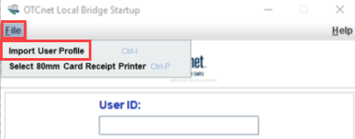

1. The *Select User Profile File* window appears. Navigate to the location on the workstation where the OLB credential file was saved. Select the file and select **Import**.

Application Tip



The default location on the *Select User Profile File* window is the user’s **My Documents** folder.

1. A *Successfully imported user profile* message appears. Select **OK**. Once you have successfully imported your OLB credentials, proceed with starting the OLB application on the workstation.

## Summary

In this chapter, you learned:

* How to download and install the OTCnet Local Bridge (OLB) Application
* How to create the OTCnet Local Bridge (OLB) Profile
* How to import the OTCnet Local Bridge (OLB) Credentials