

# Chapter 5. Configuring Administration and Card Processing Settings

OTCnet Participant User Guide

Table of Contents

Overview, Topics, and Audience 1

Overview 1

Topics 1

Audience 1

Topic 1 Managing Custom Labels 2

Define a Custom Label 3

Modify a Custom Label 5

View a Custom Label 6

Topic 2 Managing Processing Options 7

Modify Processing Options 7

Modify a Processing Option 9

View Processing Options 16

View Processing Options 17

Topic 3. Creating and Editing User Defined Fields (UDFs) 18

Create a User Defined Field 18

Create a User Defined Field 19

Modify a User Defined Field 22

Modify a User Defined Field 23

Delete a User Defined Field 25

Delete a User Defined Field 26

View a User Defined Field 28

View a User Defined Field 29

Summary 30

List of Figures

Figure 1. Step 1 of 2: Update Custom Labels 3

Figure 2. Step 2 of 2: Review Custom Labels 5

Figure 3. View Custom Labels 6

Figure 4. Step 2 of 3: Define Processing Options page with Accounting Classifications for Adjustments, Corrections and Returned Items expanded 10

Figure 5. Define Processing Options page with Correspondence expanded 12

Figure 6. Update Deposit Processing Options with Deposit Preparation expanded 14

Figure 7. Deposit Procession Options with Transaction History expanded 15

Figure 8. View Processing Options 17

Figure 9. Select 1 of 3: Select User Defined Field to Maintain 19

Figure 10. Review User Defined Fields page 21

Figure 11. Select User Defined Field to Maintain 23

Figure 12. Select 1 of 3: Select User Defined Field to Maintain 26

Figure 13. View User Defined Field 29

Glossary

Click this [link](https://www.fiscal.treasury.gov/otcnet/training/wbt/content/course_OTC/glossary.htm) to access the full OTCnet Glossary.

## Overview, Topics, and Audience

### Overview

Welcome to *Configuring Administration and Card Processing Settings*. In this chapter, you will learn:

* How to create, edit and delete custom labels
* How to set your options for processing and deposits
* How to create, edit and delete user defined fields (UDFs) specific to your agency

### Topics

The topics in this chapter include the following:

1. Managing Custom Labels
2. Managing Processing Options
3. Creating and Editing User Defined Fields (UDFs)

### Audience

The intended audience for the *Configuring Administration and Card Processing Settings* Participant User Guide includes:

* Accounting Specialist
* Local Accounting Specialist
* Card Administrator

## Topic 1 Managing Custom Labels

As an **Accounting Specialist**, you are authorized to define (create), modify and/or view a custom label. As part of your responsibility in managing your organization hierarchy, which includes entering the appropriate accounting codes, you can also customize the field labels in the deposit preparation page. These fields are called custom labels.

Customizing the labels for your organization’s **Deposit Preparers** and **Deposit Approvers** is relative when these roles are preparing and submitting deposits and/or reports. A custom label allows you to define: a level in the organization hierarchy, the internal control number, or an agency accounting code. Performing this customization is *optional*.

**Agency Accounting Code** is the default name for the label; when you define the label, you are actually modifying its name. When referring to a custom label, the terms *define* and *create* are used interchangeably.

As an example, if your agency refers to *Accounting Codes* as *Financial Numbers,* you can modify the custom label to be *Financial Number*.

Once a custom label is defined, you may modify it. You can also view your custom labels from **Manage Organizations**, **Custom Labels**.

Define a Custom Label

To define (create) a custom label, complete the following steps:

1. From the **Administration** tab, click **Manage Organizations**>**Custom Labels**>**Modify**. The *Select OTC Endpoint* page appears.
2. Select the highest-level OTC Endpoint for which you want to modify custom labels. The *Step 1 of 2: Update Custom Labels* page appears.
3. Update the custom label(s) for the organization hierarchy and click **Next**. The *Step 2 of 2: Review Custom Labels* page appears as shown in Figure 1.

Figure . Step 1 of 2: Update Custom Labels

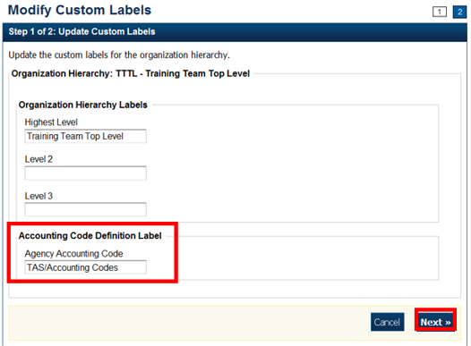

Update the labels by completing the following steps:

* + Enter a title for your **Organization Hierarchy Labels**.
  + Enter an agency accounting code title for the **Accounting Code Definition Label**.

Application Tips



The **Accounting Specialist** is authorized to complete the following steps:

* Define a new **Organization Hierarchy Label**
* Update the existing label(s)
* Modify the label of the accounting code definition

1. Verify the information is correct and click **Submit**. A *Confirmation* page appears presenting the custom labels modified for the organization hierarchy.

Additional Buttons



* Click **Cancel** to return to the OTCnet Home Page. No data is saved.
* Click **Edit** to make additional changes.
* Click **Previous** to return to the previous page.
* Click **Submit** to complete the process and display the Confirmation page.

Modify a Custom Label

To modify a custom field label, complete the following steps:

1. From the **Administration** tab, click **Manage Organizations**>**Custom Labels**>**Modify**. The *Select OTC Endpoint page* appears.
2. Select the organization endpoint for which you want to modify custom labels. *The Step 1 of 2: Update Custom Labels* appears.
3. Update the custom labels for the organization hierarchy and click **Next**. The *Step 2 of 2: Review Custom Labels* page appears as shown in Figure 2.

Figure . Step 2 of 2: Review Custom Labels

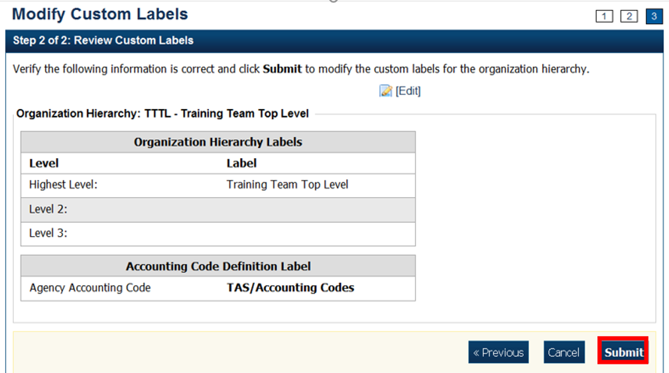

Application Tips



* If an Agency Accounting Code label is customized, it is displayed as the label above the imported or modified codes within the Maintain Accounting Codes module, according to the custom label that was defined for the highest-level organization.
* Within the rest of the application, custom labels apply to deposit processing functionalities, but are not extended to check processing functionalities.
* The default accounting code label is **Agency Accounting Code**.

1. Verify the information is correct and click **Submit**.

A *Confirmation* page appears presenting the custom labels modified for the organization hierarchy.

View a Custom Label

To view a custom label, complete the following steps:

1. From the **Administration** tab, click **Manage Organizations**>**Custom Labels**>**View**. The *Select OTC Endpoint* page appears.
2. Select the highest-level organization for which you would like to view the custom labels. The *View Custom Labels* page appears showing the custom labels that are in effect for the organization hierarchy as shown in Figure 3

Figure . View Custom Labels

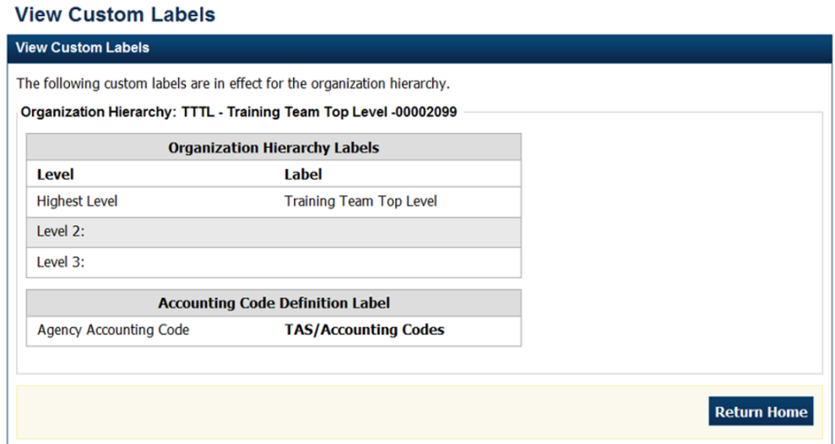.

Additional Buttons



* Click **Cancel** to return to the OTCnet Home Page. No data is saved.
* Click **Return Home** to return to the OTCnet Home Page.

## Topic 2 Managing Processing Options

Managing your organization hierarchy includes defining your deposit processing options. **Processing options** are parameters for the deposit and adjustments process. For processing options, you must define the following:

* First, define processing options at the highest level of the organization, before defining lower-level options.
* For lower-level organizations, you must define these options, or the lower-level organizations will take on the options set for the next higher-level organization that does have the options set.

You must define processing options or your organization cannot create deposits. Define processing options at any level within your organization. View the processing options by **OTC Endpoint** report to manage processing options in your organization.

As an **Accounting Specialist**, you are authorized to modify the following processing options for your organization’s hierarchy:

* **Accounting Classifications for Adjustments**: Identifies the default accounting codes to which you want adjusted amounts credited and debited
* **Correspondence**: Provides the financial institution with address information for any correspondence, including returned item information
* **Deposit Preparation**: Sets default settings for deposit preparation to save time for Deposit Preparers
* **Transaction History**: Sets default settings for historical data about transactions

### Modify Processing Options

**Accounting Specialists** are authorized to modify processing options for the following:

* **Accounting Classifications for Adjustments, Corrections, and Returned Items**
* **Correspondence**
* **Deposit Preparation**
* **Transaction History**

When defining processing options, keep the following information in mind:

* To narrow an accounting code search, enter a partial or full accounting code.
* All accounting codes that meet your search criteria and that are not applied as a debit or credit adjustment to your OTC Endpoint are displayed on the page. You must enter search criteria, or all the accounting codes defined for the highest-level organization appear.
* By default, the first ten accounting codes display, in the following order, by:
  + Ascending special character order
  + Numerical order
  + Ascending alphabetical order by accounting code
* If an organization has more than ten accounting codes, click the pagination menu above the section containing the existing accounting codes to view additional page results. The system only allows a user to view and apply active accounting codes not designated as Treasury Account Symbol (TAS) or those designated as TAS and that have been validated by Share accounting Module (SAM).
* After an accounting code is assigned to debit or credit adjustment, it appears in the Adjustment Type table.

Modify a Processing Option

To modify a processing option, complete the following steps:

1. From **Administration**, click **Manage Organizations**>**Processing** **Options**>**Modify**. The *Step 1 of 3: Select Organization Endpoint* page appears.

Application Tips



* Processing options must first be defined for the highest-level organization before any lower-level organization’s processing options can be defined.
* If the processing options are not defined for the highest-level organization, all lower-level organization links are disabled.

1. Select the OTC Endpoint for which you want to modify a processing option. The *Step 2 of 3: Define Processing Options* page appears.
2. Modify the processing option(s) and click **Next**.

To modify **Accounting Classifications for Adjustments**, **Corrections**, and **Returned Items** as shown in Figure 4, complete the following steps:

Update **Default Accounting Codes** by

* + - Selecting either **Use parent’s values** or **Use my values**

Or

* + - Clicking **Search** (magnifying glass) to view accounting codes

Application Tip



* If selecting **Use my values**, enter the search criteria for the accounting code you would like to view and click **Search** (magnifying glass)
* To narrow an accounting code search, enter a partial or full accounting code
  + - Selecting the accounting code to apply a credit and/or debit adjustment type and click Assign to Debit and/or Assign to Credit
    - Selecting Yes or No to allow changes by an organization lower in hierarchy

Application Tip



* An accounting code can be assigned to both a debit adjustment and credit adjustment
* After an accounting code is assigned to debit or credit adjustment it appears in the Adjustment Type table

Figure 4. Step 2 of 3: Define Processing Options page with Accounting Classifications for Adjustments, Corrections and Returned Items expanded

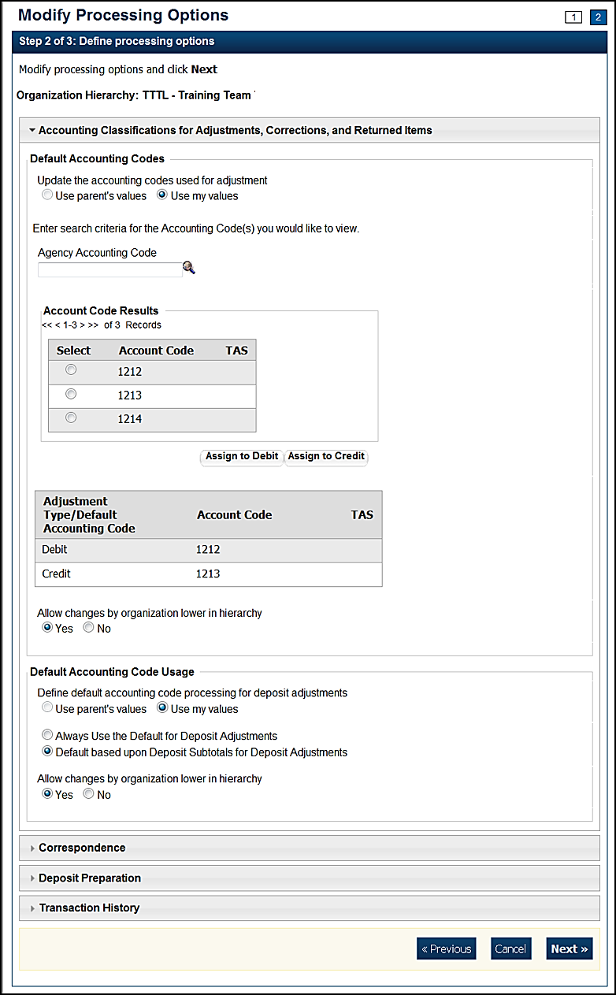

Update **Default Accounting Code Usage** by completing the following steps:

* Selecting either **Use parent’s values** or **Use my values**
* Selecting either **Always Use the Default for Deposit Adjustments** or **Default based upon Deposit Subtotals for Deposit Adjustments**
* Selecting **Yes** or **No** to allow changes by an organization lower in hierarchy

To modify **Correspondence**, complete the following steps as shown in Figure 5:

Update **Returned Items** by completing the following steps:

* Selecting **Use parent’s values** or **Use my values**
* Entering the corresponding address information that you would like to be displayed to a financial institution when return item adjustment is created
* Selecting **Yes** or **No** to allow changes by an organization lower in hierarchy

Update **Deposit Adjustment** by completing the following steps:

* Selecting Use parent’s values or Use my values
* Entering the corresponding address information that you would like to be displayed to a financial institution when a deposit adjustment is created
* Selecting Yes or No to allow changes by an organization lower in hierarchy

Figure . Define Processing Options page with Correspondence expanded

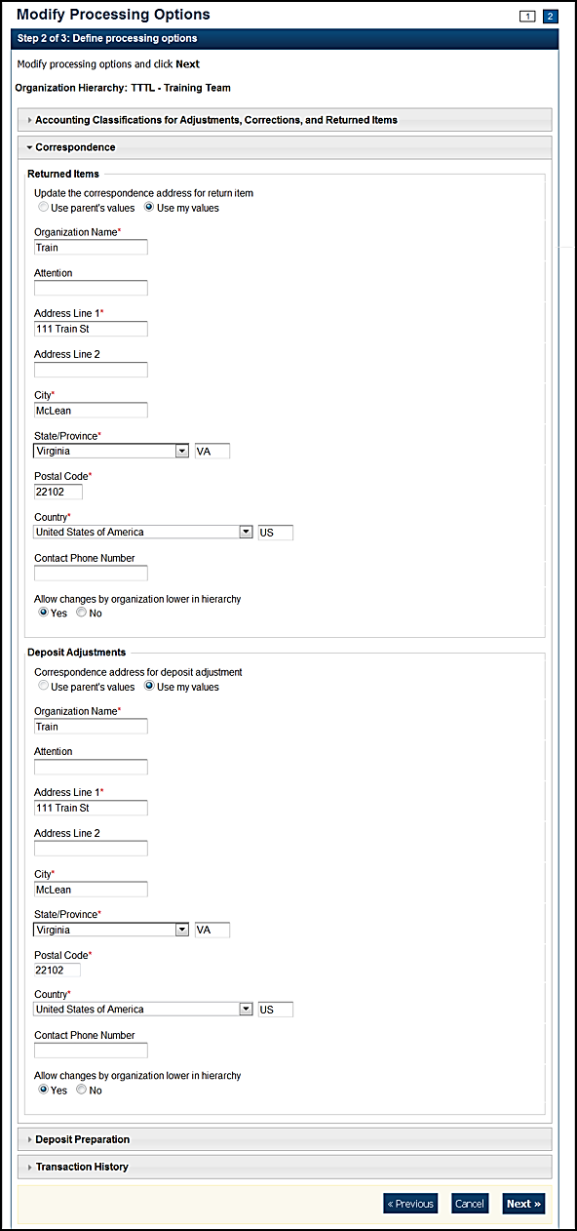

To modify **Deposit Preparation**, complete the following:

Update **ITGA Deposit Creation** by completing the following steps:

* Selecting **Use parent’s values** or **Use my values**
* Selecting **Yes** or **No** to allow endpoint to create foreign deposits
  + - If the endpoint accepts foreign deposits, enter the **Default foreign currency** **when creating deposits** details
* Selecting **Yes** or **No** to allow changes by an organization lower in hierarchy

Update **Subtotals and Cash Count** by completing the following steps:

* Selecting **Use parent’s values** or **Use my values**
* Selecting **Yes** or **No** for each of the following options
  + - Include Sub-totals for Checks/Money Orders and Cash
    - Include Currency count and sub-totals by denomination
    - Include Coin count and sub-totals by denomination
    - Allow changes by an organization lower in hierarchy

Update **Accounting Code Subtotals** by completing the following steps:

* Selecting **Use parent’s values** or **Use my values**
* Selecting **Yes** or **No** for each of the following options
  + - Allow negative accounting code subtotals
    - Allow changes by an organization lower in hierarchy

Update **Separation of Duties** by completing the following steps as shown in Figure 6:

* Selecting **Use parent’s values** or **Use my values**
* Selecting **Yes** or **No** for each of the following options
  + - Deposits must be prepared and approved by different employees
    - Allow changes by an organization lower in hierarchy

Figure . Update Deposit Processing Options with Deposit Preparation expanded

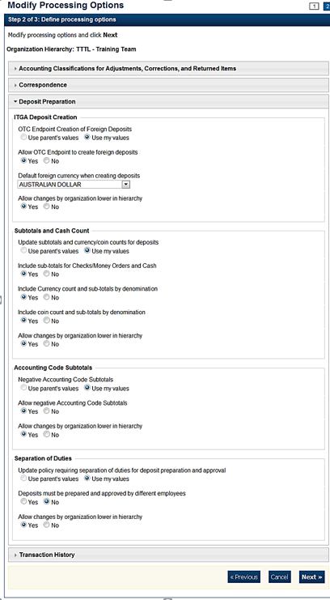

To modify **Transaction History**, complete the following steps as shown in Figure 7: Selecting **Use parent’s values** or **Use my values**

* Entering the **Number of days displayed** in the text box, if applicable
* Selecting **Yes** or **No** to allow changes by an organization lower in hierarchy

Figure . Deposit Procession Options with Transaction History expanded

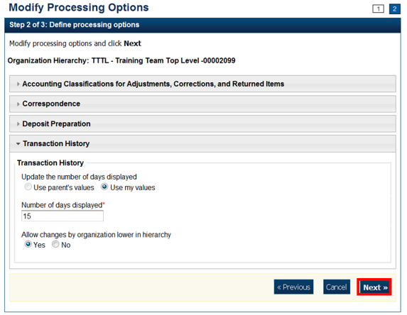

1. The *Step 3 of 3: Review the following processing options* page appears. Verify the information is correct and click **Submit**.
2. A *Confirmation* page appears showing which processing options were applied to the organization.

### View Processing Options

**Accounting Specialists** are authorized to view the following processing options details:

* **Accounting Classifications for Adjustments, Corrections, and Returned Items**
* **Correspondence**
* **Deposit Preparation**
* **Transaction History**

From the **Viewing Processing Options** page, you can view the custom labels that are in effect for your organization hierarchy.

View Processing Options

To view a processing option, complete the following steps:

1. From the **Administration** tab, click **Manage Organizations**>**Processing Options**>**View**. The *Select Organization Endpoint* page appears.
2. Select the highest-level organization or any lower-level OTC Endpoint for which you would like to view the processing options. A *View Processing Options* page appears showing which custom labels are in effect for the organization hierarchy as shown in Figure 8.

Additional Button



Click **Return Home** to return to the OTCnet Home Page.

Figure . View Processing Options

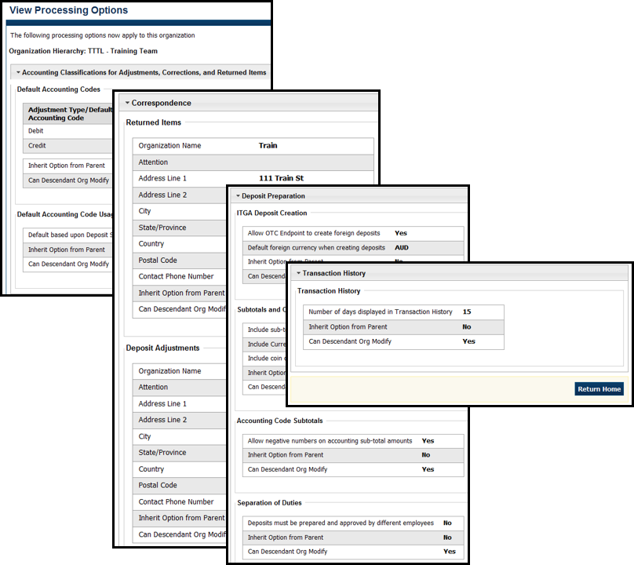

## Topic 3. Creating and Editing User Defined Fields (UDFs)

As an **Accounting Specialist** and **Card Administrator** you are authorized to create, modify and delete a UDF for your organization hierarchy. **Deposit Preparers** use the UDFs when entering deposit activity and accounting activity information during the deposit preparation process.

**Card Operators** use UDFs when entering card payment details during card transaction processing. A UDF is an optional field for the **Deposit Preparer** and **Card Operator** to complete that describes a deposit activity or deposit accounting activity (e.g., a vendor number) or a card transaction, specific to your organization.

Your organization may elect to use UDFs, if so, communicate this to each of your OTC Endpoints and identify the information to be included.

**Accounting Specialists** and **Card Administrators** perform the following tasks in working with UDFs:

* Create a UDF
* Modify a UDF
* Delete a UDF
* View a UDF

Deposit processing activities are disabled to read-only if an **Accounting Specialist** or **Card Administrator** has selected an endpoint that is both a Deposit Processing and a Card Processing Endpoint, and this endpoint has a deposit that is currently in progress. You cannot modify or delete any deposit processing UDFs at this endpoint. You can select the **Create Card Processing** activity.

### Create a User Defined Field

**Accounting Specialists** and **Card Administrators** are authorized to create up to four UDFs for deposit activity and three UDFs for card processing, for your agency. Up to three UDFs for a **Create Deposit** UDF and up to two UDFs for the **Create Deposit Subtotals** UDF can be created.

To create a UDF, from the *Select User Defined Field to Maintain* page, create a UDF by clicking **Create UDF.** When the*Step 2 of 3: Modify the User Defined Field* page appears, add your UDF fields (i.e., **Activity**, **Label**, **Description**, **Date Type**, **Maximum Input Length**, **Minimum Input length**, **Display Order Number**, and **Activity User Entry**).

Create a User Defined Field

To create a UDF, complete the following steps:

1. From the **Administration** tab click **Manage****Organizations**>**User Defined Fields**> **Modify**. The *Select OTC Endpoint* screen appears.
2. Select the highest-level organization for which you want to modify UDFs. The *Step 1 of 3: Select User Defined Field to Maintain* page appears.
3. Click **Create UDF** as shown in Figure 9. The *Step 2 of 3: Modify the User Defined Field* page appears.

Figure 9. Select 1 of 3: Select User Defined Field to Maintain

Modify User Defined Fields,
Step 1 of 3: Select User Defined Field to Maintain page, Create UDF is highlighted


Application Tip



A message is displayed discouraging users from creating UDFs that request PII data.

1. Add the UDF and click **Done**.

Add a UDF by:

* + Selecting the **Activity** type for the UDF

Application Tips



* There are two types of deposit processing activities (**Create   
  Deposit** and **Create Deposit Subtotal**) and one activity for card processing (**Create Card Processing**).
* For TGA/CDC Endpoints with active deposits, in the drop-down **Activity** menu, the deposit activities are disabled. In this case, **Accounting Specialists** and **Card Administrators** can only select the **Create Card Processing** activity
  + Entering the **Label** and **Description**
  + Selecting a **Data Type**
    - If the **Drop Down List of Alphanumeric Values** Data Type is selected, proceed to step 6.
    - If another **Data Type** is selected, continue entering in information for the fields below. Proceed to step 7.
  + Entering the
    - **Maximum Input Length (Maximum length is 255)**
    - **Minimum Input Length**
    - **Display Order Number**
  + Selecting **Mandatory** or **Optional** for Activity User Entry

Application Tips



* When a deposit is in progress at a TGA or CDC endpoint, a UDF cannot be modified or deleted if the deposit is in **Draft** or **Awaiting Approval** **(AWAP)** status.
* If the **Accounting Specialist** or **Card Administrator** selected an endpoint that is both a TGA, and a CDC Endpoint and this endpoint has a deposit that is currently in progress, the deposit processing activities are disabled to read-only.
* Only the **Card Processing** activity is active.
* The **Card Administrator** continues card processing activities when a deposit is in progress.

Application Tips



* If the **Drop-Down List of Alphanumeric** values data type is selected a **Permitted Values** section appears.
* Click **List Values**. A *Step 2 of 3 (Continued): Define Permitted Values* page appears.
* Enter details for both the **Value** and **Description.**
* Click **Done** to return to the *Step 2 of 3: Modify the User Defined Field* page.

1. The *Step 1 of 3: Select User Defined Field to Maintain* page appears again. Select **Next**.
2. The *Step 3 of 3: Review* page appears. Verify the UDF information is correct. Select the plus sign next to the UDF to expand it.
3. The *Step 3 of 3: Review page* appears. Verify the UDF information is correct and click **Submit** as shown in Figure 10.

Figure 10. Review User Defined Fields page

Modify User Defined Fields,
Step 3 of 3: Review page, the Active User Defined Fields are displayed. Submit is highlighted.


1. A confirmation page appears presenting the UDF data that is saved to the database.

Additional Buttons



* Click **Cancel** to return to the OTCnet Home Page. No data is saved.
* Click **Edit** to make additional changes.
* Click **Next** to advance to the next page.
* Click **Previous** to return to the previous page.
* Click **Return Home** to return to the OTCnet Home Page

### Modify a User Defined Field

**Accounting Specialists** and **Card Administrators** are authorized to modify UDFs, as needed, to accommodate your organization’s changing needs.

For deposit processing you cannot modify a UDF that is associated with a deposit that is still in **Draft** or **awaiting approval (AWAP)** status. **Draft** or **AWAP** deposits must be submitted to the Financial Institution before you modify any UDFs associated with them. **Draft** or **AWAP** status does not impact card processing.

When modifying a UDF, you can modify the following UDF fields:

* **Activity**
* **Label**
* **Description**
* **Date Type**
* **Maximum Input Length**
* **Minimum Input length**
* **Display Order Number**
* **Activity User Entry**

Modify a User Defined Field

To modify an existing UDF, complete the following steps:

1. From the **Administration** tab, click **Manage Organizations**>**User Defined Fields**>**Modify**. The *Select OTC Endpoint* screen appears.
2. Select the highest-level organization for which you want to modify a UDF. The *Step 1 of 3: Select User Defined Field to Maintain* page appears.
3. Click the **UDF Label hyperlink**. The *Step 2 of 3: Modify User Defined Field* page appears.

Application Tip



A message is displayed discouraging users from creating UDFs that request personally identifiable information (DII) data.

1. Make the changes to the UDF and click **Done**. The *Step 1 of 3: Select User Defined Field to Maintain* page appears as shown in Figure 11.

Figure . Select User Defined Field to Maintain

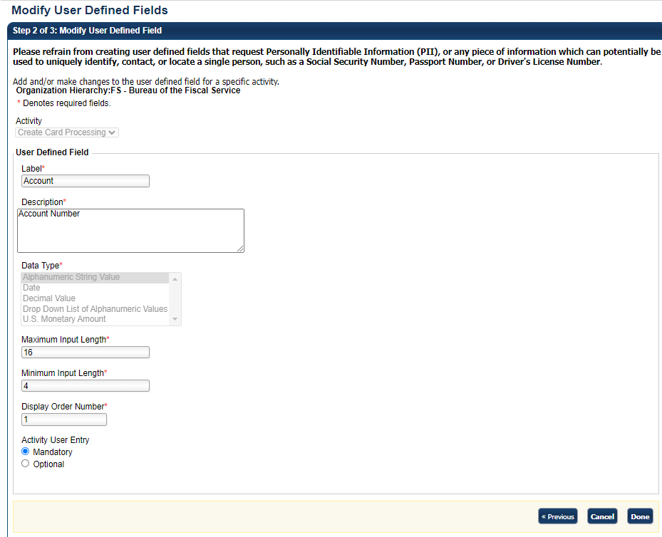

1. Click **Next**. The *Step 3 of 3: Review* page appears.
2. Verify the UDF information is correct and click **Submit**. A confirmation page appears presenting the UDF data that has been saved to the database.

Additional Buttons



* Click **Cancel** to return to the OTCnet Home Page. No data is saved.
* Click **Create UDF** to create a new UDF.
* Click **Next** to advance to the next page.
* Click **Previous** to return to the previous page.
* Click **Edit** to make additional changes to a UDF.
* Click **Submit** to complete the process and display the **Confirmation** page.
* Click **Return Home** to return to the OTCnet Home Page.

### Delete a User Defined Field

**Accounting Specialists** and **Card Administrators** are authorized todelete a user defined field (UDF). If a UDF isn’t needed, delete it to save labor for your **Deposit Preparers** and **Card Administrators**.

For deposit processing, you cannot modify a UDF that is associated with a deposit that is still in **Draft** or **awaiting approval (AWAP)** status. **Draft** or **AWAP** deposits must be submitted to the Financial Institution before you modify any UDFs associated with them. **Draft** or **AWAP** status does not impact card processing.

Delete a User Defined Field

To delete a UDF, complete the following steps:

1. From the **Administration** tab, click **Manage Organizations**>**User Defined Fields**>**Modify**. The *Select OTC Endpoint* screen appears.
2. Select the highest-level organization for which you want to delete the UDF. The *Step 1 of 3: Select User Defined Field to Maintain* page appears.
3. Click the **Delete** checkbox next to the appropriate field and click **Next**. *The Step 3 of 3: Review* page appears. Select the plus sign next to the UDF to expand it as shown in Figure 12.

Figure 12. Select 1 of 3: Select User Defined Field to Maintain  
Modify User Defined Fields,
Step 1 of 3: Select User Defined Field to Maintain page, Delete-Delete All/Undelete ALL is highlighted


Application Tip



A UDF, during deposit processing, cannot be deleted if it is associated with a deposit that is in **Draft** or **awaiting approval (AWAP)** status. Only the **Card Processing** activity is active.

1. Verify the correct information is marked for deletion and click **Submit**. A *Confirmation* page appears showing the UDF data is saved to the database.

Additional Buttons



* Click **Cancel** to return to the OTCnet Home Page. No data is saved.
* Click **Create UDF** to create a new UDF.
* Click **Next** to advance to the next page.
* Click **Previous** to return to the previous page.
* Click **Edit** to make additional changes to a UDF.
* Click **Submit** to complete the process and display the Confirmation page.
* Click **Return Home** to return to the OTCnet Home Page.

### View a User Defined Field

As an **Accounting Specialist**, **Local Accounting Specialist**, **Viewer** and **Card Administrator,** you are authorized to view the UDFs that exist for your organization.

To view a UDF, when the *View User Defined Field* page appears, you can choose a UDF and view the following characteristics:

* **Activity Type**
* **Label**
* **Description**
* **Data Type**
* **Display Order Number**
* **Activity User Entry**
* **Minimum Input Length**
* **Maximum Input Length**

View a User Defined Field

To view a UDF, complete the following steps:

1. From the **Administration** tab, click **Manage Organizations**>**User Defined Fields** >**View**. The *Select OTC Endpoint* screen appears.
2. Select the highest-level organization for which you would like to view UDF. *A View User Defined Field* page appears.
3. Click on any of the UDFs to view its characteristics (e.g., activity type, label, description, etc.). The characteristics appear as shown in Figure 13.

Figure 13. View User Defined Field

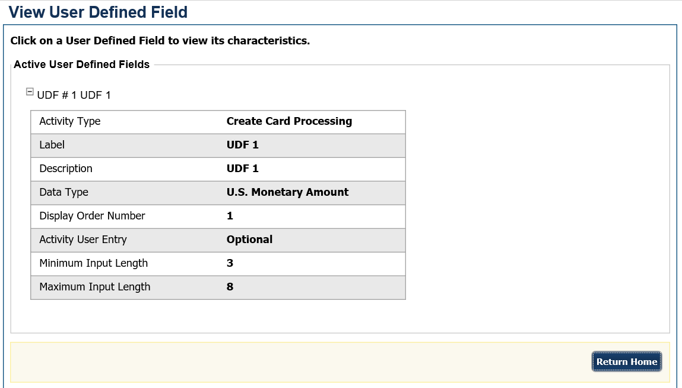

## Summary

This chapter provided information on:

* How to create, edit and delete custom labels
* How to set your options for processing deposits
* How to create, edit and delete UDFs specific to your agency