Differences between GFRS to TFM – July 2018 Published Date

TFM Appendix 3 Note 1 –
Note 1 in GFRS will now be called Other significant events and accounting changes.
Agencies will fill out section A, “Significant events or transactions since the financial statement date that requires disclosure” most Agencies will be entering zero in the field then going over to the text data tab to type in the answers to the following questions:
  - Describe any significant events or transactions that occurred after the date of the Balance Sheet but before the issuance of agency's audited financial statements that have a material effect on the financial statements and; therefore, require adjustments or disclosure in the statements.
  - Describe any departures from U.S. GAAP.
  - When applying the general rule of the Statements of Federal Financial Accounting Standards describe the specific potential accruals that are not made and the practical and inherent limitations affecting the accrual of taxes and duties.
  - Describe any change in accounting if a collecting entity adopts accounting standards that embody a fuller application of accrual accounting concepts that differ from that prescribed by SFFAS No. 7, par. 48.
  - Describe any additional significant accounting policies specific to the agency not included in GFRS Module GF006 FR Notes.

The TFM is no longer editable, so the above will be a departure from the current TFM 4700 guidance. We will not be collected any of this information in OMB Max.
TFM Appendix 3 Note 4A – Data will now be collected in GFRS Note 4C
Due to the complexity of our GFRS application, the published TFM guidance for Note 4A (below) has become Note 04C in GFRS for FY2018. With the updated TFM requirements for Note 4A and historical data needed from prior year to complete a format JV, it was decided the best action plan was to leave Note 04A as it was in GFRS. This will allow CFRB to perform a format JV on prior year data to the new data requirements for FY 2018, which has become Note 04C.

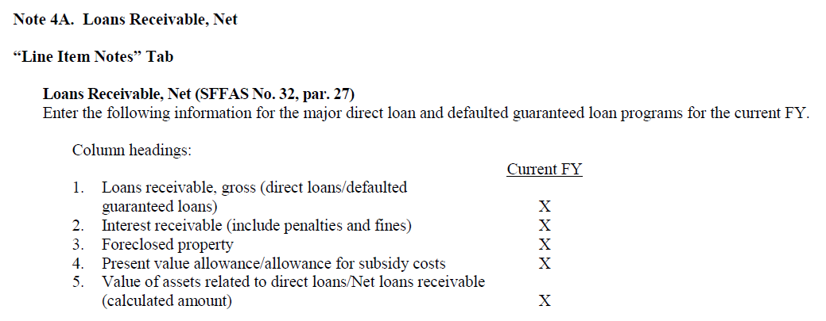
GFRS Note 4A – Should not be viewable/reportable for Agencies
FY2017 Direct Loans Receivable, Net
CY Face value of loans outstanding
CY Long-term cost of loans outstanding
CY Net loans receivable
PY Face value of loans outstanding
PY Long-term cost of loans outstanding
PY Net loans receivable
GFRS Note 4C –
FY2018 Loans Receivable, Net
CY Loans receivable, gross
CY Interest receivable
CY Foreclosed property
CY Present Value allowance/allowance for subsidy costs
CY Value of assets related to direct loans/Net loans receivable
PY Loans receivable, gross – Not Required for Agencies to input
PY Interest receivable – Not Required for Agencies to input
PY Foreclosed property – Not Required for Agencies to input
PY Present Value allowance/allowance for subsidy costs – Not Required for Agencies to input
PY Value of assets related to direct loans/Net loans receivable – Not Required for Agencies to input

TFM Appendix 4 Note 16 – Note 16 is inactive in GFRS. Due to the large overhaul of this note and system limitations, Note 16 data will now be collected in Note 20. Also in Section A – Components of Loans Receivable, Gross, the Column headings and Row headings are reversed.

