Change TC D528 Comment section “See USSGL TC D318” to “See USSGL TC-D526”
TC D318 no longer exists.

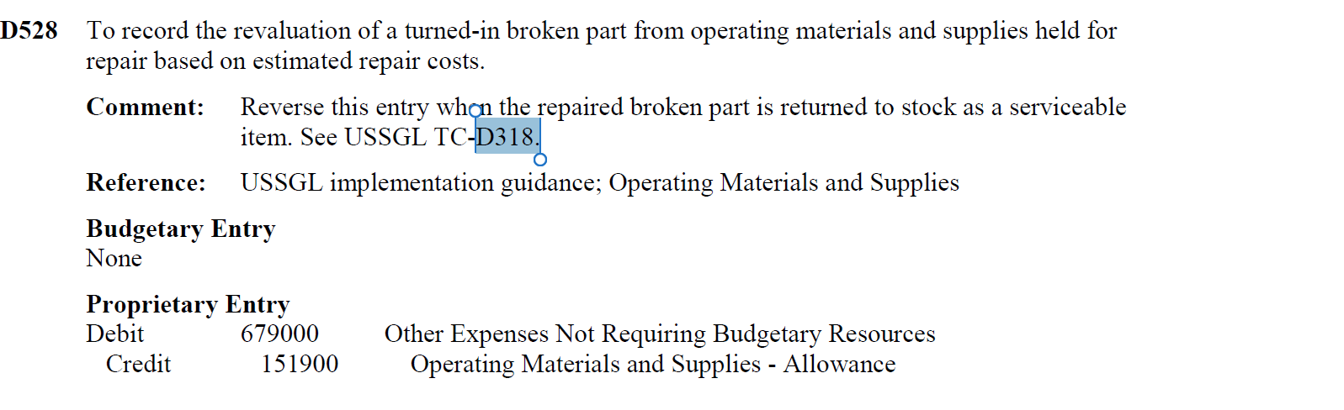

D528 To record the revaluation of a turned-in broken part from operating materials and supplies held for repair based on estimated repair costs.

Comment: Reverse this entry when the repaired broken part is returned to stock as a serviceable item. See USSGL TC-D526.

Reference: USSGL implementation guidance; Operating Materials and Supplies

Budgetary Entry
None

Proprietary Entry
Debit 679000 Other Expenses Not Requiring Budgetary Resources
Credit 151900 Operating Materials and Supplies – Allowance

We will continue to review Section III and make necessary updates.

