Treasury and OMB Guidance Related to Financial Statements, Budgetary Reporting, and USSGL Reporting

**Treasury and OMB update the following guidance on an annual basis:**

* **TFM 2-4700**
* **OMB Circular A-136**
* **OMB Circular A-11**
* **USSGL TFM Supplement**

**These updates (excluding OMB Circular A-11) are based on lessons learned at Treasury, OMB, and the federal entities during the financial statement preparation process, including any audit recommendations from the audit community. As the timeline below demonstrates, in the current process followed by OMB and Treasury, we are reliant on the agency financial statements being finalized normally in November and the government-wide statements being finalized normally in February. Even while the Financial Report of the U.S. Government is still being finalized, Treasury and OMB start their work with the federal entities and audit community on drafting updated guidance for TFM 2-4700 and OMB Circular A-136. In the current process, Treasury and OMB have draft guidance to the agencies in the March/April timeframe. As a matter of practice, the goal is to publish the final guidance for both TFM 2-4700 and OMB Circular A-136 by June 30 each year.**

**The similar pattern happens with OMB Circular A-11 in that OMB uses the lessons learned based on the monthly GTAS reporting windows and the required budgetary reporting for the President’s Budget and other budgetary (including legal) reporting requirements. These changes are incorporated into their OMB Circular A-11 guidance during its annual update.**

**Lastly, the USSGL TFM Supplement merges the above three guidance documents (TFM 2-4700, OMB Circular A-136, and OMB A-11) updates above into an annual publication. In addition to these external document updates that have impacts incorporated into the USSGL TFM Supplement, there are also several TFM Bulletins for USSGL changes, including GTAS edits and validations, throughout the year. Therefore, the USSGL TFM Supplement incorporates all of these changes to show the results of all updates to USSGLs, crosswalks, edits, validations, etc.**

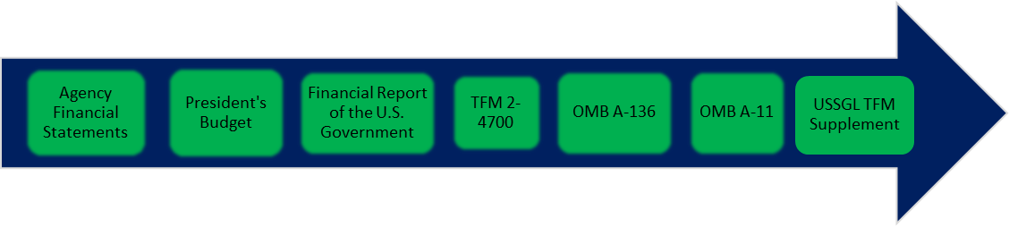

**Nov. 15**

**January**

**February**

**June 30**

**June 30**

**June 30**

**June 30**

Ideas to Solicit Feedback from Agencies for Improvements

* Optional One Year and Required Next Year
* Legislation Changes
* System Changes
* Requested Changes by Agencies
* GTAS Proposed Analytical versus Fatal Edits
* Structure of IRC Meetings
* Structure of CRT Meetings
* Agency Review Periods

The Proposed Solution

While Treasury plans to take feedback from the FMSC, IRC, and CRT government-wide groups. Based on that feedback, we will bring back our proposed changes to these government-wide groups to not only our timelines but also the presentation and review periods given to agencies. Any feedback regarding OMB Circulars A-11 and A-136 will be forwarded to our OMB counterparts. Our goal is to build a structured process that works for OMB, Treasury, and federal entities.

**9/30/2018**

**7/30/2018**

**LEAD ∙ TRANSFORM ∙ DELIVER**

