**New and Revised Budgetary USSGL accounts**

**FY 2025 Additions**

**Account Title:** Appropriations Derived from Future Trust Fund Receipts

**Account Number:** 439440

**Normal Balance:** Debit

**Definition:** This account is used to identify the amount of future Airport and Airway Trust Fund and Highway Trust Fund receipts where Department of Transportation trust fund appropriations to liquidate contract authority and appropriations have been enacted in excess of trust fund receipts collected to date. This account does not close at year-end.

**Justification:** While this account was already voted on and approved effective FY 2026 at the February 2025 IRC Meeting, it is currently required to address a DOT anomaly as of September 30, 2025. The vote in May is simply to change the effective date to FY 2025.

**Affected TCs:** **A521 & A525** **(See Budgetary TC Additions and Revisions handout for details)**

**FY 2025 Modifications**

**Account Title:** Appropriation Withdrawn

**Account Number:** 435400

**Normal Balance:** Credit

**Definition:** This account is used to record the amount of indefinite appropriations (or repayable advances) derived from the General Fund of the U.S. Government withdrawn due to recoveries of prior-year obligations.

**Justification:** To clarify that this account can be used with repayable advances.

**FY 2026 Additions**

**Account Title**: Undelivered Orders - Obligations Transferred, Unpaid – With Offset

**Account Number**: 483110

**Normal Balance**: Credit

**Definition**: This account is used to record the amount of goods and/or services ordered and obligated in one

Treasury Appropriation Fund Symbol (TAFS) and transferred to or from another TAFS, which have not been

actually or constructively received and not prepaid or advanced at the time of transfer. This account is offset by a

federal receivable in USSGL account 416600 and/or 416612. This includes amounts specified in other contracts or

agreements such as grants, program subsidies, undisbursed loans and claims, and similar events for which an

advance or prepayment has not occurred. Although the normal balance for this account is credit, it is acceptable for

this account to have a debit balance.

**Justification:** This USSGL account is needed to merge existing agency allocation accounts into a parent account

of a Treasury Managed Trust Fund related to long term projects. This USSGL account is only for Treasury

Managed Trust Fund accounts: Inland Waterways Trust Fund, Harbor Maintenance Trust Fund, Federal

Supplementary Medical Insurance Trust Fund, Federal Hospital Insurance Trust Fund, Vaccine Injury

Compensation Program Trust Fund, Federal Old-Age and Survivors Insurance Trust Fund, Federal Disability

Insurance Trust Fund, Black Lung Trust Fund, Hazardous Substance Superfund, and Leaking Underground Storage

Tank Trust Fund.

**Account Title**: Delivered Orders - Obligations Transferred, Unpaid - With Offset

**Account Number**: 493110

**Normal Balance**: Credit

**Definition**: This account is used to record the amount in USSGL account 490100, "Delivered Orders –

Obligations, Unpaid," which was transferred during the fiscal year to or from another Treasury Appropriation Fund

Symbol. This account is offset by a federal receivable in USSGL account 416600 and/or 416612. This includes

amounts accrued or due for: (1) services performed by employees, contractors, vendors, carriers, grantees, lessors,

and other government funds; (2) goods and tangible property received; and (3) programs for which no current

service performance is required such as annuities, insurance claims, benefit payments, loans, etc. Although the

normal balance for this account is credit, it is acceptable in certain instances for this account to have a debit

balance.

**Justification:** This USSGL account is needed to merge existing agency allocation accounts into a parent account

of a Treasury Managed Trust Fund related to long term projects. This USSGL account is only for Treasury

Managed Trust Fund accounts: Inland Waterways Trust Fund, Harbor Maintenance Trust Fund, Federal

Supplementary Medical Insurance Trust Fund, Federal Hospital Insurance Trust Fund, Vaccine Injury

Compensation Program Trust Fund, Federal Old-Age and Survivors Insurance Trust Fund, Federal Disability

Insurance Trust Fund, Black Lung Trust Fund, Hazardous Substance Superfund, and Leaking Underground Storage

Tank Trust Fund.

**FY 2026 Revisions**

**Account Title**: Undelivered Orders - Obligations Transferred, Unpaid – No Offset

**Account Number**: 483100

**Normal Balance**: Credit

**Definition**: This account is used to record the amount of goods and/or services ordered and obligated in one

Treasury Appropriation Fund Symbol (TAFS) and transferred to or from another TAFS, which have not been

actually or constructively received and not prepaid or advanced at the time of transfer. This account is not offset by

a federal receivable in USSGL account 416600 and/or 416612. This includes amounts specified in other contracts

or agreements such as grants, program subsidies, undisbursed loans and claims, and similar events for which an

advance or prepayment has not occurred. Although the normal balance for this account is credit, it is acceptable for

this account to have a debit balance.

**Justification**: This change is needed to separate 4831xx by accounts not offset by a federal receivable versus those

offset by a federal receivable.

**Account Title**: Delivered Orders - Obligations Transferred, Unpaid - No Offset

**Account Number**: 493100

**Normal Balance**: Credit

**Definition**: This account is used to record the amount in USSGL account 490100, "Delivered Orders - Obligations,

Unpaid," which was transferred during the fiscal year to or from another Treasury Appropriation Fund Symbol.

This account is not offset by a federal receivable in USSGL account 416600 and/or 416612. This includes amounts

accrued or due for: (1) services performed by employees, contractors, vendors, carriers, grantees, lessors, and other

government funds; (2) goods and tangible property received; and (3) programs for which no current service

performance is required such as annuities, insurance claims, benefit payments, loans, etc. Although the normal

balance for this account is credit, it is acceptable in certain instances for this account to have a debit balance.

**Justification**: This change is needed to separate 4931xx by accounts not offset by a federal receivable versus those

offset by a federal receivable.

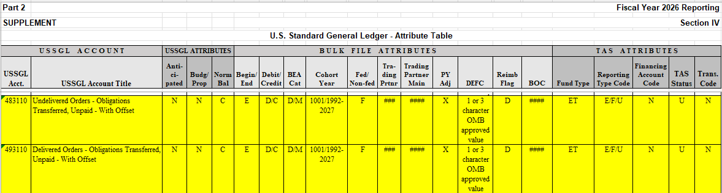

|  |  |  |  |  |  |  |  |  |  |
| --- | --- | --- | --- | --- | --- | --- | --- | --- | --- |
| **USSGL**  **Account** | **Balance**  **Sheet** | **Net**  **Cost** | **Net**  **Position** | **Custodial**  **Activity** | **Reclassified**  **Net Cost** | **Reclassified**  **Net**  **Position** | **SF133** | **Schedule P** | **SBR** |
| **483110**  **(FY 26)** | N/A | N/A | N/A | N/A | N/A | N/A | 3030, 3031,  3050, 5341,  5343 & 5344 | 3030, 3031,  3050, 5341,  5343 & 5344 | N/A |
| **493110**  **(FY 26)** | N/A | N/A | N/A | N/A | N/A | N/A | 3030, 3031,  3050, 5341,  5343 & 5344 | 3030, 3031,  3050, 5341,  5343 & 5344 | N/A |