Profile of the Economy
(Office of Macroeconomic Analysis)
August 16, 2023
Introduction
The U.S. economy continued to show resilience and strength in the second quarter of 2023. Real GDP grew 2.4 percent at an annual rate, up from 2.0 percent in the first quarter and the fourth consecutive quarterly increase. Although employment growth has slowed in recent months—payroll job growth was 187,000 in July, slowing from an average of 228,000 jobs per month in the second quarter and an average of 312,000 in the first quarter—it was still sufficient to keep the unemployment rate low and stable. Indeed, the unemployment rate edged down to 3.5 percent in July, just above the 54-year low reached earlier in the 2023. Despite persistent tightness in labor markets, inflation continued to trend lower in the second quarter. Relative to the twelve-month, 9.1 percent peak in June 2022, the headline inflation rate (as measured by the consumer price index, or CPI) fell by 5.9 percentage points as of July, reflecting a slowdown in food price inflation by two-thirds from its August 2022 peak, as well as receding energy price inflation. Although core inflation remains elevated, inflation for rent of housing (rent of primary residence and owner-occupied houses) has eased, as has price growth for other core services. Finally, even as the current cycle of monetary tightening weighs on housing market activity, signs of stabilization—which first appeared early in 2023—have persisted into the summer, and some measures suggest the sector has turned upward.
Economic Growth
In the advance estimate for real economic activity in the second quarter of 2023, real GDP rose 2.4 percent at an annual rate, picking up from a 2.0 percent advance in the first quarter. The acceleration in headline growth was largely due to a marked upturn in business fixed investment, and the contribution from private inventory investment also turned from a large drag on growth in the first quarter to slightly positive impetus in the second. Over the four quarters through the second quarter of 2023, real GDP was up 2.6 percent, following a 1.8 percent advance over the previous four quarters.

Despite the acceleration in overall growth, final domestic private demand slowed in the second quarter. While GDP is the most comprehensive measure of the economy’s performance, each of its four main components—private domestic final purchases (PDFP), government consumption and investment, net international purchases, and intermediate demand—can indicate specific trends, both current and prospective. For example, PDFP—which aggregates personal consumption expenditures (PCE), business fixed investment, and residential investment—captures the private sector’s capacity to drive self-sustaining growth and can be a predictor of future economic performance. In the second quarter, real PDFP growth slowed to 2.3 percent at an annual rate (from 3.2 percent in the first quarter) and contributed 2.0 percentage points to total GDP growth.

Looking into the components of PDFP, household consumption growth slowed in the second quarter to 1.6 percent at an annual rate, from 4.2 percent in the first quarter, due to a sharp deceleration in demand for goods and slower—though still solid—growth in spending on services. Consumption of goods was up 0.7 percent in the second quarter following a 6.0 percent advance in the previous quarter, as growth in durable goods purchases—particularly of motor vehicles—slowed to 0.4 percent from a 16.3 percent surge in the first quarter. The rotation in consumer spending towards services continued, with growth slowing modestly to 2.1 percent in the second quarter from 3.2 percent in the first quarter–dominated by purchases of housing and utilities, health care, and financial services and insurance. Notably, consumption of foods services and accommodations declined in the second quarter for the first time since 2020.

After four consecutive quarters of contraction, business fixed investment (BFI) drove the acceleration in overall growth in the second quarter. Among the components of BFI, spending on equipment turned up sharply after two consecutive quarters of decline, rising 10.8 percent at an annual rate due to increased purchases of transportation equipment. Growth in business investment in structures was very strong at 9.7 percent, even after slowing from rates of 15.8 percent in each of the previous two quarters. Businesses continued to invest heavily in manufacturing factories—and, to a lesser extent, other structures—activity which offset declines in spending in health care structures, power and communications buildings, and mining exploration. Spending on intellectual property products picked up from 3.1 percent in the first quarter to 3.9 percent in the second quarter.

The final component of PDFP, residential investment, continued to constrain overall GDP growth in the second quarter, affected by an ongoing correction in the housing sector as well as tighter monetary policy. The contraction in this sector started in the second quarter of 2021, widening and deepening over the next year and a half before tapering and stabilizing in the two quarters of 2023. After three consecutive quarters of double-digit declines, residential investment fell by 4.0 percent at an annual rate in the first quarter and then by 4.1 percent in the second quarter. Residential investment was hampered by spending on other structures—a category that includes brokers’ commissions and home improvements—which fell 2.3 percent. By contrast, residential construction turned positive in the second quarter: single-family home construction spending increased 0.2 percent, marking the first positive contribution to GDP growth since early 2022, while investment in multi-family buildings advanced 0.4 percent.

The other three categories of GDP—government expenditures, international trade, and the change in the build-up or drawdown of private inventories—made mixed contributions to the overall expansion in the second quarter. Annualized growth of total government spending slowed to 2.6 percent in the second quarter, after rising by 5.0 percent in the previous quarter. Federal spending growth decelerated from 6.0 percent in the first quarter to 0.9 percent in the second, owing to a sharp swing in nondefense expenditures. Meanwhile, defense spending held steady. Growth of state and local government expenditures decelerated modestly to a 3.6 percent pace, after rising 4.4 percent in the first quarter, but still reflected growth in compensation of state and local government employees and also gross public investment in structures.

With export growth falling faster than import growth, international trade was a net negative contributor to real GDP growth in the second quarter, after making positive—though shrinking—contributions in each of the previous four quarters. The net export deficit was smaller by $2.9 billion in the second quarter at -$1,205.5 billion and subtracted 0.1 percentage point from second quarter GDP growth (after contributing 0.6 percentage points in the previous quarter). Total exports of goods and services declined by 10.8 percent at an annual rate, amid slowing global growth, while total imports fell by 7.8 percent.

As noted previously, the change in private inventories (CIPI) contributed to GDP growth in the second quarter, after posing a major impediment to growth in the previous quarter. The contribution was led by builds in the construction, mining, and utilities sectors as well as the retail trade sector. The pace of real private inventory growth quickened by $5.8 billion to $9.3 billion in the second quarter, after slowing by $133.0 billion to just a $3.5 billion inventory buildup in the first quarter. As a result, CIPI added 0.1 percentage point to real GDP growth in the second quarter, after subtracting 2.4 percentage points in the first quarter. Inventories tend to be a volatile component of GDP and became even more so during and after the pandemic, given changing household consumption patterns and supply-chain disruptions.

Growth of Real GDP
(Quarterly percent change at annual rate)
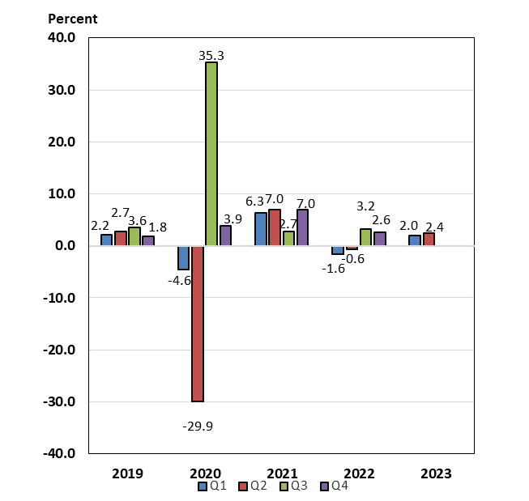
Labor Markets and Wages
Labor markets remained tight during the first seven months of 2023, but signs of easing became more apparent. The pace of job creation averaged 399,000 per month in 2022, then slowed to an average 258,000 per month through July of this year. Nonetheless, the pace of job creation this year remains sufficient to maintain a stable unemployment rate with a constant labor force participation rate. After dropping to a 54-year low of 3.4 percent in January 2023 and again in April, the unemployment rate stood at 3.5 percent as of July. Meanwhile, the broadest unemployment rate—which includes those working part-time for economic reasons and those marginally-attached to the labor force—stood at 6.7 percent in July, just 0.2 percentage points higher than the record low of 6.5 percent set in December 2022 (series dates from January 1994).

Thus far in 2023, the imbalance between labor supply and demand in the economy has improved slowly. Labor force participation rates (LFPR) for all workers, as well as prime-age (ages 25-54) workers, improved in the first quarter of 2023 after stalling late last year. Between March and July 2023, the headline LFPR has stabilized at 62.6 percent, its highest level since March 2020. Meanwhile, the prime-age LFPR has continued to improve, reaching 83.5 percent as of July 2023, surpassing the pre-pandemic high in January 2020 by 0.4 percentage points. Even so, participation by workers over age 54 has been trending lower, dropping to 38.1 percent as of July 2023—or 2.2 percentage points below the 40.3 percent rate posted in February 2020. In addition to increased labor supply, demand for labor continues to move lower, albeit slowly. The number of job openings and the job openings rate have each trended down since March 2022; as of June 2023 (latest available data), there were still 1.61 jobs per unemployed worker, the lowest ratio since October 2021. This lower ratio (fewer jobs per unemployed worker) signals improving balance in labor markets.

Measures of wage growth in the private sector remain mixed. Average hourly earnings rose 4.4 percent over the twelve months through July 2023, gradually slowing from the 5.9 percent peak in March 2022. After adjusting for inflation, however, real average hourly earnings advanced 1.1 percent over the year through July 2023, contrasting sharply with the 2.7 percent decline in real wages over the year-earlier period. But an alternative measure of wage growth, the Employment Cost Index (ECI), suggests that wage pressures moderated in the second quarter. (The ECI controls for employment shares among industries and occupations, making it a better reference for wage growth.) Over the four quarters through the second quarter of 2023, the ECI for private sector wages and salaries grew 4.6 percent, slower by more than a full percentage point than the rate over the previous four quarters. Wage growth in goods-producing industries slowed dramatically in the second quarter, while that in service-producing industries was stable relative to the first quarter at an elevated rate.

Payroll Employment
(Monthly average for year shown and monthly amounts, in thousands)
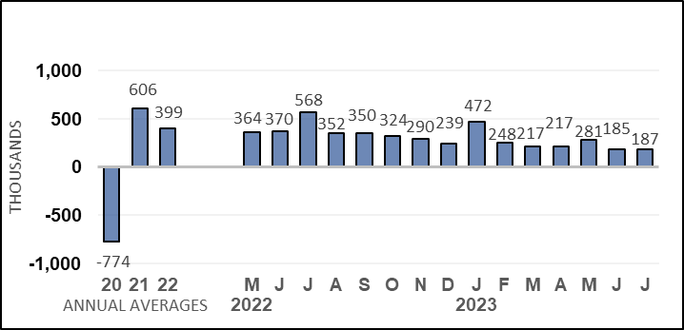

Unemployment Rate
(Percent)
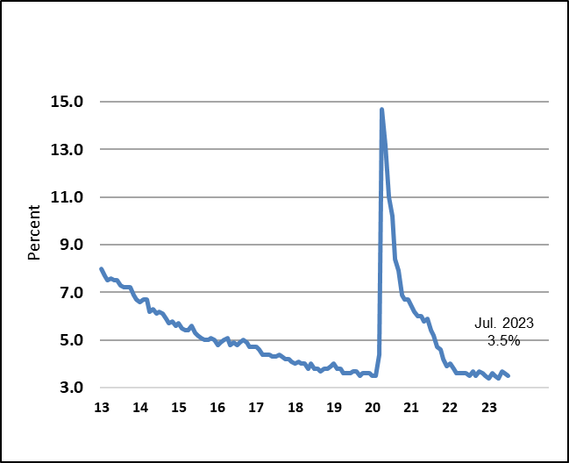

Nonfarm Productivity of Labor
After declining in the first quarter of this year, nonfarm productivity growth grew strongly in the second quarter, although the acceleration was mainly a function of a decline in worker hours. Productivity growth was up 3.7 percent at an annual rate in this year’s second quarter, following a 1.2 percent retreat in the first quarter. The second-quarter gain reflected a 2.4 percent advance in output, combined with a 1.3 percent decline in worker hours. Over the four quarters through the second quarter of 2023, productivity was up 1.3 percent, the first four-quarter increase after five consecutive twelve-month declines, including a 2.5 percent drop over the four quarters through the second quarter of 2022, which marked the largest four-quarter decline since 1974.

Nominal hourly compensation costs in the nonfarm business sector rose 5.5 percent at an annual rate in the second quarter of 2023, accelerating from the 2.1 percent pace in the first quarter. Compensation costs rose by 3.7 percent over the four most recent quarters, slowing from a 4.3 percent, year-earlier pace. Growth of unit labor costs, defined as the average cost of labor per unit of output, slowed to 1.6 percent at an annual rate in this year’s second quarter, after rising by 3.3 percent in the previous quarter. On a four-quarter basis, however, these costs advanced 2.4 percent over the most recent four quarters, less than one-half the 7.0 percent pace over the four quarters through the second quarter of 2022.

Industrial Production, Manufacturing, and Services
Total industrial production has trended somewhat higher over the first seven months of 2023, after declining on net in the last quarter of 2022. Since December, output at factories, mines, and utilities has increased 1.4 percent.

Manufacturing production, which accounts for about 74 percent of all industrial output, has increased 1.6 percent since December. The contribution from the automotive sector has been generally positive in recent months, including a 5.2 percent advance in July. Other measures of manufacturing, however, have been mixed so far in 2023. Output at select high-technology factories was up 1.5 percent in July but, excluding motor vehicles and parts and high-technology industries, manufacturing output ticked up 0.1 percent that month.

Output at mines, most of which is crude oil and natural gas extraction and related support activities, accounts for 16 percent of industrial output. As a result, mining activity is sensitive to energy prices; the trend of rising energy prices in 2021 and well into 2022 contributed to strong mining output growth in those years. Earlier this year, mining output slowed, but more recently has turned up, such that since December, output was 3.1 percent higher, including a 0.5 percent increase in July. Twelve-month rates are slowing, however, with output up 2.3 percent over the year through July, much slower than the 7.4 percent, year-earlier advance. Monthly oil and gas extraction declined 1.8 percent in July, the third consecutive monthly decline. Over the 12 months through July 2023, oil and gas extraction was down 4.4 percent.

Utilities output, the remaining 10 percent of total industrial output, has also fluctuated from month to month; weather is usually a factor contributing to swings in this sector; unseasonable weather in months often causes sharp swings in output from one month to the next. Utilities output declined to varying degrees in April, May, and June, then surged 5.4 percent in July. Over the 12 months through July 2023, utilities production declined 0.9 percent.

According to survey measures of manufacturing and service-sector businesses, growth remains negative in manufacturing, and has continued to slow in services. The Institute for Supply Management’s (ISM) manufacturing index has remained below the 50 level for the past nine months, signaling contraction. After dropping in June to its lowest level since May 2020, the index rose to 46.4 in July 2023. For the services sector, the ISM’s index dipped below the 50 mark in December 2022 but has held above 50 for the past seven months. In July 2023, the index fell 2.2 points to 52.7. This index has signaled expansion in 37 of the past 38 months but recent readings have indicated slow growth.

Housing Markets

The correction in housing markets that began early in 2022 has tapered thus far in 2023, although much higher mortgage rates and still-high house prices continue to weigh on affordability. In June 2023, existing home sales—which account for nearly 90 percent of all home sales—declined 3.3 percent over the month and were 18.9 percent lower on a twelve-month basis. Year-to-date, existing home sales were up 3.2 percent but have trended lower since surging 13.8 percent in February. By contrast, new single-family home sales have trended higher since July 2022 and, despite a 2.5 percent decline in June, are 23.8 percent higher over the year. Inventories of existing homes available for sale have risen from all-time lows in 2022 but remain constrained as many existing homeowners are still reluctant to sell homes with lower mortgage rates in exchange for new mortgages at much higher rates. Even so, the months’ supply of existing homes for sale has been edging up in recent months and stood at 3.1 months in June, roughly double the supply available in January 2022, but still well below the average 3.9 months of supply in 2019. Inventories of new homes on the market remain elevated but have declined: after surging above 10 months’ supply in July 2022, months’ supply has trended lower and stood at 7.4 months in June 2023, well above the 5.8 months of sales posted in January 2022.

Measured with a lag, house prices remain elevated following a sharp acceleration for well over two years, including double-digit twelve-month rates for nearly that long. But during the latter half of 2022, yearly as well as monthly rates began to slow considerably. Since early 2023, monthly rates have been rising, although yearly rates continue to slow or even decline. The Case-Shiller national house price index—which measures sales prices of existing homes—declined each month between July 2022 and January 2023, then began rising, and was up 1.0 percent in May 2023 (latest data available). However, the index has declined on a twelve-month basis since March, including a 1.7 percent drop over the year through May. These were the first yearly declines since early 2012 and contrast sharply with the peak 20.8 percent pace over the year through March 2022. The FHFA purchase-only house price index showed flat or slightly positive growth between October 2022 and January 2023 but, starting in February, has shown robust monthly growth—including a 0.7 percent advance in May. Twelve-month rates remain positive but are trending lower; over the year through May 2023, this index was up 2.9 percent, about one-sixth the peak pace of 19.3 percent over the year through February 2022 and the slowest twelve-month pace since May 2012.

Signals from new construction starts and permits for future starts have been mixed thus far in 2023. Single-family housing starts have been trending higher since late last year, including a 6.7 percent advance in July. Twelve-month declines have tapered considerably from the eleven-month string of double-digit declines seen through June 2023 and, over the year through July, were up 9.5 percent. Similarly, after declining for eleven consecutive months through the end of 2022, single-family permits have been growing in 2023, including a 0.6 percent gain in July. Yearly declines have also tapered to low single digits. In the volatile multi-family sector, starts have been running at an elevated pace since late 2021 but have declined in recent months; meanwhile permits have declined in five of the past seven months, suggesting a softening trend in this segment of the market.

Despite mixed trends in starts and permits, activity in the housing sector remains relatively elevated, as builders continue to work through construction backlogs. The number of total homes under construction—both single-family and multi-family—stood at 1.682 million as of June 2023, modestly below the record high of 1.710 million reached in October 2022 (data series begins in 1970). Earlier this year, home builders had grown more optimistic about conditions in single-family housing markets, with the National Association of Home Builders’ housing market index rising to 56 in July, the highest reading since June 2022. However, this index dropped to the neutral threshold of 50 in August—though this level that still represents a sharp improvement from the recent low of 31 in December 2022.

Prices
Monthly increases in inflation have slowed substantially from the range of 0.4 percent to 1.2 percent seen in the first half of 2022 and have recently neared pre-pandemic patterns. Lower energy and food prices have helped dampen headline price pressures. In June and July 2023, CPI inflation was 0.2 percent. The CPI for energy goods and services continues to fluctuate from month to month, ticking up 0.1 percent in July, after a 0.6 percent gain in June and a 3.6 percent drop in May. Food inflation, meanwhile, has been trending lower since mid-2022. In July, monthly food price inflation was 0.2 percent, matching the year-to-date average and down from the peak of 1.1 percent growth in May and July of 2022.

Core CPI inflation (which strips out the volatile energy and food components) was elevated for much of 2022 but slowed to a range of 0.3 percent to 0.4 percent during the final three months of the year. Core inflation has slowed further this year: in June and July 2023, core prices increased just 0.2 percent over each month. Core goods price inflation has slowed markedly from 2022, helping to contain core inflation readings; in July, the core goods CPI declined 0.3 percent. Meanwhile, inflation for core services has been the largest driving force behind core CPI inflation in 2023, particularly due to shelter prices—such as rents and owners’ equivalent rents—which have set a high floor for core services inflation, despite some recent slowing. Monthly shelter price inflation readings fluctuated in a range of 0.5 percent to 0.8 percent between February 2022 and March 2023, but in April, June, and July, shelter inflation slowed to 0.4 percent. This monthly rate is still well above the 0.2 percent to 0.3 percent pace seen prior to the pandemic’s onset.

On a twelve-month basis, inflation has slowed considerably from peak readings but is still elevated relative to pre-pandemic paces. Over the year ending July 2023, CPI inflation was 3.2 percent: this was about one-third of the 9.1 percent pace recorded over the year through June 2022. Energy prices dropped 12.5 percent over the twelve months ending in July 2023, roughly one-quarter of the 41.6 percent twelve-month rise seen in June 2022—the peak rate following the Russian invasion of Ukraine. After running at double-digit paces for nine consecutive months, food price inflation slowed to single digits as of February and, over the year through July 2023, was 4.9 percent—the slowest twelve-month pace since October 2021. Core inflation has also slowed on a yearly basis, but to a lesser extent than headline: over the year ending in July 2023, core inflation was 4.7 percent, or 1.9 percentage points below the peak rate of 6.6 percent reached over the year through September 2022. As with monthly inflation, price growth of core services—driven by strong shelter inflation—was the primary contributor to still-rapid core inflation. After running at 7.3 percent over the year through February 2023—the fastest rate in over forty years—core services price inflation was 6.1 percent over the twelve months through July – largely driven by shelter inflation (despite slower monthly readings of late. Over the year through July 2023, core goods inflation was 0.8 percent, a fraction of the peak yearly rate of 12.3 percent through February 2022.

The Federal Reserves’ preferred measure of inflation is the PCE price index. The PCE price index assigns different weights for different components than does the CPI and uses a different methodology in its calculation—though the drivers of both measures remain similar. Inflation as measured by the PCE price index typically runs at a slower pace than CPI inflation due to these methodological and weighting differences. From 2000 to 2019, headline PCE inflation was 0.3 percentage points slower than CPI inflation on a year-over-year basis, while core PCE inflation was typically 0.3 percentage points slower than core CPI inflation. Gaps widened considerably starting in Spring 2021, but over time, have narrowed sharply. In fact, as of June 2023, PCE inflation was 3.0 percent on a year-over-year basis, matching CPI inflation for the comparable timeframe. The gap between core measures has also narrowed recently - though to a lesser extent. Core PCE inflation was 4.1 percent over the year ending June 2023, still 0.7 percentage points below the 4.8 percent inflation as measured by the core CPI over the same time frame. (Prior to March 2021, inflation as measured by the PCE price index had held below the FOMC’s target since November 2018, which contributed to the FOMC adopting a new inflation regime. The flexible average inflation target regime allows for inflation to exceed 2 percent for some period, such that PCE inflation would average 2 percent over time.)

Consumer Prices
(Percent change from a year earlier)
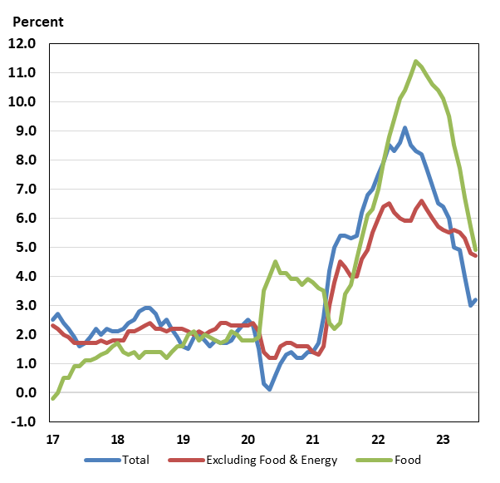

Consumer and Business Sentiment
Consumer and business sentiment measures remain at relatively low levels, despite progress in lowering inflation, the strength of labor markets, and declining concerns about an impending recession. The Reuters/Michigan consumer sentiment index trended lower between April 2021 and June 2022, when it reached a record low of 50.0 (series debuted in November 1952). It subsequently fluctuated in a ten-point range, but since January 2023, has trended modestly higher. Nonetheless, as of early August, the index stood at 71.2, still 0.6 points below the early-pandemic low reached in April 2020.

In The Conference Board’s alternative household survey, the consumer confidence index has remained above the early pandemic low reached in April 2020 but has also fluctuated in a broader range. After reaching 128.9 in June 2021, a level within four points of the pre-pandemic high, this index trended broadly lower, though to a lesser extent than the Reuters/Michigan index. Over the past twelve months, however, the index has remained above 100, and in July 2023, climbed to 117.0, a two-year high and about 31 points above the early pandemic low.

On the business side, the National Federation of Independent Business’s (NFIB) small business optimism index has trended lower since mid-2021. As of July 2023, the small business optimism index stood at 91.9, or 1 point below the early pandemic low. This marked the nineteenth consecutive month below the pre-pandemic long-term average of 98.

Federal Budget Deficit and Debt
The federal government’s deficit and debt were trending higher before the pandemic but rose sharply following the multiple fiscal responses to combat the pandemic’s effects on the economy. At the end of fiscal year 2022, the federal government’s budget deficit was $1.38 trillion (5.4 percent of GDP)—down from $2.78 trillion (12.3 percent of GDP) at the end of fiscal year 2021. Despite the decline in the deficit of $1.40 trillion in the most recent fiscal year, the deficit was still up from 4.7 percent of GDP in fiscal year 2019 (i.e. the fiscal year which ended just before the onset of the pandemic in early 2020), and also higher than the 40-year average of 3.8 percent. Federal receipts totaled $4.90 trillion in fiscal year 2022, up $850 billion (21.0 percent) from fiscal year 2021. Net outlays for fiscal year 2022 were $6.27 trillion, down $550 billion (-8.1 percent) from fiscal year 2021, primarily due to the expiration of temporary programs to contain the pandemic and mitigate the impact on families and businesses. In the first seven months of FY 2023 (October 2022 to July 2023), the federal deficit was $1,613 billion, up $887 billion from the same period in FY 2022.
In June 2023, the Treasury’s borrowing limit was suspended until 2025. Gross federal debt was $30.9 trillion at the end of fiscal year 2022, up from $28.4 trillion at the end of fiscal year 2021. Federal debt held by the public, which includes debt held by the Federal Reserve but excludes federal debt held by government agencies, rose from $22.3 trillion at the end of fiscal year 2021 (98.4 percent of GDP) to $24.3 trillion by the end of fiscal year 2022 (97.1 percent of GDP). At the end of July 2023, gross federal debt stood at $32.6 trillion while debt held by the public was $25.7 trillion.

Economic Policy
In August 2023, the Administration celebrated the one-year anniversary of the Inflation Reduction Act (IRA), which sought to improve the resiliency of supply chains—which had been disrupted in late-2021 and early-2022 and contributed to rising inflation—and address other long-run supply-side vulnerabilities, particularly those arising from climate change. The IRA included provisions to reduce health care costs for prescription drugs and health care coverage as well as an additional $370 billion for measures to reduce emissions and substantial deficit reduction through improved tax compliance and closing of tax loopholes.

The current cycle of monetary policy tightening, which began at the FOMC’s March 2022 meeting to address inflation, has eased in 2023. So far this year, the FOMC has increased the interest by 100 basis points, versus a 425-basis point increase in 2022. In the accompanying statement issued on July 26, the Committee observed that “economic activity has been expanding at a moderate pace” and that “Job gains have been robust in recent months, and the unemployment rate has remained low” but it also noted that “Inflation remains elevated.” The FOMC also repeated that “tighter credit conditions for households and businesses are likely to weigh on economic activity, hiring, and inflation.”

The Federal Reserve also has been reducing its holdings of long-run assets of Treasury securities and mortgage-backed securities (MBS), putting upward pressure on longer-term interest rates. The FOMC’s balance sheet runoff—that is, allowing maturity of longer-term assets without reinvestment—began on June 1, 2022. In September 2022, monthly runoff caps were raised as scheduled to $95 billion ($60 billion for Treasuries and $35 billion for MBS), where they remain.

