Profile of the Economy
(Office of Macroeconomic Analysis)
May 17, 2023

Introduction
Although U.S. economic growth slowed in the first quarter of 2023, it continued to show resilience in the face of global and domestic economic headwinds. Real gross domestic product (GDP) grew at a solid 1.1 percent annualized rate—boosted by strong private domestic demand—while labor market tightness persisted. Over the first four months of this year, employers have added an average of 285,000 payroll jobs—a pace faster than that needed to keep the unemployment rate stable, and the unemployment rate in April returned to a 53-year low. Meanwhile, inflation has slowed further. Since peaking at 9.1 percent in June 2022, the 12-month headline inflation rate (as measured by the consumer price index, or CPI) has fallen by 4.2 percentage points, owing to ongoing moderation in energy prices, easing non-energy goods inflation, and notably slower food price growth over the last several months. Core inflation (excluding food and energy) has slowed—but to a lesser extent than headline due to elevated shelter inflation. However, for some months, timely measures of house prices and rents have been showing some slowdown in housing inflation, and most recently, lagged measures of shelter inflation have begun to moderate. Housing markets weakened noticeably last year following tighter monetary policy, but housing data for this year’s first quarter were suggestive of a possible bottoming out.

Economic Growth
In the advance estimate for real economic activity in the first quarter of 2023, real GDP rose 1.1 percent at an annual rate, following a 2.6 percent advance in the final quarter of 2022. Headline growth largely slowed due to a drawdown in private inventories. Over the four quarters through the first quarter of 2023, real GDP was up 1.6 percent, following a 3.7 percent advance over the previous four quarters.

Significantly, final domestic private demand strengthened in the first quarter. Although GDP is the most comprehensive measure of the economy’s performance, each of its four main components—private domestic final purchases (PDFP), government consumption and investment, net international purchases, and intermediate demand—signal specific current and future trends. For example, PDFP—which aggregates personal consumption expenditures (PCE), business fixed investment, and residential investment—captures the private sector’s capacity to drive self-sustaining growth and can be a predictor of future economic performance. In the first quarter, real PDFP grew 2.9 percent at an annual rate, contributing 2.4 percentage points to total GDP growth.

Looking into the components of PDFP, household consumption accelerated solidly in the first quarter to 3.7 percent, from 1.0 percent in the fourth quarter, as demand for goods shifted from a modest drag to solid growth. Goods consumption, which advanced 6.5 percent, was largely boosted by purchases of motor vehicles, which alone added 1.1 percentage points to GDP growth (or just under half of PDFP’s total growth contribution). Consumer spending growth on services, meanwhile, accelerated to 2.3 percent in the first quarter from 1.6 percent in the fourth quarter, due in part to increased consumption in pandemic-sensitive industries (transportation, recreation services, and food services and accommodation). Business fixed investment (BFI) contracted for the fourth consecutive quarter, although the decline in the first quarter tapered to 0.4 percent, relatively neutral compared with the larger 3.8 percent drop in the previous quarter. Among the components of BFI, only equipment spending posed a drag on growth, declining 7.3 percent. At 11.2 percent, growth in business investment in structures remained in double-digits for the second consecutive quarter, boosted by spending on manufacturing factories and mining exploration, shafts, and wells—though growth in those two categories was partly offset by a drag from commercial real estate investment. Spending on intellectual property products slowed from 6.2 percent in the fourth quarter but was still solid at 3.8 percent.

The final component of PDFP, residential investment, continued to constrain overall GDP growth in the first quarter, reflecting an ongoing correction in housing as well as tighter monetary policy. The contraction in this sector started in the second quarter of 2021 and widened and deepened over the next eighteen months or so. After three consecutive quarters of double-digit declines, residential investment fell by 4.2 percent in the first quarter, primarily due to a decline in single-family construction. The drop in single-family structures spending tapered to -20.7 percent, while multi-family structures investment rose 10.1 percent. Other structures investment—which includes manufactured homes, group housing, and ancillary spending like brokers’ commissions—turned positive in the first quarter, rising 6.3 percent.

The other three categories of GDP—government expenditures, international trade, and the change in the build-up or drawdown of private inventories—made mixed contributions to the overall expansion in the first quarter. Growth of total government spending accelerated to 4.7 percent in the first quarter from an already-rapid pace of 3.8 percent in the final quarter of 2022. Federal spending advanced by 7.8 percent in the first quarter, up from 5.8 percent in the fourth quarter, reflecting increases in both defense and nondefense expenditures. State and local government expenditures were up by 2.9 percent in the first quarter, somewhat more than the 2.6 percent pace in the previous quarter, due to higher state and local employee compensation.

International trade was a very small but net positive contributor to real GDP growth in the first quarter, after making a larger contribution to growth in the fourth quarter, as exports grew faster than imports. The net export deficit was smaller by $2.8 billion in the first quarter at -$1,235.8 billion, and added 0.1 percentage point to first quarter GDP growth (after contributing 0.4 percentage points in the previous quarter). Total exports of goods and services grew by 4.8 percent at an annual rate, while total imports grew by 2.9 percent. Although the contribution from net exports has been shrinking, this was the fourth consecutive quarter that this component added to growth.

As noted previously, the change in private inventories (CIPI) was the strongest impediment to growth in the first quarter, led by drawdowns of manufacturers’ inventories of petroleum and coal products, as well as nonautomotive transportation equipment. Firms’ total inventories decreased $1.6 billion (constant 2012 dollars) in the first quarter, after building their inventories by $136.5 billion in the fourth quarter. Due to the $138.2 billion downswing in inventory growth, CIPI subtracted 2.3 percentage points from real GDP growth in the first quarter. Inventories tend to be a volatile component of GDP and became even more so during and after the pandemic, given changing household consumption patterns and supply-chain disruptions.

Growth of Real GDP
(Quarterly percent change at annual rate)
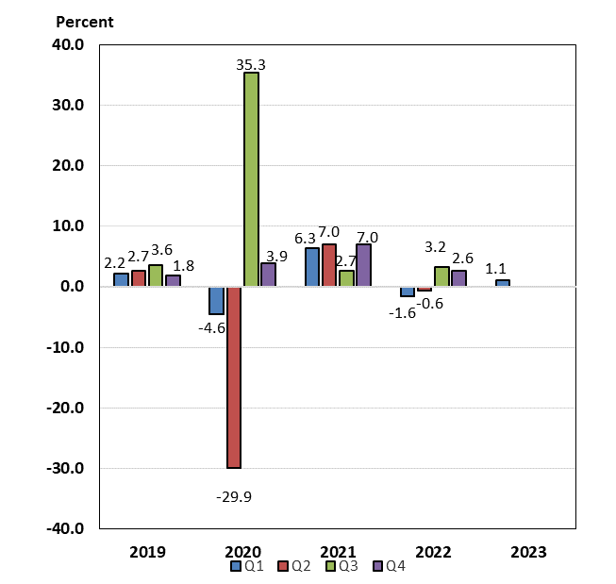

Labor Markets and Wages
Labor markets remained tight during the first four months of 2023, although the signs of easing that emerged during the final months of 2022 were also evident to some extent in the new year. The pace of job creation averaged 399,000 per month in 2022, then slowed to an average 285,000 per month during the first four months of this year. Nonetheless, the pace of job creation this year remains sufficient to maintain a stable unemployment rate with a constant labor force participation rate. After dropping to a 54-year low of 3.4 percent in January 2023, the unemployment rate increased only slightly in subsequent months before returning to that level again in April 2023. Meanwhile, the broadest unemployment rate—which includes those working part-time for economic reasons and those marginally-attached to the labor force—stood at 6.6 percent in April, just 0.1 percentage point higher than the record low of 6.5 percent set in December 2022 (series dates from January 1994).

Despite an ongoing imbalance between labor supply and demand in the economy, there were signs of improving supply in the first few months of 2023. Labor force participation rates (LFPR) for all workers, as well as prime-age (ages 25-54) workers, improved over the first four months of 2023, after stalling in last year’s final quarter. The headline participation rate increased by 0.3 percentage points to 62.6 percent from December 2022 to April 2023. In addition, the participation rate for prime-age workers moved substantially higher during the first few months of this year, rising to 83.3 percent by April 2023—or 0.2 percentage points above the prime-age LFPR in January 2020, just before the pandemic. Even so, participation by workers over age 54 remained subdued at 38.4 percent in April 2023, or 1.9 percentage points below the 40.3 percent rate posted in February 2020. In addition to increased labor supply, demand for labor has slowly moved lower. The number of job openings and job openings rates have trended down since March 2022; as of March 2023 (latest available data), there were still 1.64 jobs per unemployed worker, the lowest ratio since October 2021. This lower ratio (fewer jobs per unemployed worker) signals improving balance in labor markets. One labor development to monitor is the increase in weekly unemployment claims since September 2022 and the number of job losers who are not on temporary layoff over the past two quarters—though the increases are from abnormally low levels. Indeed, with inflation still uncomfortably high, the increase in unemployment claims and share of workers not on temporary layoff may be signaling a gradual return to more balanced labor markets in coming quarters.

Measures of nominal wage growth in the private sector were mixed in the first few months of this year. Average hourly earnings rose 4.4 percent over the twelve months through April 2023, gradually slowing from the 5.9 percent peak in March 2022. After adjusting for inflation, however, real average hourly earnings declined by 0.5 percent over the year through April 2023, but this was far less an erosion of purchasing power than the 2.2 percent decline in real wages over the year-earlier period. Nonetheless, an alternative, quarterly measure of wage growth, the Employment Cost Index (ECI), suggests that wage pressures did not moderate in first quarter. The ECI for private sector wages and salaries rose 5.1 percent (year-over-year) in the first quarter of 2023, matching the pace in the final quarter of 2022 (although lower than the 5.7 percent peak in 2022 Q2). The ECI controls for employment shares among industries and occupations, making it a better reference for wage growth.

Payroll Employment
(Monthly average for year shown and monthly amounts)
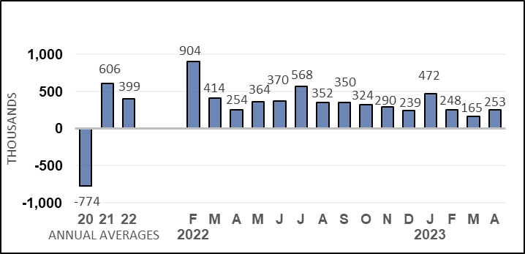
Unemployment Rate
(Percent)
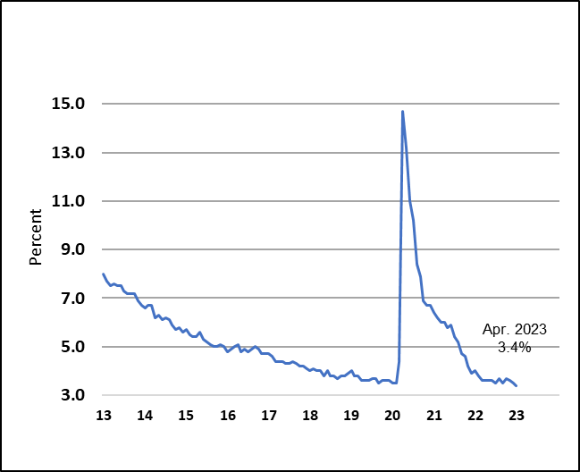

Nonfarm Productivity of Labor
After improving during the final two quarters of last year, nonfarm productivity growth declined in the first quarter of 2023, as moderate growth in labor hours more than offset slower growth in output. Productivity growth declined 2.7 percent at an annual rate in this year’s first quarter, reflecting a 3.0 percent gain in worker hours, combined with a much smaller, 0.2 percent increase in output. The decline followed a 1.6 percent advance in the fourth quarter of 2022. On a year-over-year basis, productivity growth was down 0.9 percent through the first quarter of 2023, comparable to the four-quarter decline of 1 percent a year earlier. Productivity growth on a four-quarter basis has declined for five consecutive quarters, including a 2.5 percent plunge over the four quarters through the second quarter of 2022, which marked the largest four-quarter decline since 1974.

Nominal hourly compensation costs in the nonfarm business sector rose 3.4 percent at an annual rate in the first quarter of 2023, slowing from the 4.9 percent pace in last year’s final quarter. Compensation costs rose by 4.8 percent over the four most recent quarters, also slowing from a 5.4 percent, year-earlier pace. Growth of unit labor costs, defined as the average cost of labor per unit of output, had slowed dramatically in previous quarters, but rebounded to 6.3 percent at an annual rate in this year’s first quarter, after slowing to 3.3 percent in the fourth quarter of 2022. On a four-quarter basis, however, these costs advanced 5.8 percent over the most recent four quarters, slowing from the 6.4 percent pace over the four quarters through the first quarter of 2022.

Industrial Production, Manufacturing, and Services
Total industrial production has trended higher in the first four months of 2023 after declining on net in the last quarter of 2022. Since December, output at factories, mines, and utilities has increased 1.5 percent, including a 0.5 percent advance in April 2023. However, total industrial production continues to slow on a year-over-year basis and was only 0.2 percent higher over the twelve months through April.

Manufacturing production, which accounts for about 74 percent of all industrial output, has increased 2.0 percent since December, after falling 2.7 percent over the last three months of 2022, including a 1 percent advance in April. On a twelve-month basis, manufacturing output has turned negative in recent months, including a 0.9 percent drop over the year through April 2023. The contribution from the automotive sector has been more positive in the past four months; output in this category surged 9.3 percent in April. Although twelve-month production rates have slowed from the double-digit paces seen last year (associated with increased availability of semi-conductors), production has been positive on a yearly basis for the past 14 consecutive months and was 8.5 percent higher over the year through April. Other measures of manufacturing brightened in April. Output at select high-technology factories was up 1.5 percent after declining in late 2022 and was 1.8 percent higher over the past year. Excluding motor vehicles and parts and high-technology industries, manufacturing output was up 0.3 percent but fell 1.7 percent from a year earlier.

Output at mines, most of which is crude oil and natural gas extraction and related support activities, accounts for 16 percent of industrial output. As a result, mining activity is sensitive to energy prices; the trend of rising energy prices in 2021 and well into 2022 contributed to strong mining output growth in those years. Since the beginning of this year, however, mining output has declined 1.3 percent, but was still up 5.6 percent over the 12 months through April. Monthly oil and gas extraction increased 0.7 percent in April, following consecutive declines of 0.5 percent and 1.0 percent in February and March, respectively. Over the 12 months through April 2023, oil and gas extraction was up 5.8 percent.

Utilities output, the remaining 10 percent of total industrial output, has also fluctuated from month to month; weather is usually a factor contributing to swings in this sector; unseasonable weather in months often causes sharp swings in output from one month to the next. This pattern was noteworthy in March and April; utilities output surged 8.4 percent in March, then fell 3.1 percent in April. Over the 12 months through April 2023, utilities production was declined 0.4 percent.

According to survey measures of manufacturing and service-sector businesses, growth has turned negative in manufacturing, and has continued to slow in services. The Institute for Supply Management’s (ISM) manufacturing index has remained below the 50 level for the past six months, and fell to 46.3 in March 2023, the lowest reading since May 2020. The index rose in April to 47.1 but continued to signal contraction for the sixth consecutive month. The ISM’s services index also dipped below the 50 mark but only in December 2022, and since then, has remained above 50, including an advance to 51.9 in April. This index has signaled expansion in 34 of the past 35 months but has trended lower since reaching an all-time high of 68.4 in November 2021.

Housing Markets

The correction in housing markets that began early in 2022 appeared to stabilize in the early months of 2023, although much higher mortgage rates and still-high house prices continue to weigh on affordability. In April 2023, existing home sales—which account for nearly 90 percent of all home sales—declined 3.4 percent over the month and were down 23.2 percent on a twelve-month basis. However, since January 2023, existing home sales are up 7.0 percent, owing to a 13.8 percent surge in February. New single-family home sales have trended higher since July 2022, including a 4.1 percent advance in April. As a result of recent gains, new home sales are 11.8 higher over the year. Inventories of existing homes available for sale have risen from all-time lows in 2022 but remain constrained as many existing homeowners are “locked” into their lower rate mortgages. The months’ supply of existing homes for sale stood at 2.9 months in April, nearly double the supply available at the beginning of last year, but still below the average 3.9 months of supply in 2019. Inventories have also increased for the new homes market. After surging above 10 months’ supply last summer, months’ supply has trended somewhat lower, but stood at 7.6 months in April 2023, still higher than the 5.8 months of sales in January 2022.

Measured with a lag, house prices remain elevated following a sharp acceleration for well over two years, including double-digit twelve-month rates for nearly that long. But during the latter half of 2022, yearly as well as monthly rates began to slow considerably. The Case-Shiller national house price index—which measures sales prices of existing homes—declined each month between July 2022 and January 2023 before increasing 0.2 percent in February 2023 (latest data available). The index was up 2.1 percent over the year through February, a tiny fraction of the peak 20.8 percent pace over the year through March 2022 and also the slowest yearly pace since July 2012. The FHFA purchase-only house price index showed flat or slightly positive growth between October 2022 and January 2023, then rebounded by 0.5 percent in February. However, over the year through February 2023, this index was up 4.0 percent, about one-fifth the peak pace of 19.3 percent over the year through February 2022, and the slowest twelve-month pace since an identical reading in September 2014.

After continuing their weakening trend through the early months of 2023, new construction starts and permits for future starts have brightened a bit in very recent months. Single-family housing starts appeared to have bottomed in November 2022 and have been trending higher since, including a 1.6 percent increase in April. Similarly, after declining for eleven consecutive months through the end of 2022, single-family permits have grown solidly in the first few months of 2023 and were up 3.3 percent in April. In the volatile multi-family sector, starts have been running at an elevated pace since late 2021, however, permits have started to decline, suggesting some softening in new construction may be forthcoming.

Against a backdrop of recent improvements in starts and permits, activity in the housing sector remains relatively elevated, as builders continue to work through construction backlogs. The number of total homes under construction—both single-family and multi-family—fell to 1.675 million in April 2023, modestly below the record high of 1.710 reached in October 2022 (data series begins in 1970). In addition, builders have grown more optimistic about the conditions of single-family housing markets. The National Association of Home Builders’ housing market index rebounded to the neutral threshold of 50 in May, a sharp improvement from the recent low of 31 in December 2022.

Prices
Monthly increases in inflation have slowed substantially from the range of 0.4 percent to 1.2 percent seen in the first half of 2022, but rates are still relatively elevated. Significant improvement in supply chain problems and lower energy prices have helped dampen price pressures. In December 2022 as well as in March 2023, CPI inflation was 0.1 percent, although it picked up to 0.4 percent in April 2023. The CPI for energy goods and services continues to fluctuate from month to month, rising 0.6 percent in April 2023 after declining by 3.5 percent the previous month. Between January and September 2022, food price inflation hovered between 0.8 percent and 1.1 percent, but from October 2022 onwards, has trended lower. In March as well as April 2023, monthly food price inflation readings were flat.

Core CPI inflation (which strips out the volatile energy and food components) was elevated for much of 2022 but remained in a lower range of 0.3 percent to 0.4 percent during the final three months of the year and stood at 0.4 percent in April. Price growth for services has been the largest driving force behind core CPI inflation for the past several months; persistent and strong growth of shelter prices, such as rents and owners’ equivalent rents, has set a high floor for core services inflation. Monthly shelter price inflation readings fluctuated in a range of 0.5 percent to 0.8 percent between February 2022 and March 2023, but in April, shelter inflation slowed to 0.4 percent. This monthly rate is still well above the 0.2 percent to 0.3 percent pace seen prior to the pandemic’s onset. Core goods price inflation, meanwhile, has been slowing markedly, helping to contain core inflation readings.

On a twelve-month basis, inflation has slowed considerably from peak readings but is still elevated relative to pre-pandemic paces. Over the year ending April 2023, CPI inflation was 4.9 percent: this was 4.2 percentage points lower than the 9.1 percent pace recorded over the year through June 2022. Energy prices fell 5.1 percent over the twelve months ending in April 2023, contrasting sharply with the 41.6 percent twelve-month rise seen in June 2022—the peak of which followed the Russian invasion of Ukraine. After running at double-digit paces for nine consecutive months, food price inflation has also slowed, rising by 7.7 percent over the year through April 2023 and marking the slowest twelve-month pace since January 2022. Core inflation has also slowed, but to a lesser extent than headline: over the year ending in April 2023, core inflation was 5.5 percent, or 1.1 percentage points below the peak rate of 6.6 percent reached over the year through September 2022. As with monthly inflation, price growth of core services—driven by strong shelter inflation—was the primary driver of still-rapid core inflation. After running at 7.3 percent over the year through February 2023—the fastest rate in over forty years—core services price inflation was 6.8 percent over the twelve months through April – largely driven by shelter inflation (despite slower monthly readings of late). Over the year through April 2023, core goods inflation was 2.0 percent, a fraction of the 12.3 percent yearly rate through February 2022.

The Federal Reserves’ preferred measure of inflation is the PCE price index. The PCE price index assigns different weights for different components than does the CPI and uses a different methodology in its calculation—though the drivers of both measures remain similar. Inflation as measured by the PCE price index typically runs at a slower pace than CPI inflation due to these methodological and weighting differences. From 2000 to 2019, headline PCE inflation was 0.3 percentage points slower than CPI inflation on a year-over-year basis, while core PCE inflation was typically 0.3 percentage points slower than core CPI inflation. Gaps widened considerably starting in Spring 2021 and remain far above average but have narrowed in recent months. As of March 2023, PCE inflation was 4.2 percent on a year-over-year basis, or 0.8 percentage points below the comparable timeframe for CPI inflation. The gap between core measures has also narrowed recently - though to a lesser extent. Core PCE inflation was 4.6 percent over the year ending March 2023, compared with 5.6 percent inflation as measured by the core CPI over the same time frame. (Prior to March 2021, inflation as measured by the PCE price index had held below the FOMC’s target since November 2018, which contributed to the FOMC adopting a new inflation regime. The flexible average inflation target regime allows for inflation to exceed 2 percent for some period, such that PCE inflation would average 2 percent over time.)

Consumer Prices
(Percent change from a year earlier)
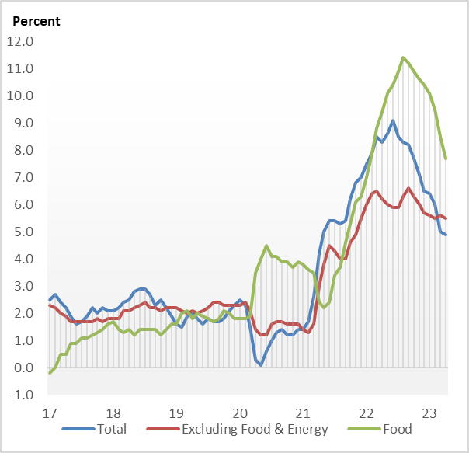

Consumer and Business Sentiment
Consumer and business sentiment measures have deteriorated in recent months, after rallying modestly around the turn of the year on declining energy prices, strong labor markets, and progress in lowering inflation. More recently, concerns about slowing growth, a surprise production cut by OPEC, and tightening credit conditions have eroded measures of consumer mood and business sentiment. The Reuters/Michigan consumer sentiment index trended lower between April 2021 and June 2022, when it reached a record low of 50.0 (series debuted in November 1952). It subsequently fluctuated in a ten-point range, but in January 2023, broke above 60 and remained in that range through April 2023. As of early May, however, the index dropped to 57.7, more than 14 points below the early-pandemic low reached in April 2020.

In The Conference Board’s alternative household survey, the consumer confidence index has remained above the early pandemic low reached in April 2020 but has also fluctuated in a broader range. After reaching 128.9 in June 2021, a level within four points of the pre-pandemic high, this index has trended broadly lower, though to a lesser extent than the Reuters/Michigan index. Over the past nine months, however, the index has remained above 100, and as of April 2023, stood at 101.3, or about 16 points above the early pandemic low.

On the business side, the National Federation of Independent Business’s (NFIB) small business optimism index has trended lower since mid-2021. As of April 2023, the small business optimism index stood at 89.0, dropping 1.9 points below the early pandemic low. This marked the sixteenth consecutive month below the pre-pandemic long-term average of 98.

Federal Budget Deficit and Debt
The federal government’s deficit and debt were trending higher before the pandemic but rose sharply following the multiple fiscal responses to combat the pandemic’s effects on the economy. At the end of fiscal year 2022, the federal government’s budget deficit was $1.38 trillion (5.4 percent of GDP)—down from $2.78 trillion (12.3 percent of GDP) at the end of fiscal year 2021. Despite the decline in the deficit of $1.40 trillion in the most recent fiscal year, the deficit was still up from 4.7 percent of GDP in fiscal year 2019 (i.e. the fiscal year which ended just before the onset of the pandemic in early 2020), and also higher than the 40-year average of 3.8 percent. Federal receipts totaled $4.90 trillion in fiscal year 2022, up $850 billion (21.0 percent) from fiscal year 2021. Net outlays for fiscal year 2022 were $6.27 trillion, down $550 billion (-8.1 percent) from fiscal year 2021, primarily due to the expiration of temporary programs to contain the pandemic and mitigate the impact on families and businesses. In the first seven months of FY 2023 (October 2022 to April 2023), the federal deficit was $925 billion, up $565 billion from the same period in FY 2022.
The Treasury’s borrowing limit was raised to $31.38 trillion in December 2021. At the end of fiscal year 2022, gross federal debt was $30.9 trillion, up from $28.4 trillion at the end of fiscal year 2021. Federal debt held by the public, which includes debt held by the Federal Reserve but excludes federal debt held by government agencies, rose from $22.3 trillion at the end of fiscal year 2021 (98.4 percent of GDP) to $24.3 trillion by the end of fiscal year 2022 (97.1 percent of GDP). On January 19, 2023, the outstanding debt of the United States reached the statutory limit. Once at the debt limit, Treasury began taking extraordinary measures to prevent the United States from default on its obligations. These measures are expected to be exhausted sometime after early June 2023. At the end of April 2023, gross federal debt stood at $31.5 trillion while debt held by the public was $24.6 trillion.

Economic Policy
In late-2021 and early-2022, the objective of public policy turned toward addressing inflation, which was being elevated in part by shifts in consumption behavior from services to goods, supply-chain disruptions, and labor force shortages. Congress’s first bill to build supply-chain resiliency over the long term was the Infrastructure Investment and Jobs Act of 2021, which among its provisions appropriated funds to rebuild deteriorating transportation infrastructure. In addition, the Administration’s Build Back Better framework was modified into a second bill in 2022 that would address other long-run supply-side vulnerabilities, particularly those arising from climate change. On August 16, 2022, President Biden signed the Inflation Reduction Act, which included provisions to reduce health care costs for prescription drugs and health care coverage as well as an additional $370 billion for measures to reduce emissions and substantial deficit reduction through improved tax compliance and closing of tax loopholes.

Persistent inflation prompted the FOMC to launch a new cycle of monetary policy tightening at the March 2022 meeting, when it raised the Federal funds target range 25 basis points to 0.25 to 0.50 percent. At subsequent meetings during the remainder of 2022, the Committee hiked the target range by a further 400 basis points, including four separate and consecutive increases of 75 basis points each as well as a smaller, 50 basis point increase at the December meeting. At the January 31/February 1 meeting, the FOMC began slowing the pace of tightening when it raised the target range by just 25 basis points. It continued to raise the target range in 25 basis point increments at the March and May meetings, bringing the total amount of tightening in the current cycle to 500 basis points and the Federal funds target to a range of 5.0 to 5.25 percent. In the accompanying statement issued on May 3, the Committee observed growth “at a modest pace in the first quarter” and indicated that “job gains have been robust in recent quarters” but also stated that “inflation remains elevated.” The FOMC added that “tighter credit conditions for households and businesses are likely to weigh on economic activity, hiring, and inflation.”

The Federal Reserve also has been reducing its holdings of long-run assets of Treasury securities and mortgage-backed securities (MBS), putting upward pressure on longer-term interest rates. The FOMC’s balance sheet runoff—that is, allowing maturity of longer-term assets without reinvestment—began on June 1, 2022. In September 2022, monthly runoff caps were raised as scheduled to $95 billion ($60 billion for Treasuries and $35 billion for MBS), where they remain.

