Profile of the Economy
(Office of Macroeconomic Analysis)
May 19, 2022
Introduction
Real GDP growth declined in the first quarter of 2022, following a rapid acceleration of 6.9 percent in last year’s final quarter. The outright decline in real GDP was driven by sharp swings in the contributions of net exports and inventory investment, two components which had added strongly to growth in the fourth quarter. However, underlying private final demand accelerated in the first quarter relative to the second half of 2021. Household consumption and business and residential investment grew at healthy rates despite a backdrop which included a resurgence of COVID-19 cases from the Omicron variant, expectations of tightening monetary policy, and Russia’s invasion of Ukraine and the consequent effects on sentiment and prices for oil and food.

Labor market conditions improved further during the first four months of 2022, after making record gains in 2021—including the largest advance in payroll job creation, and the largest drops in the headline and the U-6 (broadest) unemployment rates in a calendar year. With jobs plentiful and workers in short supply, strong nominal wage gains drew more prime-age (ages 25-54) workers back into the labor force.

However, supply-demand mismatches in the economy have driven headline—as well as core—inflation higher thus far in 2022. Rising inflation in 2021 reflected in part elevated demand for goods, originating from high household savings as well as constrained supply due to underinvestment by firms during the pandemic and supply-chain disruptions. These factors continue to influence prices this year, and headline inflation has been further elevated by rising prices for energy and grains related to Russia’s invasion of Ukraine. In addition, the persistence of the pandemic in Asia has further disrupted supply chains, leading to lean inventories and upward pressure on prices. Still, year-over-year core inflation possibly peaked in spring 2022, given the waning severity of the pandemic, federal government efforts to contain energy prices, and an easing of supply bottlenecks in some markets.

A consensus of private forecasters expects real GDP growth to accelerate to 2.8 percent at an annual rate in the second quarter of 2022. On a fourth quarter over fourth quarter basis, GDP growth is expected to be 1.5 percent in 2022.

Economic Growth
According to the advance estimate, real GDP declined by 1.4 percent at an annual rate in the first quarter of 2022, following an unusually rapid 6.9 percent jump in the final quarter of 2021. The slowdown in the first quarter reflected greater domestic demand for imports, higher prices and weaker demand for U.S. exports, slower growth of private inventories, and higher prices for government spending.

By contrast, private domestic demand strengthened in early 2022. Real private domestic final purchases (PDFP)—the sum of personal consumption, business fixed investment, and residential investment—accelerated to a 3.7 percent growth rate at an annual rate during the first quarter, following a 2.6 percent advance in the fourth quarter. By stripping out international trade, government spending, and the volatile inventory component, PDFP is typically a stronger indicator of future GDP increases and represents the private sector’s capacity to generate self-sustaining growth.

Real personal consumption expenditures (PCE)—the largest component of PDFP and roughly two-thirds of real GDP—rose by 2.7 percent in the first quarter on an annualized basis, up slightly from the 2.5 percent increase in the fourth quarter. The first-quarter advance reflected an acceleration in consumption of services, which grew by 4.3 percent and more than offset a 0.1 percent decline in goods purchases. The negligible decline in goods consumption reflected higher purchases of durable goods (particularly of motor vehicles and parts) being fully offset by lower spending on real nondurables—notably gasoline as demand adjusted to the sharp jump in gas prices during the first quarter.

Meanwhile, the continued recovery in services PCE was led by spending on health care services but also reflected strong growth in imputed categories such as shelter and financial services. In addition, consumers returned to pandemic-sensitive sectors, such as travel and recreation services, as the Omicron wave faded throughout the quarter. However, despite the strong growth in services PCE in the first quarter, the composition of total PCE remains weighted more heavily toward goods than services: as of the first quarter of 2022, goods PCE was still over 6 percent higher than the pre-pandemic (2015-2019) trend. By contrast, PCE services was still 4 percent below trend.

Business fixed investment (BFI) jumped up by 9.2 percent at an annual rate in the first quarter, following a 2.9 percent gain in the fourth quarter. Investment in structures remained a drag on growth—albeit a negligible drag—as it slipped 0.9 percent in the first quarter after dropping by 8.3 percent in the fourth quarter. Investment in mining-related structures, including oil and gas wells, continued to increase due to rising energy prices. Meanwhile, surging investment in business equipment and intellectual property products outweighed the slight decline in structures. Equipment investment rose 15.3 percent at an annual rate in the first quarter, and investment in intellectual property products increased 8.1 percent at an annual rate in the first quarter.
Real residential investment—the third and final component of PDFP—rose by 2.1 percent at an annual rate in the first quarter, following a 2.2 percent increase in the previous quarter. As of the early 2022, residential investment was nearly 7 percent above its pre-pandemic trend—even as construction prices have risen sharply since mid-2020. Higher construction costs have been driven in part by disruptions in supply chains for materials as well as shortages of labor.

The change in private inventories (CIPI), a volatile component, posed the second-largest drag on real GDP growth in the first quarter, subtracting 0.8 percentage points, a sharp contrast with the 5.3 percentage-point addition made in the fourth quarter. Although businesses continued to build inventories in the first quarter at a healthy clip, it was at a slower pace than in the fourth quarter. Inventories tend to be a volatile component of GDP; in the first quarter, the slowdown was led by decreases in inventories of wholesale durables trade and other retail stores, which was partly offset by stronger buildup in manufacturers’ inventories.

The trade deficit widened by $191.6 billion to $1,541.7 billion in the first quarter, which imposed the largest drag (3.2 percentage points) of any component on GDP growth. Total exports of goods and services dropped by 5.9 percent at an annual rate, while total imports of goods and services jumped 17.7 percent. Nominal exports rose in the quarter, but real exports fell on a sharp increase in the export price index.

Total government spending declined 2.7 percent at an annual rate in the first quarter, nearly matching the decline in the previous quarter. Federal government consumption and investment accounted for about 80% of the decrease, largely concentrated in national defense purchases—defense spending contracted by 5.9 percent, the fourth consecutive quarterly loss. State and local government consumption declined 0.8 percent in the first quarter, half the decline in the fourth quarter. Like exports, these real declines reflected large increases in price index for government consumption and investment.

Growth of Real GDP
(Quarterly percent change at annual rate)

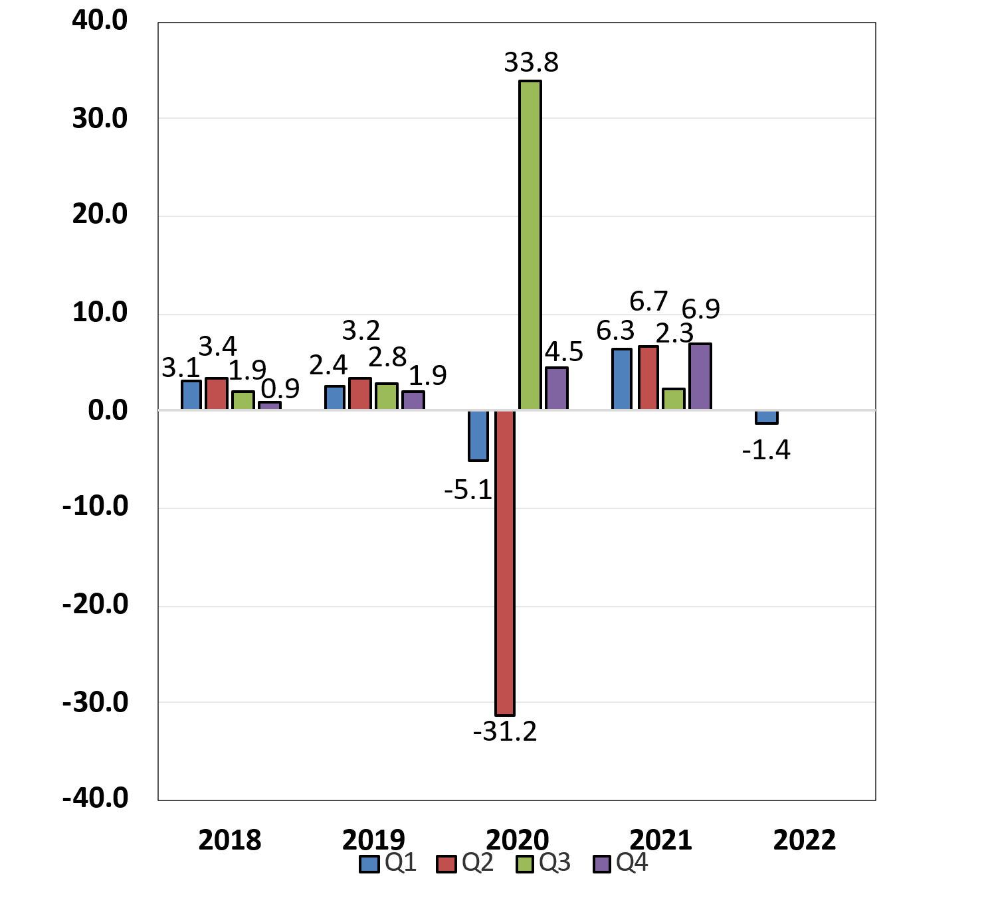

Labor Markets and Wages
In 2021, U.S. labor markets realized robust employment gains and the largest calendar-year drop in the unemployment rate on record; labor market improvement continued during the first quarter of 2022. After generating a record 6.74 million payroll jobs in 2021, the economy added another 2.1 million during the first four months of 2022. As of April, a total of 20.8 million jobs have been recovered during the current recovery, or 95 percent of those lost during the two-month recession in early 2020. Meanwhile, the headline unemployment rate dropped by a record 2.8 percentage points over 2021—the largest drop on record in a single calendar year—to 3.9 percent of the labor force. By April, it stood at 3.6 percent, just 0.1 percentage points above the half-century low registered before the pandemic. The broadest measure of unemployment—the U-6 rate, a measure of labor underutilization that includes underemployment and discouraged workers in addition to the unemployed—also dropped by a record amount (-4.4 percentage points) last year. Thus far in 2022, the U-6 has trended lower and, as of April, stood at 7.0 percent, just two-tenths of a percentage point above its pre-pandemic low. The long-term (27 or more weeks) unemployment rate also declined sharply last year and, as of April 2022, stood at 0.9 percent, or just 0.2 percentage points above the pre-pandemic low.

Recovery in the overall labor force participation rate (LFPR) was somewhat restrained in 2021, related in part to the multiple COVID-19 variants that arose during the year and slower population growth due to increased mortality rates and lower immigration. During the first half of 2021, total LFPR increased by only 0.1 percentage points and by another 0.3 percentage points during the latter half. Recovery in the LFPR continued this year, picking up another 0.3 percentage points to 62.2 percent as of April 2022, but after adjusting for revised population controls published by the Bureau of Labor Statistics, headline LFPR has been little changed because of the pandemic’s effect on specific age groups. By contrast, the prime-age LFPR, which is not as sensitive to the revised population controls, improved significantly, has improved significantly since the end of 2020. In the first half of the year, the prime-age LFPR rose by 0.7 percentage points to 81.7 percent. Although it was rangebound between 81.6 percent and 81.9 for the second six months. the prime-age LFPR has climbed 0.5 percentage points so far in 2022, rising to 82.4 percent as of April—just below the 82.5 percent rate in March 2020 and just 0.7 percentage points below the high of 83.1 percent reached in January 2020.

Progress in participation for older workers has been slower. For those older than 55 years of age, the LFPR stagnated during 2021, ending the year 0.1 percentage points lower. In the first four months of 2022, their LFPR increased by 0.5 percentage points to 38.9 percent, but this is still more than a full percentage point below the 40.1 percent average rate from 2016 to 2019. Further progress in older worker LFPR could support employment growth in 2022.

By some measures, labor markets are even tighter than what headline statistics suggest. According to the Job Openings and Labor Market Turnover Survey (JOLTS), labor demand has been at or near record highs since February 2021. Prior to the pandemic, the number of job openings peaked at 7.42 million at the end of October 2019. By the end of March 2022 (latest available date), job openings were 11.5 million, a fresh series’ high. Despite more rapid improvement in labor force participation, labor supply is still not keeping pace with labor demand, which had helped boost workers’ confidence about job mobility and their leverage in wage negotiations. By the end of March 2022, there were 4.5 million job quits, also a fresh series’ high, and about three-quarters of a million more than the pre-pandemic high. A particularly telling statistic of labor market tightness is the official number of unemployed persons per job openings, which declined to 0.5 by the end of March, implying there are roughly two job openings for every unemployed person. A reading of 0.5 sets a new series’ low and is one-half of the pre-pandemic reading of 1.0

This favorable labor market for workers has led to strong growth in nominal wages. For production and nonsupervisory workers, nominal average hourly earnings increased 6.4 percent over the year through April 2022; twelve-month gains in this measure have remained well above 6.0 percent in each of the past seven months. The Employment Cost Index (ECI), which better controls for changes in labor composition and is a more comprehensive measure of total compensation, showed private sector wages increasing 5.0 percent over the four quarters ending in March 2022, matching the previous quarter’s twelve-month pace as the fastest since the first quarter of 1984. Lower wage occupations and industries continue to see the fastest growth in wages. In leisure and hospitality industries, the ECI for private wage growth jumped 9.0 percent over the year ending in the fourth quarter of 2021, while the retail trade ECI was 7.4 percent higher. Wage growth appears to be outpacing productivity growth, likely contributing to inflation.

Payroll Employment
(Monthly average for year shown and monthly amounts)
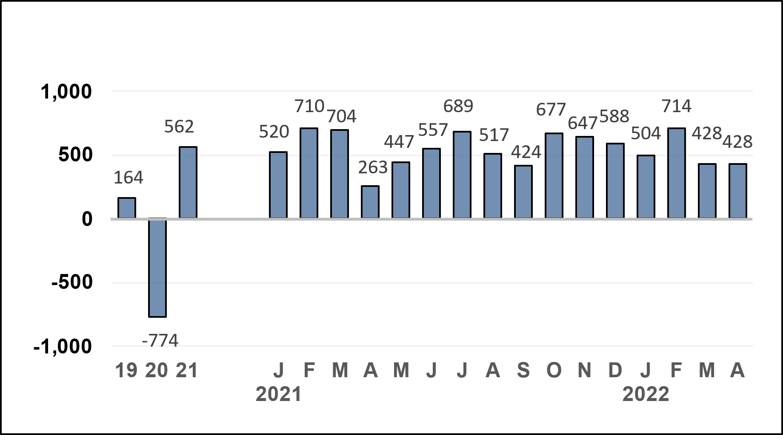

Unemployment Rate
(Percent)
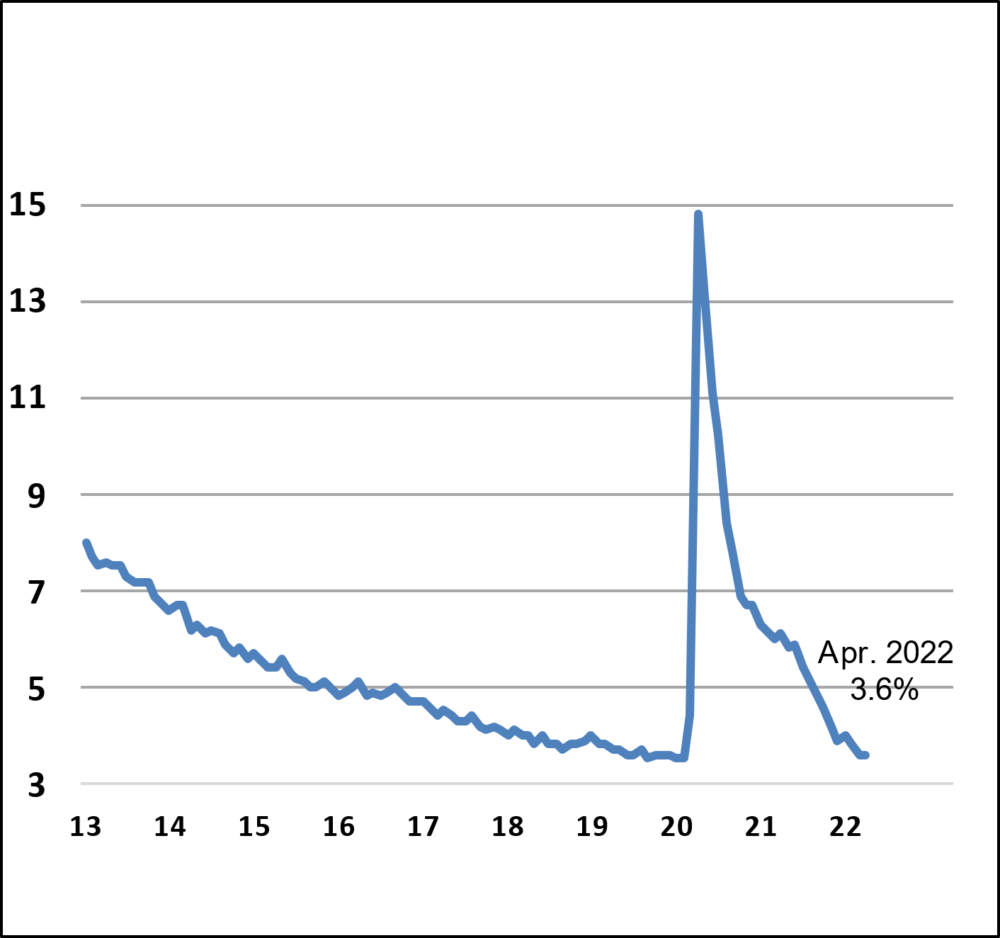

Nonfarm Productivity of Labor

Quarterly productivity growth rates have fluctuated markedly in recent quarters. After advancing 6.3 percent at an annual rate in the final quarter of 2021, productivity dropped 7.5 percent in the first quarter of 2022, reflecting the combination of a 2.4 percent decline in output and a 5.5 percent increase in worker hours. On a year-over-year basis, productivity growth was down 0.6 percent through the first quarter of 2022, swinging from a 3.9 percent, four-quarter increase a year earlier.

Nominal hourly compensation costs in the nonfarm business sector rose 3.2 percent at an annual rate in the first quarter of 2022, after advancing 7.4 percent in the final quarter of 2021. Compensation costs rose at a solid 6.5 percent over the four most recent quarters–picking up from the 6.2 percent year-earlier pace. Unit labor costs, defined as the average cost of labor per unit of output, were up 11.6 percent at an annual rate in the first quarter, escalating sharply from a 1.0 percent gain in the fourth quarter of 2021. These costs were up 7.2 percent over the most recent four quarters, about three times the 2.3 percent pace over the four quarters ending in 2021’s first quarter.

Industrial Production, Manufacturing, and Services
Total industrial production trended higher in 2021, rising 3.5 percent over the year ending December. Total output growth was propelled by an 8.8 percent increase in mining output—largely from increased oil and natural gas extraction and related support activities—and a 3.7 percent gain in manufacturing production.

In 2021, manufacturing output—which accounts for about 74 percent of all industrial output—was hindered by persistent supply-chain disruptions, particularly in the production of motor vehicles and parts.
Over the year ending December 2021, automotive manufacturing output was down 6.5 percent. Supply-chain disruptions have led to volatile production patterns for motor vehicles and parts. Automotive output declined in six months of 2021, and production rarely grew or shrank in consecutive months until the second half of the year. After a combined, nearly 12 percent increase in output over October and November 2021, automotive production trended lower over the next three months, dropping by a combined 4.6 percent through February. By contrast, nonautomotive manufacturing output grew relatively steadily in 2021, ending the year up 4.6 percent from December 2020.

Recently, there have been some signs that supply-chain problems may be easing. In March and April, automotive output jumped by a combined12.5 percent as assemblies of autos and light trucks rebounded from 8.30 million units at an annual rate to 10.26 million units as of April 2022—just below the 10.56 million units produced in 2019 before the pandemic. During the same period, nonautomotive manufacturing production increased by 0.9 percent, with broad-based gains across non-energy industries.

Output at mines, which includes crude oil and natural gas extraction and accounts for 14 percent of industrial output, rose 8.8 percent over 2021, largely due to a 55.0 percent jump in activity supporting the drilling of oil and gas wells. Mining activity is sensitive to energy prices, and the increase in energy prices in 2021 contributed to strong mining output growth. More recently, monthly growth has accelerated with the spike in oil prices in connection with Russia’s illegal invasion of Ukraine. Over the year through April 2021, mining output was up 8.6 percent.

Utilities output, the remaining 12 percent of total industrial output, was up 2.1 percent in April due to unusually cold weather in the month. Weather is usually a factor contributing to swings in this sector; unseasonable weather in months often causes sharp swings in output from one month to the next. Over the 12 months through April, utilities production was up 8.9 percent.

Measures of manufacturing and services business activity in the economy have recovered since summer 2020 and have signaled expansion ever since. Although ISM manufacturing index has trended lower since October 2021, it stood at 55.4 in April 2022, signaling expansion for the twenty-third consecutive month. Similarly, the ISM’s services index rose to 68.4 in November 2021, an all-time high (series dates from July 1997), then declined in each of the subsequent five months, standing at 57.1 in April. The services index also has signaled expansion for twenty-three consecutive months.

Housing Markets
Throughout 2021, housing markets were marked by an imbalance between supply and demand, driving rapid home price growth and eroding affordability. This imbalance has persisted in 2022, further driving up home prices. The Case-Shiller national house price index—which measures sales prices of existing homes—was up 20.2 percent over the year ending in February 2022, a sharp acceleration from the 12.1 percent and 3.5 percent rates seen in February 2021 and February 2020, respectively. The FHFA house price index rose 19.5 percent over the year ending in February 2022 and showed comparable accelerations over the previous two years. Moreover, in each of the past ten months, year-over-year increases in both indices have run between 17 percent and 20 percent.

Last fall, single-family housing starts rose by a combined 10.8 percent from September to December 2021, while single- family housing permits, which signal future starts, increased 6.1percent over that same period.

During the first four months of this year, however, activity has contracted: single-family housing starts declined a combined 4.9 percent from January to April 2022. After jumping 7.1 percent in January 2022, single-family permits also trended lower and, in March and April 2022, fell by a combined 7.9 percent. Even so, single-family starts were 3.7 percent higherover the year through April but permits were down 3.7 percent. Home builder sentiment has also deteriorated so far this year: after rising during the final four months of 2021, the National Association of Home Builder’s confidence index has declined during the first four months of 2022, dropping to 77 in April 2022, 13 points below the series’ high of 90 reached in November 2020. On the other hand, single-family units under construction has risen to a 15-year high of 815,000—suggesting an increase in forthcoming housing supply in this segment of the market—while the number of new housing units that have been authorized, but not yet started (i.e., the backlog of new construction) continued its upward trend, hitting a fresh all-time high of 288,000 units (data begin in 1999).

Sales of homes continued to trend lower during the first four months of 2022. In April, total existing home sales—which account for 90 percent of all home sales—declined 2.4 percent over the month and were down 5.9 percent over the year. After jumping by double-digit rates last November and December, new single-family home sales have declined in each month of the first quarter, falling by 8.6 percent in March (last available data as of May 19). The decline in both existing and new sales has contributed to an increase in inventories of home for sale, which is slowly bringing the housing markets back into balance. After reaching an all-time low last December, existing home inventories rose steadily during the first four months of 2022 to a still-low 1.03 million homes on the market, the equivalent of 2.2 months of sales in April. The inventory of new single-family homes available for sale moved even closer to a balanced market, rising to 407,000 homes in March—equivalent to a 6.4-month supply, which is just above its long-term supply of roughly 6 months.
.

Prices
Starting in early 2021, inflation rates began accelerating markedly, elevated by supply-chain disruptions, persistently high demand for durable goods, rising food prices, a global energy shortage, and (to a lesser extent) the reopening of sectors that had languished during the pandemic—such as travel, leisure, and hospitality. Inflation has continued to accelerate well into 2022, propelled in part by steady growth of shelter costs (rent and imputed rent for homeowners). Russia’s invasion of Ukraine has exacerbated headline inflation as it has severely disrupted energy supply: the price of West Texas Intermediate advanced 10.9 percent from the end of February through mid-May and U.S. retail gasoline price increased 26.2 percent through the mid-May. Supplies of grain from Russia and the Ukraine have also been disrupted, which is likely to exacerbate already-rapid food price inflation.

In April 2022, headline inflation – as measured by the consumer price index (CPI) – was 0.3 percent. This was significantly slower than March’s 1.2 percent rate ,which marked the fastest monthly pace since September 2005. Energy price inflation declined 2.7 percent in April, while food price inflation was 0.9 percent. Core inflation was 0.6 percent in April, reflecting an acceleration in services prices and steady, elevated growth of shelter costs. Shelter price inflation was 0.5 percent in April. On a year-over-year basis, headline and core inflation readings remain quite elevated: CPI inflation was 8.3 percent, and core inflation was 6.2 percent. Twelve-month core inflation has remained above 6.0 percent for four consecutive months. Energy and food price inflation remains brisk as well: the energy price index was up 30.3 percent over the year through April, while food price inflation was 8.3 percent over the past 12 months – the latter was the fastest yearly rate since April 1981.

The headline Personal Consumption Expenditures (PCE) Price Index (the preferred measure for the Federal Open Market Committee (FOMC)’s 2-percent inflation target) rose 6.6 percent over the year through March 2022 (last available data as of May 19), which was the fastest pace since June 1982. Core PCE inflation was 5.2 percent. Prior to March 2021, inflation as measured by the PCE price index had held below the FOMC’s target since November 2018, which contributed to the FOMC adopting a new inflation regime. The flexible average inflation target regime would allow for inflation to exceed 2 percent for some period, such that PCE inflation would average 2 percent over time.

Consumer Prices
(Percent change from a year earlier)
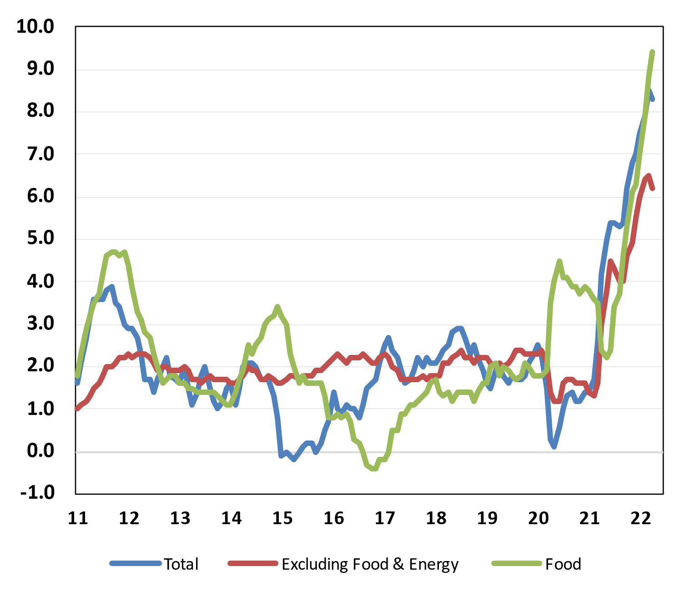

Consumer and Business Sentiment
The Reuters/Michigan consumer sentiment index has trended much lower since April 2021, falling to 59.1 by the early-May survey—that is, it is now nearly 13 points below the pandemic low reached in April 2020. The ongoing decline in the last few months has reflected strong concerns about the persistence of rapid inflation as well as Russia’s illegal invasion of Ukraine and its impact on commodity prices, including oil and grains. In addition, but to a lesser extent, households remain concerned about the novel coronavirus.

The Conference Board’s consumer confidence index has followed a different path than the Michigan survey. The confidence index began a noticeable uptrend in March 2021; by June 2021, it had risen to 128.9, only 3.7 points below its pre-pandemic level. Since then, the index has slowly trended lower and stood at 107.3 in April, but was still 21.6 points above the pandemic low.

On the business side, the National Federation of Independent Business’s (NFIB) small business optimism index has recovered noticeably since the initial months of the pandemic, with the index rising to 104.0 in October 2021 (or only 0.5 points below its level in February 2020). Since then, however, it has trended lower and, as of April 2022, stood at 93.2, its lowest reading in two years.

Federal Budget Deficit and Debt
The federal government’s deficit and debt were trending higher before the pandemic but rose sharply following the multiple fiscal responses to combat the pandemic’s effects on the economy. At the end of fiscal year 2021, the federal government’s budget deficit was $2.78 trillion (12.4% of GDP); although down from $3.13 trillion (15.0% of GDP) at the end of fiscal year 2020, the deficit was still $1.79 trillion higher than in fiscal year 2019. Federal receipts totaled $4.05 trillion in fiscal year 2021, up $626 billion (18.3%) from fiscal year 2020. Net outlays for fiscal year 2021 were $6.82 trillion, up $266 billion (4.1%) from fiscal year 2020, primarily due to the extensive fiscal measures enacted in late 2020 and early 2021 to counter the pandemic’s effects on low- and middle-income households and small businesses. Current fiscal year to date (FYTD), through April, the deficit was to $3.60 trillion, or $1.57 trillion lower than the previous FYTD.
At the end of fiscal year 2021, gross federal debt was $28.4 trillion, up from $26.9 trillion at the end of fiscal year 2020. The Treasury’s borrowing limit was raised to $28.89 trillion in mid-October 2021. Federal debt held by the public, which includes debt held by the Federal Reserve but excludes federal debt held by government agencies, rose from $21.0 trillion at the end of fiscal year 2020 (100.3% of GDP) to $22.3 trillion by the end of fiscal year 2021 (99.7% of GDP). As of April 2022, gross federal debt had increased to $30.4 trillion, and federal debt held by the public had increased to $23.8 trillion.

Economic Policy
The U.S. government responded to the effects of the COVID-19 pandemic with a range of significant countercyclical fiscal and monetary policies, including an unprecedented level of fiscal assistance and a reduction in the key policy interest rate to near-zero. The latest relief package, the American Rescue Plan (ARP) was signed into law spring 2021 by President Biden. The ARP provided an additional $1.9 trillion in economic aid, primarily through Economic Impact Payments and direct aid to low- to middle-income families and to the economically vulnerable. Due to the multiple relief packages in fiscal year (FY) 2021, the federal deficit was $2.78 trillion (12.4 percent of GDP), a moderate improvement from the record-high $3.13 trillion (15.0 percent of GDP) reached in FY 2020. Meanwhile, federal debt held by the public rose to $22.3 trillion in FY 2021, up $1.3 trillion from FY 2022. However, given the strong economic growth in 2021, debt as a share of GDP decreased by 0.5 percentage points to 99.6 percent in FY 2021.

So far this fiscal year (October 2021 to April 2022), the federal deficit has fallen to $360.0 billion, down from $1,931.8 billion over the same period in FY 2021. The decrease has been driven by strong employment growth, which has improved both individual income taxes and payroll taxes above projections, and the phase out of relief packages. As a result, total federal revenues were up by $842.5 trillion for the fiscal year to date and outlays were lower by $729.3 billion. Federal debt for the fiscal year to date has risen by $1.79 trillion to $23.8 trillion.

On the monetary policy side in response to rising inflation and tight labor markets the FOMC launched a new cycle of monetary tightening, raising the target range by 25 basis points to 0.25 to 0.5 percent at the March 15-16 meeting. At the subsequent meeting on May 3-4, the Committee hiked the target range by 50 basis points to a range of 0.75 to 1.0 percent. In its accompanying statement, the FOMC stated that it “anticipates that ongoing increases in the target range will be appropriate.” Elevated rates of inflation were attributed to “supply and demand imbalances related to the pandemic” with “higher energy prices and broader price pressures” cited as additional factors. The statement added that the FOMC “is highly attentive to inflation risks.”

Also at the May 3-4 meeting, the FOMC announced that it will begin reducing holdings of Treasury securities and mortgage-backed securities (MBS). It will allow up to $30 billion of Treasury securities and $17.5 billion of MBS per month to runoff its balance sheet for three months beginning June 1. In September, the caps will be raised to $60 billion for Treasury securities and $35 for MBS.

