**G-Invoicing**

**System Interface**

**Specifications - Push**

A Guide to transmit, insert, and process IGT Buy/Sell Order data in the New G-Invoicing Environment

***Orders***

***Version 2.0***

***June 2018***



**Table of Contents**

1 Introduction 3

1.1 Purpose 3

1.2 Scope 3

1.3 References 3

2 Assumptions/Constraints 3

2.1 Assumptions 3

2.2 Constraints 4

3 Interface Mechanism 4

3.1 Physical Interface 4

3.2 Protocol 4

3.3 Supported Environments 9

4 Interface Specification 10

4.1 Processing Logic 10

4.2 Business Rules 11

4.3 File Naming Convention 13

4.4 Interface Timing 13

4.5 Retransmissions 13

4.6 Interface Data Details 13

5 Error Specifications 17

6 User Interface (UI) Specification 17

7 Security 17

8 Interface Integrity 18

8.1 TWAI 18

8.2 Communication Channel 18

Appendix A: Messaging Protocol & Data Encapsulation 19

# 1 Introduction

## Purpose

This artifact defines the interface specification to define the transmission of Order data between Federal Program Agencies (FPA) and their software providers and the G-Invoicing application. Once approved, it serves as an agreement between G-Invoicing, agencies with interfacing systems, their software provider development teams and Bureau of the Fiscal Service business owners, upon which the system-to-system interface will be based.

## Scope

This artifact defines the G-Invoicing specifications to transmit, insert, and process IGT Buy/Sell Order data and the communication channel that carries these messages. The focus is on the specifications that must be mutually agreed upon by G-Invoicing and agencies with interfacing systems. The G-Invoicing application team owns the maintenance of this document.

## References

The artifacts listed below support the current Production release of this specification and may be downloaded from the provided location. Artifacts that support future enhancements and releases of this specification can be made available upon request.

### The Federal Intragovernmental Data Standards (FIDS) Orders Data Elements

<https://www.fiscal.treasury.gov/fsservices/gov/acctg/g_invoice/g_invoice_home.htm>

### System Mapping and Validation Rules (SM&VR) for Orders, explains how each data element in the FIDS maps to G-Invoicing and the validation rules enforced for each change in status.

### <https://www.fiscal.treasury.gov/fsservices/gov/acctg/g_invoice/g_invoice_home.htm>

### XML Schema Documentation

* Order.xsd
* Order_Documents_Summary.xsd
* Order_Attachment_Push.xsd
* Order_Attachment_Response.xsd
* Order_Error.xsd

### <https://www.fiscal.treasury.gov/data/>

# Assumptions/Constraints

## Assumptions

1. While this artifact represents an agreement by G-Invoicing, Federal Program Agencies and their software providers, it does not imply a release schedule or project plan. Those topics are described by other artifacts for the respective projects and are not referenced here.
2. The interface is limited to the transmission of Order data and associated Attachments inbound from agencies with interfacing systems to G-Invoicing. Additional data types are not included in this interface at this time.

## Constraints

1. This interface will be delivered via web services, access governed by the Treasury Web Application Infrastructure (TWAI), as per agreement between FRB St Louis, the Department of the Treasury Bureau of the Fiscal Service and Defense Logistics Agency (DLA) Transaction Services, and is consistent with the Bureau of the Fiscal Service’s desire to move towards delivering system-to-system interfaces via web services.
   1. Similar operating agreements may be made with other agencies, as-needed.
2. Messages will be sent over the internet utilizing the HTTPS protocol.
3. The Bureau of the Fiscal Service reference data XML Schemas will be published by the Enterprise Data Architecture group at <https://www.fiscal.treasury.gov/data/>. These schemas will be used to format the payload portion of the data transmission.

# Interface Mechanism

## Physical Interface

The G-Invoicing to agency system interface will communicate using HTTPS with 2-way TLS (Transport Layer Security) using a client certificate through the TWAI. The TWAI will employ a web service proxy to serve as a focal route for incoming web service requests so that the web service provider is only configured to receive requests from a single point of origination. The web service response is routed back on the same stream to the initial requestor.

## Protocol

The G-Invoicing to agency system interface will employ a push/pull model utilizing RESTful Services with an XMLpayload. All services below are referenced via URLs in the following format. <https://host-name:port/base-path/resource-path>

**Note:** XML is the U.S. Treasury’s standard data format.

### Host names:

### Production: ws.igt.fiscal.treasury.gov

Quality Assurance Current: qa.ws.igt.fiscal.treasury.gov

Quality Assurance Future: qaf.ws.igt.fiscal.treasury.gov

Functional Test: ft.ws.igt.fiscal.treasury.gov

### Base Path: /ginv

### Resource: /services

***Note:*** *The resource definitions in the tables below specify a System ID parameter that is optional. If an agency trading partner is acting on behalf of an agency system, the System ID is required and must be submitted in the request. The agency system must be authorized for the data that is being requested, otherwise the partner (Agency Partner ID only submitted in the request) must be authorized and System ID would be optional.*

#### Resource: New Order

| **Component** | **Detail / Description** |
| --- | --- |
| **Path** | /ginv/services/v1_0/order |
| **Method** | POST |
| **Description** | Creates a new Order in the System. |
| **Example** | POST /ginv/services/v1_0/order  Host: [ws.igt.fiscal.treasury.gov](http://www.igt.fiscal.treasury.gov) |
| **Parameters** | Name: Accept  Description: Indicates the service client expects content in XML format. No other format is currently supported.  Value: application/xml  Required: true |
| Name: Accept-Encoding  Description: Allows the service client to indicate it supports compressing the response payload using gzip compression.  Value: gzip, deflate  Required: false (highly suggested: if not supplied, server will send back uncompressed response data resulting in a larger payload) |
| Name: Transfer-Encoding  Description: The type of transformation that has been applied to the message body in order to safely transfer it between the sender and the recipient.  Value: chunked  Required: false |
| Name: Connection  Description: Indicates the service client wants to use HTTP keep-alive to more efficiently make multiple requests.  Value: keep-alive  Required: false (highly suggested when making multiple calls. Failure to use keep-alives will slow concurrent calls and strain both the client and server). |
| Name: SystemID  Description: Identifies the system that is exchanging data with G-Invoicing.  In: header  Type: string [100]  Required: false (may be required for partners acting on behalf of agency systems, see Note above for details). |
| Name: Agency-Tracking-Identifier  Description: Unique identifier from agency system, optionally supplied in the request.  In: header  Type: string [50]  Required: false |
| **Consumes** | Required: application/xml |
| **Produces** | Status Code: 200  Description: Successful call returns Call Detail and the newly created Order data.  Content Type: application/xml  Schema: Call Detail, Order |

#### Resource: Update Order

| **Component** | **Detail / Description** |
| --- | --- |
| **Path** | /ginv/services/v1_0/order/<id> |
| **Method** | PUT |
| **Description** | Updates an existing Order referenced by the passed unique identifier <id>. |
| **Example** | PUT /ginv/services/v1_0/order/O1610-017-021-012345  Host: [ws.igt.fiscal.treasury.gov](http://www.igt.fiscal.treasury.gov) |
| **Parameters** | Name: Accept  Description: Indicates the service client expects content in XML format. No other format is currently supported.  Value: application/xml  Required: true |
| Name: Accept-Encoding  Description: Allows the service client to indicate it supports compressing the response payload using gzip compression.  Value: gzip, deflate  Required: false (highly suggested: if not supplied, server will send back uncompressed response data resulting in a larger payload) |
| Name: Transfer-Encoding  Description: The type of transformation that has been applied to the message body in order to safely transfer it between the sender and the recipient.  Value: chunked  Required: false |
| Name: Connection  Description: Indicates the service client wants to use HTTP keep-alive to more efficiently make multiple requests.  Value: keep-alive  Required: false (highly suggested when making multiple calls. Failure to use keep-alives will slow concurrent calls and strain both the client and server). |
| Name: id  Description: A Unique ID referencing an individual Order.  In: path (required)  Type: string [20]  Required: true |
| Name: SystemID  Description: Identifies the system that is exchanging data with G-Invoicing.  In: header  Type: string [100]  Required: false (may be required for partners acting on behalf of agency systems, see Note above for details). |
| Name: Agency-Tracking-Identifier  Description: Unique identifier from agency system, optionally supplied in the request.  In: header  Type: string [50]  Required: false |
| **Consumes** | Required: application/xml |
| **Produces** | Status Code: 200  Description: Successful call returns Call Detail and the newly updated Order data.  Content Type: application/xml  Schema: Call Detail, Order |

#### Resource: New Attachment

| **Component** | **Detail / Description** |
| --- | --- |
| **Path** | /ginv/services/v1_0/order/attachment |
| **Method** | POST |
| **Description** | Creates a new Attachment in the System. |
| **Example** | See Multipart Form-Data example in Appendix A below.  Host: [ws.igt.fiscal.treasury.gov](http://www.igt.fiscal.treasury.gov) |
| **Parameters** | Name: Accept  Description: Indicates the service client expects content in XML format. No other format is currently supported.  Value: application/xml  Required: true |
| Name: Accept-Encoding  Description: Allows the service client to indicate it supports compressing the response payload using gzip compression.  Value: gzip, deflate  Required: false (highly suggested: if not supplied, server will send back uncompressed response data resulting in a larger payload) |
| Name: Transfer-Encoding  Description: The type of transformation that has been applied to the message body in order to safely transfer it between the sender and the recipient.  Value: chunked  Required: false |
| Name: Content-Type  Description: The MIME type of the body of the request  Value: multipart/form-data; boundary=  Required: true  References: [RFC 7578](https://tools.ietf.org/html/rfc7578) |
| Name: Connection  Description: Indicates the service client wants to use HTTP keep-alive to more efficiently make multiple requests.  Value: keep-alive  Required: false (highly suggested when making multiple calls. Failure to use keep-alives will slow concurrent calls and strain both the client and server). |
| Name: SystemID  Description: Identifies the system that is exchanging data with G-Invoicing.  In: header  Type: string [100]  Required: false (may be required for partners acting on behalf of agency systems, see Note above for details). |
| Name: Agency-Tracking-Identifier  Description: Unique identifier from agency system, optionally supplied in the request.  In: header  Type: string [50]  Required: false |
| **Consumes** | Required: application/xml  Optional: application/octet-stream  Schema: Attachment Push |
| **Produces** | Status Code: 200  Description: Successful call returns Call Detail and the Attachment Response data.  Content Type: application/xml  Schema: Call Detail, Attachment Response |

#### Resource: Delete Attachment

| **Component** | **Detail / Description** |
| --- | --- |
| **Path** | /ginv/services/v1_0/order/attachment/<id> |
| **Method** | DELETE |
| **Description** | Deletes an Attachment from the System. |
| **Example** | DELETE /ginv/services/v1_0/order/attachment/1234567890  Host: [ws.igt.fiscal.treasury.gov](http://www.igt.fiscal.treasury.gov) |
| **Parameters** | Name: Accept  Description: Indicates the service client expects content in XML format. No other format is currently supported.  Value: application/xml  Required: true |
| Name: Accept-Encoding  Description: Allows the service client to indicate it supports compressing the response payload using gzip compression.  Value: gzip, deflate  Required: false (highly suggested: if not supplied, server will send back uncompressed response data resulting in a larger payload) |
| Name: Transfer-Encoding  Description: The type of transformation that has been applied to the message body in order to safely transfer it between the sender and the recipient.  Value: chunked  Required: false |
| Name: Connection  Description: Indicates the service client wants to use HTTP keep-alive to more efficiently make multiple requests.  Value: keep-alive  Required: false (highly suggested when making multiple calls. Failure to use keep-alives will slow concurrent calls and strain both the client and server). |
| Name: id  Description: A Unique ID referencing an individual Attachment.  In: path (required)  Type: string [30]  Required: true |
| Name: SystemID  Description: Identifies the system that is exchanging data with G-Invoicing.  In: header  Type: string [100]  Required: false (may be required for partners acting on behalf of agency systems, see Note above for details). |
| Name: Agency-Tracking-Identifier  Description: Unique identifier from agency system, optionally supplied in the request.  In: header  Type: string [50]  Required: false |
| **Consumes** | Required: application/xml  Schema: Attachment Push |
| **Produces** | Status Code: 200  Description: Successful call returns Call Detail data.  Content Type: application/xml  Schema: Call Detail |

## Supported Environments

The G-Invoicing application operates within the Treasury Web Application Infrastructure (TWAI) environments. Interface testing will take place in G-Invoicing’s Functional Test and Quality Assurance environments. G-Invoicing operates both Production and Contingency environments.

Fail-over by G-Invoicing from Production to Contingency environments will be transparent.

**Table 1: Supported Environments**

| **G-Invoicing TWAI** | **Use** |
| --- | --- |
| Functional Test (FT) | Future view of Production (new release) – will be used on a limited basis for interface testing. |
| Quality Assurance - Current (QAC) | Current view of Production environment – used for agency testing. |
| Quality Assurance - Future (QAF) | Future view of Production (new release) – used for UAT. |
| Production | Production |

# Interface Specification

## Processing Logic

The G-Invoicing workflow determines which actions may be executed on an Order based on its current status (state). Diagram 1 (below) shows the various states that an Order may be reported through the API (i.e., states where arrow heads terminate, specifically ‘Shared with Servicing Agency’, ‘Open’, ‘Rejected’ and ‘Closed’).

Also shown are states available though the User Interface but not the API (i.e., ‘Draft’, ‘Pending Requesting Agency Approval’ and ‘Pending Servicing Agency Approval’).

Three swim lanes are shown, presenting the Requesting Agency, the Servicing Agency and any system user authorized to represent both sides of the Order. G-Invoicing will reject any service request which does not conform to the Order States diagram.

**Diagram 1: Order States**



*Note: The G-Invoicing processing states are represented by vertical lines just to the right of the name of each state.There are seven possible states for an Order, four of which are supported by the API.*

**Table 2: Order Processing** (below) summarizes the different types of requests G-Invoicing will accept as an Order moves through its lifecycle. The Requesting and Servicing Agencies actions are limited by the old state, new state, and the permissions of the System User. Rows noted by an asterisk (*) are applicable when one system is authorized to act on behalf of both the Requesting and Servicing Agencies.

**Table 2: Order Processing**

| **Requested By** | **Type of Request** | **Method** | **Current State** | **New State** | **Data Validation Rules** |
| --- | --- | --- | --- | --- | --- |
| Requesting Agency | New Order | POST | N/A | Shared with Servicing Agency | * All required Buyer data in request (see SM&VR) * All Seller data in request will be ignored |
| Servicing Agency | Approved Order | PUT | Shared with Servicing Agency | Open | * All required Seller data in request (see SM&VR) * All Buyer data in request will be ignored |
| Servicing Agency | Rejected Order | PUT | Shared with Servicing Agency | Rejected | * Required data for rejection in request (see SM&VR) * All other Seller data in request will be ignored * Buyer data not in request |
| Requesting Agency | Modified Order | PUT | Open, Rejected or Closed | Shared with Servicing Agency | * All required Buyer data in request (see SM&VR) * Changes detected to buyer data elements (xml) * All Seller data in request will be ignored |
| Requesting Agency | Closed Order | PUT | Open | Closed | * Required data for closure in request (see SM&VR) * All other Buyer data in request will be ignored * All Seller data in request will be ignored |
| * Requesting & Servicing Permissions | Approved Order | POST | N/A | Open | * All required Buyer data in request (see SM&VR) * All required Seller data in request (see SM&VR) |
| * Requesting & Servicing Permissions | Modified Order | PUT | Open or Closed | Open | * All required Buyer data in request (see SM&VR) * All required Seller data in request (see SM&VR) * Change detected to both buyer and seller data elements (xml) |

*Note: Specific data element and state validations may be found in the System Mapping and Data Validation Rules (SM&VR) document referenced in section 1.3.*

## Business Rules

### The agency system must be provisioned for a Data Access Group containing the ALC(s) and other organizational filters for which the data is being processed.

### The agency system must be granted permissions to transmit the type of data being submitted for processing.

### When calling the Update Order resource, agency systems must return the BusinessTransactionIdentifier in the XML payload, thus ensuring they are updating the most recent version of the record.

#### Every change made to an Order will force a new BusinessTransactionIdentifier to be assigned to that record. The BusinessTransactionIdentifier is returned for all Pull and Push Order requests.

#### This new value must be returned by agency systems for all Order actions after initial creation. The BusinessTransactionIdentifier will be validated by G-Invoicing to ensure agencies are taking action against the most recent version of an Order.

#### An out of sequence or invalid BusinessTransactionIdentifier will result in error code 400 – “The transaction ID for this order does not match the latest version. Please request the latest version before updating.”

### Order requests may only be submitted with a DocumentStatusCode of SSA-Shared with Servicing Agency, REC-Open, REJ-Rejected, or CLZ-Closed. Requests submitted with a DocumentStatusCode other than those identified here will be rejected.

### The Servicing Agencies are not allowed to change the data elements belonging to the Requesting Agency and vice-versa. Submission of partner’s data will be ignored.

### For closed Order requests, the Requesting Agency must send only those data identified as required in the SM&VR document. All other data will be ignored. (G-Invoicing business rules prevent the modification and closure of an Order simultaneously).

### For rejected Order requests, the Servicing Agency must send only those data identified as required in the SM&VR document. All other data will be ignored. (G-Invoicing business rules prevent the modification and rejection of an Order simultaneously).

### There are required elements that overlap (section C in Diagram 2). Those elements may be sent by both the Requesting and Servicing Agencies and they will be validated by the System (e.g., LineNumber, ScheduleNumber, OrderNumber). In cases where changes to data elements violate validation rules, the request will be rejected. (See SM&VR document for details).

### There are two scenarios for which a system may submit data for both the Requesting and the Servicing Agency: (a) creating a new Order, advancing it to Open status, and (b) modifying an existing Order, advancing it directly to Open status. To achieve this:

#### The system must be granted permissions for both the Requesting and the Servicing agencies, otherwise, the request will be rejected.

#### All required data for both the Requesting and the Servicing agencies must be submitted, otherwise the request will be rejected.

### Agency Systems are limited to the state changes described in Table 2 (Order Processing). Requests outside of those described in Table 2 will be rejected.

### All requests must be properly formatted and comply with the appropriate schema shown in Appendix A in order to be accepted by G-Invoicing.

### Attachments may be added to, and deleted from, existing Orders using the Attachment service.

### For add Attachment requests, the attachment FileName in the XML payload must exactly match the filename in the Content-Disposition parameter within the multipart form-data.

### The Requesting Agency may logically delete lines and schedules by using the appropriate codes (e.g., A-Active, C-Cancelled) for OrderLineStatusCode and OrderScheduleStatusCode.

#### All lines and schedules must be pushed for an Order, even those that have been logically deleted. (see SM&VR document for line and schedule requirements)

#### Physical deletion of lines or schedules is not permitted. Requests submitted with missing lines or schedules will be rejected.

#### Missing lines or schedules will result in error code 400 – “The lines and schedules provided for this order do not match existing data. Please send all lines and schedules for this order.”

## File Naming Convention

N/A – The only files involved in this interface are the optional attachments which are streamed in the request to G-Invoicing and described by data elements (e.g., file name) in the XML of the request.

## Interface Timing

The web service is available 24 hours per day, 7 days per week. G-Invoicing has a daily scheduled outage for maintenance as noted below.

3:45 AM - 4:15 AM EST (Monday through Saturday)

11:00 AM - 11:30 AM EST (Sunday)

Agency systems are in full control of the frequency and the timing of this interface.

## Retransmissions

N/A – Retransmissions are not needed because the G-Invoicing web services provide for synchronous operation in that the agencies with interfacing systems will be waiting for the response from G-Invoicing before continuing.

Should the web service connection somehow fail in the middle of a series of client requests to G-Invoicing (e.g., multiple Order requests, multiple attachment requests) the client (i.e., interfacing agency system) is responsible for continuing the requests when services are restored.

## Interface Data Details

The documents referenced below, along with the details contained in this interface specification, document the required data for the request type and state of a transaction via these web services. For additional documentation, refer to the XML schemas shown in Appendix A and published on the Fiscal Service Data Registry.

Diagram 2 (below) depicts which of the data exchange participants has the ability to alter and / or send the data being exchanged through this interface. The letters in the diagram (A-C) correspond to a data element in the System Mapping and Validation Rules document (referenced in section 1.3 above). Table 2 (above), Diagram 2 (below) and the System Mapping and Validation Rules will be used together to determine the required data elements for type of request and state of a transaction. The System Mapping and Validation Rules also contain the business rules for each type of request and state at the data element level.

The FIDS (also referenced in section 1.3 above) is the source for all data element specifications (e.g., data type, size, etc.) for this interface and is the system agnostic standard for all IGT Buy/Sell data. The FIDS does contain data elements that can be derived from other data (i.e., calculated values). These derived data elements do not appear in the XML schema.

**Diagram 2: Data Exchange Participants**



### Business – Data Elements

The business data for Orders may be accessed from the Bureau of the Fiscal Service [G-Invoicing website](https://www.fiscal.treasury.gov/fsservices/gov/acctg/g_invoice/g_invoice_home.htm) then clicking the Data Elements – Orders link.

**Table 3: Attatchment Push Data Elements**

| **Familiar Name** | **XML Tag** | **Definition** | **Constraints** | **Optionality** |
| --- | --- | --- | --- | --- |
| Attachment File Name | <FileName> | The actual name of the attachment file. | String [1, 132]  Maximum length = 132  String UTF-8 | Required |
| Attachment File Alias | <FileNameAlias> | Descriptive name for an attachment. Different from the name assigned to the file itself. | String [0,132]  Maximum length = 132  String UTF-8 | Optional |
| Document Number | <DocumentNumber> | Unique identifier for a document to which the attachment will be associated. | String [1, 20]  Maximum length = 20  String UTF-8 | Required |
| Buy Sell Indicator | <BuySellIndicator> | Indicates whether the submitter of the attachment is the buyer (Requesting) or seller (Servicing). | String [1,1]  Maximum length = 1  String UTF-8  Values: “R” – Requesting, “S” – Servicing  **Note:** G-Invoicing will verify that the user has update privileges based on the submitted Buy Sell Indicator and will reject the request if they do not. | Required |

### Response – Data Elements

The data elements in Table 4 below will be returned in the body of every response generated by G-Invoicing.

### Table 4: Call Detail Response Data Elements

| **Familiar Name** | **XML Tag** | **Definition** | **Constraints** | **Optionality** |
| --- | --- | --- | --- | --- |
| Agency Partner ID | <PartnerID> | Identifies the intended recipient of the transmission. | String [100]  Minimum length = 0  Maximum length = 100  String UTF-8 | Required |
| Agency System ID | <SystemID> | Identifies the system that is exchanging data with G-Invoicing. | String [100]  Minimum length = 0  Maximum length = 100  String UTF-8 | Optional |
| Agency Tracking Identifier | <RequestID> | Unique identifier optionally supplied in the request and echoed back in the response. | String [50]  Minimum length = 0  Maximum length = 50  String UTF-8 | Optional |
| G-Invoicing Tracking Identifier | <GINVTrackingID> | Unique tracking identifier, generated by G-Invoicing. | String [50]  Minimum length = 0  Maximum length = 50  String UTF-8 | Required |
| Environment | <Environment> | Describes the environment in which the system interface resides. | String [30]  Minimum length = 0  Maximum length = 30  String UTF-8 | Required |
| Request Type | <RequestType> | Type of request that was submitted to G-Invoicing by the agency system. | String [30]  Minimum length = 0  Maximum length = 30  String UTF-8  Values: “New Order”, “Update Order”, “New Attachment”, “Delete Attachment”.  ***Note:*** *Values are derived from the service that is being accessed.* | Required |
| Record Count | <RecordCount> | The total number of records in the payload. | Integer | Required |

### Table 5: Attachment Response Data Elements

| **Familiar Name** | **XML Tag** | **Definition** | **Constraints** | **Optionality** |
| --- | --- | --- | --- | --- |
| Attachment File Name | <FileName> | The actual name of the attachment file. | String [1, 132]  Maximum length = 132  String UTF-8 | Required |
| Attachment File Alias | <FileNameAlias> | Descriptive name for an attachment. Different from the name assigned to the file itself. | String [0,132]  Maximum length = 132  String UTF-8 | Optional |
| Attachment ID | <AttachmentID> | Unique identifier for an attachment. | Integer  Maximum length = 30 | Required |
| Attachment Updated By | <FullName> | The user name or partner (Buyer or Seller) that uploaded the attachment | String [0,100]  Maximum length = 100  String UTF-8 | Required |
| Attachment Date Time | <UploadDateTime> | The time and date the file was uploaded into G-Invoicing. | DateTime  Format: YYYY-MM-DDThh:mm:ss.SSS+|-00:00  All time should be specified in local time zone with time zone offset from UTC in hours and minutes ahead (+) or behind (-) UTC. | Required |
| File Size | <FileSize> | The size of the attachment expressed in kilobytes (kB). | Integer  Minimum length = 1  Maximum length = 8 | Required |
| Document URL | <URL> | The URL that will be used in a subsequent request by the agency system to retrieve the document. | String [0, 4000]  Maximum length = 4000  String UTF-8 | Required |

# Error Specifications

Standard web service faults are generated for exceptions that can cause the request to not be processed. If the agency system cannot be authenticated or authorized, then a fault is returned. If the requested resource is unavailable then a fault will be thrown. All services may return the following HTTP status codes along with variable error message text describing the error(s) in the response.

| **Error ID** | **HTTP Status Code** | **Example** |
| --- | --- | --- |
| 1 | 400 – Bad Request  ValidationFailedException  ***Note:*** *Message text included in the <ErrorDesc> element will vary depending on the error condition.* | <ns0:ErrorDetail>  <ns0:ErrorDesc>ValidationFailedException message = Requesting agency Point Of Contact Full Name is required.</ns0:ErrorDesc>  <ns0:ErrorTitle>400 ValidationFailedException</ns0:ErrorTitle>  <ns0:RequestDateTime>2018-05-24T15:43:27.578-04:00</ns0:RequestDateTime>  <ns0:RequestTypeIdentifier>Order Create</ns0:RequestTypeIdentifier>  <ns0:Status>400</ns0:Status>  </ns0:ErrorDetail> |
| 2 | 403 – Unauthorized  AccessDeniedException  ***Note:*** *Message text included in the <ErrorDesc> element will vary depending on the error condition.* | <ns0:ErrorDetail>  <ns0:ErrorDesc>AccessDeniedException message = User is not authorized to the system.</ns0:ErrorDesc>  <ns0:ErrorTitle>403 AccessDeniedException</ns0:ErrorTitle>  <ns0:RequestDateTime>2018-05-23T08:33:04.426-04:00</ns0:RequestDateTime>  <ns0:RequestTypeIdentifier>Order Create</ns0:RequestTypeIdentifier>  <ns0:Status>403</ns0:Status>  </ns0:ErrorDetail>  </Ginv_Error> |
| 3 | 500 – Internal Server Error  ServerException  ***Note:*** *Message text included in the <ErrorDesc> element will vary depending on the error condition.* | <ns0:ErrorDetail>  <ns0:ErrorDesc>ServerException message = Multiple users found.</ns0:ErrorDesc>  <ns0:ErrorTitle>500 ServerException</ns0:ErrorTitle>  <ns0:RequestDateTime>2018-05-23T08:29:07.566-04:00</ns0:RequestDateTime>  <ns0:RequestTypeIdentifier>Order Create</ns0:RequestTypeIdentifier>  <ns0:Status>500</ns0:Status>  </ns0:ErrorDetail> |

# User Interface (UI) Specification

N/A

# Security

The TWAI will accept web service traffic, perform certificate-based authentication against security policies, and route the requests to G-Invoicing. Separate certificates are needed for test and production environments.

No Personal Identifying Information (PII) is being transported by this system interface. There is no risk that this interface or the included functions will allow additional access to G-Invoicing data.

The Department of Defense has rated information contained in G-Invoicing as Mission Assurance Category III. The MAC III rating is for systems handling information that is necessary to conduct day-to-day business, but does not materially affect support to deployed or contingency forces in the short-term. The consequences of loss of integrity or availability can be tolerated or overcome without significant impacts on mission effectiveness or operational readiness. The consequences could include the delay or degradation of services or commodities enabling routine activities. Mission Assurance Category III systems require protective measures, techniques or procedures generally commensurate with commercial best practices.

# Interface Integrity

## TWAI

TWAI security infrastructure, policies and procedures guarantee that only authenticated and authorized entities are permitted access to the G-Invoicing application and its assets. Virus detection, intrusion detection, and network and infrastructure monitoring software and hardware are provided by and operated in the TWAI (see TWAI Security Architecture document).

## Communication Channel

Adhere to the Guidelines for protecting sensitive data during electronic dissemination across networks as stated in the NIST Special Publication (SP) 800-52 (rev 1), Selection, Configuration, and Use of Transport Layer Security (TLS) Implementations.

Meet security requirements for NIST Special Publication (SP) 800-53 (rev 4), Recommended Security Controls for Federal Information Systems, and other applicable guidance, such as Treasury Directive Publication (TDP) 85-01.

# Appendix A: Messaging Protocol & Data Encapsulation

### G-Invoicing Message Encapsulation

Transmissions into and out of G-Invoicing will utilize RESTful web-services over the internet with an XML payload. The HTTP Request and Response will have the structure depicted in diagrams in 1.1 and 1.2 below.

The HTTP Request will have an empty Body when the Header contains a “GET” command. When the Request contains a “POST” or “PUT” command the Body will contain an XML payload.

#### **HTTP Request**

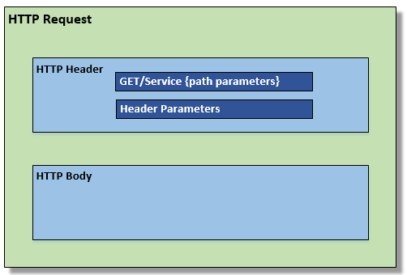

#### **HTTP Response**

Call Detail data will be returned in every response generated by G-Invoicing. Call Detail contains metadata about the Request/Response. The Call Detail data will be part of the HTTP Body and precede any data included in the response that satisfies the initial request.

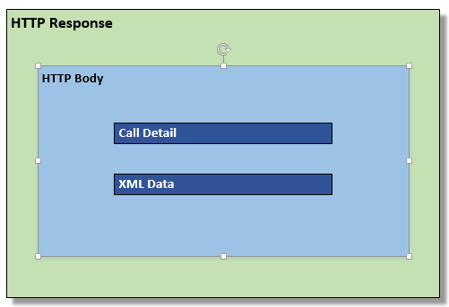

### Order

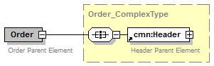

#### Header

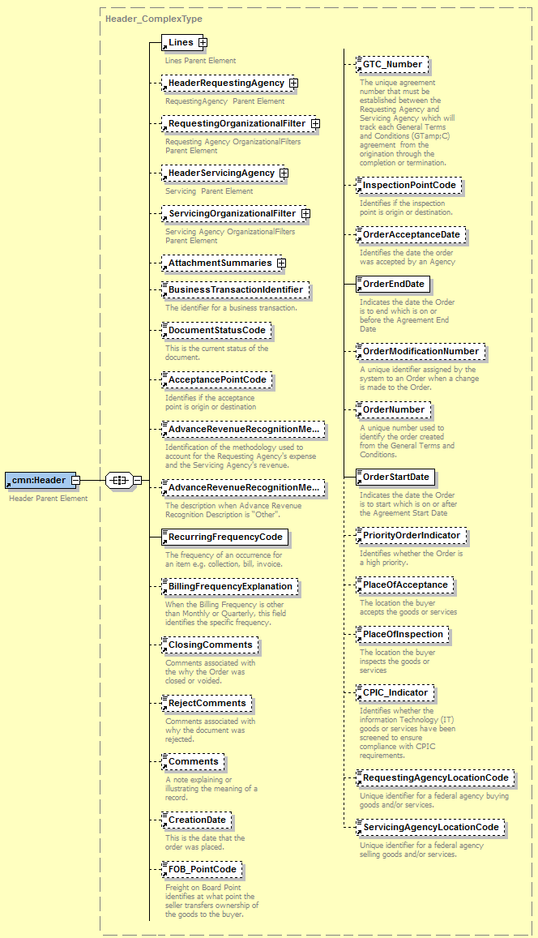

**Header Sample XML**

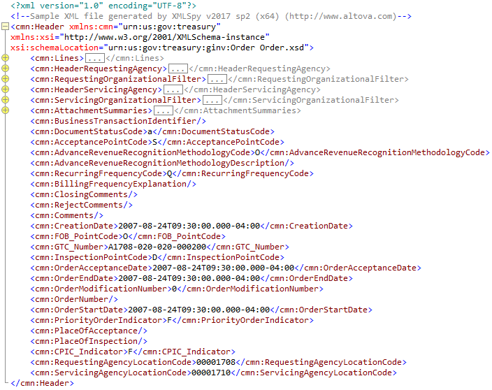

##### **Header Requesting Agency**

Submitted only by the Requesting Agency

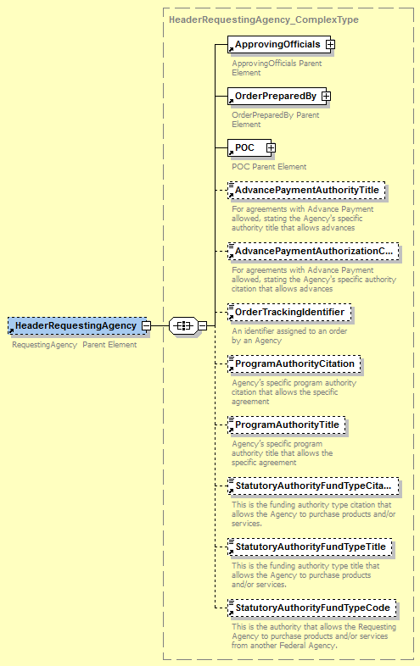

**Header Requesting Agency Sample XML**

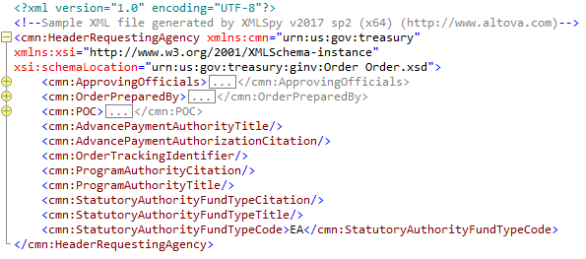

##### **Header Servicing Agency**

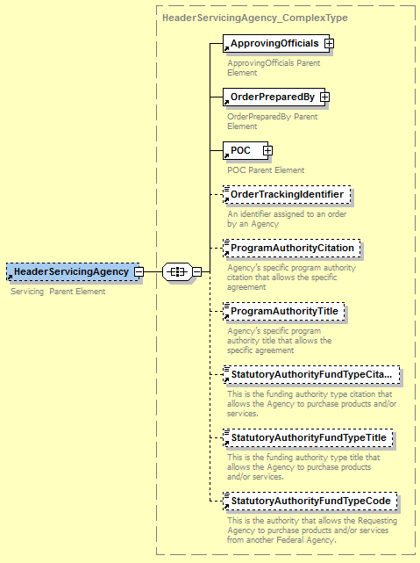Submitted only by the Servicing Agency

**Header Servicing Agency Sample XML**

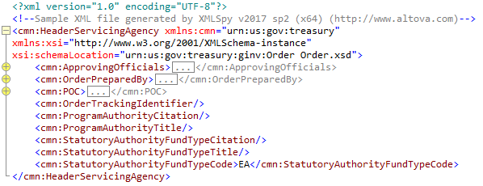

##### **Line**

##### 

##### **Line Sample XML**

##### 

##### **Attachment Summary**

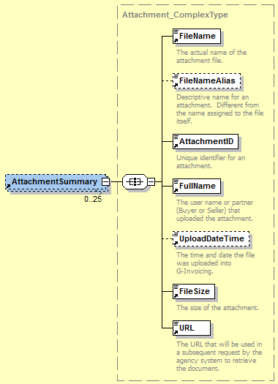

**Attachment Summary Sample XML**

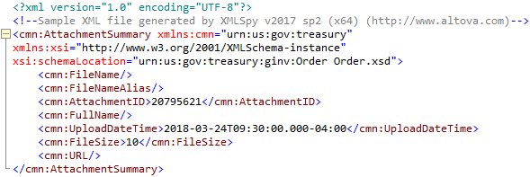

##### **Schedule**

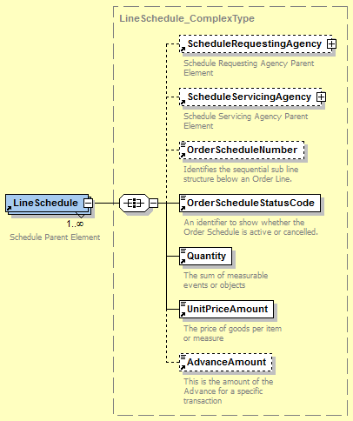

**Schedule Sample XML**

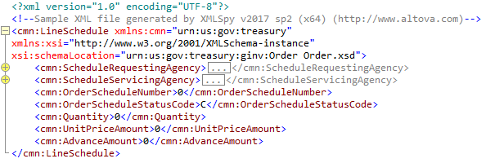

###### **Schedule Requesting Agency**

Submitted only by the Requesting Agency

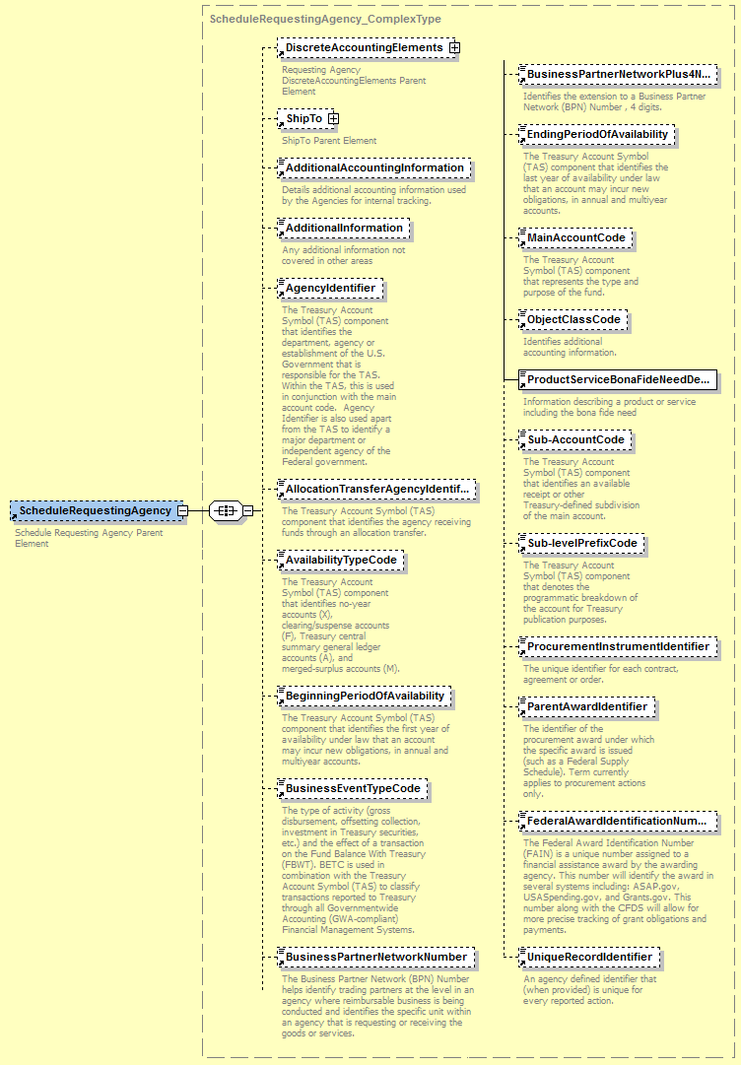

**Schedule Requesting Agency Sample XML**

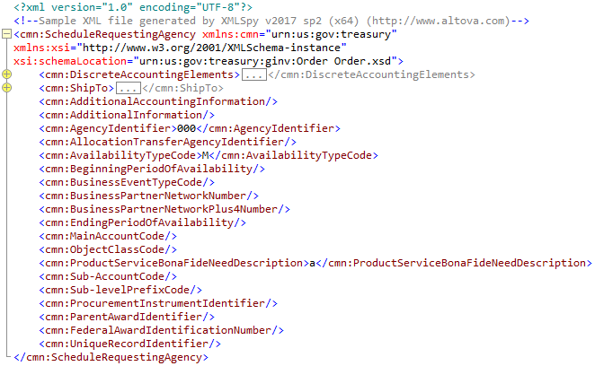

###### **Schedule Servicing Agency**

Submitted only by the Servicing Agency

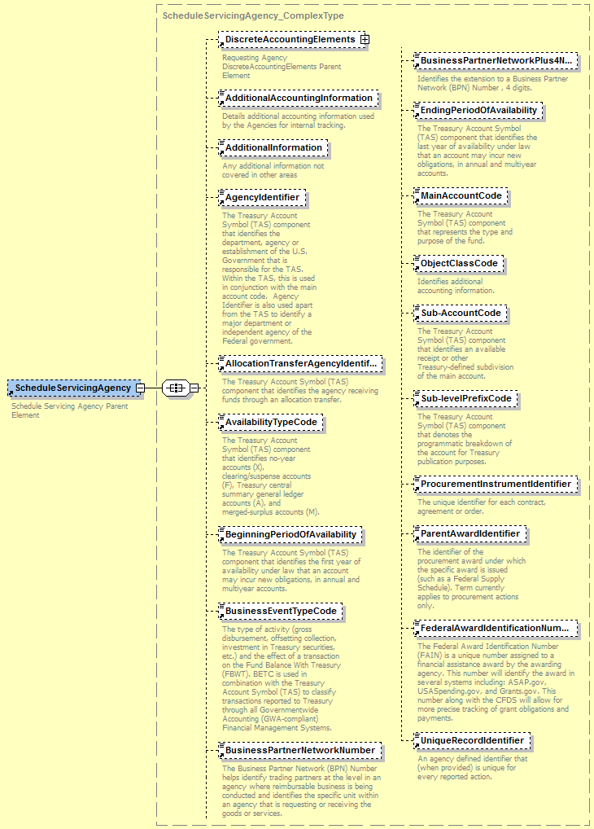

**Schedule Servicing Agency Sample XML**

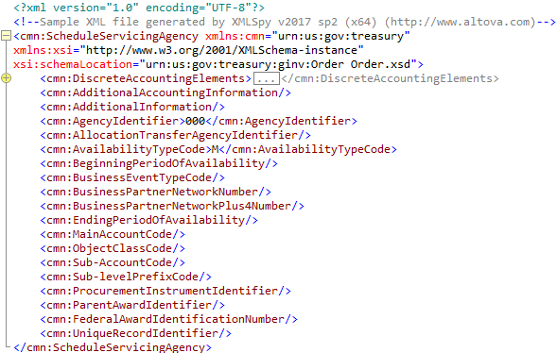

#### **Call Detail**

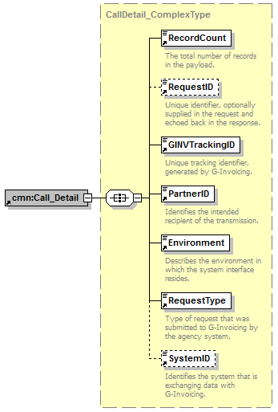

**Call Detail Sample XML**

<?xml version="1.0" encoding="UTF-8"?>

<!--Sample XML file generated by XMLSpy v2017 sp2 (x64) (http://www.altova.com)-->

<cmn:Call_Detail xmlns:cmn="urn:us:gov:treasury" xmlns:xsi="http://www.w3.org/2001/XMLSchema-instance" xsi:schemaLocation="urn:us:gov:treasury:ginv:orders Orders.xsd">

<cmn:RecordCount>0</cmn:RecordCount>

<cmn:RequestID>0</cmn:RequestID>

<cmn:GINVTrackingID>2</cmn:GINVTrackingID>

<cmn:PartnerID>2</cmn:PartnerID>

<cmn:Environment/>

<cmn:RequestType>a</cmn:RequestType>

<cmn:SystemID>0</cmn:SystemID>

</cmn:Call_Detail>

### Error

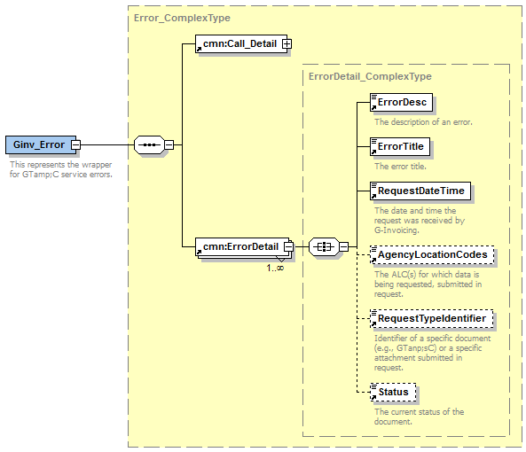

**Error Sample XML**

<?xml version="1.0" encoding="UTF-8"?>

<!--Sample XML file generated by XMLSpy v2017 sp2 (x64) (http://www.altova.com)-->

<cmn:ErrorDetail xmlns:cmn="urn:us:gov:treasury" xmlns:xsi="http://www.w3.org/2001/XMLSchema-instance" xsi:schemaLocation="urn:us:gov:treasury:ginv:error Error.xsd">

<cmn:ErrorDesc/>

<cmn:ErrorTitle/>

<cmn:RequestDateTime>2017-05-09T17:30:00.000Z</cmn:RequestDateTime>

<cmn:AgencyLocationCodes>a</cmn:AgencyLocationCodes>

<cmn:RequestTypeIdentifier>a</cmn:RequestTypeIdentifier>

<cmn:Status>a</cmn:Status>

</cmn:ErrorDetail>

### Attachment

### Attachment Push

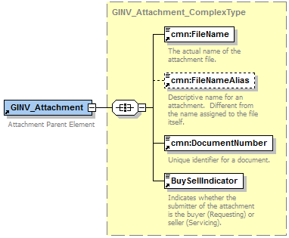

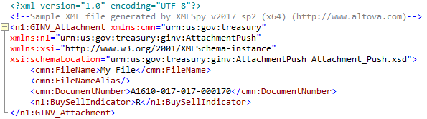**Attachment Push Sample XML**

### Attachment Response



**Attachment Response Sample XML**

### Multipart Form-Data

The following is an example of the multipart form-data when submitting an attachment. The method for submitting an attachment is POST and the DocumentNumber is required in the XML body of the attachment request in order to add the attachment to the appropriate document.

POST /ginv/services/v1_0/order/attachment

Host: www.igt.fiscal.treasury.gov

Accept: application/xml

Accept-Encoding: gzip,deflate

Transfer-Encoding: chunked

Content-Type: multipart/form-data; boundary=wyh0b_2-92vSvGKh-nHe7HA3qyIggPjPG

Connection: Keep-Alive

--wyh0b_2-92vSvGKh-nHe7HA3qyIggPjPG

Content-Disposition: form-data; name="attachment-meta-data"

Content-Type: application/xml

Content-Transfer-Encoding: binary

<?xml version="1.0" encoding="UTF-8"?>

<!--Sample XML file generated by XMLSpy v2017 sp2 (x64) (http://www.altova.com)-->

<n1:GINV_Attachment xmlns:cmn="urn:us:gov:treasury"

xmlns:n1="urn:us:gov:treasury:ginv:OrderAttachmentPush"

xmlns:xsi="http://www.w3.org/2001/XMLSchema-instance"

xsi:schemaLocation="urn:us:gov:treasury:ginv:OrderAttachmentPush Order_Attachment_Push.xsd">

<cmn:FileName>testfile1</cmn:FileName>

<cmn:FileNameAlias>my first test file</cmn:FileNameAlias>

<cmn:DocumentNumber>O1702-3060-3060-0032</cmn:DocumentNumber>

<n1:BuySellIndicator>R</n1:BuySellIndicator>

</n1:GINV_Attachment>

--wyh0b_2-92vSvGKh-nHe7HA3qyIggPjPG

Content-Disposition: form-data; name="attachment-file"; filename="testfile1.txt"

Content-Type: application/octet-stream

Content-Transfer-Encoding: binary

Lorem ipsum dolor sit amet, consectetur adipiscing elit. In aliquet condimentum eleifend. Fusce nec efficitur magna. Duis odio nulla, scelerisque eget efficitur vitae, volutpat nec ex. Aliquam nisl quam, faucibus et tempus nec, accumsan at nibh. Quisque ultrices lacus quis consectetur faucibus. Duis velit dui, venenatis eget nisl ac, volutpat suscipit massa. Nullam cursus lacus quis quam hendrerit, a tristique lorem tristique. Vestibulum malesuada viverra augue at convallis. Curabitur nunc enim, aliquam sit amet fringilla ac, molestie quis nisi. Phasellus maximus vehicula convallis. Nullam fringilla quam placerat magna pulvinar, non ullamcorper tortor dapibus. Nam euismod auctor odio, at rhoncus elit hendrerit eleifend. Fusce aliquam leo non hendrerit ullamcorper. Cras convallis mollis felis, sagittis commodo nulla dictum ut.