**G-Invoicing**

**System Interface**

**Specifications - Pull**

A Guide to extracting, packaging, and transmitting GT&C and Order data in the New G-Invoicing Environment

***General Terms and Conditions (GT&C)***

***Orders***

***Version 3.0***

***June 2018***



Table of Contents

1 Introduction 3

1.1 Purpose 3

1.2 Scope 3

1.3 References 3

2 Assumptions/Constraints 3

2.1 Assumptions 3

2.2 Constraints 4

3 Interface Mechanism 4

3.1 Physical Interface 4

3.2 Protocol 4

3.3 Supported Environments 10

4 Interface Specification 10

4.1 Processing Logic 10

4.2 Business Rules 11

4.3 File Naming Convention 12

4.4 Interface Timing 12

4.5 Retransmissions 12

4.6 Interface Data Details 12

5 Error Specifications 15

6 User Interface (UI) Specification 16

7 Security 16

8 Interface Integrity 17

8.1 TWAI 17

8.2 Communication Channel 17

Appendix A: Messaging Protocol & Data Encapsulation 18

1. Introduction

## Purpose

This artifact defines the interface specification to define the transmission of General Terms & Conditions (GT&C) and Order data between the G-Invoicing application, Federal Program Agencies (FPA) and their software providers. Once approved, it serves as an agreement between G-Invoicing, agencies with interfacing systems, their software provider development teams and Bureau of the Fiscal Service business owners, upon which the system-to-system interface will be based.

## Scope

This artifact defines the G-Invoicing specifications to extract, package and transmit GT&C and Order data and the communication channel that carries these messages. The focus is on the specifications that must be mutually agreed upon by G-Invoicing and agencies with interfacing systems. The G-Invoicing application team owns the maintenance of this document.

## References

The artifacts listed below support the current Production release of this specification and may be downloaded from the provided location. Artifacts that support future enhancements and releases of this specification can be made available upon request.

### The Federal Intragovernmental Data Standards (FIDS) for GT&C and Order Data Elements

<https://www.fiscal.treasury.gov/fsservices/gov/acctg/g_invoice/g_invoice_home.htm>

### System Mapping and Validation Rules (SM&VR) for GT&C and Order, explains how each data element in the FIDS maps to G-Invoicing and the validation rules enforced for each change in status.

<https://www.fiscal.treasury.gov/fsservices/gov/acctg/g_invoice/g_invoice_home.htm>

### XML Schema Documentation

* GTC.xsd
* Order.xsd
* Documents Summary.xsd
* Error.xsd

<https://www.fiscal.treasury.gov/data/>

1. Assumptions/Constraints

## Assumptions

1. While this artifact represents an agreement by G-Invoicing, Federal Program Agencies and their software providers, it does not imply a release schedule or project plan. Those topics are described by other artifacts for the respective projects and are not referenced here.
2. The interface is limited to the transmission of General Terms and Conditions (GT&C) and Order data outbound from G-Invoicing to agencies with interfacing systems. Additional data types are not included in this interface at this time.

## Constraints

1. This interface will be delivered via web services, access governed by the Treasury Web Application Infrastructure (TWAI), as per agreement between FRB St Louis, the Department of the Treasury Bureau of the Fiscal Service and Defense Logistics Agency (DLA) Transaction Services, and is consistent with the Bureau of the Fiscal Service’s desire to move towards delivering system-to-system interfaces via web services.
   1. Similar operating agreements may be made with other agencies, as-needed.
2. Messages will be sent over the internet utilizing the HTTPS protocol.
3. The Bureau of the Fiscal Service reference data XML Schemas will be published by the Enterprise Data Architecture group at <https://www.fiscal.treasury.gov/data/>. These schemas will be used to format the payload portion of the data transmission.
4. Interface Mechanism

## Physical Interface

The G-Invoicing to agency system interface will communicate using HTTPS with 2-way TLS (Transport Layer Security) using a client certificate through the TWAI. The TWAI will employ a web service proxy to serve as a focal route for incoming web service requests so that the web service provider is only configured to receive requests from a single point of origination. The web service response is routed back on the same stream to the initial requestor.

## Protocol

The G-Invoicing to agency system interface will employ a push/pull model utilizing RESTful Services with an XML payload.

All services below are referenced via URLs in the following format.

<https://host-name:port/base-path/resource-path>

### Host names:

### Production: ws.igt.fiscal.treasury.gov

Quality Assurance Current: qa.ws.igt.fiscal.treasury.gov

Quality Assurance Future: qaf.ws.igt.fiscal.treasury.gov

Functional Test: ft.ws.igt.fiscal.treasury.gov

### Base Path: /ginv

### Resource: /services

***Note:*** *The resource definitions in the tables below specify a System ID parameter that is optional. If an agency trading partner is acting on behalf of an agency system, the System ID is required and must be submitted in the request. The agency system must be authorized for the data that is being requested, otherwise the partner (Agency Partner ID only submitted in the request) must be authorized and System ID would be optional.*

#### Resource: GT&C List

| **Component** | **Detail / Description** |
| --- | --- |
| **Path** | /ginv/services/v1_0/gtc/ |
| **Method** | GET |
| **Description** | Returns a list of all GT&Cs from the System that the User is authorized to access. |
| **Example** | GET /ginv/services/v1_0/gtc?agencyLocationCode=17000001,17000002,17000003 &lastModifiedDateTime=2017-05-09T17:30:00.000-04:00  Host: [ws.igt.fiscal.treasury.gov](http://www.igt.fiscal.treasury.gov)  Accept: application/xml  Accept Encoding: gzip, deflate  Connection: Keep-Alive |
| **Parameters** | Name: agencyLocationCode  Description: Limits results to GT&Cs associated with one of the passed ALCs.  In: query  Type: Comma separated array of strings  Required: false |
| Name: status  Description: Limits results of GT&Cs associated with one of the passed status types.  In: query  Type: Comma separated array of strings, enumeration  Values: “REC” (Open For Orders), “CLZ” (Closed), “PND” (Pending Approval), “REJ” (Rejected).  Required: false |
| Name: lastModifiedDateTime  Description: Limits results to GT&Cs updated since the passed date/time.  In: query  Type: dateTime; Format: YYYY-MM-DDThh:mm:ss.SSS+|-00:00  All time should be specified in local time zone with time zone offset from UTC in hours and minutes ahead (+) or behind (-) UTC.  Required: false |
| Name: SystemID  Description: Identifies the system that is exchanging data with G-Invoicing.  In: header  Type: string [100]  Required: false (may be required for partners acting on behalf of agency systems, see Note above for details). |
| Name: Agency-Tracking-Identifier  Description: Unique identifier from agency system, optionally supplied in the request.  In: header  Type: string [50]  Required: false |
| **Consumes** | N/A |
| **Produces** | Status Code: 200  Description: Successful call returns Call Detail and a list of GT&Cs.  Content Type: application/xml  Schema(s): Call Detail, Document List |

#### Resource: Single GT&C by ID

| **Component** | **Detail / Description** |
| --- | --- |
| **Path** | /ginv/services/v1_0/gtc/<id> |
| **Method** | GET |
| **Description** | Returns an individual GT&C referenced by the passed unique RequestType / RequestTypeID combination. |
| **Example** | GET /ginv/services/v1_0/gtc/A1610-017-021-012345  Host: [ws.igt.fiscal.treasury.gov](http://www.igt.fiscal.treasury.gov)  Accept: application/xml  Accept Encoding: gzip, deflate  Connection: Keep-Alive |
| **Parameters** | Name: id  Description: A Unique ID referencing an individual GT&C.  In: path (required)  Type: string [30]  Required: true |
| Name: SystemID  Description: Identifies the system that is exchanging data with G-Invoicing.  In: header  Type: string [100]  Required: false (may be required for partners acting on behalf of agency systems, see Note above for details). |
| Name: Agency-Tracking-Identifier  Description: Unique identifier from agency system, optionally supplied in the request.  In: header  Type: string [50]  Required: false |
| **Consumes** | N/A |
| **Produces** | Status Code: 200  Description: Successful call returns Call Detail and an individual GT&C.  Content Type: application/xml  Schema(s): Call Detail, GT&C |

#### Resource: Single Attachment by ID

| **Component** | **Detail / Description** |
| --- | --- |
| **Path** | /ginv/services/v1_0/attachment/<id>  /ginv/services/v1_0/order/attachment/<id> |
| **Method** | GET |
| **Description** | Returns an individual Attachment referenced by the passed unique ID. |
| **Example** | GET /ginv/services/v1_0/attachment/987654321  GET /ginv/services/v1_0/order/attachment/987654321  Host: [ws.igt.fiscal.treasury.gov](http://www.igt.fiscal.treasury.gov)  Accept: application/xml  Accept Encoding: gzip, deflate  Connection: Keep-Alive |
| **Parameters** | Name: id  Description: A Unique ID referencing an individual Attachment.  In: path  Type: string [30]  Required: true |
| Name: SystemID  Description: Identifies the system that is exchanging data with G-Invoicing.  In: header  Type: string [100]  Required: false (may be required for partners acting on behalf of agency systems, see Note above for details). |
| Name: Agency-Tracking-Identifier  Description: Unique identifier from agency system, optionally supplied in the request.  In: header  Type: string [50]  Required: false |
| **Consumes** | N/A |
| **Produces** | Status Code: 200  Description: Successful call returns the binary content of the Attachment file.  Content Type: application/octet-stream  Schema(s): file |

#### Resource: Orders List

| **Component** | **Detail / Description** |
| --- | --- |
| **Path** | /ginv/services/v1_0/order |
| **Method** | GET |
| **Description** | Returns a list of all Orders from the System that the User is authorized to access. |
| **Example** | GET /ginv/services/v1_0/order?lastModifiedDateTime=2017-05-09T17:30:00.000-04:00  Host: [ws.igt.fiscal.treasury.gov](http://www.igt.fiscal.treasury.gov)  Accept: application/xml  Accept Encoding: gzip, deflate  Connection: Keep-Alive |
| **Parameters** | Name: agencyLocationCode  Description: Limits results to Orders associated with one of the passed ALCs.  In: query  Type: Comma separated array of strings  Required: false |
| Name: status  Description: Limits results of Orders associated with one of the passed status types.  In: query  Type: Comma separated array of strings, enumeration  Values: “SSA” (Shared with Servicing Agency), “REC” (Open), “REJ” (Rejected), “CLZ” (Closed).  Required: false |
| Name: lastModifiedDateTime  Description: Limits results to Orders updated since the passed date/time.  In: query  Type: dateTime; Format: YYYY-MM-DDThh:mm:ss.SSS+|-00:00  All time should be specified in local time zone with time zone offset from UTC in hours and minutes ahead (+) or behind (-) UTC.  Required: false |
| Name: SystemID  Description: Identifies the system that is exchanging data with G-Invoicing.  In: header  Type: string [100]  Required: false (may be required for partners acting on behalf of agency systems, see Note above for details). |
| Name: Agency-Tracking-Identifier  Description: Unique identifier from agency system, optionally supplied in the request.  In: header  Type: string [50]  Required: false |
| **Consumes** | N/A |
| **Produces** | Status Code: 200  Description: Successful call returns Call Detail and a list of Orders.  Content Type: application/xml  Schema(s): Call Detail, Document List |

#### Resource: Single Order by ID

| **Component** | **Detail / Description** |
| --- | --- |
| **Path** | Ginv/services/v1_0/order/<id> |
| **Method** | GET |
| **Description** | Returns an individual Order referenced by the passed unique identifier for an individual Order. |
| **Example** | GET /ginv/services/v1_0/order/O1705-00001700-00001700-000146  Host: [ws.igt.fiscal.treasury.gov](http://www.igt.fiscal.treasury.gov)  Accept: application/xml  Accept Encoding: gzip, deflate  Connection: Keep-Alive |
| **Parameters** | Name: id  Description: A Unique ID referencing an individual Order.  In: path (required)  Type: string [30]  Required: true |
| Name: SystemID  Description: Identifies the system that is exchanging data with G-Invoicing.  In: header  Type: string [100]  Required: false (may be required for partners acting on behalf of agency systems, see Note above for details). |
| Name: Agency-Tracking-Identifier  Description: Unique identifier from agency system, optionally supplied in the request.  In: header  Type: string [50]  Required: false |
| **Consumes** | N/A |
| **Produces** | Status Code: 200  Description: Successful call returns Call Detail and an individual Order.  Content Type: application/xml  Schema(s): Call Detail, Order |

### Common Headers

#### Accept Header

| **Component** | **Detail / Description** |
| --- | --- |
| **Name** | Accept |
| **Value** | application/xml |
| **Description** | Indicates the service client expects content in XML format. No other format is currently supported. |

#### Accept-Encoding

| **Component** | **Detail / Description** |
| --- | --- |
| **Name** | Accept-Encoding |
| **Value** | gzip, deflate |
| **Description** | Allows the service client to indicate it supports compressing the response payload using gzip compression. |

#### Connection Header

| **Component** | **Detail / Description** |
| --- | --- |
| **Name** | Connection |
| **Value** | keep-alive |
| **Description** | Indicates the service client wants to use HTTP keep-alive to more efficiently make multiple requests. |

## Supported Environments

The G-Invoicing application operates within the Treasury Web Application Infrastructure (TWAI) environments. Interface testing will take place in G-Invoicing’s Functional Test and Quality Assurance environments. G-Invoicing operates both Production and Contingency environments.

Fail-over by G-Invoicing from Production to Contingency environments will be transparent.

**Table 1: Supported Environments**

| **G-Invoicing TWAI** | **Use** |
| --- | --- |
| Functional Test (FT) | Future view of Production (new release) – will be used on a limited basis for interface testing. |
| Quality Assurance - Current (QAC) | Current view of Production environment – used for agency testing. |
| Quality Assurance - Future (QAF) | Future view of Production (new release) – used for UAT. |
| Production | Production |

1. Interface Specification

## Processing Logic

### Agencies with interfacing systems will make a web service call to G-Invoicing to request new or modified GT&C and Order information. The credentials for the agency systems are verified by the TWAI. Certificate-based authentication is performed against TWAI policies. Web service requests for G-invoicing data require a United States Department of the Treasury issued certificate.

### Validate the parameters that are passed in the request depending on the data being requested (e.g., Document List, Single Document, Single Attachment) as stated in Section 3.2 of this document. The parameters to be passed are either required, optional, and/or conditional depending on the request.

### G-Invoicing will retrieve the requested data.

### The data is formatted into an XML document per the XML schema(s) referenced in Appendix A of this document.

### G-Invoicing transmits the data to the agency system.

### If errors are encountered at any time while processing the request, G-Invoicing will capture that data and respond back to the agency partner with the error details.

## Business Rules

### All system requests for GT&C, Order and Attachment data will be fulfilled with data as it exists when the request is answered.

***Note:*** *This statement covers any previous or historical states that a document would have been in prior to its current state. G-Invoicing will not provide a document history (i.e., multiple versions of the same document).*

### The agency system must be provisioned for a Data Access Group containing the ALC(s) and other organizational filters for which the data is being requested.

#### An agency system only requires access to one side of the agreement (Requesting or Servicing) not both to view all data associated with the agreement; this includes attachments. The agency system will be properly authorized to ensure it is valid for the type of request being submitted.

### The agency system must be granted permissions to view the type of data being requested.

### Document requests submitted with a Status parameter of “Draft” or “Delete” will not be fulfilled.

### Requests for Document Types submitted without a Status parameter will return documents in all statuses with the exception of “Draft” and “Delete”. The System will filter these Status Codes and prevent them from being returned in the result set.

***Note:*** *This is an implicit filter that will prevent any documents from being sent to agencies that are in “Draft” or “Delete” status.*

### Document requests submitted with a Status parameter of “Pending Requesting Agency Approval” will not be fulfilled. Orders may only be pulled by the Servicing agency when they have been fully approved by the Requesting agency.

### Character entity references ampersand (&) and less than (<) are escaped on output to XML. The escape sequence for ampersand is &amp; and the escape sequence for less than is &lt;.

## File Naming Convention

N/A

## Interface Timing

The web service is available 24 hours per day, 7 days per week. G-Invoicing has a daily scheduled outage for maintenance as noted below.

3:45 AM - 4:15 AM EST (Monday through Saturday)

11:00 AM - 11:30 AM EST (Sunday)

Agency systems are in full control of the frequency and the timing of this interface.

## Retransmissions

Retransmissions are not needed because the G-Invoicing web services provide for synchronous operation in that the agencies with interfacing systems will be waiting for the response from G-Invoicing before continuing.

Should the web service connection somehow fail in the middle of a series of client requests to G-Invoicing (e.g., multiple document requests, multiple attachment requests) the client (i.e., interfacing agency system) is responsible for continuing the requests when services are restored.

## Interface Data Details

The information below documents the data sent for the methods available on the web service. For more details, refer to the XML schemas for the service in Appendix A.

### Business – Data Elements

The business data for GT&C and Orders may be accessed on the [Bureau of the Fiscal Service G-Invoicing](https://www.fiscal.treasury.gov/fsservices/gov/acctg/g_invoice/g_invoice_home.htm) website.

The data elements in Table 2 will be returned with each single GT&C and single Order request where the requested GT&C or Order contains one or more attachments. This data describes each attachment and provides the means (i.e., URL) for a subsequent request to retrieve the attachment(s).

### Table 2: Attachment Summary Data Elements

| **Familiar Name** | **XML Tag** | **Definition** | **Constraints** | **Optionality** |
| --- | --- | --- | --- | --- |
| Attachment File Name | <FileName> | The actual name of the attachment file. | String [1, 32]  Maximum length = 132  String UTF-8 | Required |
| Attachment File Alias | <FileNameAlias> | Descriptive name for an attachment. Different from the name assigned to the file itself. | String [0,132]  Maximum length = 132  String UTF-8 | Optional |
| Attachment ID | <AttachmentID> | Unique identifier for an attachment. | Integer  Maximum length = 30 | Required |
| Attachment Updated By | <FullName> | The username or partner (Buyer or Seller) that uploaded the attachment. | String [0,100]  Maximum length = 100  String UTF-8 | Required |
| Attachment Date Time | <UploadDateTime> | The date and time the file was uploaded into G-Invoicing. | DateTime  Format: YYYY-MM-DDThh:mm:ss.SSS+|-00:00  All time should be specified in local time zone with time zone offset from UTC in hours and minutes ahead (+) or behind (-) UTC. | Required |
| File Size | <FileSize> | The size of the attachment expressed in kilobytes (kB). | Integer  Minimum length = 1  Maximum length = 8 | Required |
| Document URL | <URL> | The URL that will be used in a subsequent request by the agency system to retrieve the attachment. | String [0, 4000]  Maximum length = 4000  String UTF-8 | Required |

### Response – Data elements

The data elements below in Table 3 will be returned in the body of every response generated by G-Invoicing. The data elements contained in Table 4 will be returned when requesting a list of new or modified documents from G-Invoicing.

### Table 3: Call Detail Response Data Elements

| **Familiar Name** | **XML Tag** | **Definition** | **Constraints** | **Optionality** |
| --- | --- | --- | --- | --- |
| Agency Partner ID | <PartnerID> | Identifies the intended recipient of the transmission. | String [100]  Minimum length = 0  Maximum length = 100  String UTF-8 | Required |
| Agency System ID | <SystemID> | Identifies the system that is exchanging data with G-Invoicing. | String [100]  Minimum length = 0  Maximum length = 100  String UTF-8 | Optional |
| Agency Tracking Identifier | <RequestID> | Unique identifier, optionally supplied in the request and echoed back in the response. | String [50]  Minimum length = 0  Maximum length = 50  String UTF-8 | Optional |
| G-Invoicing Tracking Identifier | <GINVTrackingID> | Unique tracking identifier, generated by G-Invoicing. | String [50]  Minimum length = 1  Maximum length = 50  String UTF-8 | Required |
| Environment | <Environment> | Describes the environment in which the system interface resides. | String [30]  Minimum length = 0  Maximum length = 30  String UTF-8  Values: “Production”, “Quality Assurance”, “Functional Test”. | Required |
| Request Type | <RequestType> | Type of request that was submitted to G-Invoicing by the agency system. | String [30]  Minimum length = 0  Maximum length = 30  String UTF-8  Values: “GTC List”, “Order List”, “Single GTC”, “Single Order”, “Single Attachment”.  ***Note:*** *Values are derived from the service that is being accessed.* | Required |
| Record Count | <RecordCount> | The total number of records in the payload. | Integer  Minimum length = 1  Maximum length = 8 | Required |

### Table 4: Document List Data Elements

| **Familiar Name** | **XML Tag** | **Definition** | **Constraints** | **Optionality** |
| --- | --- | --- | --- | --- |
| Requesting Agency Location Code | <RequestingAgencyLocationCode> | Unique identifier for a federal agency buying goods and/or services. | String [0-9]{8}  (i.e., Digits 0 to 9. Length must be eight digits.)  String UTF-8. | Required |
| Servicing Agency Location Code | <ServicingAgencyLocationCode> | Unique identifier for a federal agency selling goods and/or services. | String [0-9]{8}  (i.e., Digits 0 to 9. Length must be eight digits.)  String UTF-8. | Required |
| Document Type | <DocumentType> | Describes the document type (e.g., GT&C, Order) that was requested. | String [30]  Minimum length = 0  Maximum length = 30  String UTF-8  Values: “GTC”, “Order” | Required |
| Manual Entry Indicator | <Manual EntryIndicator> | This indicator determines whether the document was introduced by a user or a system. | String  Enumeration: “Y” (Yes), “N” (No)  “Y” indicates System generated  “N” indicates User generated | Required |
| Document ID | <DocumentNumber> | Unique identifier for a document. | String [20]  Minimum length = 0  Maximum length = 20  String UTF-8 [A-Z, 0-9, -]  (i.e., upper case alpha characters, digits 0-9, and dashes.) | Required |
| Modification Number | <ModificationNumber> | Unique identifier assigned to a document that has been modified form the original. | Integer  Maximum length = 10 | Conditional |
| Status | <Status> | The current status of the document. | String  Enumeration  Maximum length = 3  **Valid GT&C Status Codes**  “REC” (Open For Orders), “CLZ” (Closed), “PND” (Pending Approval), “REJ” (Rejected).  **Valid Order Status Codes**  “SSA” (Shared with Servicing Agency), “REC” (Open), “REJ” (Rejected), “CLZ” (Closed) | Required |
| Last Modified Date/Time | <LastModifiedDateTime> | The date/time the document was last modified. | DateTime  Format: YYYY-MM-DDThh:mm:ss.SSS+|-00:00  All time should be specified in local time zone with time zone offset from UTC in hours and minutes ahead (+) or behind (-) UTC. | Required |
| Document URL | <URL> | The URL that will be used in a subsequent request by the agency system to retrieve the document. | String [4000]  Minimum length = 0  Maximumlength = 4000  String UTF-8 | Required |

1. Error Specifications

Standard web service faults are generated for exceptions that can cause the request to not be processed. If the agency system cannot be authenticated or authorized, then a fault is returned. If the requested resource is unavailable then a fault will be thrown. All services may return the following HTTP status codes along with variable error message text describing the error(s) in the response.

| **Error ID** | **HTTP Status Code** | **Example** |
| --- | --- | --- |
| 1 | 400 – Bad Request  ValidationFailedException  ***Note:*** *Message text included in the <ErrorDesc> element will vary depending on the error condition.* | <ns0:ErrorDetail>  <ns0:ErrorDesc>ValidationFailedException message = Requesting agency Point Of Contact Full Name is required.</ns0:ErrorDesc>  <ns0:ErrorTitle>400 ValidationFailedException</ns0:ErrorTitle>  <ns0:RequestDateTime>2018-05-24T15:43:27.578-04:00</ns0:RequestDateTime>  <ns0:RequestTypeIdentifier>Order Create</ns0:RequestTypeIdentifier>  <ns0:Status>400</ns0:Status>  </ns0:ErrorDetail> |
| 2 | 403 – Unauthorized  AccessDeniedException  ***Note:*** *Message text included in the <ErrorDesc> element will vary depending on the error condition.* | <ns0:ErrorDetail>  <ns0:ErrorDesc>AccessDeniedException message = User is not authorized to the system.</ns0:ErrorDesc>  <ns0:ErrorTitle>403 AccessDeniedException</ns0:ErrorTitle>  <ns0:RequestDateTime>2018-05-23T08:33:04.426-04:00</ns0:RequestDateTime>  <ns0:RequestTypeIdentifier>Order Create</ns0:RequestTypeIdentifier>  <ns0:Status>403</ns0:Status>  </ns0:ErrorDetail>  </Ginv_Error> |
| 3 | 500 – Internal Server Error  ServerException  ***Note:*** *Message text included in the <ErrorDesc> element will vary depending on the error condition.* | <ns0:ErrorDetail>  <ns0:ErrorDesc>ServerException message = Multiple users found.</ns0:ErrorDesc>  <ns0:ErrorTitle>500 ServerException</ns0:ErrorTitle>  <ns0:RequestDateTime>2018-05-23T08:29:07.566-04:00</ns0:RequestDateTime>  <ns0:RequestTypeIdentifier>Order Create</ns0:RequestTypeIdentifier>  <ns0:Status>500</ns0:Status>  </ns0:ErrorDetail> |

1. User Interface (UI) Specification

N/A

1. Security

The TWAI will accept web service traffic, perform certificate-based authentication against security policies, and route the requests to G-Invoicing. Separate certificates are needed for test and production environments.

No Personal Identifying Information (PII) is being transported by this system interface. There is no risk that this interface or the included functions will allow additional access to G-Invoicing data.

The Department of Defense has rated information contained in G-Invoicing as Mission Assurance Category III. The MAC III rating is for systems handling information that is necessary to conduct day-to-day business, but does not materially affect support to deployed or contingency forces in the short-term. The consequences of loss of integrity or availability can be tolerated or overcome without significant impacts on mission effectiveness or operational readiness. The consequences could include the delay or degradation of services or commodities enabling routine activities. Mission Assurance Category III systems require protective measures, techniques or procedures generally commensurate with commercial best practices.

1. Interface Integrity

## TWAI

TWAI security infrastructure, policies and procedures guarantee that only authenticated and authorized entities are permitted access to the G-Invoicing application and its assets. Virus detection, intrusion detection, and network and infrastructure monitoring software and hardware are provided by and operated in the TWAI (see TWAI Security Architecture document).

## Communication Channel

Adhere to the Guidelines for protecting sensitive data during electronic dissemination across networks as stated in the NIST Special Publication (SP) 800-52 (rev 1), Selection, Configuration, and Use of Transport Layer Security (TLS) Implementations.

Meet security requirements for NIST Special Publication (SP) 800-53 (rev 4), Recommended Security Controls for Federal Information Systems, and other applicable guidance, such as Treasury Directive Publication (TDP) 85-01.

# Appendix A: Messaging Protocol & Data Encapsulation

1. G-Invoicing Message Encapsulation

Transmissions into and out of G-Invoicing will utilize RESTful web-services over the internet with an XML payload. The HTTP Request and Response will have the structure depicted in diagrams in 1.1 and 1.2 below.

**Note:** The G-Invoicing framework will output empty XML tags when elements do not contain data.

HTTP Request

The HTTP Request will have an empty Body when the Header contains a “GET” command. When the Request contains a “PUT” command the Body will contain an XML payload.

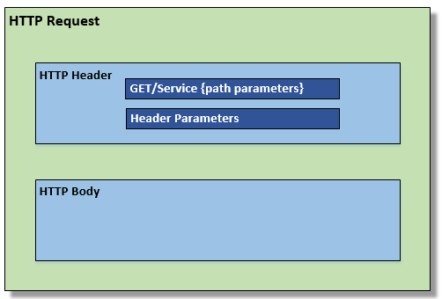

HTTP Response

Call Detail data will be returned in every response generated by G-Invoicing with the exception of the individual attachment download. Call Detail contains metadata about the Request/Response. The Call Detail data will be part of the HTTP Body and precede any data included in the response that satisfies the initial request.

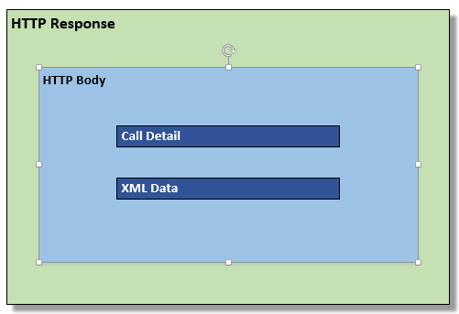

1. Call Detail

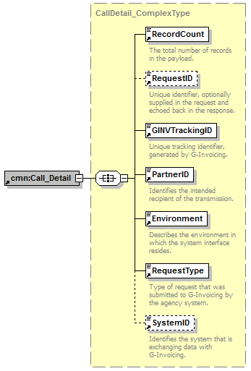

#### **Call Detail Sample XML**

<?xml version="1.0" encoding="UTF-8"?>

<!--Sample XML file generated by XMLSpy v2017 sp2 (x64) (http://www.altova.com)-->

<cmn:Call_Detail xmlns:cmn="urn:us:gov:treasury" xmlns:xsi="http://www.w3.org/2001/XMLSchema-instance" xsi:schemaLocation="urn:us:gov:treasury:ginv:gtc GTC.xsd">

<cmn:RecordCount>50</cmn:RecordCount>

<cmn:RequestID>277655239</cmn:RequestID>

<cmn:GINVTrackingID>3357822214</cmn:GINVTrackingID>

<cmn:PartnerID>1789</cmn:PartnerID>

<cmn:Environment>Production</cmn:Environment>

<cmn:RequestType>Single GTC</cmn:RequestType>

<cmn:SystemID>789</cmn:SystemID>

</cmn:Call_Detail>

1. Document List

#### 

**Document List Sample XML**

<?xml version="1.0" encoding="UTF-8"?>

<!--Sample XML file generated by XMLSpy v2017 sp2 (x64) (http://www.altova.com)-->

<cmn:DocumentList xmlns:cmn="urn:us:gov:treasury" xmlns:xsi="http://www.w3.org/2001/XMLSchema-instance" xsi:schemaLocation="urn:us:gov:treasury:ginv:documents Documents_Summary.xsd">

<cmn:Document>

<cmn:DocumentNumber>A1610-017-017-000170</cmn:DocumentNumber>

<cmn:Status>REC</cmn:Status>

<cmn:LastModifiedDateTime>2017-08-28T14:05:37.534-04:00</cmn:LastModifiedDateTime>

<cmn:URL>https://host-name:port/base-path/resource-path</cmn:URL>

<cmn:RequestingAgencyLocationCode>00005023</cmn:RequestingAgencyLocationCode>

<cmn:ServicingAgencyLocationCode>00005197</cmn:ServicingAgencyLocationCode>

<cmn:DocumentType>GTC</cmn:DocumentType>

<cmn:ModificationNumber/>

<cmn:ManualEntryIndicator>Y</cmn:ManualEntryIndicator>

</cmn:Document>

</cmn:DocumentList>

1. 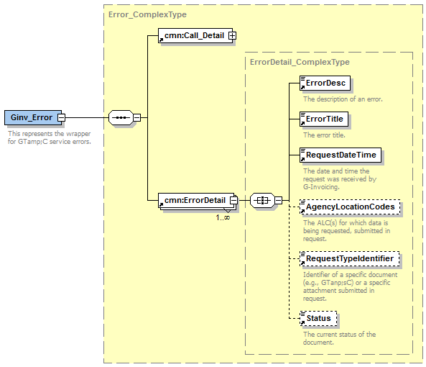Error

**Error Sample XML**

<?xml version="1.0" encoding="UTF-8"?>

<!--Sample XML file generated by XMLSpy v2017 sp2 (x64) (http://www.altova.com)-->

<cmn:ErrorDetail xmlns:cmn="urn:us:gov:treasury" xmlns:xsi="http://www.w3.org/2001/XMLSchema-instance" xsi:schemaLocation="urn:us:gov:treasury:ginv:error Error.xsd">

<cmn:ErrorDesc>Unknown GTC ID provided. Correct and resubmit.</cmn:ErrorDesc>

<cmn:ErrorTitle>400 Unknown GTC ID</cmn:ErrorTitle>

<cmn:RequestDateTime>2017-08-28T14:05:37.534-04:00</cmn:RequestDateTime>

<cmn:AgencyLocationCodes>00008501,00008502</cmn:AgencyLocationCodes>

<cmn:RequestTypeIdentifier/>

<cmn:Status>PND</cmn:Status>

</cmn:ErrorDetail>

1. 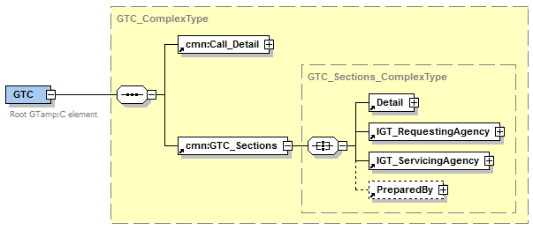GT&C

Detail

#### 

#### **Detail Sample XML**

<?xml version="1.0" encoding="UTF-8"?>

<!--Sample XML file generated by XMLSpy v2017 sp2 (x64) (http://www.altova.com)-->

<cmn:Detail xmlns:cmn="urn:us:gov:treasury" xmlns:xsi="http://www.w3.org/2001/XMLSchema-instance" xsi:schemaLocation="urn:us:gov:treasury:ginv:gtc GTC.xsd">

<cmn:GTC_Number>A1610-017-017-000170</cmn:GTC_Number>

<cmn:GTC_ModificationNumber/>

<cmn:GTC_Title>My GTC</cmn:GTC_Title>

<cmn:AgreementStartDate>2017-08-28T14:05:37.534-04:00</cmn:AgreementStartDate>

<cmn:AgreementEndDate>2017-08-28T14:05:37.534-04:00</cmn:AgreementEndDate>

<cmn:AgreementTypeCode>M</cmn:AgreementTypeCode>

<cmn:StatusCode>REC</cmn:StatusCode>

<cmn:TotalDirectCostAmount>10000</cmn:TotalDirectCostAmount>

<cmn:TotalOverheadFeesChargesAmount>0</cmn:TotalOverheadFeesChargesAmount>

<cmn:TotalEstimatedAmount>10000</cmn:TotalEstimatedAmount>

<cmn:OverheadFeesChargesAmountExplanation/>

<cmn:Restrictions>List of Restrictions</cmn:Restrictions>

<cmn:TerminationDays>10</cmn:TerminationDays>

<cmn:TotalRemainingAmount>10000</cmn:TotalRemainingAmount>

<cmn:Comments/>

<cmn:AssistedAcquisitionsIndicator>N</cmn:AssistedAcquisitionsIndicator>

<cmn:AdvancePaymentIndicator>Y</cmn:AdvancePaymentIndicator>

<cmn:EnforceTotalRemainingAmountIndicator>N</cmn:EnforceTotalRemainingAmountIndicator>

<cmn:RejectComments/>

</cmn:Detail>

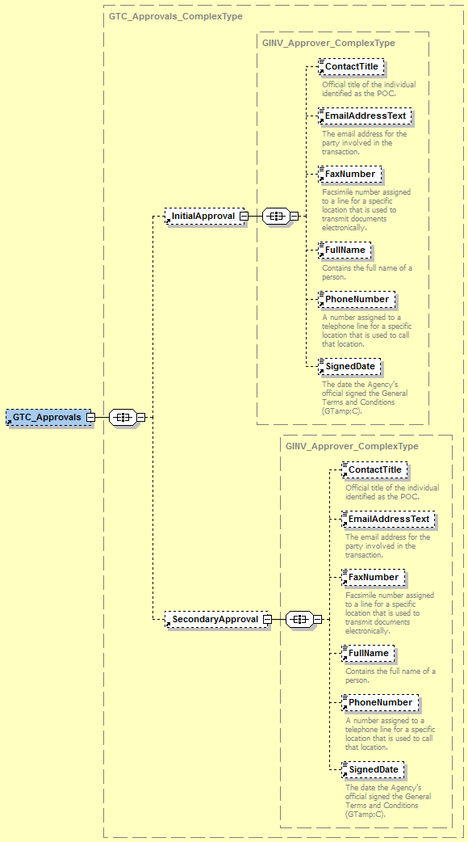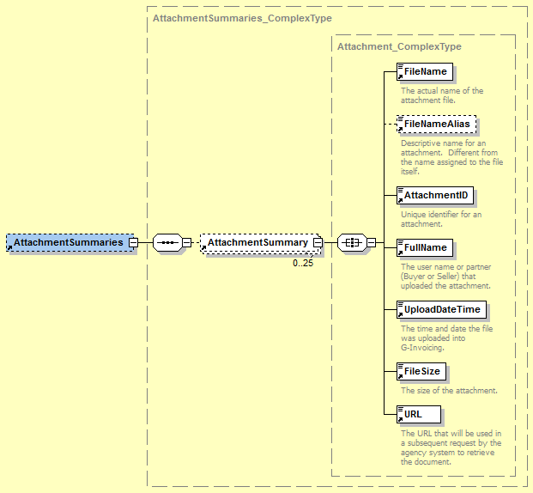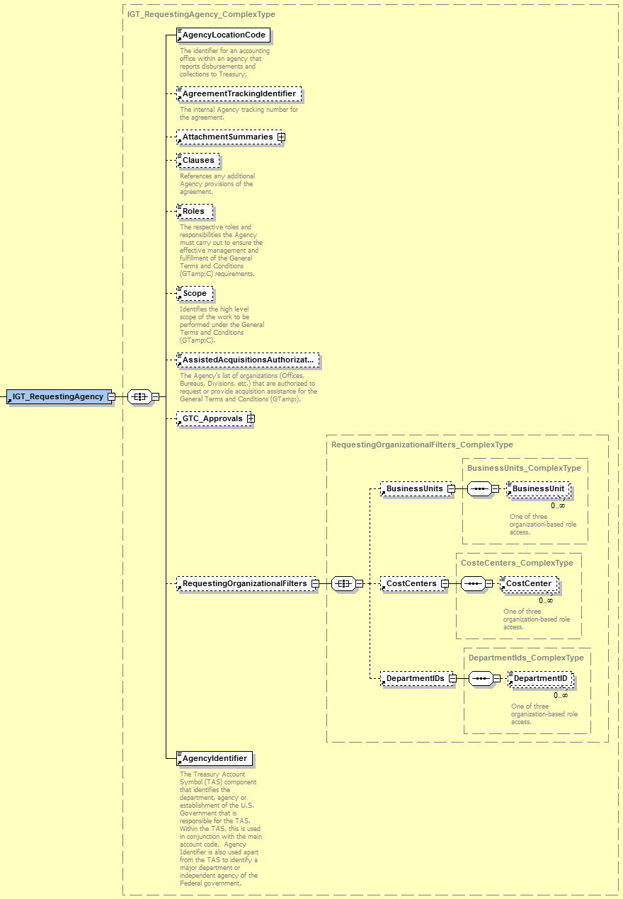Requesting Agency

#### **Requesting Agency Sample XML**

<?xml version="1.0" encoding="UTF-8"?>

<!--Sample XML file generated by XMLSpy v2017 sp2 (x64) (http://www.altova.com)-->

<cmn:IGT_RequestingAgency xmlns:cmn="urn:us:gov:treasury" xmlns:xsi="http://www.w3.org/2001/XMLSchema-instance" xsi:schemaLocation="urn:us:gov:treasury:ginv:gtc GTC.xsd">

<cmn:AgencyLocationCode>00005023</cmn:AgencyLocationCode>

<cmn:AgreementTrackingIdentifier>987654</cmn:AgreementTrackingIdentifier>

<cmn:AttachmentSummaries>

<cmn:AttachmentSummary>

<cmn:FileName>MyFile</cmn:FileName>

<cmn:FileNameAlias/>

<cmn:AttachmentID>298532147895</cmn:AttachmentID>

<cmn:FullName>Joe Fileuploader</cmn:FullName>

<cmn:UploadDateTime>2017-08-28T14:05:37.534-04:00</cmn:UploadDateTime>

<cmn:FileSize>200</cmn:FileSize>

<cmn:URL/>

</cmn:AttachmentSummary>

</cmn:AttachmentSummaries>

<cmn:Clauses/>

<cmn:Roles/>

<cmn:Scope/>

<cmn:AssistedAcquisitionsAuthorizationText/>

<cmn:GTC_Approvals>

<cmn:InitialApproval>

<cmn:ContactTitle/>

<cmn:EmailAddressText/>

<cmn:FaxNumber/>

<cmn:FullName/>

<cmn:PhoneNumber/>

<cmn:SignedDate/>

</cmn:InitialApproval>

<cmn:SecondaryApproval>

<cmn:ContactTitle/>

<cmn:EmailAddressText/>

<cmn:FaxNumber/>

<cmn:FullName/>

<cmn:PhoneNumber/>

<cmn:SignedDate/>

</cmn:SecondaryApproval>

</cmn:GTC_Approvals>

<cmn:RequestingOrganizationalFilters>

<cmn:BusinessUnits>

<cmn:BusinessUnit>999</cmn:BusinessUnit>

</cmn:BusinessUnits>

<cmn:CostCenters>

<cmn:CostCenter>12345</cmn:CostCenter>

</cmn:CostCenters>

<cmn:DepartmentIDs>

<cmn:DepartmentID>17</cmn:DepartmentID>

</cmn:DepartmentIDs>

</cmn:RequestingOrganizationalFilters>

<cmn:AgencyIdentifier>000</cmn:AgencyIdentifier>

</cmn:IGT_RequestingAgency>

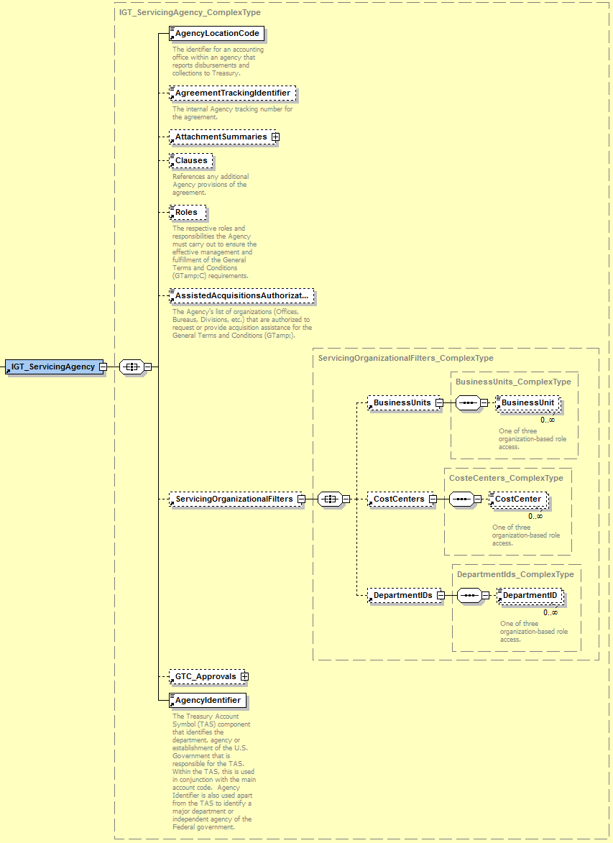Servicing Agency

#### **Servicing Agency Sample XML**

<?xml version="1.0" encoding="UTF-8"?>

<!--Sample XML file generated by XMLSpy v2017 sp2 (x64) (http://www.altova.com)-->

<cmn:IGT_ServicingAgency xmlns:cmn="urn:us:gov:treasury" xmlns:xsi="http://www.w3.org/2001/XMLSchema-instance" xsi:schemaLocation="urn:us:gov:treasury:ginv:gtc GTC.xsd">

<cmn:AgencyLocationCode>00005197</cmn:AgencyLocationCode>

<cmn:AgreementTrackingIdentifier>39685</cmn:AgreementTrackingIdentifier>

<cmn:AttachmentSummaries>

<cmn:AttachmentSummary>

<cmn:FileName>MyFile</cmn:FileName>

<cmn:FileNameAlias/>

<cmn:AttachmentID>235698745231400</cmn:AttachmentID>

<cmn:FullName>Cindy Filepusher</cmn:FullName>

<cmn:UploadDateTime>2017-08-28T14:05:37.534-04:00</cmn:UploadDateTime>

<cmn:FileSize>500</cmn:FileSize>

<cmn:URL/>

</cmn:AttachmentSummary>

</cmn:AttachmentSummaries>

<cmn:Clauses/>

<cmn:Roles/>

<cmn:AssistedAcquisitionsAuthorizationText/>

<cmn:ServicingOrganizationalFilters>

<cmn:BusinessUnits>

<cmn:BusinessUnit>999</cmn:BusinessUnit>

</cmn:BusinessUnits>

<cmn:CostCenters>

<cmn:CostCenter>12345</cmn:CostCenter>

</cmn:CostCenters>

<cmn:DepartmentIDs>

<cmn:DepartmentID>17</cmn:DepartmentID>

</cmn:DepartmentIDs>

</cmn:ServicingOrganizationalFilters>

<cmn:GTC_Approvals>

<cmn:InitialApproval>

<cmn:ContactTitle/>

<cmn:EmailAddressText/>

<cmn:FaxNumber/>

<cmn:FullName/>

<cmn:PhoneNumber/>

<cmn:SignedDate/>

</cmn:InitialApproval>

<cmn:SecondaryApproval>

<cmn:ContactTitle/>

<cmn:EmailAddressText/>

<cmn:FaxNumber/>

<cmn:FullName/>

<cmn:PhoneNumber/>

<cmn:SignedDate/>

</cmn:SecondaryApproval>

</cmn:GTC_Approvals>

<cmn:AgencyIdentifier>000</cmn:AgencyIdentifier>

</cmn:IGT_ServicingAgency>

Prepared By

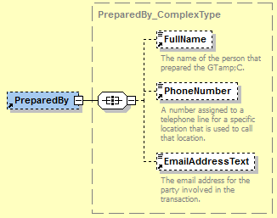**Prepared By Sample XML**

<?xml version="1.0" encoding="UTF-8"?>

<!--Sample XML file generated by XMLSpy v2017 sp2 (x64) (http://www.altova.com)-->

<cmn:PreparedBy xmlns:cmn="urn:us:gov:treasury" xmlns:xsi="http://www.w3.org/2001/XMLSchema-instance" xsi:schemaLocation="urn:us:gov:treasury:ginv:gtc GTC.xsd">

<cmn:FullName>Margaret Preparer</cmn:FullName>

<cmn:PhoneNumber>4444444</cmn:PhoneNumber>

<cmn:EmailAddressText>mpreparer@agency.com</cmn:EmailAddressText>

</cmn:PreparedBy>

1. Order

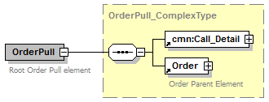

Header

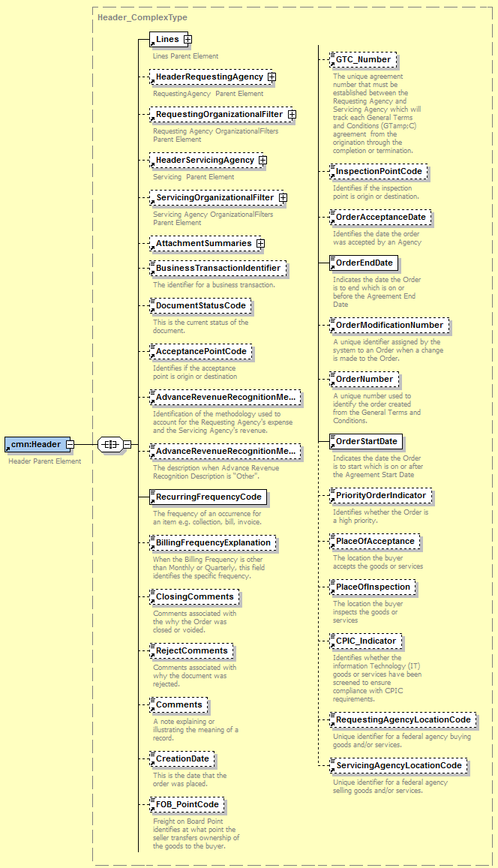

**Header Sample XML**

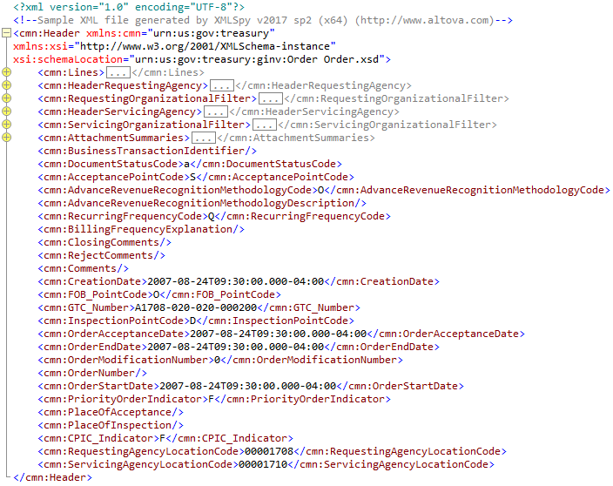

### Header Requesting Agency

Submitted only by the Requesting Agency

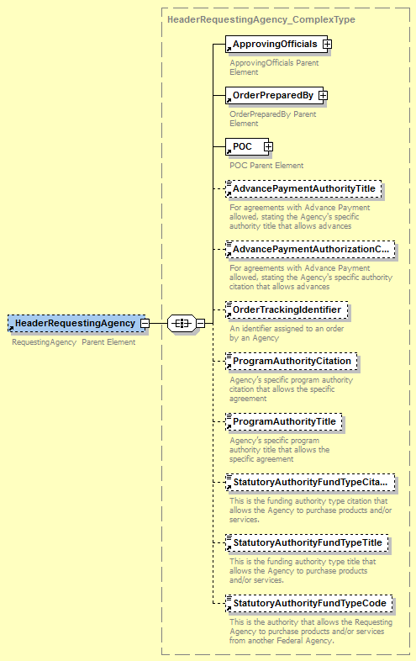

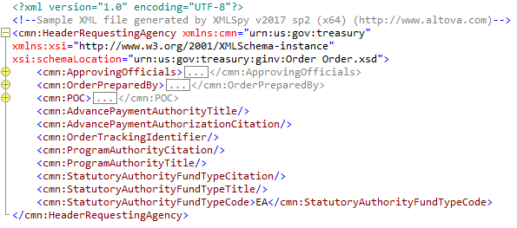**Header Requesting Agency Sample XML**

### Header Servicing Agency

Submitted only by the Servicing Agency

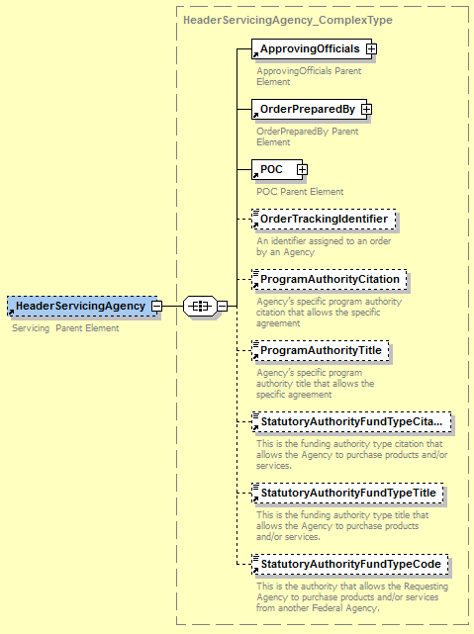

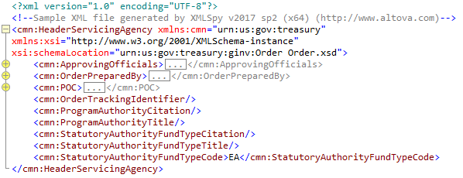**Header Servicing Agency Sample XML**

### Attachment Summary

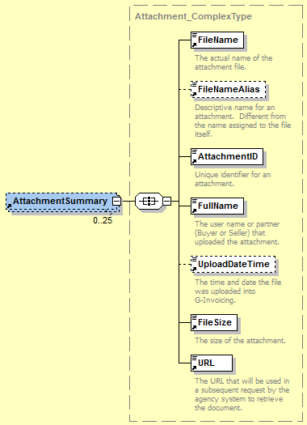

**Attachment Summary Sample XML**

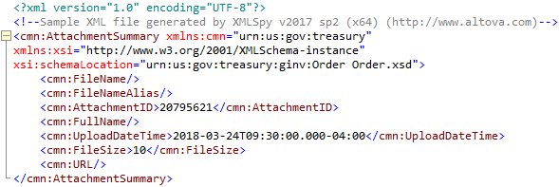

### Line

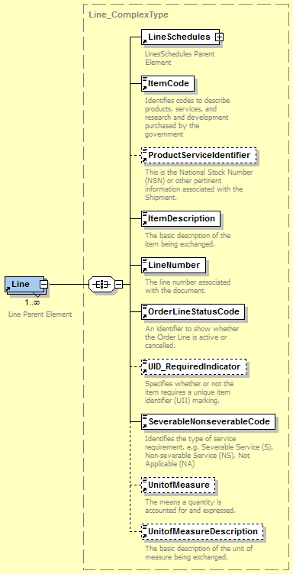

**Line Sample XML**

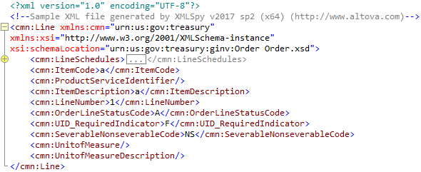

### Schedule

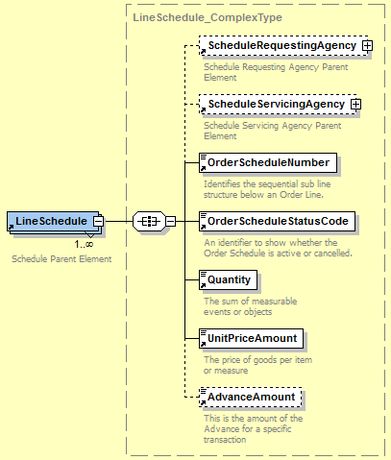

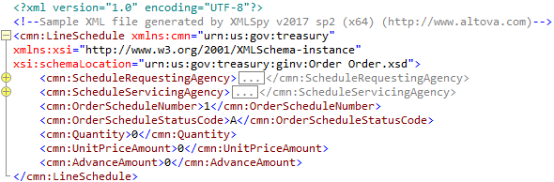**Schedule Sample XML**

#### **Schedule Requesting Agency**

Submitted only by the Requesting Agency

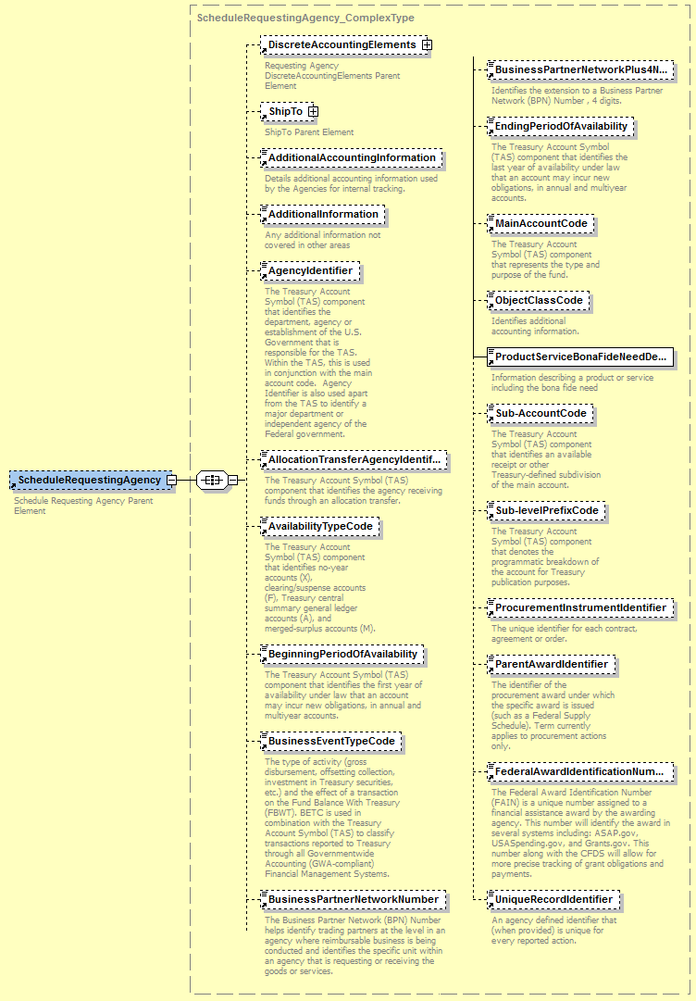

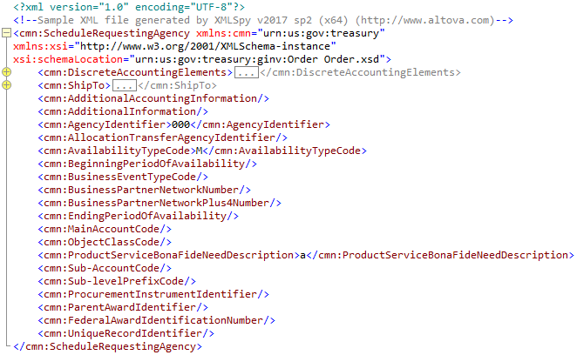**Schedule Requesting Agency Sample XML**

#### **Schedule Servicing Agency**

Submitted only by the Servicing Agency

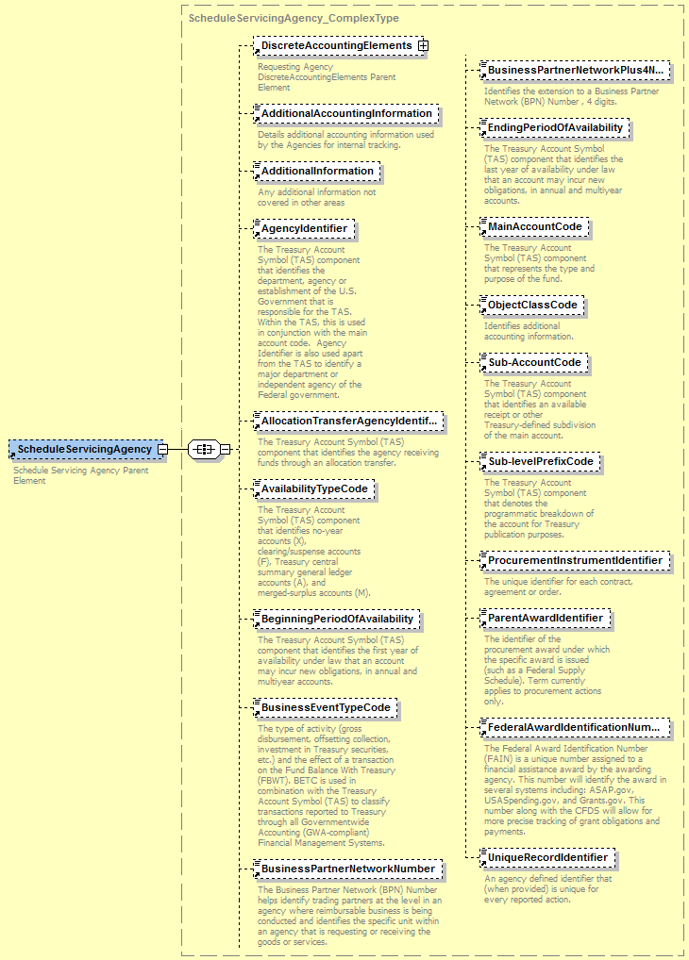

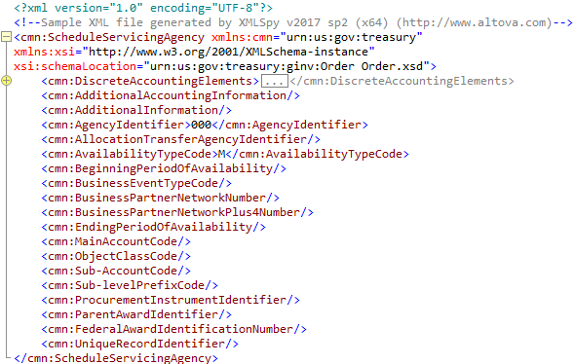**Schedule Servicing Agency Sample XML**