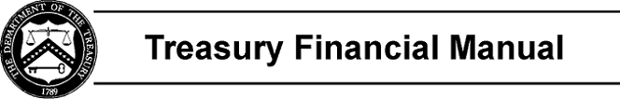

Part 2, Section V: USSGL Crosswalks to Standard External Reports
This section includes crosswalks for use in Fiscal Year 2022 GTAS Reporting. These crosswalks map USSGL accounts to external reports in accordance with current reporting guidance from the Office of Management and Budget (OMB), the Federal Accounting Standards Advisory Board (FASAB), and the Bureau of the Fiscal Service (Fiscal Service).

Each report crosswalk lists the proper USSGL accounts and applicable attributes for each line and/or column on the reports. Attributes identify information subsidiary to the basic 6-digit USSGL accounts. This subsidiary information is necessary to meet external reporting requirements. See Section IV for additional information on attributes.

All crosswalks require pre-closing USSGL account balances.

The following are crosswalks from the USSGL Chart of Accounts to standard external reports required by OMB and Fiscal Service:

Section V | Page Number
Balance Sheet (BS) | V BS - 1
Statement of Net Cost (SNC) | V SNC - 1
Statement of Changes in Net Position (SCNP) | V SCNP - 1
Statement of Custodial Activity (SCA) | V SCA - 1
Statement of Budgetary Resources (SBR) | V SBR - 1
SF 133 and Schedule P: Report on Budget Execution and Budgetary Resources and Budget Program and Financing Schedule | V SF 133/Sch P - 1

Page 1 of 1

