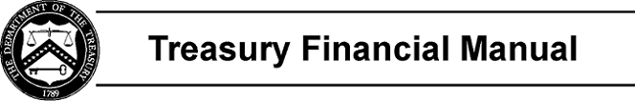

Part 2, Section I: Chart of Accounts

The Chart of Accounts provides the basic structure for the U.S. Standard General Ledger (USSGL). It incorporates both proprietary and budgetary accounts. The proprietary and budgetary sets of general ledger accounts are self-balancing (total debits equal total credits). It is important to note that central agency reporting requires a lower level of detail than the 6-digit USSGL account numbers provided. Therefore, the USSGL Board developed attributes containing various domain values that, when added to a basic 6-digit USSGL account, provide the appropriate level of detail needed for central agency reporting and, in effect, create new USSGL accounts. See Section IV for attribute definitions and domain values. It is this lower level of detail, the basic 6-digit USSGL account plus applicable attribute domain values, that agencies must capture at the transaction level to (1) comply with USSGL policy, and (2) achieve the desired result for proper reporting.

The basic 6-digit USSGL accounts are classified as follows:

100000 Assets

200000 Liabilities

300000 Net Position

400000 Budgetary

500000 Revenue and Other Financing Sources 600000 Expenses
700000 Gains/Losses/Miscellaneous Items

800000 Memorandum

Agencies may expand this numbering system to as many digits as necessary to accommodate agency- specific requirements. However, subsidiary accounts must summarize or “roll up” to the 6-digit USSGL accounts plus any related attributes.

In February 1999, the USSGL Board voted to delete summary accounts. However, agencies may summarize accounts as they find useful. Section headings replace many of the deleted summary accounts to maintain the integrity of the account structure.

Page 1 of 1

